Week 13

Roll No: 241401001
Name: Aadhithyaa T

Balanced array
Q1) Problem Statement:
Given an array of numbers, find the index of the smallest array element (the pivot), for
which the sums of all elements to the left and to the right are equal. The array may not be
reordered.
Example: arr=[1,2,3,4,6]
• the sum of the first three elements, 1+2+3=6. The value of the last element is 6.
• Using zero based indexing, arr[3]=4 is the pivot between the two subarrays.
• The index of the pivot is 3.
Function Description: Complete the function balancedSum in the editor below.
balancedSum has the following parameter(s): int arr[n]: an array of integers
Returns: int: an integer representing the index of the pivot
Constraints
• 3 ≤ n ≤ 105
• 1 ≤ arr[i] ≤ 2 × 104, where 0 ≤ i < n
• It is guaranteed that a solution always exists.
Input Format for Custom Testing
Input from stdin will be processed as follows and passed to the function. The first line
contains an integer n, the size of the array arr. Each of the next n lines contains an integer,
arr[i], where 0 ≤ i < n.
Sample Input
STDIN Function Parameters
----- -------------------
4 → arr[] size n = 4
1 → arr = [1, 2, 3, 3]
2
3
3
Sample Output 0
2
Explanation 0
• The sum of the first two elements, 1+2=3. The value of the last element is 3.
• Using zero based indexing, arr[2]=3 is the pivot between the two subarrays.
• The index of the pivot is 2.

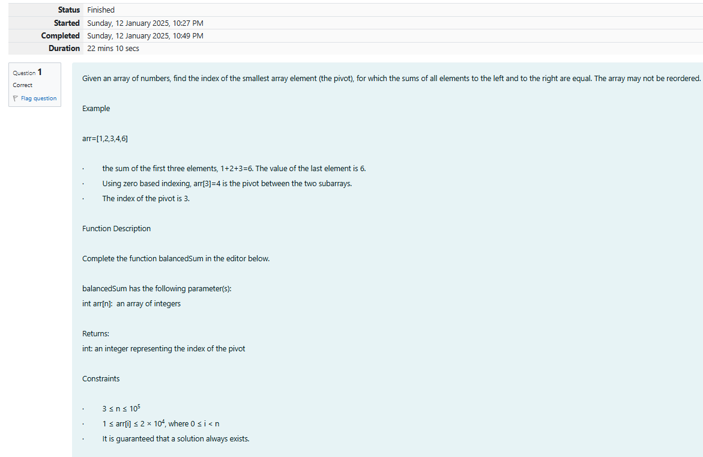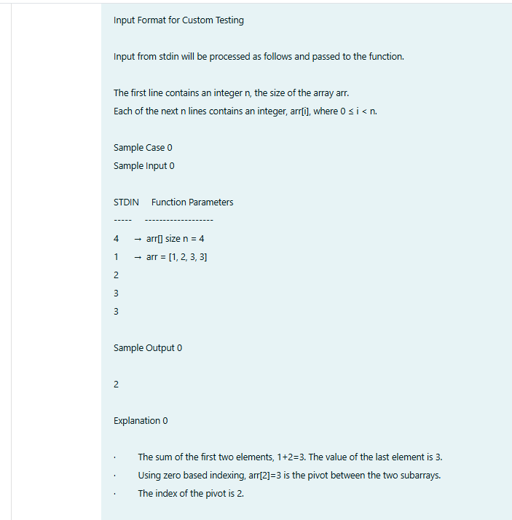

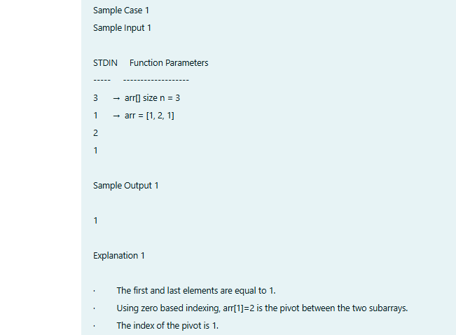
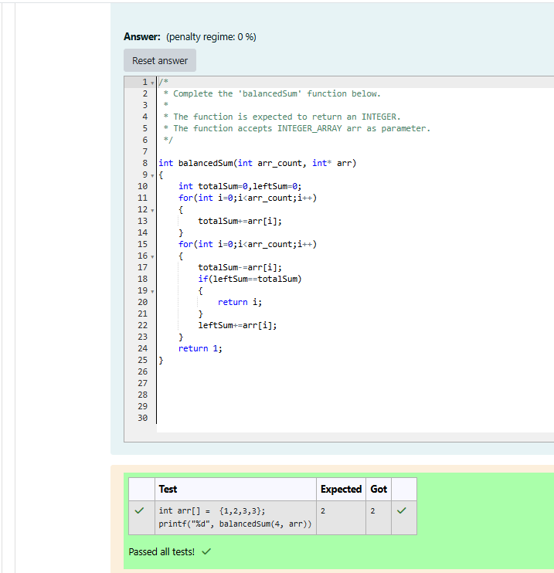
Sum them all

Q2) Problem Statement:
Calculate the sum of an array of integers.
Example
numbers = [3, 13, 4, 11, 9]
The sum is 3 + 13 + 4 + 11 + 9 = 40.
Function Description
Complete the function arraySum in the editor below.
arraySum has the following parameter(s):
int numbers[n]: an array of integers
Returns
int: integer sum of the numbers array
Constraints
1 ≤ n ≤ 104
1 ≤ numbers[i] ≤ 104
Input Format for Custom Testing
Input from stdin will be processed as follows and passed to the function.
The first line contains an integer n, the size of the array numbers.
Each of the next n lines contains an integer numbers[i] where 0 ≤ i < n.
Sample Input
STDIN Function
----- --------
5 → numbers[] size n = 5
1 → numbers = [1, 2, 3, 4, 5]
2
3
4
5
Sample Output
15
Explanation
1 + 2 + 3 + 4 + 5 = 15.
