**Getting Started**

1. Download Node.js
2. Create folder “server”
3. Create file “app.js”
4. Copy starter code from: <https://bit.ly/2UpxlIX>
5. Run “node app.js”
6. Visit localhost:3000

**Install express js**

1. npm install express –save
2. express will serve our routes to our clients.

**Some Info…**

Servers function with requests and response. You send a “message” to the server and the server replies back.

As of now, we are not sending any requests to our server. We are simply telling our server to send a response with message “Hello world” to our **client**.

**Currently…**

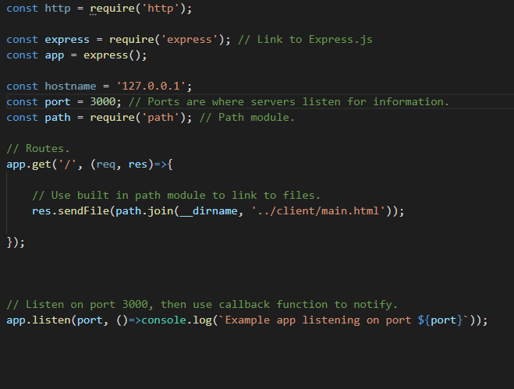

Two types of messages.

**Messages we receive from others** *message.*

**Messages we send** *self-message.*

**Get Socket.io**

1. Visit <https://www.socket.io>
2. npm install –save socket.io
3. Do socket.io set up.

  
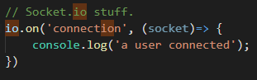

1. Get socket.io CDN so that the client can establish connection to server.

**Get jquery cdn**

1. Add on submit action on input form to emit message to the socket.

