Predicting Mechanical Properties of Complex Lattice
Metamaterials Using Graph Neural Networks

By
Alex Adams - University of Pittsburgh

Computational Mechanics and Physics Lab
Department of Mechanical and Industrial Engineering
Dr. Xing Liu - Advisor

New Jersey Institute of Technology
Newark, N.J. 07102

NSF REU Site: Optics and Photonics:
Technologies, Systems, and Devices (NSF Award No. 2349263)

Background
Lattice metamaterials, periodic or quasi-periodic architected structures built from repeating unit cells, are of growing interest across aerospace, biomedical, and structural engineering applications because their mechanical properties, such as effective stiffness, can be tuned largely through geometry rather than base material chemistry. Voronoi lattices, in particular, offer a disordered but controllable geometric design space that can be tailored to achieve target stiffness, energy absorption, or weight-reduction characteristics. Determining the effective mechanical response of a given lattice geometry conventionally requires finite element analysis (FEA), which, while accurate, is computationally expensive and becomes a bottleneck when exploring large design spaces or performing inverse design and optimization.
Graph neural networks (GNNs) are a natural fit for this problem because a lattice's nodes and struts map directly onto a graph's nodes and edges, allowing the network to reason over local connectivity and geometry the same way a structural analysis would. A trained graph convolutional network (GCN) can act as a fast surrogate model, approximating the outcome of an FEA simulation in a fraction of the computation time once trained. This project investigates whether a GCN surrogate can reliably predict the effective stiffness of Voronoi lattice structures directly from their node coordinates and connectivity, and what modeling choices most affect its accuracy and robustness.

Investigation Objective
The objective of this project is to develop and systematically optimize a graph convolutional network capable of predicting the effective stiffness of Voronoi lattice metamaterials as a computationally efficient surrogate for finite element simulation. Beyond simply training a working model, the investigation aims to identify which modeling decisions, optimizer choice, node- and graph-level feature engineering, network depth and architecture, loss function, and ensembling, produce genuine, reproducible improvements in predictive accuracy, and to characterize the model's remaining limitations, particularly its ability to generalize to lattice geometries that differ structurally from the training distribution.

Investigation Plan
The investigation proceeded as a sequence of controlled experiments, each isolating a single modeling variable so that its effect could be attributed unambiguously rather than confounded with simultaneous changes elsewhere in the pipeline. A 2-layer GCN with hidden dimension 24, trained with the Adam optimizer under a two-phase learning-rate schedule, served as the initial baseline, using only node x-y coordinates as input features and a binary adjacency structure derived from each lattice's Voronoi connectivity.
From this baseline, the plan moved through the following stages: (1) a fair, controlled comparison of optimizers (Adam, AdamW, SGD with momentum, and SGD with Nesterov momentum), correcting an initial confound in which multiple hyperparameters changed simultaneously; (2) incorporation of weighted edges using the existing adjacency-area data rather than binary connectivity; (3) enrichment of node-level features (degree, weighted degree, distance from specimen center, boundary indicators, and incident-edge statistics) computed directly from existing coordinate and adjacency data, without generating new lattice sets; (4) addition of graph-level pooled summary features (density, edge-weight statistics, degree statistics) concatenated after graph pooling; (5) target normalization of the stiffness regression label; (6) architecture comparisons across a deeper 3-layer GCN, GIN, and GraphSAGE; (7) residual (skip-connection) variants of the 3-layer GCN, including hyperparameter retuning and a Huber-loss objective, to address a robustness/generalization gap rather than a raw accuracy gap; (8) fixed-split and multi-split five-member ensembling of the promoted 3-layer GCN; and (9) a residual-error and distribution-shift analysis comparing the training, held-out test, and external prediction distributions to diagnose the source of remaining error.
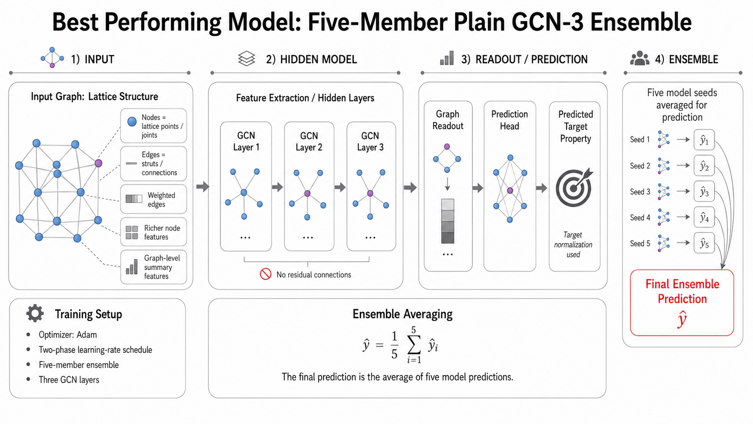 [Figure 1: Schematic of the GCN pipeline - Voronoi lattice geometry → graph construction (nodes, weighted edges) → node/graph feature engineering → 3-layer graph convolution stack → pooled graph embedding → stiffness prediction]
Every architectural or hyperparameter change was validated using a fixed decision rule: a single promising run was always followed by a multi-seed (and, where relevant, multi-split) validation before being adopted, so that favorable but non-reproducible results would not be mistaken for genuine improvements. Following the completion of the core optimization sweep, the plan extended into evaluation-strategy work: an out-of-distribution (OOD) style validation split constructed from structural similarity to the external prediction lattices, domain-weighted training, and explicit domain adaptation via fine-tuning on a small labeled subset of prediction-like source lattices. A final step characterized the selected model's uncertainty via ensemble member spread and confidence intervals, and tested its sensitivity to lattice mirroring/reflection as a check for non-physical orientation dependence learned from absolute coordinate features.

Results
The 2-layer GCN baseline achieved a test R² of 0.9148 (RMSE 0.003818) using only raw coordinates. The controlled optimizer comparison confirmed that Adam was the strongest available optimizer for this task: AdamW consistently underperformed (test R² of 0.5101 in the initial matched comparison), and both SGD variants performed far worse (best SGD test R² of 0.1424), even after being given longer training budgets and additional patience.
Feature engineering produced the largest and most reliable gains. Adding weighted edges modestly improved out-of-distribution behavior but did not meaningfully change held-out test accuracy. Enriching node-level features, by contrast, raised the multi-seed mean test R² from 0.9148 to 0.9380 (RMSE from 0.003818 to 0.003086) and was confirmed stable across five random seeds. Adding graph-level pooled summary features and target normalization produced further, smaller gains, bringing the multi-seed mean test R² to 0.9447 (RMSE 0.002908).
Architecture comparisons showed that a 3-layer GCN modestly but consistently outperformed the 2-layer control (mean test R² 0.9456 versus 0.9447), while GIN and GraphSAGE did not outperform the GCN family and were de-prioritized. Residual (skip-connection) variants of the 3-layer GCN were explored specifically to target the model's out-of-distribution weakness rather than its in-distribution accuracy: the original residual model achieved the strongest raw prediction-set R² of any configuration tested (0.5007 mean), but was unstable across seeds, and neither a broad hyperparameter retune, a narrow learning-rate-only retune, nor a Huber-loss objective surpassed the plain 3-layer GCN's mean test accuracy.
A five-member ensemble of the promoted 3-layer GCN was evaluated at both a fixed data split and across five independent splits. The fixed-split ensemble reached a test R² of 0.9555, the strongest single held-out result obtained in the project; however, the more representative multi-split mean test R² was 0.9456, essentially identical to a single 3-layer GCN, indicating that the ensemble's real, confirmed benefit is variance reduction and improved worst-case reliability (approximately 20 percent lower test-R² standard deviation, and a better worst-split result) rather than a step change in average accuracy.
[Figure 2: Bar chart comparing mean test R² and prediction-set R² across the baseline, richer-feature, graph-feature, target-normalized, GCN-3, and ensemble configurations]
A residual-error and distribution-shift analysis was carried out on the finalized ensemble to determine why prediction-set (external, structurally distinct lattice) performance remained substantially lower than held-out test performance (mean prediction-set R² of 0.4578 versus mean test R² of 0.9456). The analysis found that test-versus-training feature distributions were close, while prediction-set-versus-training distributions differed substantially in randomness value, graph density, and degree statistics. Prediction RMSE was only about 2.6 percent worse than test RMSE, and the much larger apparent R² collapse on the prediction set was shown to be an artifact of the prediction set's narrower target variance rather than proportionally larger absolute error. The model exhibited a systematic negative bias on the prediction set (mean bias approximately -0.0018 to -0.0020), meaning it consistently underpredicted stiffness for the higher-stiffness, structurally distinct external lattices.
Follow-on experiments targeting this distribution gap, domain-weighted training and explicit fine-tuning (domain adaptation) on a small labeled subset of structurally similar source lattices, showed that domain weighting's initial single-seed gain did not reproduce across five seeds and was rejected, while explicit domain adaptation produced a genuine but modest and still-unpromoted improvement (external prediction R² from 0.3764 to 0.4491) without harming ordinary validation performance. Ensemble member disagreement was found to be essentially uncorrelated with prediction error on both the test set (Spearman ≈ +0.11) and the external set (Spearman ≈ -0.03), indicating that the model's confidence, as measured by initialization spread, does not track its actual accuracy under distribution shift. A mirrored-lattice sensitivity check was run as a final characterization step to test whether the model's use of absolute node coordinates introduces non-physical orientation dependence in its stiffness predictions.
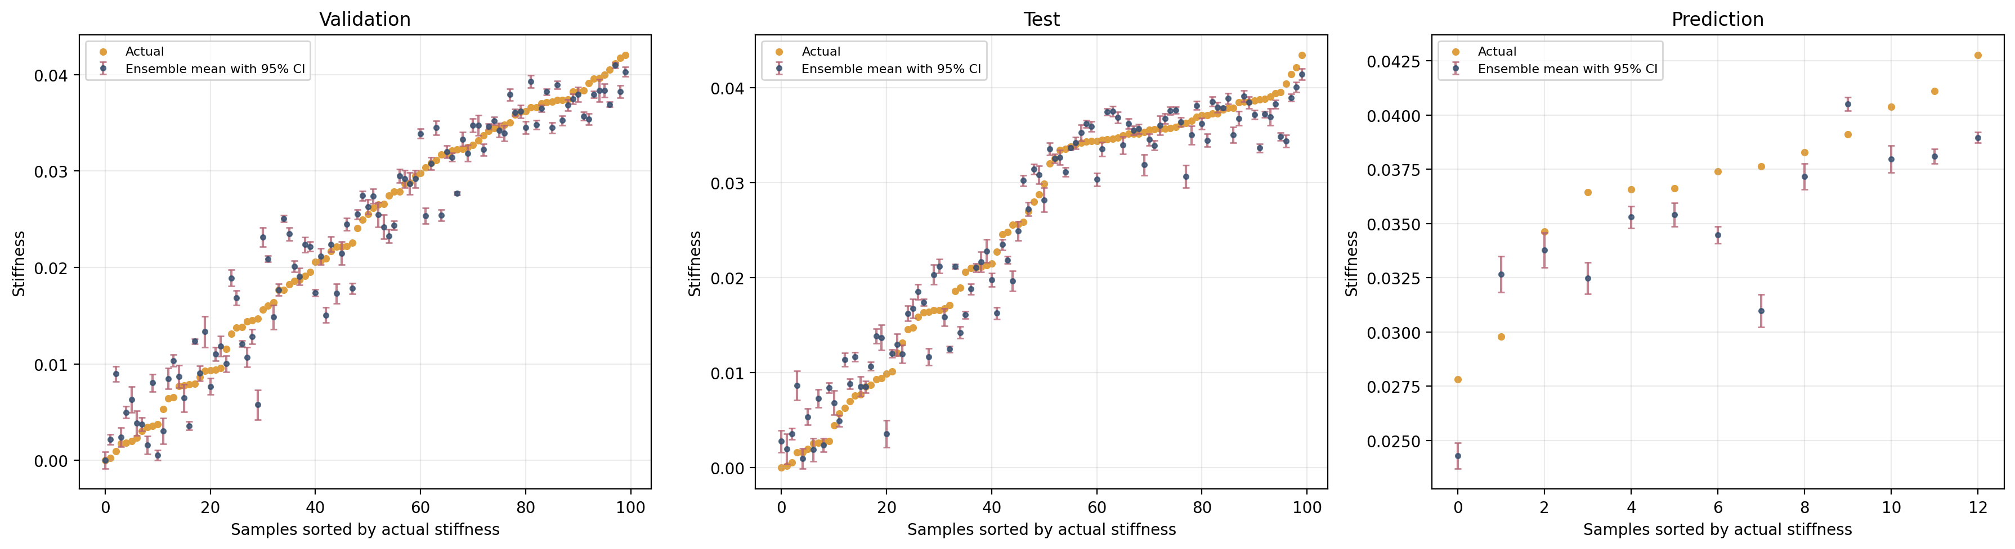 [Table/Figure 3: Final ensemble uncertainty results: member standard deviation, empirical confidence-interval coverage, and external residual bias by dataset (validation / test / prediction)]
Configuration | Test R² | Test RMSE | Prediction-set R²
2-layer GCN baseline (x, y features only) | 0.9148 | 0.003818 | -
Richer node features (multi-seed mean) | 0.9380 | 0.003086 | 0.4964
+ Graph-level summary features (multi-seed mean) | 0.9411 | 0.003003 | 0.4035
+ Target normalization (multi-seed mean) | 0.9447 | 0.002908 | 0.4459
3-layer GCN, promoted config (multi-seed mean) | 0.9456 | 0.002882 | 0.4453
5-member GCN-3 ensemble (multi-split mean) | 0.9456 | 0.002885 | 0.4578
Final characterization ensemble (fixed split) | 0.9528 | 0.002841 | 0.4024

Conclusions
A graph convolutional network can predict the effective stiffness of Voronoi lattice metamaterials with high accuracy on in-distribution geometries: the final promoted configuration (a 3-layer GCN with weighted edges, richer node and graph-level features, and target normalization, evaluated as a five-member ensemble) achieves a mean held-out test R² of approximately 0.946, rising to 0.953-0.956 on favorable individual splits. This confirms that the proposed GCN pipeline is a viable, fast surrogate for FEA-based stiffness evaluation within the training distribution.
The optimization phase of the project is considered largely settled: Adam remains the clearly superior optimizer, feature engineering (particularly richer node features) produced the largest single gains, additional network depth produced only a small further gain, and broader architecture families (GIN, GraphSAGE) and residual/loss-function variants did not exceed the plain 3-layer GCN's mean accuracy, though residual variants did show promise for a different objective - prediction-set robustness. The project's most important finding is that the model's remaining weakness is not a matter of insufficient model capacity or suboptimal training, but a distribution-shift problem: the external prediction lattices differ structurally from the training distribution, and the model responds to this shift with a systematic, non-random underprediction bias that neither larger ensembles nor further local hyperparameter tuning are able to correct.

Future Work
The clearest path to further improvement is expanding the labeled training data to better represent the structural regime occupied by the external prediction lattices, since the current bottleneck has been identified as training-domain coverage rather than model capacity. Within the existing data, explicit domain adaptation, fine-tuning the trained model on a small labeled subset of structurally similar source lattices, showed a genuine, non-trivial improvement in external prediction accuracy without harming in-distribution validation performance, and is the most promising unfinished direction; it should be validated across multiple model seeds and adaptation-split seeds before being considered for promotion. Future work should also pursue properly calibrated predictive intervals (e.g., residual-based or conformal calibration) rather than relying on ensemble-mean confidence intervals, which were shown to substantially undercover both test and external targets. Finally, the mirrored-lattice sensitivity results should inform whether rotation- or reflection-invariant node features (rather than absolute x-y coordinates) would improve physical consistency and, potentially, out-of-distribution generalization.

Acknowledgements
I would like to thank my mentor, Dr. Xing Liu of the Computational Mechanics and Physics Lab in the Department of Mechanical and Industrial Engineering, for his guidance throughout this project. I would also like to thank the National Science Foundation and New Jersey Institute of Technology for their support through the REU Site: Optics and Photonics: Technologies, Systems, and Devices (NSF Award No. 2349263).

