**Spring related instructions in STS 4 with JDK 21**

Refer to these instructions to download Spring Core 6 dependencies.

I hope you have already done this -

1. Extract from Web Java , G drive "softwares" folder

JDK 21 installer n install Java 21.

2. Download n extract (Using 7-Zip) STS 4.30 (in some other drive , than STS 3 , preferably! )

3. Launch STS 4 . Create a **new workspace** .

4. Set JRE as JDK 21 here.

Refer to this screen shot -

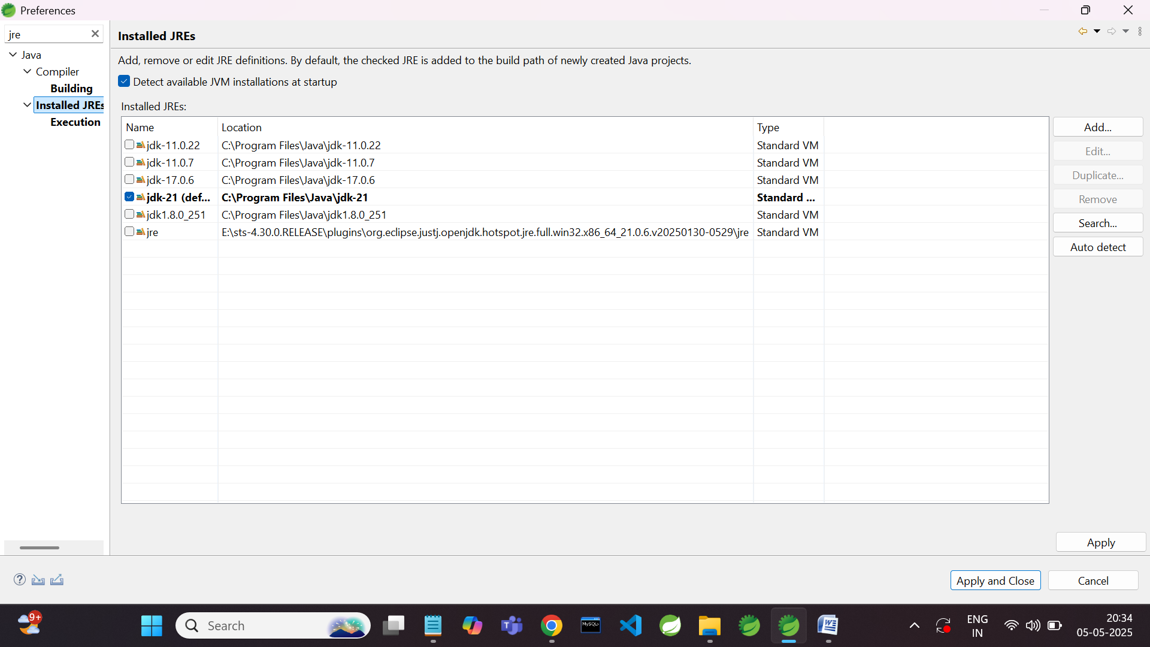

5. Download n extract

- "Spring Core Project with STS 4 Spring 6"

6. Import as Existing Maven project -

- "Spring Core Project with STS 4 Spring 6\test_spring_core"

7. It should download spring core dependencies .

Do keep them ready , as you will need them in tomorrow's lab.

8. Refer to screen shot here.

