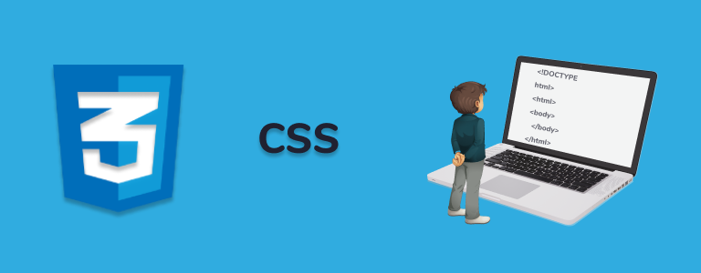

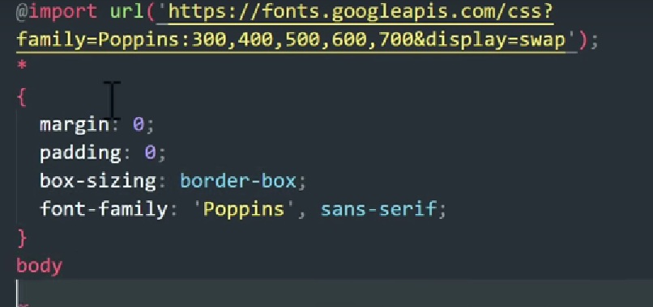

.class

#id

color:

background color:

selector:hover {}

for selecting lists element ul or ol

li:first-child{}

li:last-child{}

li:nth-child(n){}

attribute --- :link{} :visited{}

img[src^="../img/"]{ } ----all imgs with url starting with this can be manipulated

multiple class values can be given in single class attribute and can be edited by

h2.[class~= a]{}----------- for class="a b c" ( 3 classes)

color: rgb( , , ,) or hash code or name

background: url(...............); can put image

<link rel="../css/stylesheet.css" type ="" > ----- to connect to local stylesheet in hosting

background-image:url(); and backgroung-color:

background-repeat:no-repeat;

background-size:cover; ------ to cover hole thing

-------: height width ; in px or percentage;------------------

opacity: 0 or 1 ; 1 opaque and 0 - transparent

gradient

:linear-gradient(to direction, color,color,color,etc);

directions-top,bottom,left,right,bottomright,top left ,etc or use angles

:radial-gradient(shape , color size,color size,color size,etc); -- shape if required and size if needed

SIZE

relative units - percentage and em ---relative to parent element , px pt

font-size:size color;

font-weight:100---to ---600;

The min-height CSS property sets the minimum height of an element. It prevents the used value of the height property from becoming smaller than the value specified for min-height.

line-height: 1 -default 1.2/1.4/ etc ---- line spacing betweenparagraphs

text-decoration:none; --- removes line under a link , by default is underline , line-through and overline

text-transform:uppercase,lowercase,capatalise

text-align:;

text-align:centre , left , right , justify

font-styple:italic,bold,etc;

font-family:style of font;---times new roman , serif, san-serif,etc

font-family:"times new roman",serif;----if times is not available use serif

THE MORE U USE EXTERNAL SOURCES ON WEBPAGE MORE SLOW LOADING IT BECOMES

height:;

width:;

border:size style color; style- solid,dashed,dotted,double

padding:;

padding-top/right/left/bottom:;

padding: top right bottom left ;

margin : top-bottom left-right;

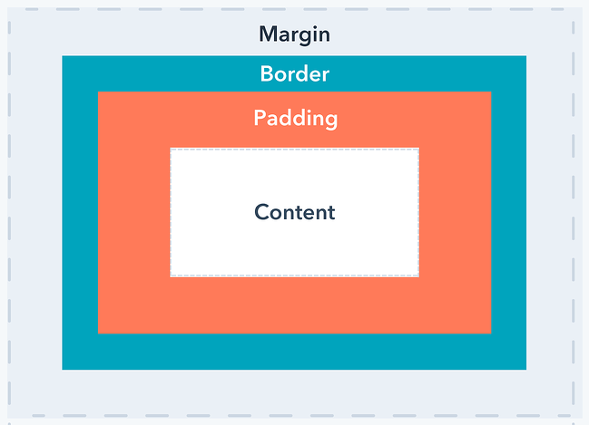

float:left,right ,none ,inherit ;------for arrangement

display:none,inline,block,inline-block

(Block- works like div)

Box-sizing:border-box ; ---The CSS box-sizing property allows us to include the padding and border in an element's total width and height.

object-fit:cover;---- completely fits in parent element

eg- 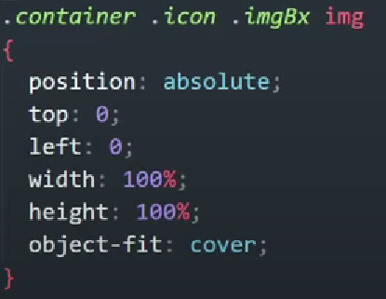

gap: _ px ; ----defines the size of the gap between the rows and columns.

unit : vw- viewport width for taking visible screen width

FLEXBOX

display:flex; ----

flex-direction:row,column,row-reverse ,etc;

flex-wrap:wrap; --instead of adjusting in a row it uses space and takes new line space

nowrap is default value

justify-content:center,flex-end, space between, space-around,----alignment of containers and spacing btw them

align-item:center,flex-end,flex-start,baseline ;

line-height: and line-width ;

order: n; ( flex item order)

flex-grow:0,1,2,3 ; helps to maintain size when window is resized

flex-shrink: 0 -dont shrink when window size reduces , 2 - shrink 2 times the size , shrink 4times , etc ;

flex-basis : px ; to give it resonable size to its elements

flex: grow shrink basis ;

align-self - to align items in flexbox individually . - centre , flex-start / end ;

GRID

display:grid;

auto - gives equal to all evenly;

grid-template-columns :column column column etc ;

grid-template-rows: row row etc ;

justify-content: start(right) , end (left) , center , evenly ( spread evenly)

align-content : space-evenly , space-between;

grid-column-gap: ; grid-row-gap: ;

or use

grid-gap: column row ;

grid-column : star / end ; grid-row: start/ end;

grid-column : start / span ( number of spaces) ;grid-row : start / span ( number of spaces) ; grid-area:;

TRANSITION

:hover;

transition : property delay ; in s and ms(mili sec)

-----------------------------transition and animation property for various browser support ---------------------

ADD MANY PROPERTIES FORBROWSER COMPATIBILITY

----------------------------------------------------------------------------------------------------------------

The major browsers use the following prefixes:

-webkit- (Chrome, Safari, newer versions of Opera, almost all iOS browsers including Firefox for iOS; basically, any WebKit based browser)

-moz- (Firefox)

-o- (old pre-WebKit versions of Opera)

-ms- (Internet Explorer and Microsoft Edge)

----------------------------------------------------------------------------------------------------------------

TRANSFORMATION FUNCTIONS -------------------------------

transform: translate( x-axis , y - axis); ----- right/left , up/down

transform: scale(number of times) -- 0 -- to size 0 ;

transform: rotate( ndeg) ;

transfor: skewX(deg) and skewY(deg) ; or skew( x , y) ----- makes element revolve around an imaginary axis;

matrix(scaleX(),skewY(),skewX(),scaleY(),translateX(),translateY());

ANIMATIONS -

animation-name: name ;

animation-duration: ;

@keyframes name {

0%{}

50%{}

100%{}

}

animation-timing-function : linear / ease /ease-in / ease- out ;

animation-delay : ; in sec

animation-iteration-count: n or infinite;

animation-direction: normal , reverse , alternate(0-100-0) , alternate-reverse (100-0-100);

animation: name duration timing-function delay iteration-count direction ;

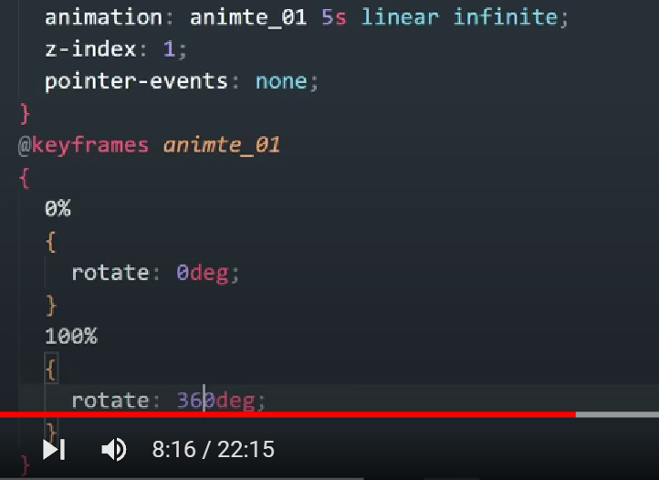

-------------------------gray out filter----------------

opacity : 0.4;

filter: alpha(opacity=40)

---------------------------------------------------------

@import url('');

Cursor property

to change the shape of cursor.

Cursor:value;

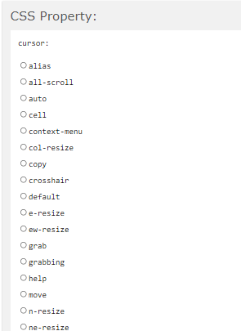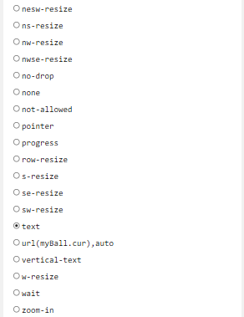



BOX-shadow

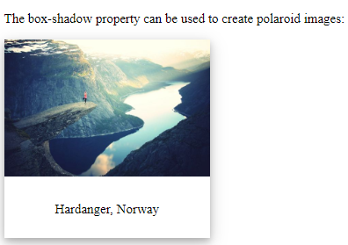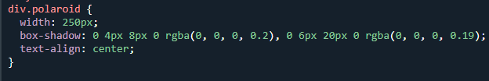

The inset property sets the distance between an element and the parent element.

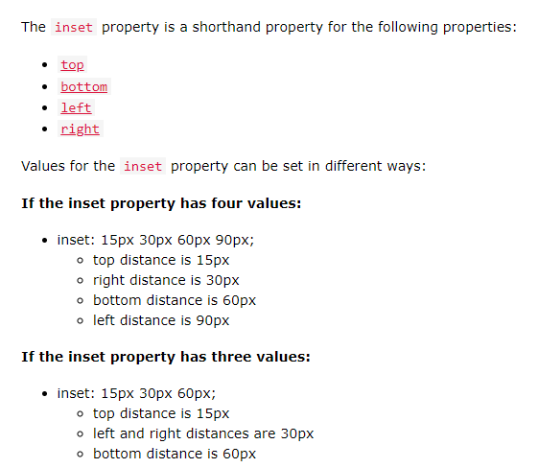

**AFTER & BEFORE**

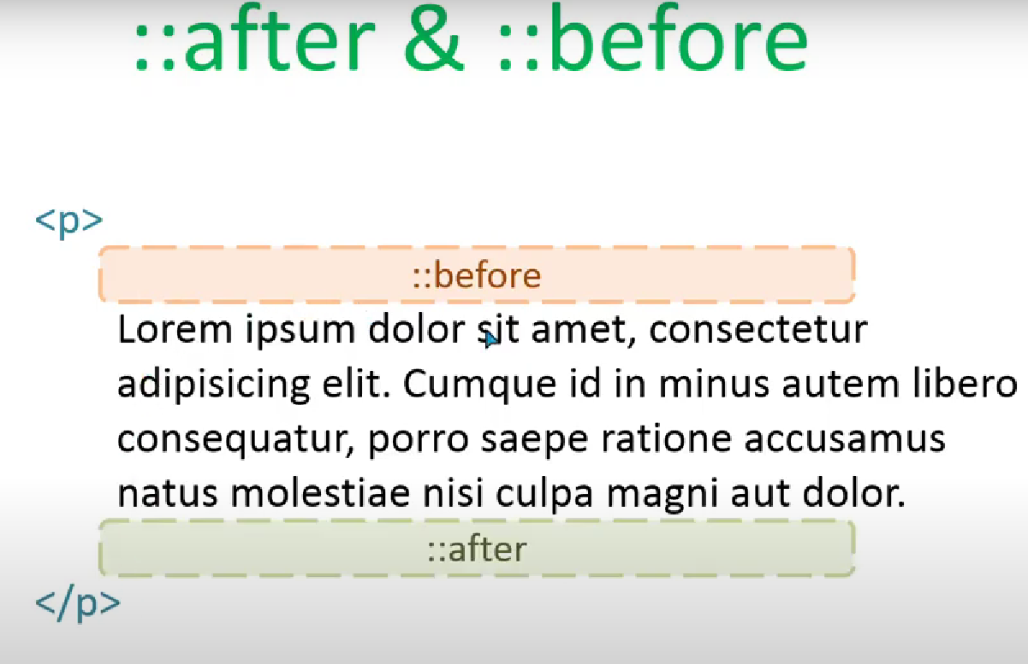

The ::before selector inserts something before the content of each selected element(s)

Use the content property to specify the content to insert.

Use the ::after selector to insert something after the content.

Code of before and after is not show in inspect element

**USING ACTIVE CLASS IN CSS WITH JAVASCRIPT**

<https://www.w3schools.com/howto/howto_js_active_element.asp>