JAVA

Java is case-sensitive

Every line of z that runs in Java must be inside a class. In our example, we named the class **Main**. A class should always start with an uppercase first letter.

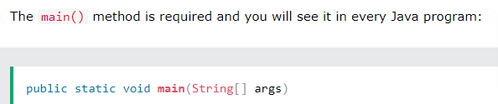

**System.out.println("Hello World")**

----------------to print in next line

There is also a print() method, which is similar to println().

The only difference is that it does not insert a new line at the end of the output:

// coment

VARIABLE DECLARATION

*type variableName = value;*

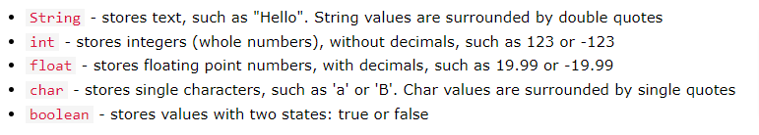

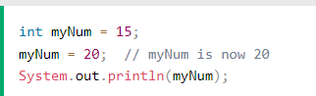

--- VALUE IS 20 HERE

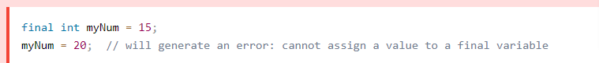

Here value will be 15 only as it is final variable

To combine both text and a variable, use the + character:

For numeric values, the + character works as a mathematical [operator](https://www.w3schools.com/java/java_operators.asp)

All Java **variables** must be **identified** with **unique names**.

These unique names are called **identifiers**.

* Primitive data types - includes byte, short, int, long, float, double, boolean and char
* Non-primitive data types - such as [String](https://www.w3schools.com/java/java_strings.asp), [Arrays](https://www.w3schools.com/java/java_arrays.asp) and [Classes](https://www.w3schools.com/java/java_classes.asp)

A primitive data type specifies the size and type of variable values, and it has no additional methods.

The float and double data types can store fractional numbers. Note that you should end the value with an "f" for floats and "d" for doubles: end with L for long.

A boolean data type is declared with the boolean keyword and can only take the values true or false:

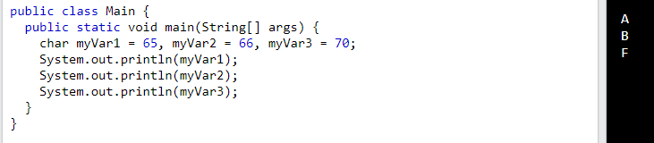

The char data type is used to store a **single** character. The character must be surrounded by single quotes, like 'A' or 'c':

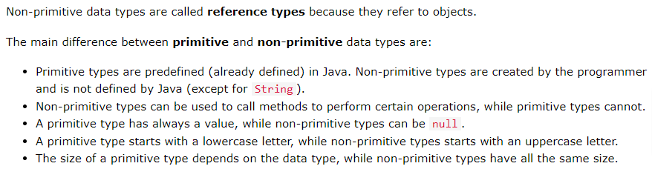

TYPE CASTING

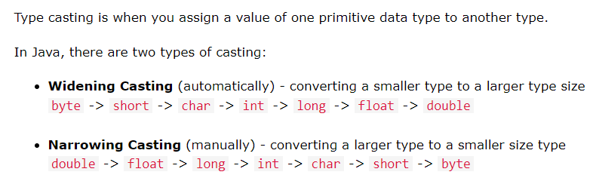

Widening

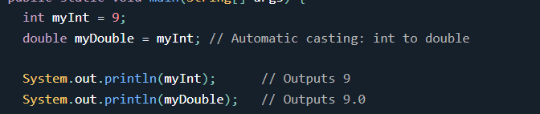

Narrowing

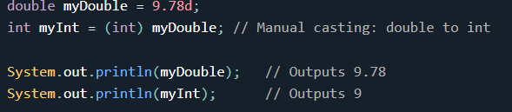

Arithmetic operators

Assignment operators

Comparison operators

Logical operators

Bitwise operators

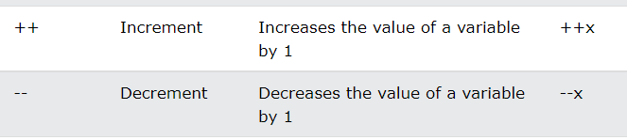

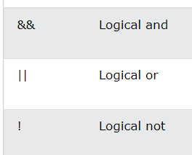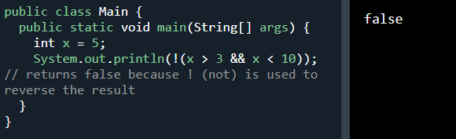

length() method: to know length of string

The backslash (\) escape character turns special characters into string characters:

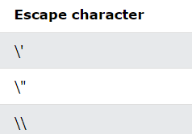

Maths ----------(java.lang.Math)

The Math.max(x,y) method can be used to find the highest value of x and y:

The Math.min(x,y) method can be used to find the lowest value of x and y:

The Math.sqrt(x) method returns the square root of x:

The Math.abs(x) method returns the absolute (positive) value of x:

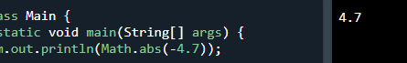

Math.random() returns a random number between 0.0 (inclusive), and 1.0 (exclusive):



Very often, in programming, you will need a data type that can only have one of two values, like:YES / NO ON / OFF TRUE / FALSE For this, Java has a boolean data type, which can take the values true or false.

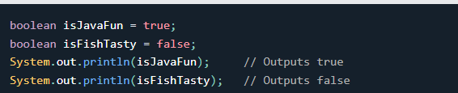



Use if to specify a block of code to be executed, if a specified condition is true

Use else to specify a block of code to be executed, if the same condition is false

Use else if to specify a new condition to test, if the first condition is false

Use switch to specify many alternative blocks of code to be executed

There is also a short-hand if else, which is known as the ternary operator

variable = (condition) ? expressionTrue : expressionFalse; ()?:

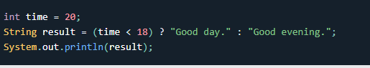

Switch 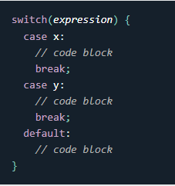 When Java reaches a break keyword, it breaks out of the switch block. The default keyword specifies some code to run if there is no case match:

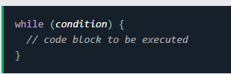

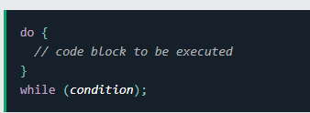

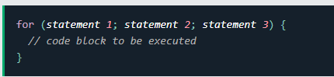

Statement 1 is executed (one time) before the execution of the code block.

Statement 2 defines the condition for executing the code block.

Statement 3 is executed (every time) after the code block has been executed.

For -each loop -🡪 There is also a "for-each" loop, which is used exclusively to loop through elements in an array:

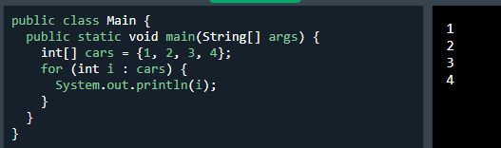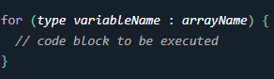

The break statement can also be used to jump out of a loop.

The continue statement breaks one iteration (in the loop), if a specified condition occurs, and continues with the next iteration in the loop.

Continue SKIPS a iteration of loop.

Java Arrays

Arrays are used to store multiple values in a single variable, instead of declaring separate variables for each value.

String[] cars; or String[] cars = {"Volvo", "BMW", "Ford", "Mazda"};

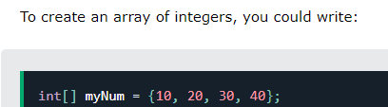

You can access an array element by referring to the index number.

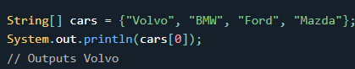

To change the value of a specific element, refer to the index number:

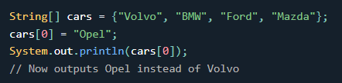

To find out how many elements an array has, use the length property:

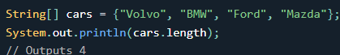

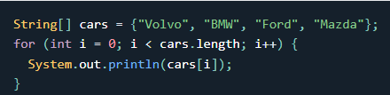

Loop Through an Array with For-Each

for (type variable : arrayname) {

...

}

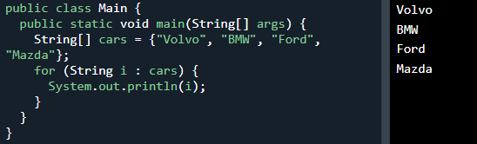

Creative way to display all array elements using for loop and array length

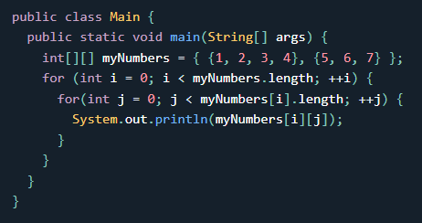

-----------------------------------------------------------------------------------------

Java Methods

A **method** is a block of code which only runs when it is called. You can pass data, known as parameters, into a method. Methods are used to perform certain actions, and they are also known as **functions**.

A method must be declared within a class. It is defined with the name of the method, followed by parentheses **()**. Java provides some pre-defined methods, such as System.out.println(), but you can also create your own methods to perform certain actions:

public class Main {

static void myMethod() {

}

}

static means that the method belongs to the Main class and not an object of the Main class.

To call a method in Java, write the method's name followed by two parentheses **()** and a semicolon**;**

Information can be passed to methods as parameter. Parameters act as variables inside the method. Parameters are specified after the method name, inside the parentheses.

static void myMethod(String fname) {

System.out.println(fname + " Refsnes");

}

The void keyword, used in the examples above, indicates that the method should not return a value. If you want the method to return a value, you can use a primitive data type (such as int, char, etc.) instead of void, and use the return keyword inside the method

Conditional statements are often used within the method.

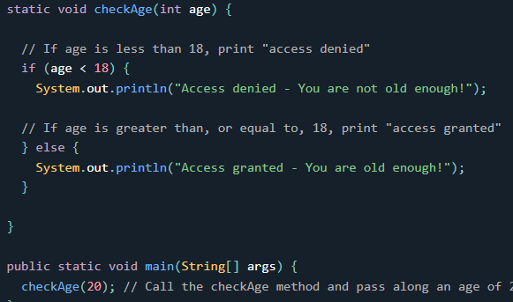

With method overloading, multiple methods can have the same name with different parameters:

Instead of defining two methods that should do the same thing, it is better to overload one.

In the example below, we overload the plusMethod method to work for both int and double:

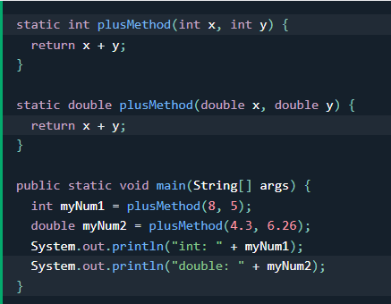 only data type is different , and method name is same , can have multipurpose .

In Java, variables are only accessible inside the region they are created. This is called scope. Variables declared inside blocks of code are only accessible by the code between the curly braces, which follows the line in which the variable was declared:

Adding two numbers together is easy to do, but adding a range of numbers is more complicated.

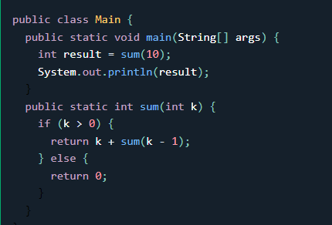 output : 55

Halting Condition

Just as loops can run into the problem of infinite looping, recursive functions can run into the problem of infinite recursion. Infinite recursion is when the function never stops calling itself. Every recursive function should have a halting condition, which is the condition where the function stops calling itself.

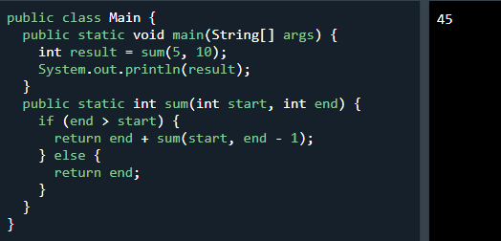

Java OOP

Procedural programming is about writing procedures or methods that perform operations on the data, while object-oriented programming is about creating objects that contain both data and methods.

Object-oriented programming has several advantages over procedural programming: faster ,DRY , clear structured , saves time and provides reusability.

"Don't Repeat Yourself" (DRY) principle is about reducing the repetition of code. You should extract out the codes that are common for the application, and place them at a single place and reuse them instead of repeating it.

Classes and objects are the two main aspects of object-oriented programming.

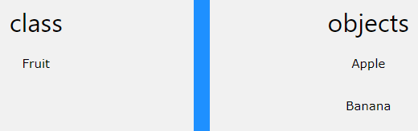

class is a template for objects, and an object is an instance of a class.

When the individual objects are created, they inherit all the variables and methods from the class.

To create a class, use the keyword class:

public class Main { int x = 5;}

To create an object of Main, specify the class name, followed by the object name, and use the keyword new:

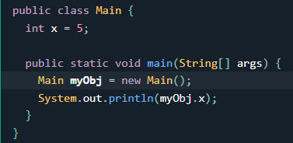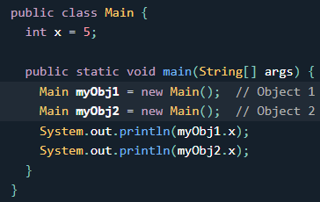

You can also create an object of a class and access it in another class. This is often used for better organization of classes (one class has all the attributes and methods, while the other class holds the main() method (code to be executed)).

Remember that the name of the java file should match the class name. In this example, we have created two files in the same directory/folder:

Main.java 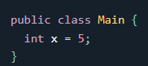 Second.java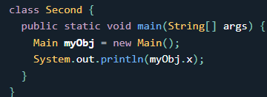

Now when compiled both gets compiled. And objects of one class main can be accessed and executed when second class is executed .

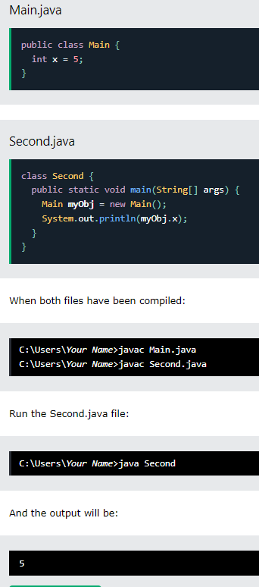

you could say that class attributes are variables within a class

You can access attributes by creating an object of the class, and by using the dot syntax (.):The following example will create an object of the Main class, with the name myObj. We use the x attribute on the object to print its value:

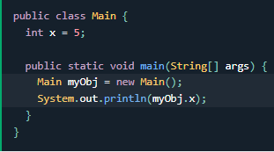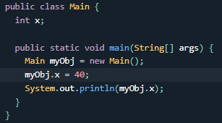

U can also modify them or override values. If you don’t want to override the existing value , declare attribute as final . 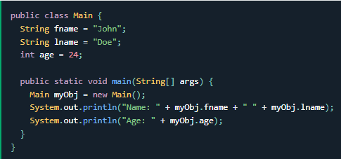

DOUBT – If methods within a class can access variables of the class then what is the need of creating object of the class ???

Can a method of a class access methods of other class ??

we created a static method, which means that it can be accessed without creating an object of the class, unlike public, which can only be accessed by objects:

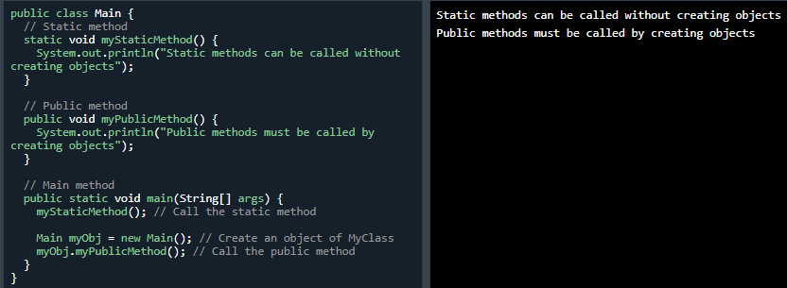

Static without creating objects and Public with objects .

Calling methods using objects 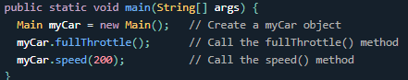

Similarly as done before U can access methods of another class (public )in your class by creating object and calling method through it. Can do it by creating 2 separate java files also .

A constructor in Java is a special method that is used to initialize objects. The constructor is called when an object of a class is created. It can be used to set initial values for object attributes:

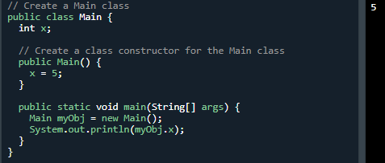

* Note that the constructor name must match the class name, and it cannot have a return type (like void).

Also note that the constructor is called when the object is created.

// Constructor help manipulate attributes of classes , resembles like method and can have parameters.

All classes have constructors by default: if you do not create a class constructor yourself, Java creates one for you. However, then you are not able to set initial values for object attributes.

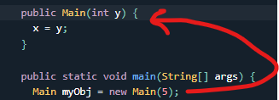You can have as many parameters as u want



The public keyword is an access modifier, meaning that it is used to set the access level for classes, attributes, methods and constructors.

We divide modifiers into two groups:

Access Modifiers - controls the access level

Non-Access Modifiers - do not control access level, but provides other functionality

// < public> The class is accessible by any other class

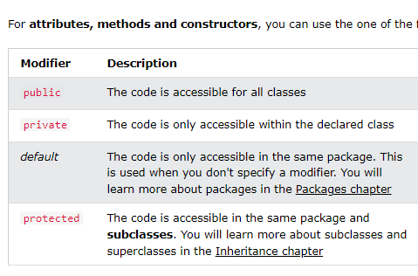 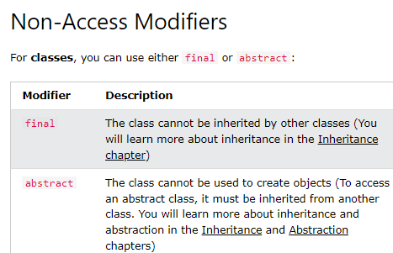

https://www.w3schools.com/java/java_modifiers.asp

If you don't want the ability to override existing attribute values, declare attributes as final:

A static method means that it can be accessed without creating an object of the class, unlike public.

An abstract method belongs to an abstract class, and it does not have a body. The body is provided by the subclass. ----SIR KE UPAR SE GAYA

Abstract (<https://www.w3schools.com/java/java_modifiers.asp>) -----!!!

The meaning of Encapsulation, is to make sure that "sensitive" data is hidden from users. To achieve this, you must:

* declare class variables/attributes as private
* provide public get and set methods to access and update the value of a private variable

You learned from the previous chapter that private variables can only be accessed within the same class. However, it is possible to access them if we provide public get and set methods.

The get method returns the variable value, and the set method sets the value.

Syntax for both is that they start with either get or set, followed by the name of the variable, with the first letter in upper case.

-------------------------Encapsulation---------------------------------------