PYTHON

It is used for:

* web development (server-side),
* software development,
* mathematics,
* system scripting.

What can Python do?

* Python can be used on a server to create web applications.
* Python can be used alongside software to create workflows.
* Python can connect to database systems. It can also read and modify files.
* Python can be used to handle big data and perform complex mathematics.
* Python can be used for rapid prototyping, or for production-ready software development.

To check if you have python installed on a Windows PC, search in the start bar for Python or run the following on the Command Line (cmd.exe): 

To check if you have python installed on a Linux or Mac, then on linux open the command line or on Mac open the Terminal and type: python –version

To run python file - C:\Users\Your Name>python helloworld.py



Whenever you are done in the python command line, you can simply type the following to quit the python command line interface: exit()

Where in other programming languages the indentation in code is for readability only, the indentation in Python is very important. Python uses indentation to indicate a block of code.



You have to use the same number of spaces in the same block of code, otherwise Python will give you an error:

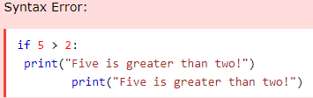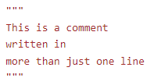

multi line comments

Variables in Python:

x = 5

y = "Hello, World!" ------- no need of semi colon in py

Comments start with a #

Python has no command for declaring a variable. A variable is created the moment you first assign a value to it.

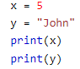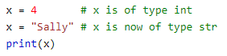

Variables do not need to be declared with any particular type, and can even change type after they have been set.

If you want to specify the data type of a variable, this can be done with casting. 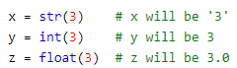You can get the data type of a variable with the type() function.

String variables can be declared either by using single or double quotes. Variable names are case-sensitive.

A variable can have a short name (like x and y) or a more descriptive name (age, carname, total_volume). Rules for Python variables:

* A variable name must start with a letter or the underscore character
* A variable name cannot start with a number
* A variable name can only contain alpha-numeric characters and underscores (A-z, 0-9, and _ )
* Variable names are case-sensitive (age, Age and AGE are three different variables)

Python allows you to assign values to multiple variables in one line:

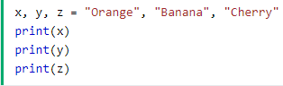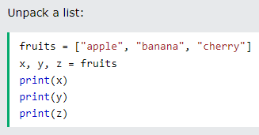

In the print() function, you output multiple variables, separated by a comma. You can also use the + operator to output multiple variables. For numbers, the + character works as a mathematical operator. In the print() function, when you try to combine a string and a number with the + operator, Python will give you an error. To do so - The best way to output multiple variables in the print() function is to separate them with commas, which even support different data types. Print(x, y) where x would be int and y be string.

**NOTE - a = [element for element in a if element != 0] IS USED TO REMOVE ALL THE 0 VALUES FROM THE LIST**

In Python, you can use the split() method to split a string into a list of substrings based on a specified delimiter. If you want to split a string into groups of three characters, you can achieve that by iterating over the string and using slicing to extract the desired groups. Here's an example:

