**VIBE ;) ALONG**

AADARSH  
 4NM19IS001

DESCRIPTION:  
  
The project is named **‘Vibe ;) Along’** as it is a music player, where for now I’ve added 5 famous tracks and in which I further plan to do edits to make it a full fledged **music player** where the user can access and play all of his mp3 tracks. This project uses various features of **JavaFX** and is **fun and easy to use, designed for entertainment purpose**.

I’ve used **Group layout** for this project and set the position of all the nodes used by using the **setLayoutX** and **setLayoutY**  . For the heading I’ve used **DropShadow** text effect. In total I’ve defined **6 buttons** , 5 of them containing the song names and 1 being the stop button. The action event for each button plays the track provided in path using the **‘Media’** and **‘AudioClip’** features of **JavaFX** and also pops up the album art of the track chosen which is done by the **‘ImageInput’** feature.

When the user clicks on any button, the respective track plays and also the heading changes from Vibe ;) Along to the name of the song being played and vice-versa, which is accomplished using the **‘setText’** option as well as the album art of the song selected is displayed. If the user wants to stop the track being played, then he can click on the **‘Stop’** button and if he wants to play any other track, he can click on its respective button which automatically stops the previous track and plays the one been clicked. Also after all the track buttons have been clicked, the buttons are no longer visible but the user can still play any of them like before by clicking on the Album art of the respective song.

**Some basic details:**

**Stage and Scene** :- Title of stage is set using **setTitle(“Vibe ;) Along “)** and scene dimensions for the Group layout object **root** is set as **1200 by 790** with **Light Pink** background.

**Group layou**t :- All the nodes defined are added to Group object **root** using the **root.getChildren().AddAll()**.

**DropShadow Text effect** :- Font used is **STHupo (52)** with color and shadow concentrations set as (0.4f, 0.6f, 0.8f) .

**Buttons** :- 6 in total with text style **STHupo (13)** and set at required position using **setLayoutX** and **setLayoutY**.

**Adding and Playing Tracks** :- Provided path in a String, then converted the media to a string and assigned it to a **Media** object and then created an **AudioClip** object of the media and the respective media is played and stopped using **.play() .stop()** options respectively.

**Images** :- Created an **Image** object and passed the path of image to it, then created an **ImageInput** object and passed the image object to it and used setEffect option to add it as a pop up effect to the respective button. Used **.setX()** and **.setY()** to set the position of images.

Results:

1)

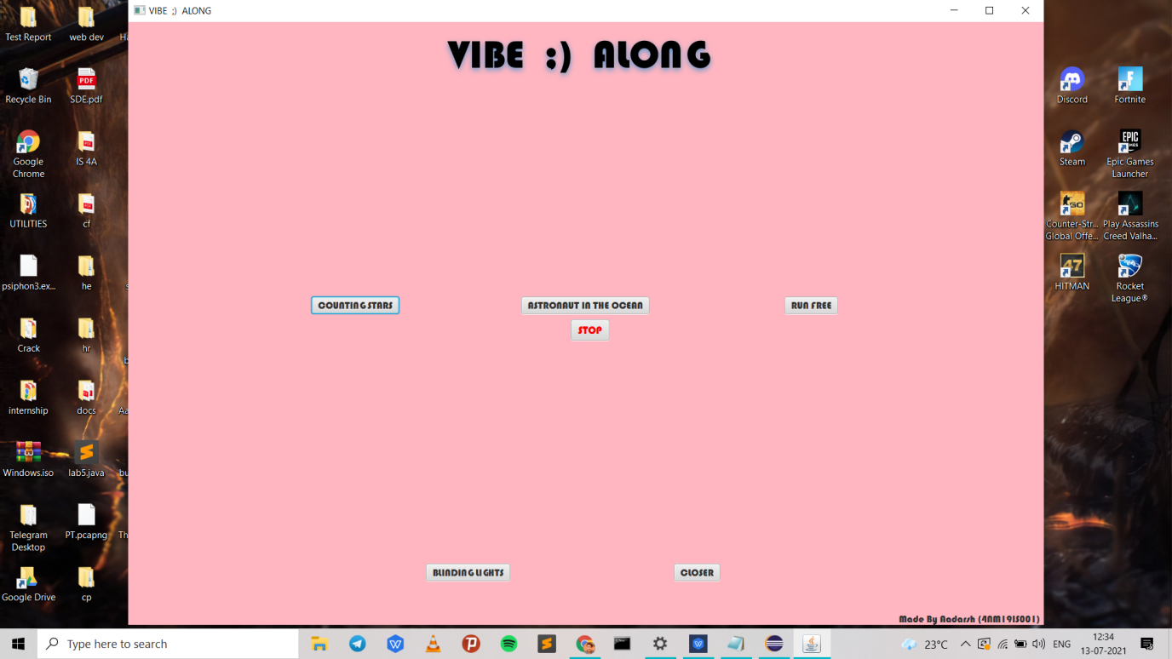

On execution this window appears, containing the project title along with respective track buttons as well as the stop button. The user can click on the desired button to play the track and display the album art and can click on the stop button to stop the track. To play any other track the user can click on its respective button which stops the song being played and starts the song whose button is clicked.

2)

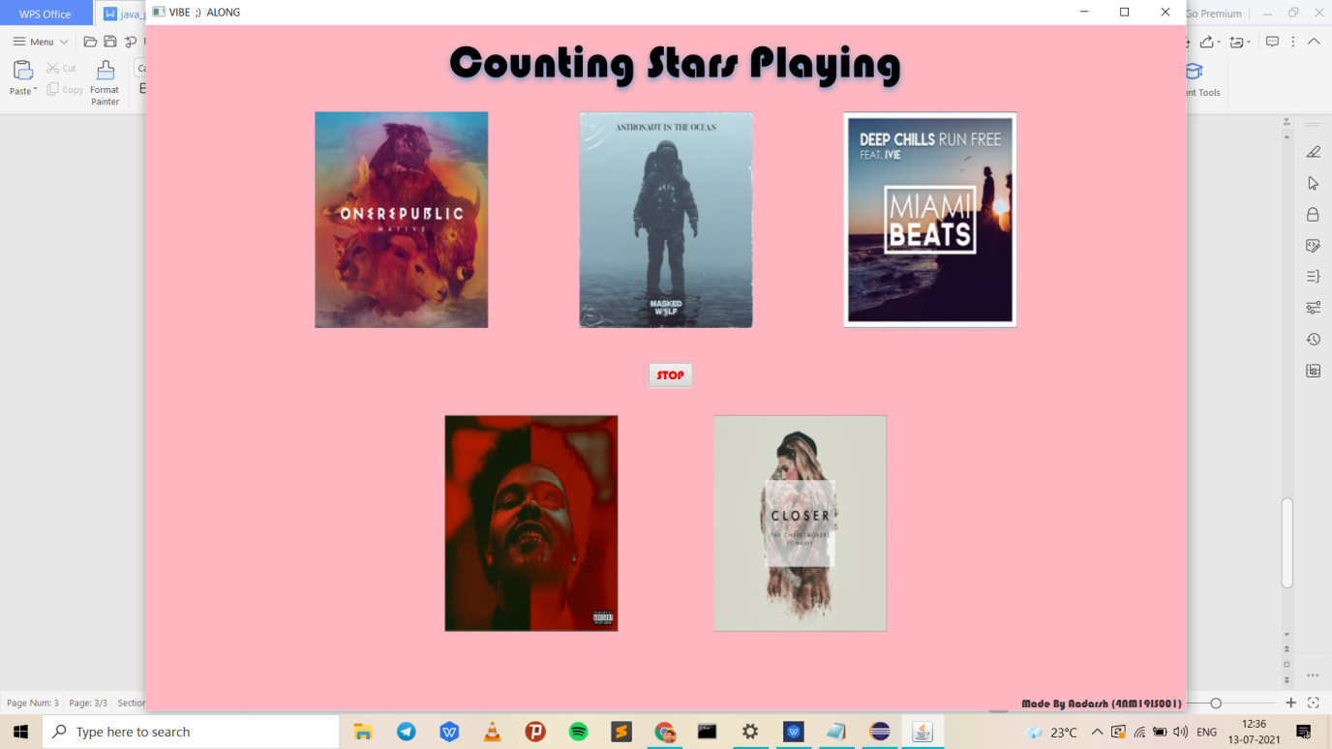

In this snapshot all the tracks have been played atleast once, hence none of the buttons are visible, rather the album arts of songs are visible and so to play any track again the user can click on the respective album art. Also here the heading says Counting Stars Playing as I’ve clicked on the album art of that song and its playing.