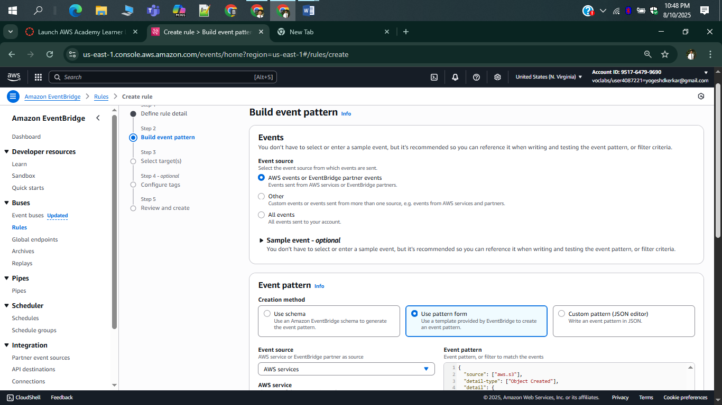

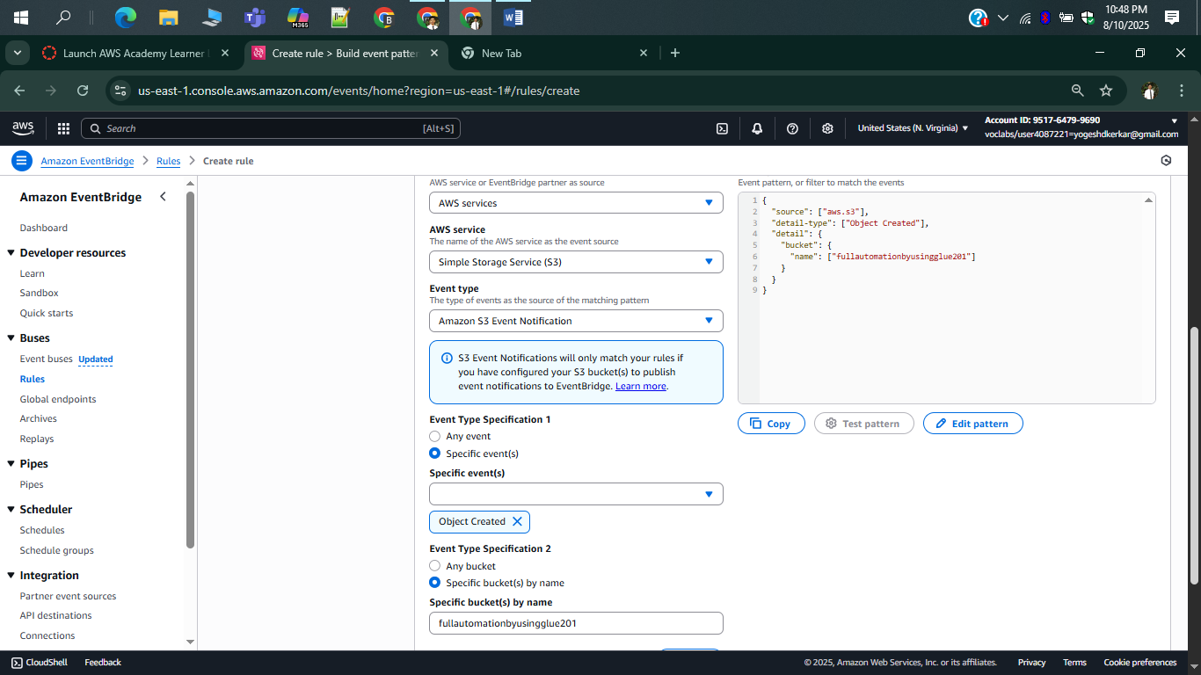

{

"source": ["aws.s3"],

"detail-type": ["Object Created"],

"detail": {

"bucket": {

"name": ["fullautomationbyusingglue201"]

}

}

}.

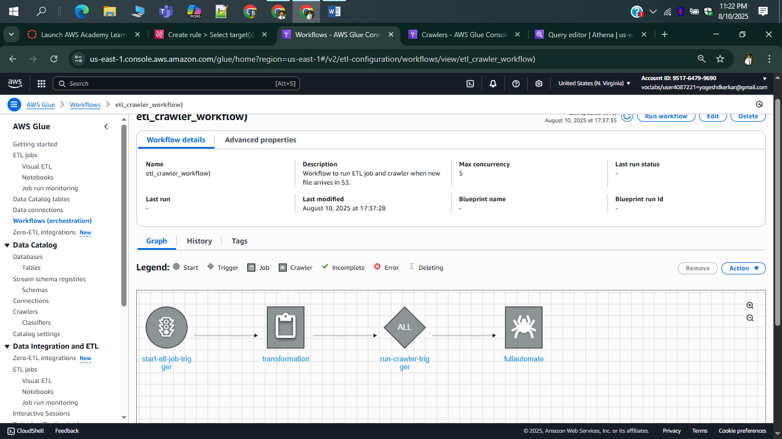

I have tried using eventbridge to trigger the workflows but it failing most of the times like we don’t have permission to do awsworkflowrun using eventbridge

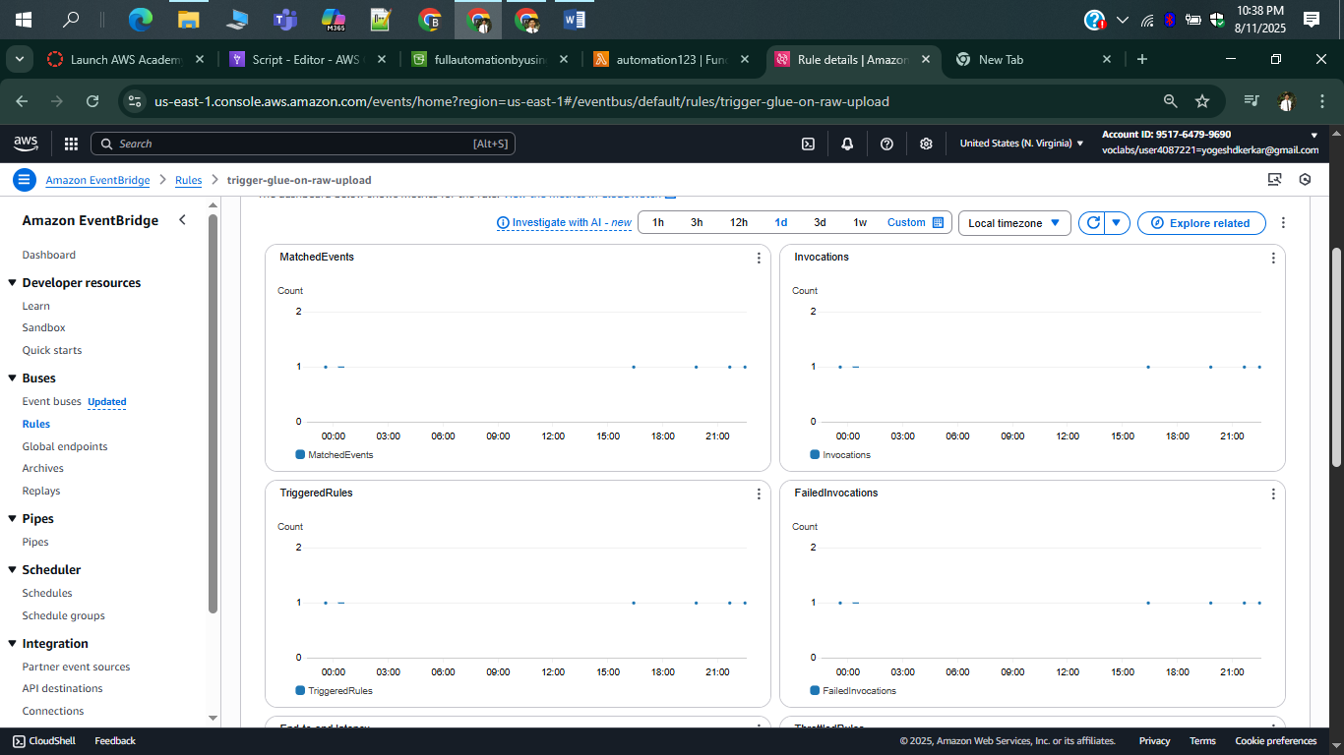

From eventbridge cloudwatch it is clearly seen that when I am uploading data in s3 its gets match with pattern written in eventbridge.but it is fail during invoking etl workflow.

SO I PROCEEED WITH LAMBDA TRIGGER TO RUN MY WORKFLOW

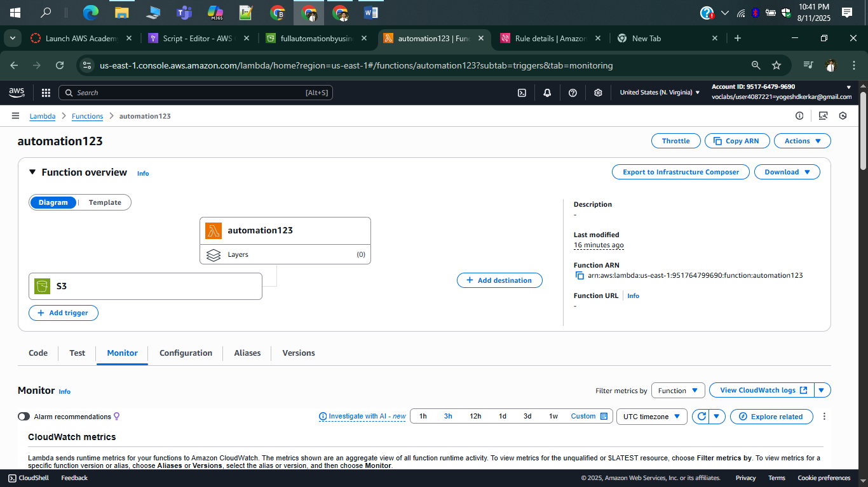

LAMBDA FUNCTION FOR GLUE WORKFLOW

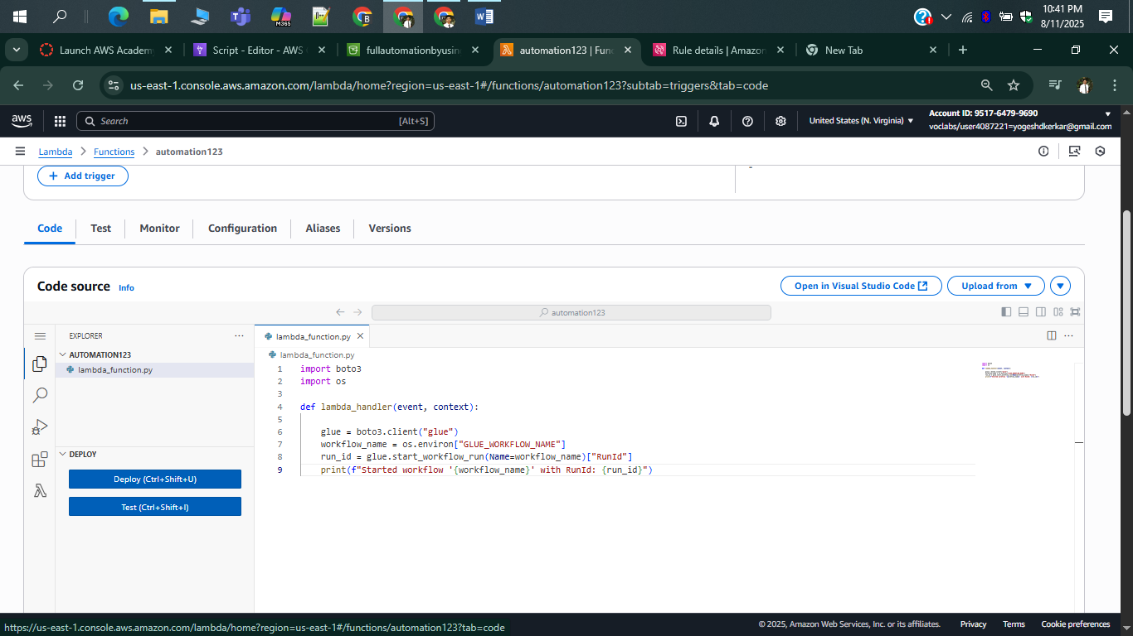

SUCCESFULLY RUN THE WORKFLOW USING LAMBDA FUNCTION

