1. Limit and Continuity

Limit

Program

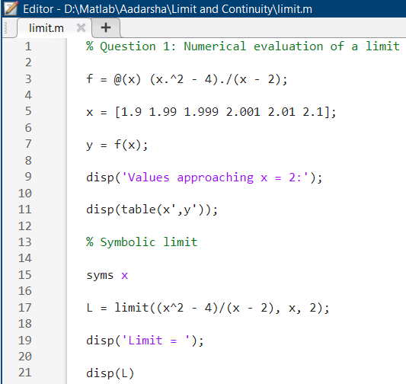

Output

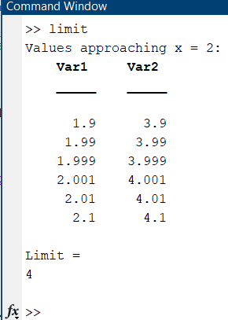

Continuity

Program

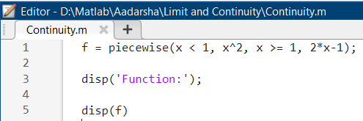

Output

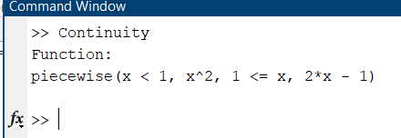

2. Derivatives

Program

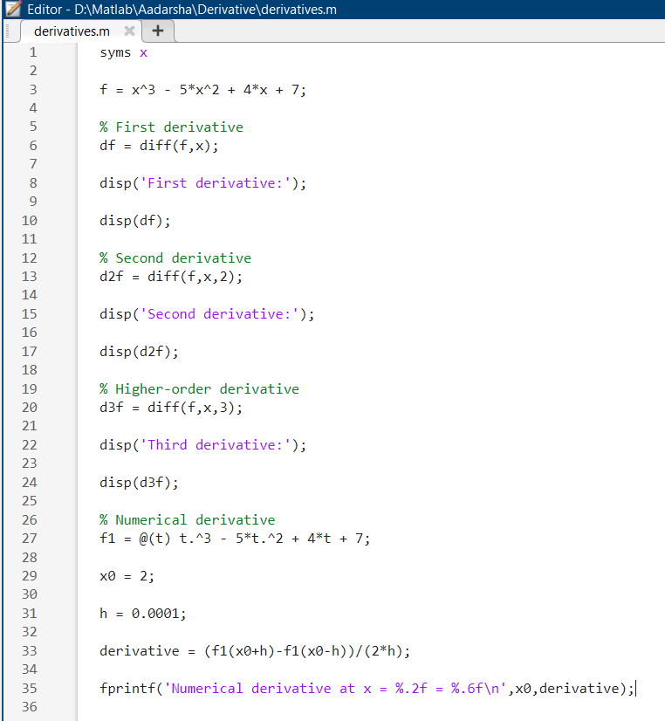

Output

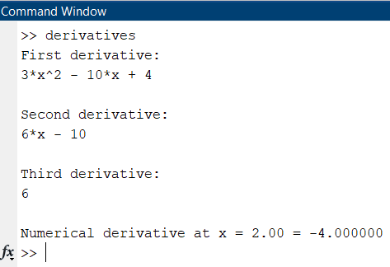

3. Applications of Derivatives

Program

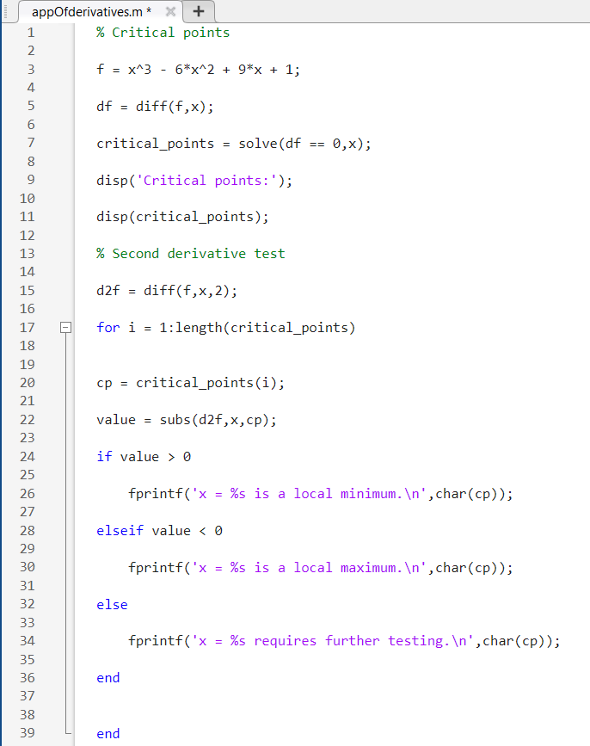

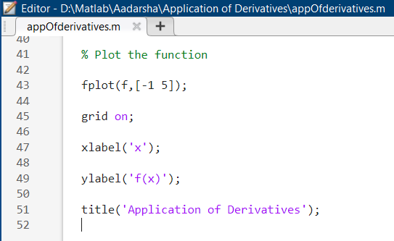

Output

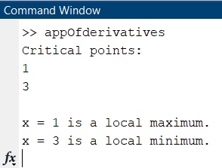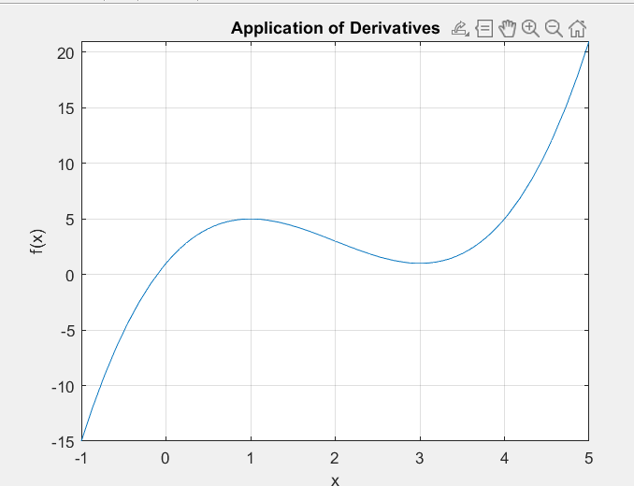

4. Antiderivatives and Applications

Program

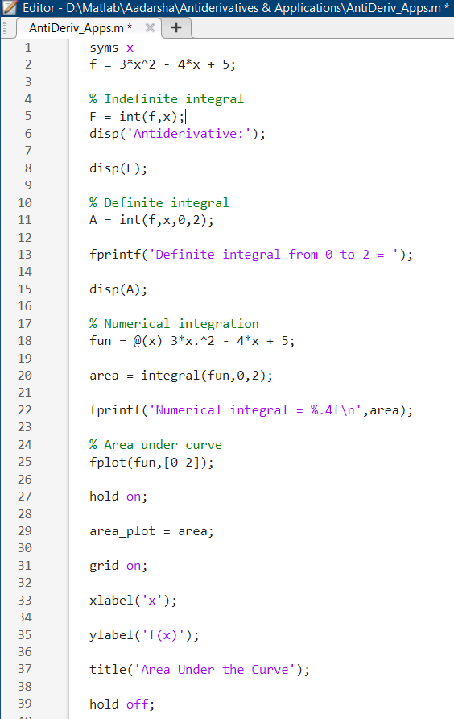

Output

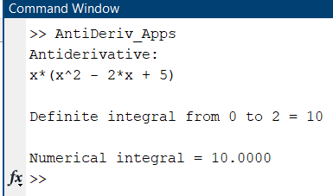

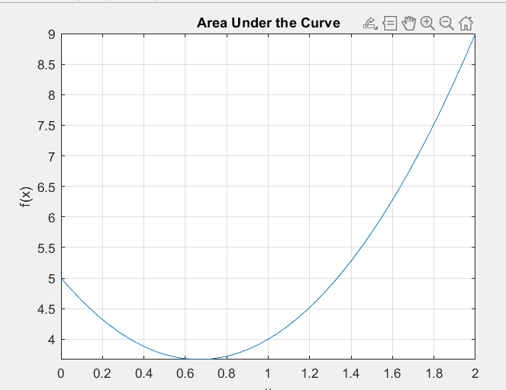

5. Differential Equations

Program

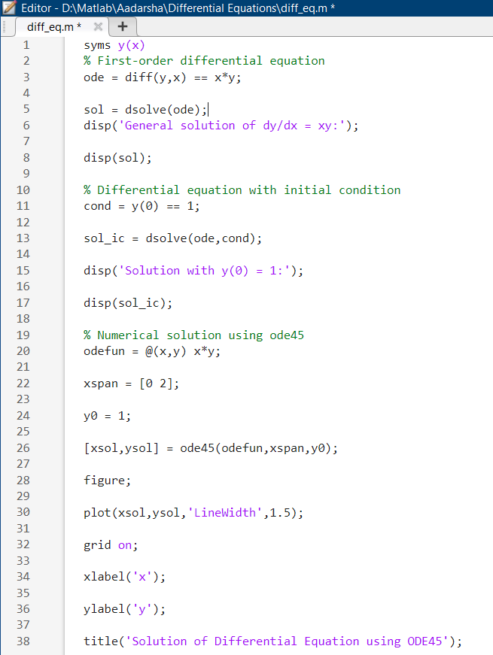

Output

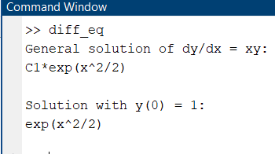

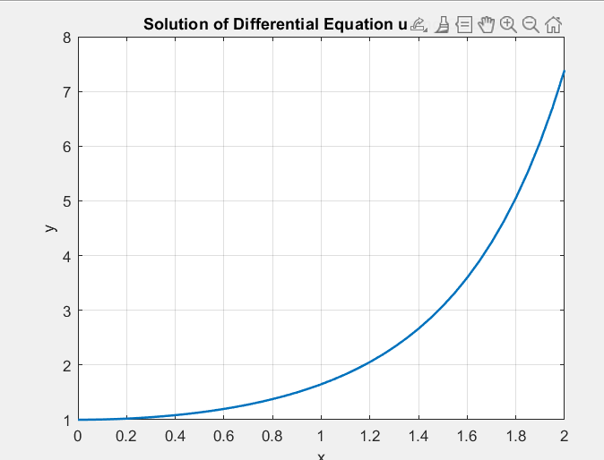

6. Computational Methods

6.1 Bisection Method

Program

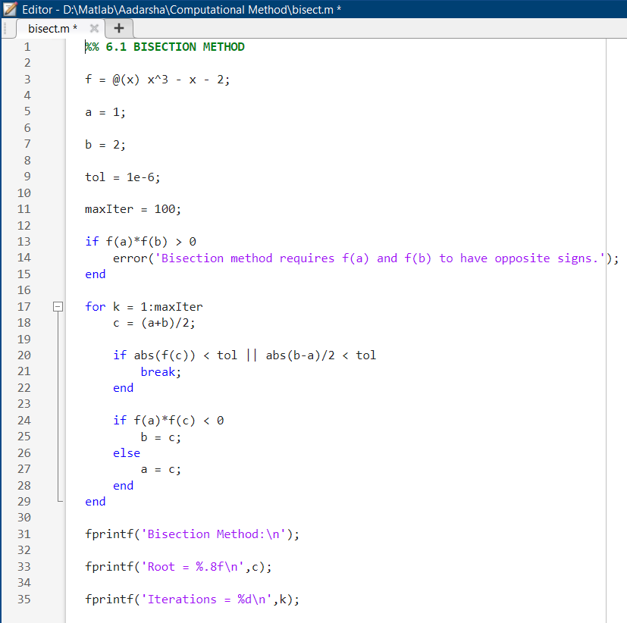

Output

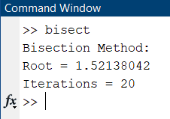

6.2 Newton-Raphson Method

Program

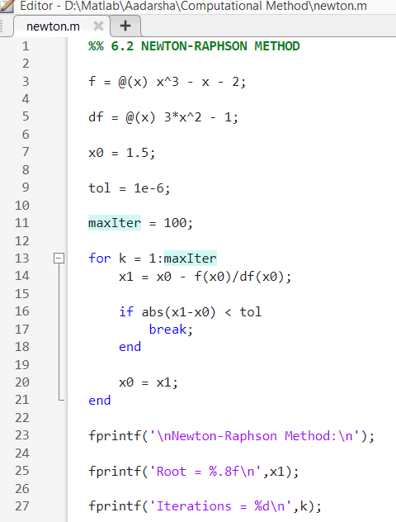

Output

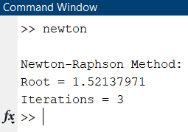

6.3 Gauss-Seidel Method

Program Output

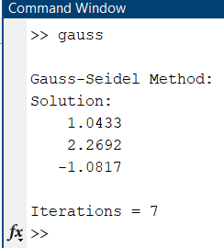
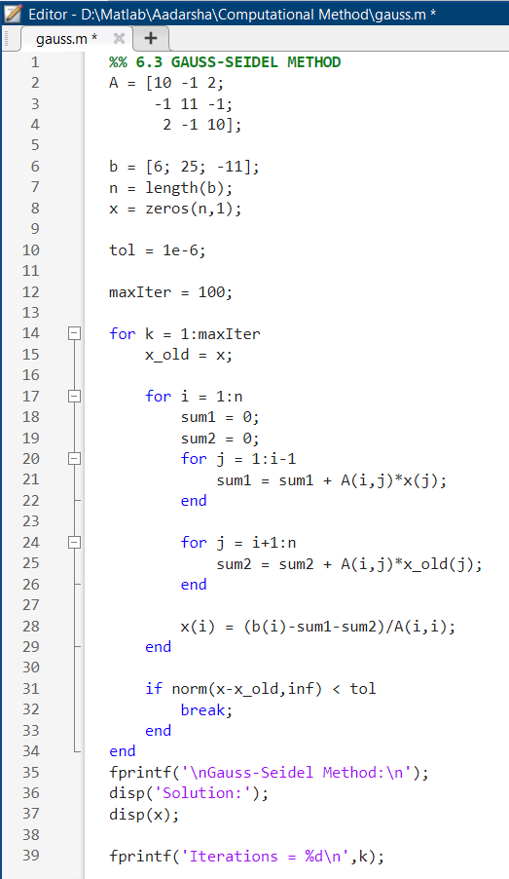

6.4 Simplex Method (Linear Programming)

Program Output

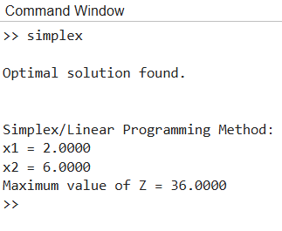
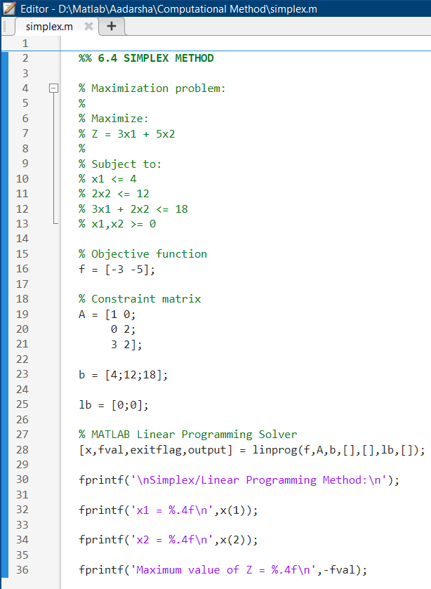

Conclusion
Through this MATLAB practical, I was able to explore and apply fundamental concepts of Mathematics II including limits and continuity, derivatives, applications of derivatives, antiderivatives, differential equations, and various computational methods (Bisection, Newton-Raphson, Gauss-Seidel, and Simplex) using MATLAB as a computational tool. This practical strengthened my understanding of how numerical and symbolic techniques can be used to solve mathematical problems that are difficult to solve by hand, and it improved my skills in MATLAB programming, plotting, and result interpretation.
I would like to express my sincere gratitude to my teacher, Mohit Prasad Guragai, for his valuable guidance, support, and encouragement throughout this practical work. His clear explanations and constant motivation made it possible for me to complete this lab report successfully.

