## Abstract

Nepal, being an agricultural country, relies heavily on agricultural production development and agro-industry goods. Data mining is a new area of study in crop production analysis. Yield prediction is a critical topic in agriculture. Any farmer is interested in understanding how much harvest he may anticipate.

Analyze the different associated parameters such as location, pH value, and alkalinity of the soil. It also includes a proportion of nutrients such as nitrogen (N), phosphorus (P), and potassium (K). Other factors that are used in this model for improved crop forecast for the end user include temperature, humidity, and rainfall. All of these data properties will be examined, and the data will be trained using multiple machine learning methods to create a model.

The system includes a model that is exact and reliable in forecasting crop production and provides the end user with appropriate suggestions regarding necessary fertilizer ratios based on atmospheric and soil factors of the land, hence increasing crop yield and farmer revenue.

A crop recommendation system for agriculture based on technology assists farmers in increasing crop production by proposing a suitable crop for their land based on soil and weather information.

Soil nutrients are important for the crops that will be grown in it. This model examines soil nutrients and makes crop suggestions based on that analysis. The ultimate goal is to assist farmers boost crop yields and favorably affect their revenues through the use of algorithms. This project involves the use of artificial intelligence (AI) technology to aid farmers in picking acceptable crops for production.

**1.1: Introduction**

Agriculture is the backbone of many economies, and the significance of making educated agricultural decisions cannot be understated. One of the most important decisions farmers make is which crop to grow in their farms. Choosing the proper crop, on the other hand, can be a difficult undertaking since it needs taking into account aspects such as soil type, climate, and the temperature of the agricultural region. To make this process easier, a crop recommendation system may be created to help farmers make data-driven decisions. Based on characteristics such as soil content, humidity, and temperature, this system employs data analysis techniques to select the optimum crop for a certain agricultural field

Crop recommendation systems are gaining popularity in the agriculture business as a technique of enhancing crop output and decreasing waste. These systems assess data on numerous environmental parameters that impact crop development, such as temperature, humidity, rainfall, and soil nutrient levels, and make suggestions on which crops are expected to thrive best in a specific region, using machine learning algorithms.

We will present a crop recommendation system in this project report that use the random forest algorithm to forecast the best crop to grow based on a mix of environmental parameters, especially nitrogen, potassium, rainfall, humidity, and temperature.

The purpose of this system is to give farmers with a tool that will allow them to make educated decisions about which crops to sow based on known factors affecting crop development and production. Because of its capacity to handle complicated datasets with various input variables and offer good predictions even in the face of noisy or missing data, the random forest method was chosen for this project. We were able to construct a model that can forecast the best crop to grow in a specific region based on current environmental variables by training the algorithm on a dataset of previous crop yields and environmental data.

Overall, the crop recommendation system presented in this report has the potential to significantly increase crop yields and reduce waste in the agricultural industry by providing farmers with a tool that can assist them in making informed decisions about which crops to plant based on a variety of environmental factors.

**1.2 Problem and Statement**

i. limited assistance tools:- There are few platforms that support farmers with their agricultural approach. Decisions based on intuition may not be useful in the long run. Farmers frequently underestimate or overestimate the fertility of their farm's soil. They frequently find it difficult to detect a drop in agricultural output over the course of the year.

ii. Institution based cultivation:- Many farmers develop crops depending on their feelings or the choices of surrounding farms, which can be inefficient and financially burdensome for the farmer. This leads to resource misuse and increased investment in crops that may not be beneficial in the long term.

**1.3 Objective Statement**

**i.** to offer farmers specialized crop advice based on their particular region, soil type, climate, and temperature.

ii. By recommending crops that are suitable for their environments and have significant market demand, to boost agricultural yields and profitability for farmers.

iii. By recommending crops that are most compatible with the local environment and use fewer resources to cultivate, we may reduce waste and resource consumption.

iv. to continuously update and improve the recommendation algorithm in order to take shifting climatic patterns and soil conditions into account.

v. to give farmers explanations of the rationale behind the suggestions so they can comprehend them better and choose their crops wisely.

vi. By encouraging the use of crops that are suitable for their environment and have a high market demand, it will be possible to increase the overall efficiency and sustainability of agriculture.

**1.4 Scope and Limitation**

**1.4.1 Scope**

i. The crop recommendation system will make personalized suggestions based on soil quality, climate, and temperature.

ii. Machine learning techniques will be used to continuously modify and improve the suggestion process.

iii. The technology will give insights into the reasons behind the suggestions, allowing farmers to make educated data driven crop selection selections.

iv. The system may be combined with other agricultural technologies and platforms to give farmers with a full solution.

1.4.2 Limitation

i. The approach may not take into consideration all of the elements that might affect crop development, such as pests, diseases, and weather occurrences.

ii. The algorithm may not be capable of making suggestions for all crops or areas.

iii. Incomplete or inaccurate information may have an influence on the correctness of the suggestions.

iv. Certain data sources may be required by the system, which may not be available in all locations or to all farmers.

v. Some farmers may be unable to use the system since it requires a particular level of technological skill or access to technology.

**1.5 Development Methodology**

We employed an agile software development strategy for this project. Each team member was given a little portion of the overall project to work on. The team members were able to gauge the level of development for each component's development thanks to this. As a result, numerous needs for this project have been gathered and are explained below:

1. Traditional approach:

The conventional approach to gathering requirements for this project consists of:

-One-on-one conversations about the project with respected supervisors.

-Individual discussions regarding the project with each member of the group.

2. Modern technique:

The following contemporary techniques were utilized to gather the project's requirements:

-Research paper

-Websites

**1.6 Report Organization**

We have organized our report in the following way:

Chapter 1: It includes the introduction section, the problem we attempted to solve, and the objectives and scope of the project.

Chapter 2: It includes the background study and literature review of the system.

Chapter 3: It includes the requirement and feasibility analysis of the system.

Chapter 4: It includes how the system was designed and the algorithms that are used throughout the process.

Chapter 5: It includes the tools we used to build the system and how the testing process was done.

Chapter 6: It includes the conclusion and future recommendations to be done on this project.

**Chapter 2: Background Study and Literature Review**

2.1. Background Study

Crop recommendation systems give farmers individualized suggestions for the crops to produce in their particular location and circumstances of their particular soil components using machine learning algorithms and data from multiple sources. They may aid farmers in selecting crops with the support of data-driven judgments, resulting in better yields, less waste, and more revenues. The project has difficulties such as gathering and combining data from many sources, the complexity of machine learning techniques, and the requirement to make the system simple to use and available to farmers with little technological expertise. These systems may offer precise and individualized suggestions for each individual farmer by assessing data from many sources, such as soil composition, temperature, and rainfall.

2.2 Literature Review

**Chapter 3: System Analysis**

**3.1 System Analysis**

**3.1.1 Functional Requirement**

A requirement analysis was done in order to create the specific system that will achieve the goals we set. Below is a list of the system's functional and non-functional needs:

1. Functional Requirements:

A functional requirement outlines the particular actions, behaviors, or features that a system or software application must possess in order to satisfy user demands or corporate goals.

The functional requirements of our project are as follows:

1. User Registration

Registration is open to all visitors to AgroMate. User can register to AgroMate by filling the necessary information in the Sing Up tab. User then selects an appropriate Login credentials (Username and Password) to access recommendation page.

1. User Sign Out

User can log out of system after finishing using the web application.

1. Crop Recommendation:

The system considers climatic elements like temperature and humidity as well as soil contents like percentages of nitrogen (N), phosphorus (P), and potassium (K), among others, to offer the crop with its highest possible yield under the given conditions.

1. Non-functional Requirements:

A non-functional requirement defines the criteria that a system or software application must meet in terms of its quality attributes, such as performance, usability, reliability, security, or scalability. These requirements focus on how the system should perform or behave rather than what it should do.

As for the non-functional requirements of our project, our system is designed to operate under the following conditions:

1. User Friendly:

The term user-friendly is self-explanatory. When something is user-friendly, it is easy to access and work with. AgroMate is user friendly. Visitors or users with basic knowledge and skill of computer and mobile can easily use the web application. AgroMate uses a simplified design and navigation, as well as simple language on the content to improve the user friendliness of web application.

1. Easy Access

AgroMate is web application. Thus, it can be accessed anytime from anywhere with an internet connection. This overcomes the geo-boundary and concurs with ‘Go beyond Borders’.

1. Responsive

Agromate is responsive, it uses Bootstrap, which improves the responsiveness of web application. Since it uses Bootstrap, it also concur the mobile first technology which would enhance the functionality of web application in mobile devices.

1. Speed

The speed of application depends on basically two factors: System configuration and Internet speed. System with good configuration will most definitely lag performance if the internet bandwidth is below par and vice versa.

1. Agriculture New update

Argomate too provides the latest news related to agriculture in Nepal. Which will benefits farmer to know the latest condition of agriculture market, polices and different program soon to be conduct related to agriculture and many more.

3.1.2 **Feasibility analysis**

Feasibility analysis evaluates how feasible the proposed project is. The degree of viability of the proposed project is determined by the feasibility analysis. It aids in estimating the project's value, determining whether or not there is a market for it, determining if the project is financially feasible, and ultimately deciding whether or not it is worthwhile to devote time and resources to it.

Following Feasibility analysis was performed prior to working on the project.

1. Technical Feasibility

The website is technically practical, and the system, including the hardware and software, complies with modern technology. All current web browsers and modern computer systems can run the WE application.

1. Operational Feasibility

The difficulty that farmers had, which was highlighted as the problem statement, is resolved by the online application. Anytime an issue develops, the target audience may seek up the application. The online application's efficacy and cost effectiveness are further proof that it can be used in practice.

1. Economic Feasibility

It is economically possible since the web application is available and accessible over the internet. To access the web application's contents, the target audience merely needs an internet connection. Web application has no associated fees of any kind, including subscription fees.

1. Schedule

The project is smaller compared to industry level applications and the requirements were very well understood in the beginning. So it was easier to set schedules and deadlines for each stage of development and the project did proceed through the development process model phase by phase as shown in the figure below.

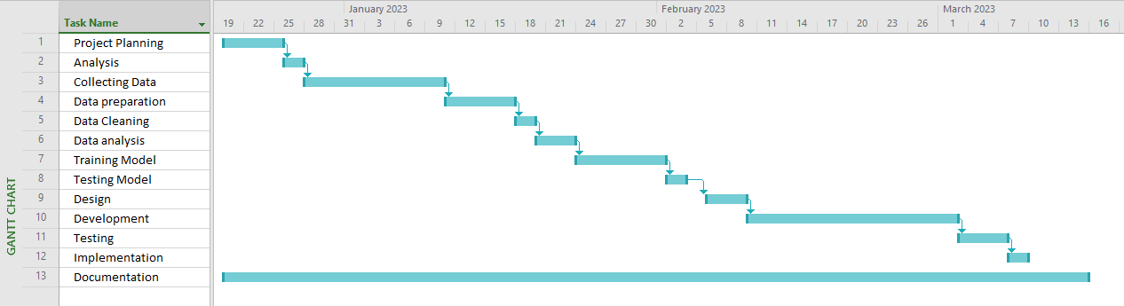

FIG- GANTT-CHART

3.1.3. **Structured Analysis**

The information system is understood and described by analysts using a variety of technologies. Using structured analysis is one method. A development technique called structured analysis enables the analyst to have a logical understanding of the system and its operations.

It is a methodical strategy that makes use of graphical tools to assess and improve the goals of a current system and create a new system specification that is user-friendly.

1. ER-Diagram;

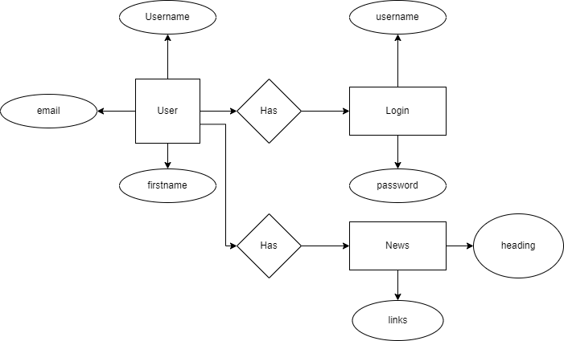

1. DFD (Dataflow Flow Diagram):

**Chapter 4: System Design**

**4.1 Design**

**4.1.1 Interface design**

The system interface was created using HTML, CSS, and Bootstrap. Users may enter soil constituents like nitrogen (N), phosphorus (P), and potassium (K), as well as climatic variables like humidity and temperature, and they will obtain the appropriate forecast in response.

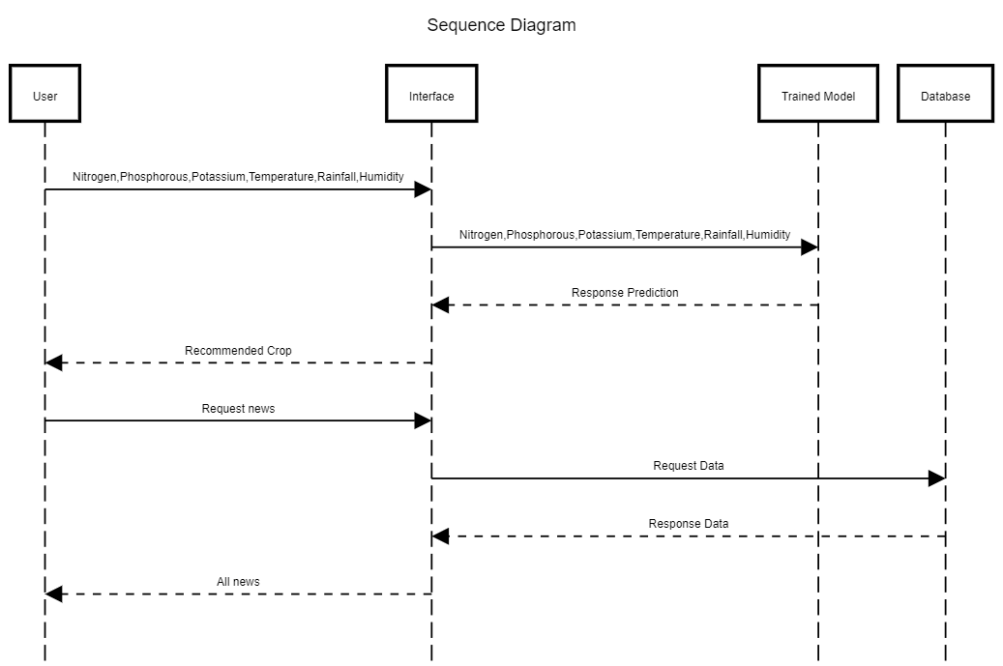

**4.1.2 System architecture**

An abstract representation of a system's structure and behavior is called a system architecture. A system is formally represented by it. System architecture can refer to either a model used to explain the system or a process used to create the system, depending on the context. Building a suitable system architecture aids in project analysis, particularly at the beginning.

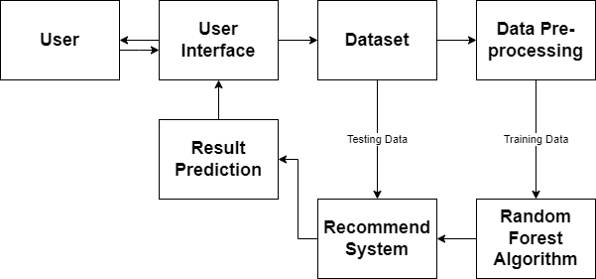

**4.1.3 Process Design**

A process diagram is a visual depiction that uses symbols and arrows to show the interactions and order of stages in a process or workflow. It aids in comprehending and evaluating the process by giving a comprehensive picture of the process flow.

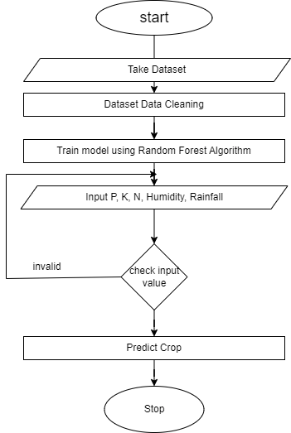

Fig- flowchart of system

**4.2. Algorithm Details**

**4.2.1 Random Forest Algorithm**

Random Forest is a classifier that uses many decision trees on different subsets of the input dataset and averages the results to increase the dataset's predicted accuracy. Instead of depending on a single decision tree, the random forest uses forecasts from each tree and predicts the result based on the votes of the majority of predictions.

Random Forest is a classifier that uses many decision trees on different subsets of the input dataset and averages the results to increase the dataset's predicted accuracy. Instead of depending on a single decision tree, the random forest uses forecasts from each tree and predicts the result based on the votes of the majority of predictions.

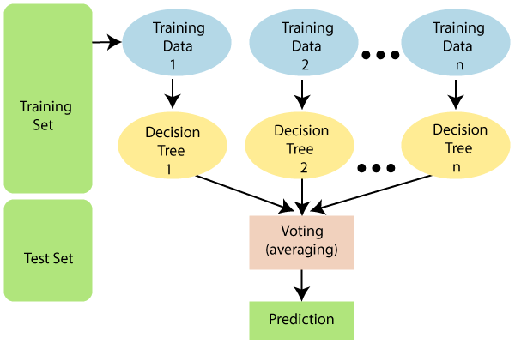

Fig Random Forest algorithm

**4.2.2 Web Scraping**

The practice of deploying bots to gather information and material from a website is known as web scraping. Web scraping is a computerized technique for gathering large volumes of data from websites. The majority of this data is unstructured in HTML format and is transformed into structured data in a database or spreadsheet so that it can be used in multiple applications.

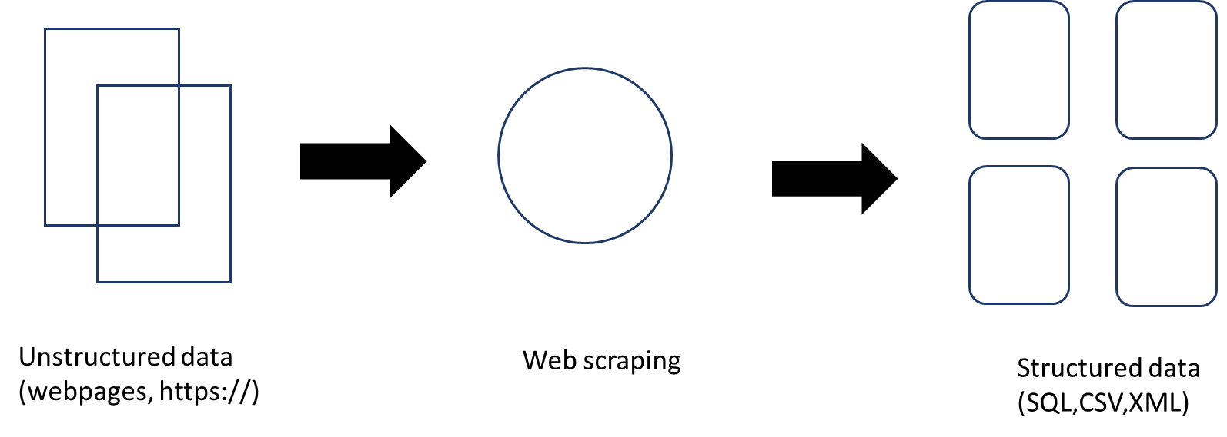

**Chapter 5: System Development and Testing**

**5.1. System Development**

Software development is the methodical, phase-by-phase process of generating software. This process involves writing code, but it also involves setting criteria and objectives, designing the material that needs to be written, and confirming that the material produced has produced the required results.

**5.1.1 Coding Tool**

The so-called front end and back end of a program, whose logical fusion produces the real-world application or software, are developed using several tools. It would seem fair to provide an overview of the many tools used in the web application since our project is entirely focused on the construction of a web-based application.

1. Frontend

The user interface that communicates with the target audience and the backend is called the front end. It serves as the mediator for the system and the intended audience. We utilize HTML, CSS, and Bootstrap to build a straightforward yet distinctive front end for the crop recommendation system.

1. Backend

The back end supports the front end of the system. The actual work such as analyzing and decision making etc are done in the back end of the program. for the crop recommendation system, we use Django. Here Django enables the rapid development of secure and maintainable web applications.

**5.2. Testing**

**5.2.1. Unit Testing**