**A Major Project Proposal on**

**tripMate**

Submitted in partial fulfillment of the requirements for the degree of

Bachelor of Engineering in Software Engineering at Pokhara University

###### By

**AADARSHA BARAL**

**AASHISH BHANDARI**

**ANUP SUBEDI**



**Department of Research and Development**

**GANDAKI COLLEGE OF ENGINEERING AND SCIENCE**

**Lamachaur, Kaski, Nepal**

**(JANUARY, 2023)**

**A Major Project Proposal On**

**tripMate**

Submitted in partial fulfillment of the requirements for the degree of

Bachelor of Engineering in Software Engineering at Pokhara University

###### By

**AADARSHA BARAL**

**AASHISH BHANDARI**

**ANUP SUBEDI**

###### Supervisor



**Department of Research and Development**

**GANDAKI COLLEGE OF ENGINEERING AND SCIENCE**

**Lamachaur, Kaski, Nepal**

**(JANUARY, 2023)**

**APPROVAL CERTIFICATE**

This project entitled **tripMate** prepared and submitted by Aadarsha Baral, Aashish Bhandari, Anup Subedi under the supervision of ………. in partial fulfilment of the requirements for the Degree of Bachelor of Engineering in Software Engineering has been examined and is recommended for approval and acceptance.

Date of Evaluation: Jan, 2023

……………………………………

……………………

(Project Supervisor)

…………………………………

Er. Rajendra Bahadur Thapa

(Project Head)

Research Management Committee

Gandaki College of Engineering and Science

**ABSTRACT**

The world is a vast and wondrous place, full of endless opportunities for exploration and discovery. And yet, for many of us, the idea of embarking on a journey alone can be intimidating, even daunting. It is in this spirit that we present our **tripMate** app, a digital platform that seeks to bring together adventurous souls from all corners of the globe. By matching users based on shared interests, destinations, and schedules, our app endeavours to facilitate connections between travellers and provide a space for socializing and networking. Whether you're seeking a companion for a solo trip, hoping to join an existing group, or envisioning a custom adventure with friends, our app is here to help you plan and book the trip of your dreams.

But don't just take our word for it - the data speaks for itself. According to a recent survey, nearly half of all travellers say they prefer to travel with a companion, yet finding the right person can be challenging. This is where our app comes in, offering a one-stop shop for all your travel needs. From the moment you download the app to the moment you return home; we'll be there to help you every step of the way. And with a user-friendly interface and a wide range of features and services, our app is sure to be a hit with travellers of all ages.

So why travel alone when you can travel together and make new friends along the way? Join us on this journey of a lifetime and discover the world in a whole new way. We can't wait to see where your adventures take you!

**TABLE OF CONTENTS**

APPROVALCERTIFICATE................................................................................ I

ABSTRACT.......................................................................................................II

TABLE OF CONTENT.................................................................................................... III

LIST OF FIGURES .......................................................................................... IV

CHAPTER 1 INTRODUCTION 1

1.1 BACKGROUND 1

1.2 PROBLEM STATEMENT 1

1.3 OBJECTIVES 1

1.4 IMPLICATION 2

CHAPTER 2 LITRATURE REVIEW 3

CHAPTER 3 TOOLS AND METHODOLGY 4

3.1 REQUIRED TOOLS 4

3.2 APPROACH 5

3.3 DESIGNS 6

3.3.1 USE CASE DIAGRAM 6

3.3.3 ENTITY RELATIONSHIP DIAGRAM 7

3.4 ALGORITHMS 8

CHAPTER 4 TIMELINE DIAGRAM 9

CHAPTER 5 WIREFRAME 10

BIBLIOGRAPHY 11

**LIST OF FIGURES**

FIGURE 3.2: AGILE METHOD……….................................................... 5

FIGURE 3.3.1: USE CASE DIAGRAM ................................................... 6

FIGURE 3.3.2: ENTITY-RELATIONSHIP DIAGRAM. ........................ 7

FIGURE 4.1: TIMELINE DIAGRAM……………………………………8

FIGURE 5.1: WIREFRAME. .................................................................... 9

**CHAPTER 1**

# INTRODUCTION

### 1.1. BACKGROUND

In today's fast-paced world, the desire to explore and discover new lands can often be overshadowed by the fear of embarking on a journey alone. But what if there was a way to alleviate that fear and connect with like-minded travellers who share your passions and interests? Enter our **tripMate** app, a digital platform that aims to bring together adventurous souls from all corners of the globe. By matching users based on shared interests, destinations, and schedules, our app seeks to facilitate connections between travellers and provide a space for socializing and networking. Whether you're seeking a companion for a solo trip, hoping to join an existing group, or envisioning a custom adventure with friends, our app is here to help you plan and book the trip of your dreams. So why travel alone when you can travel together and make new friends along the way? Download our app and begin your journey today.

### 1.2. STATEMENT PROBLEM

* Challenges in finding compatible travel companions.
* Lack of support and resources for trip planning.
* Fewer opportunities for making connections.

### 1.3. OBJECTIVES

This project will fulfil the following goals: -

* To facilitate the connection of travellers who share common interests, destinations and schedules.

### 1.4 IMPLICATIONS

* Economic impact: Potential to stimulate tourism industry.
* Social consequences: May facilitate new friendships and social networks.
* Cultural impact: Potential to introduce users to different cultures and ways of life.
* Safety: May alleviate solo travel safety concerns.
* Accessibility: May make travel more accessible to certain groups.

**Chapter 2**

# LITERATURE REVIEW

1. **Tourlina**

Tourlina is a fun travel app to meet others travelling. Do you want it to be easier to meet other backpackers? Tourlina is a backpacker social networking app for any destination. Connect with women looking for backpackers with common interests. Whether you’re travelling solo or in a group, Tourlina is a great way to meet nearby travellers as well as locals! Tourlina app makes it very easy to meet up with other solo female travellers. (Tourlina, 2015 - 2022)

1. **Travel Buddy**

Travel Buddy is a one-of-a-kind travel app designed as a social networking that let you find a travel buddy locally, discover & share interesting itineraries that act as a travel guide and get unbiased location information from local experts, explore hidden destinations and attractions, meet up with friends. (Travel Buddy, 2020 - 2021)

**3. Hostelworld**

Hostelworld is a social travel app that connects backpackers and budget travelers for shared trips and adventures. Users can search for travel partners, join existing trips, or create their own. They can also share travel tips and experiences with other users. (Hostelworld, 2020)

**4. Tripr**

Tripr is a social travel app that connects travelers with locals and other travelers for shared travel experiences. Users can search for travel partners, join existing trips, or create their own. The app also has a feature that allows users to search for locals who can show them around and act as a guide. (Triprapp, 2021)

**Chapter 3**

# TOOLS AND METHODOLOGY

### 3.1. REQUIRED TOOLS

Many tools are required for the development of Bookaholic. Some of the tools that are required in the project are listed below:

1. Visual studio code: For IDE
2. Flutter: For Front-end development
3. NodeJS: For back-end development
4. MS-Word: For preparing the proposal and the final report
5. Draw.io: For designing UML diagrams
6. MongoDB: For managing database
7. GitHub: For Collaboration and version control.
8. XCode: For Simulators.

### 3.2. APPROACH USED

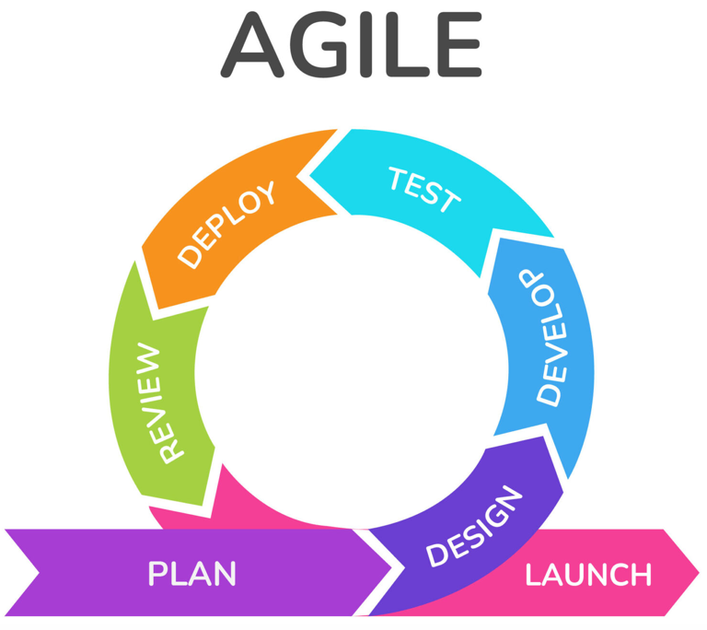

We propose using the Agile approach for the development of our app. Agile is a flexible and collaborative approach to software development that emphasizes continuous delivery and rapid prototyping. It is based on the Agile Manifesto and is well-suited for projects with rapidly changing requirements and a focus on customer satisfaction.

Using the Agile approach, our development team will be able to quickly respond to changing requirements and customer needs, delivering value faster and more effectively. We will use a process of continuous iteration and delivery, releasing small increments of the app to stakeholders for feedback on a regular basis. This will help to ensure that the app is always aligned with the needs of our users.

Our team will also be cross-functional and work closely together to ensure that all aspects of the project are aligned and moving in the same direction. We will use various tools and techniques, such as agile project management software and daily stand-up meetings, to track progress and identify any issues or roadblocks. This will help to ensure that the team is always on track and able to deliver value to stakeholders.

Overall, we believe that the Agile approach is the best fit for our app and will help us to deliver a high-quality product efficiently and effectively.

### 3.3. DESIGNS

##### 3.3.1. USE CASE DIAGRAM

There are two users in our system Users, Admin. Their cases are shown below:

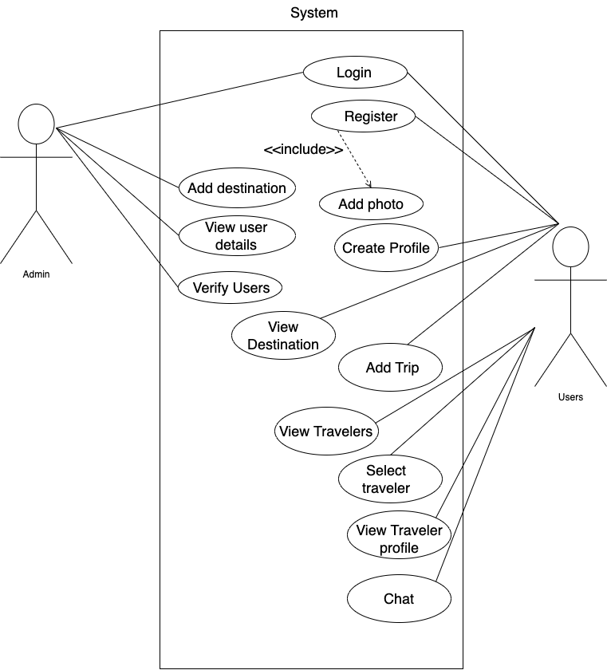

**FIG 3.3.1: USE CASE DIAGRAM**

##### 3.3.2. ENTITY RELATIONSHIP DIAGRAM

Entity relationship diagram gives the general idea about relationship between entities and what kind of data is going to be stored. In our case, we have entities such as user, admin, profile and destination. In case of attributes id represent primary key, and remaining attributes have no specific type. There is relationship between entities and cardinality to every relationship.

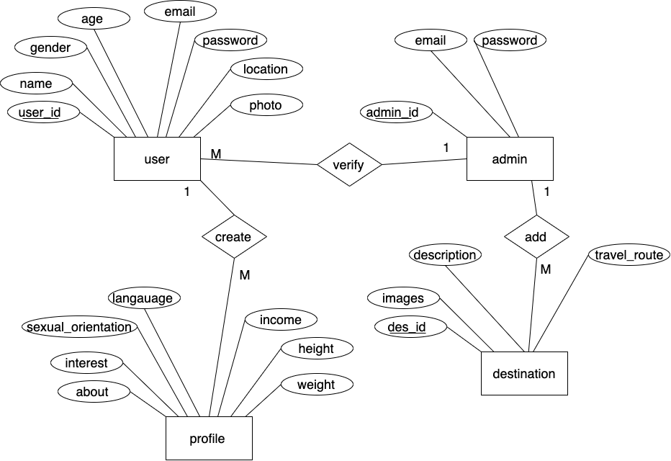

**FIG 3.3.2: ENTITY RELATION DIAGRAM**

**3.4 ALGORITHM**

**Collaborative Filtering**

Collaborative Filtering (CF) is a type of recommendation algorithm that is based on the idea that people who have similar preferences in the past will have similar preferences in the future.

There are two main types of CF:

**User-based Collaborative Filtering**: This algorithm makes recommendations based on the past behavior of users similar to the current user. It works by identifying similar users to the current user and recommending items that those similar users have liked.

**Item-based Collaborative Filtering**: This algorithm makes recommendations based on the past behavior of the user with respect to items. It works by identifying items that are similar to the ones the user has liked in the past, and recommending those similar items to the user.

**TOP-K Algorithm**

A top-k algorithm is a recommendation method that selects the k most relevant items from a large set for a user. It combines both collaborative filtering and content-based filtering to provide recommendations. The aim is to present a concise set of highly pertinent items to the user instead of a lengthy list of items that may be of less significance.

**Chapter 4**

## Timeline Diagram Fig 4.1: Timeline Diagram

**CHAPTER 5**

**WIREFRAMES**

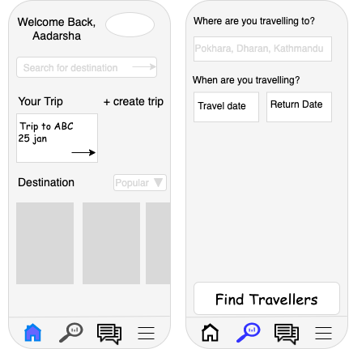

**Fig 5.1 Wireframes**

# Bibliography

Tourlina. (2015 - 2022). *About us*. From Tourlina: https://tourlina.com/

Travel Buddy. (2020 - 2021). *About Us*. From Beattravelbuddy: https://www.beatravelbuddy.com/#about

Hostelworld. (2020). *About us*. From Hostelworld: https://www.hostelworld.com/

Triprapp. (2021). *About us*. From Tripr: https://triprapp.com/