Table of Contents

Introduction 2

Task 1: Source Codes and UI 3

Spreadsheet (UI) 3

Spreadsheet (Source codes): 4

Numerical_Op_AMS Class: (Source codes) 26

Null exception Class (Source code): 29

Grid_AMS Class (Source code): 30

Barchart_Aadarsha Class (Source Code): 30

Barchart_aadarsha (GUI): 31

Task-2 32

Black box testing 32

White box testing 38

Unit testing 1 : Average 38

Unit testing 2: Division 38

Unit testing 3: Mean 39

Unit testing 4: Median 39

Unit testing 5: Multiplication 40

Unit testing 6 : Sum 40

Task 3: Class-Diagram 41

Conclusion 42

# Introduction

A spreadsheet application prototype is to be designed for a company competing with Microsoft and Google. I have used C# language to complete this task. Visual Studio 2017 with .NET framework Community edition is used as the IDE for the development of this prototype. It is a very good IDE for software development which provides facilities of writing, deleting, debugging, building and also publishing the software.

# Task 1: Source Codes and UI

## Spreadsheet (UI)

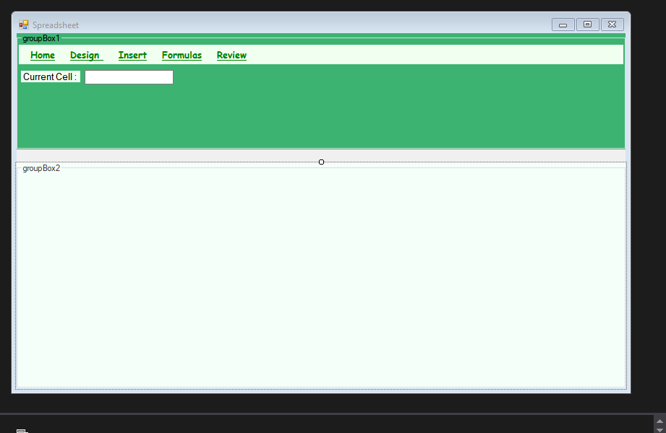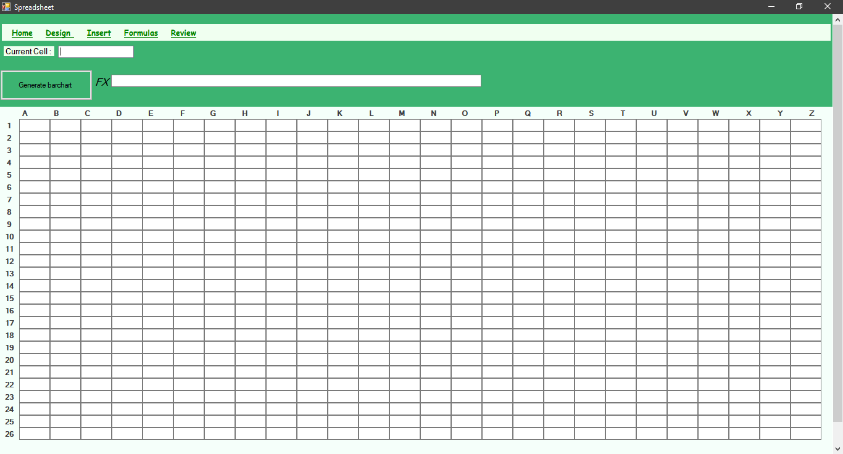

## Spreadsheet (Source codes):

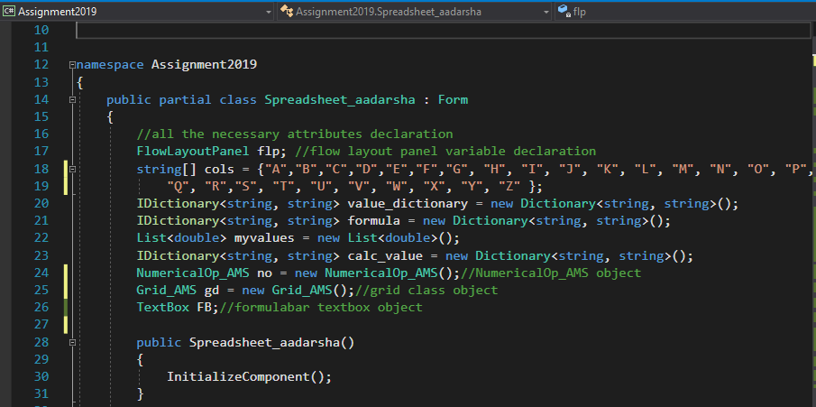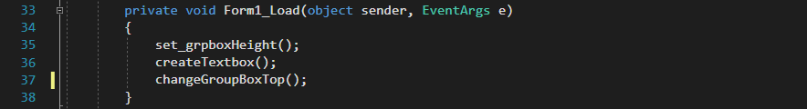

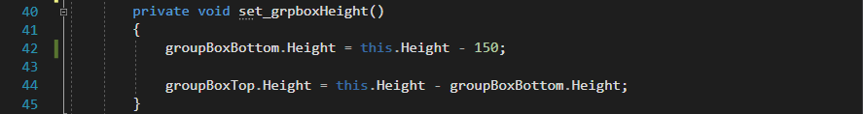

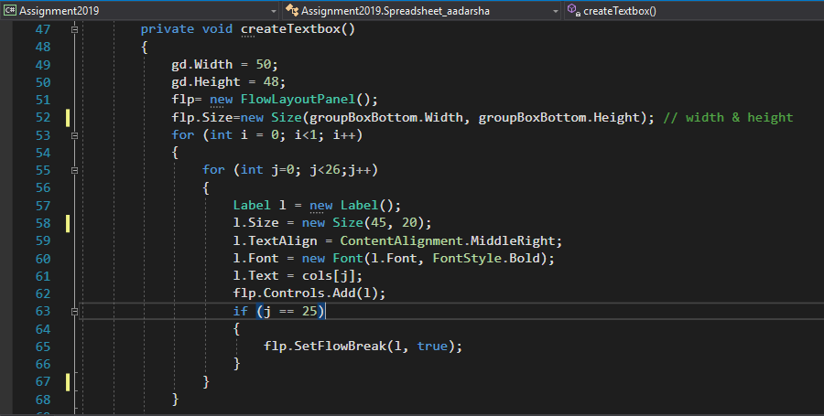

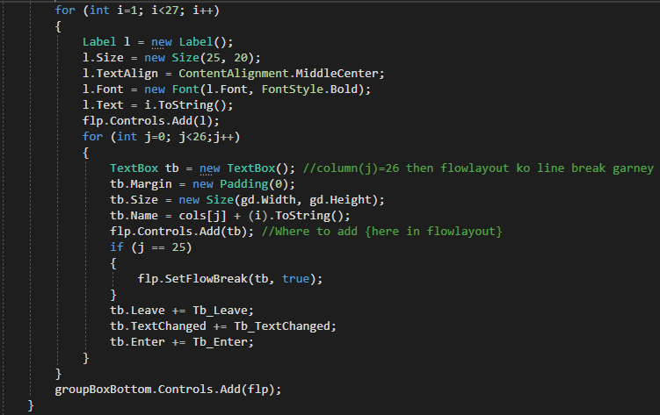

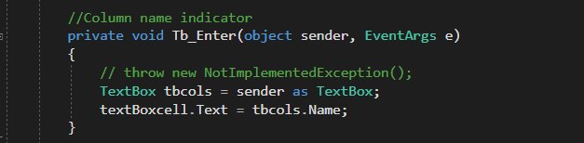

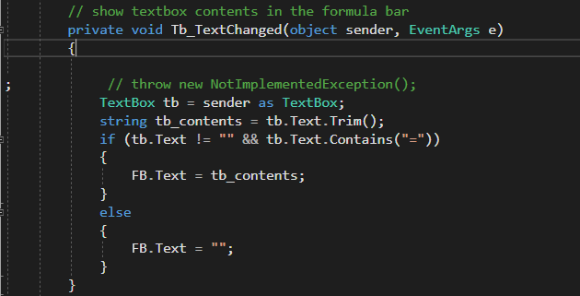

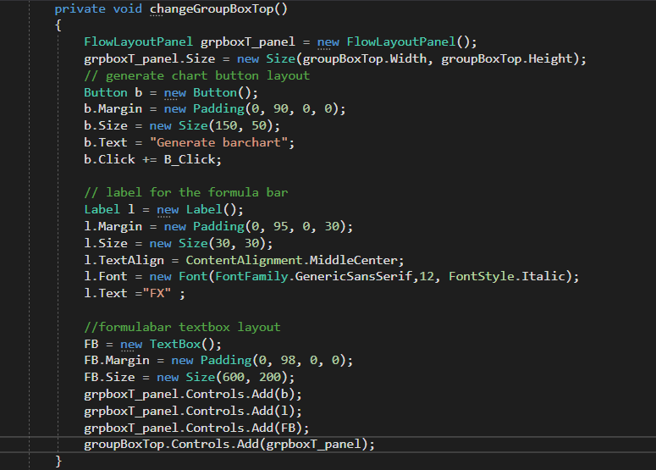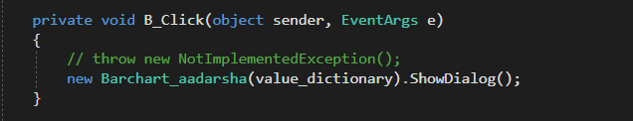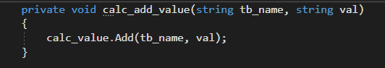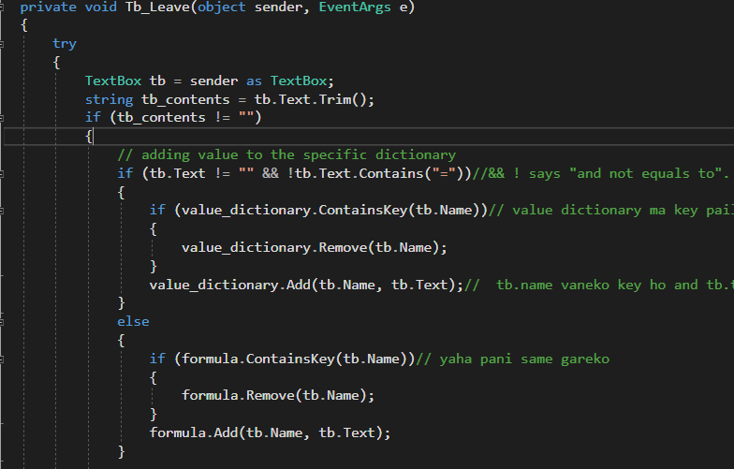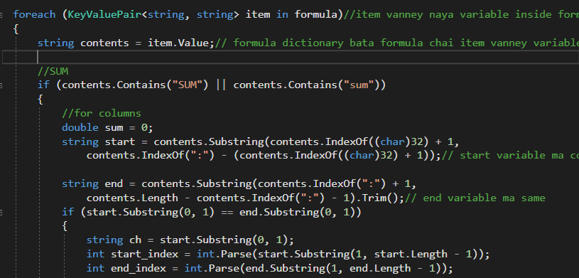

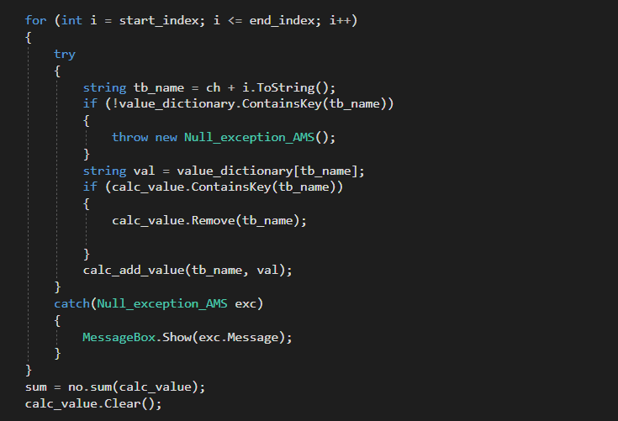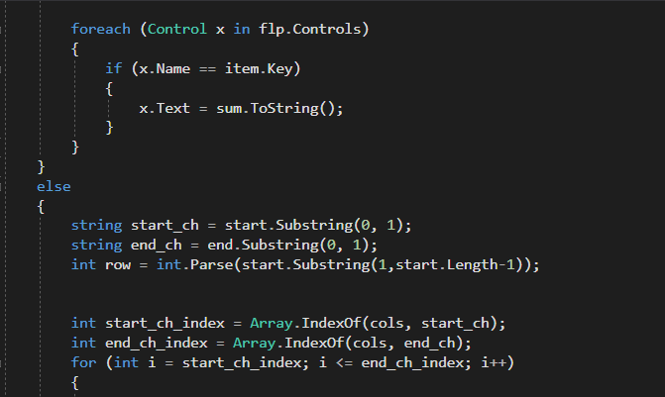

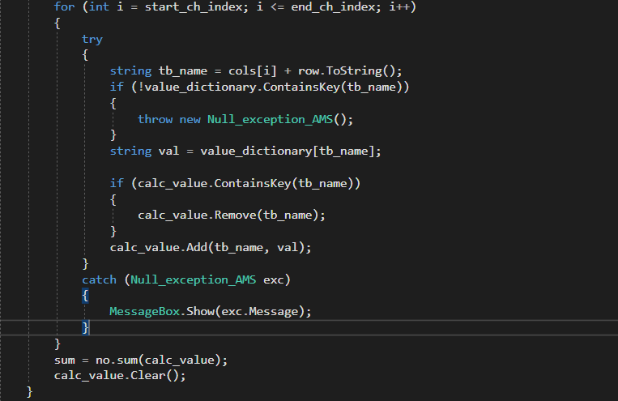

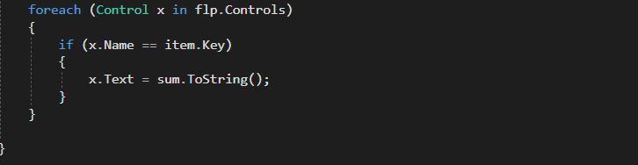

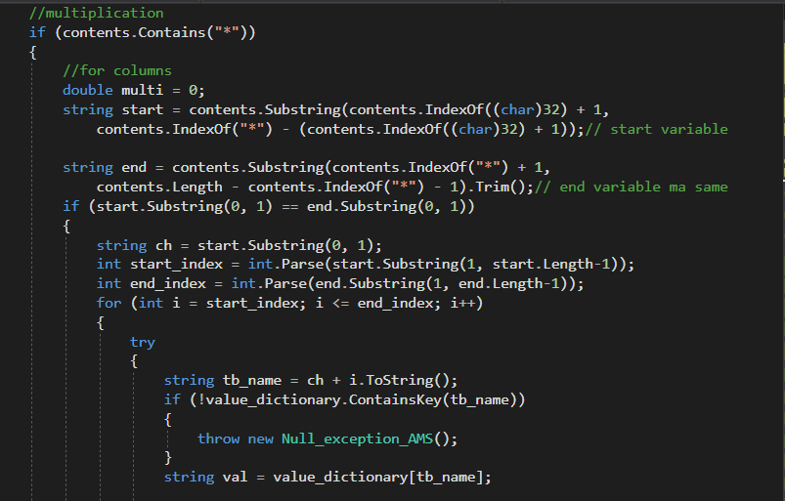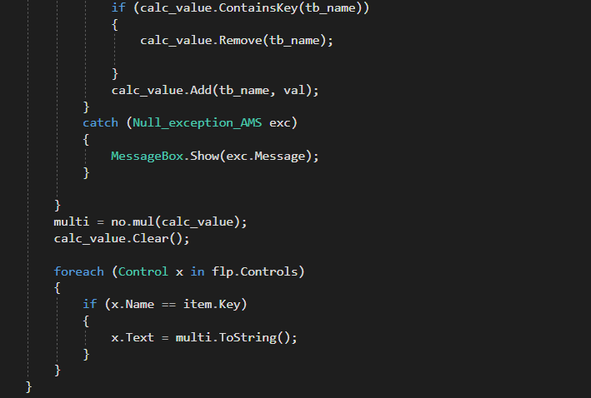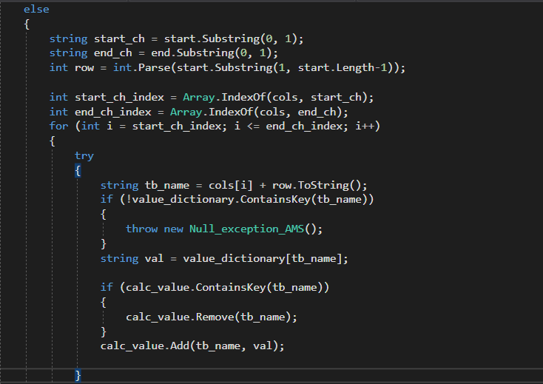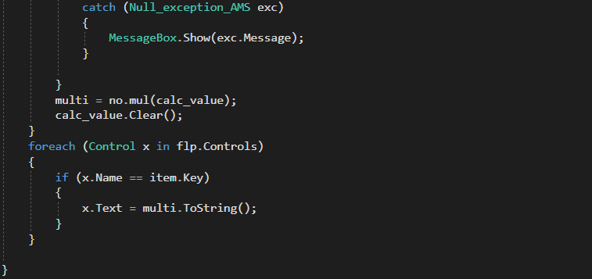

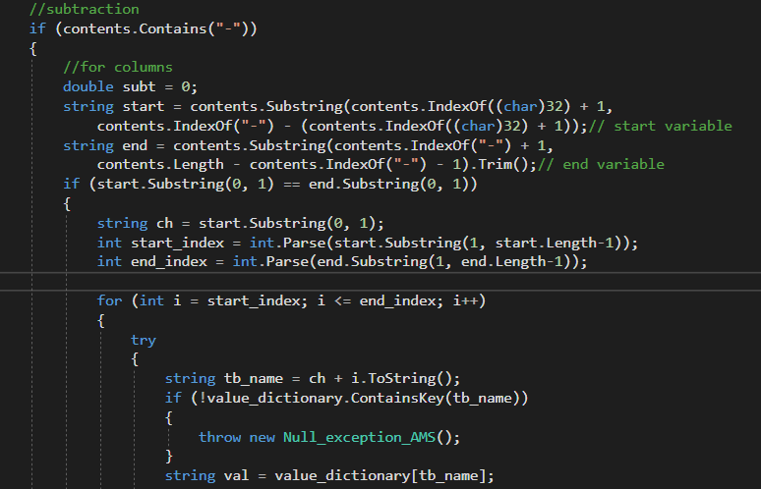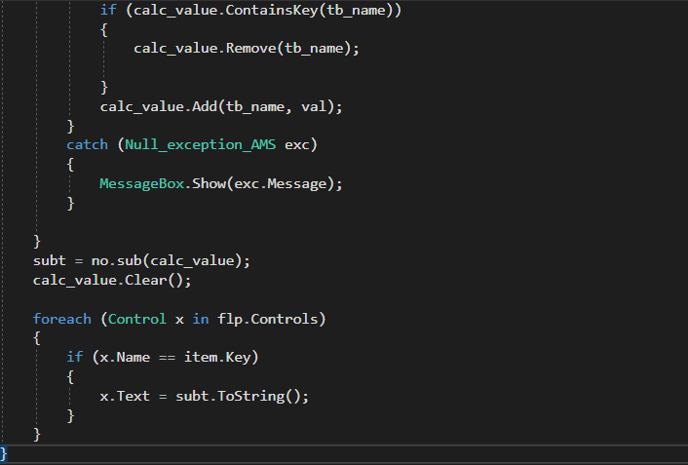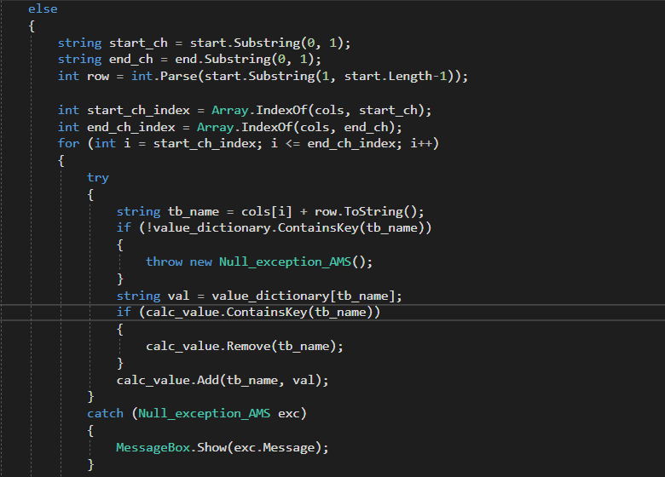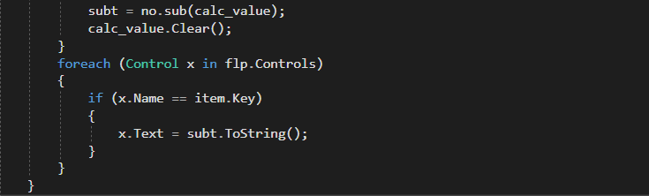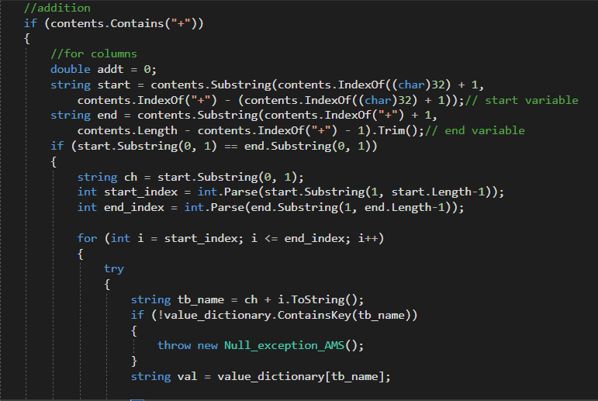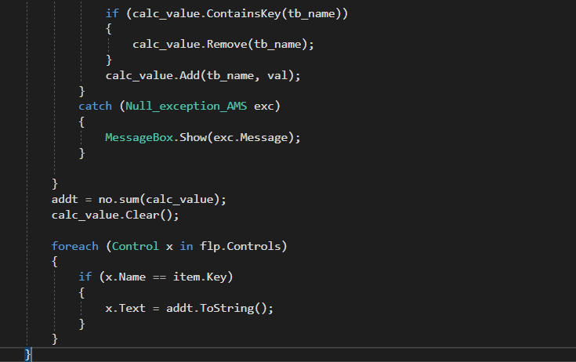

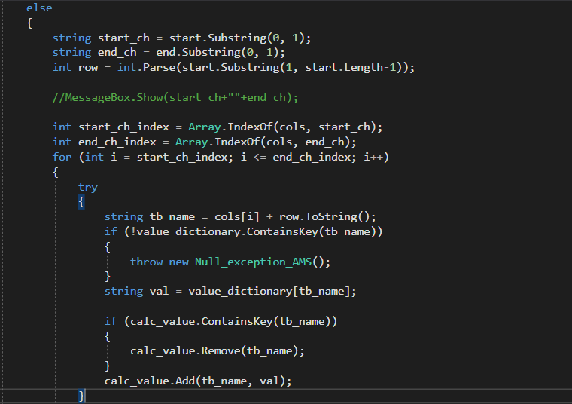

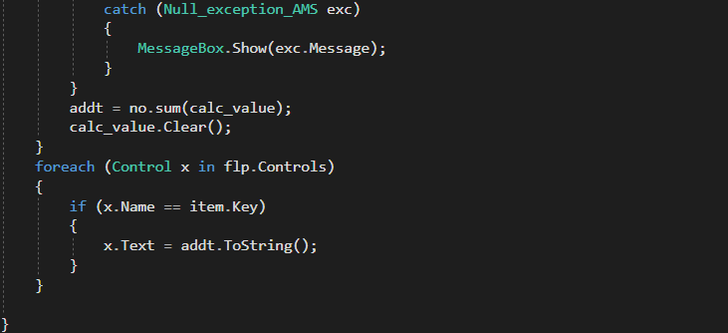

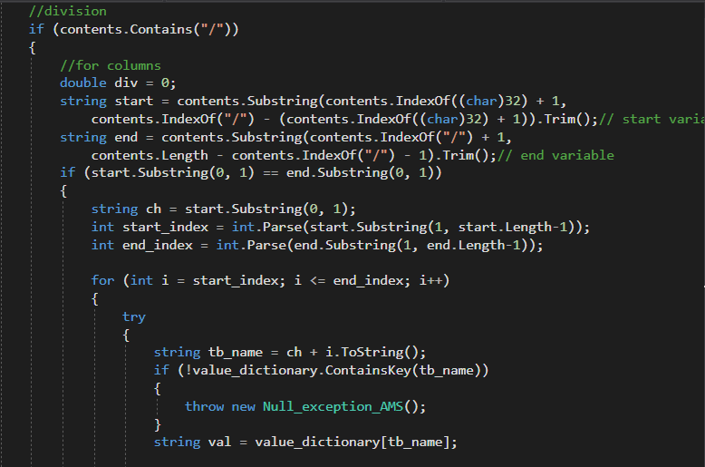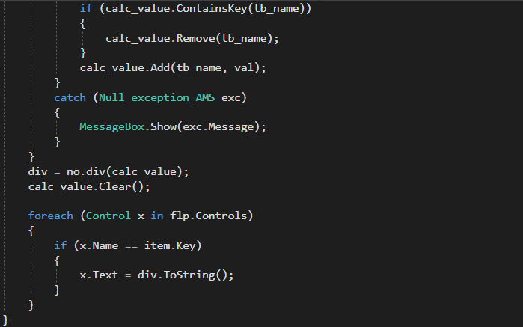

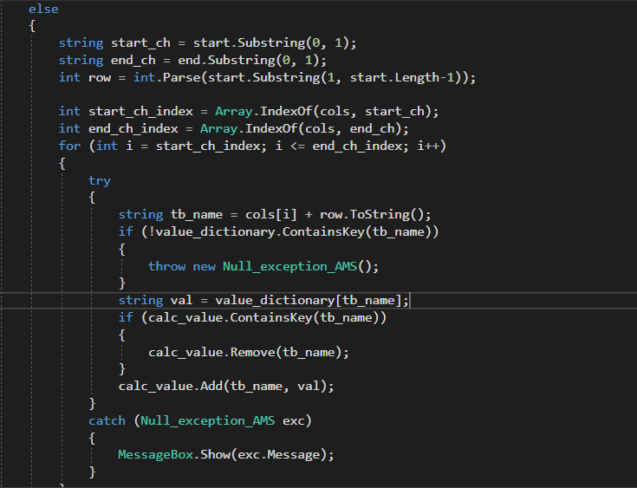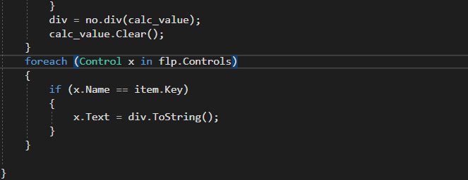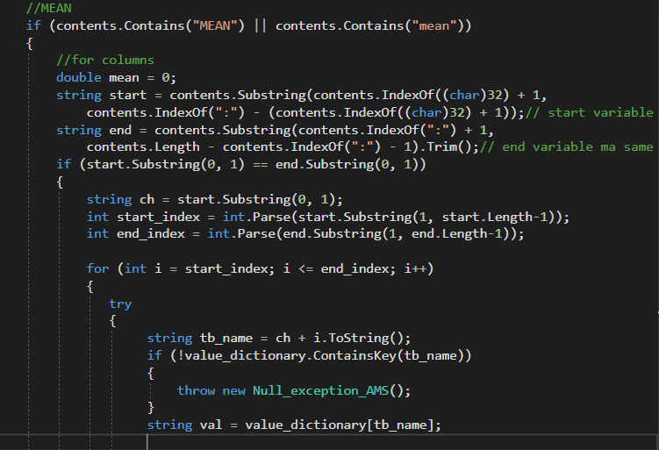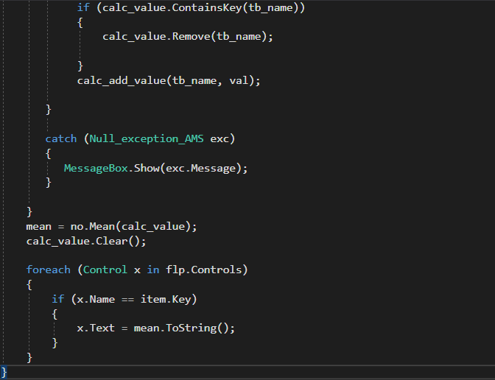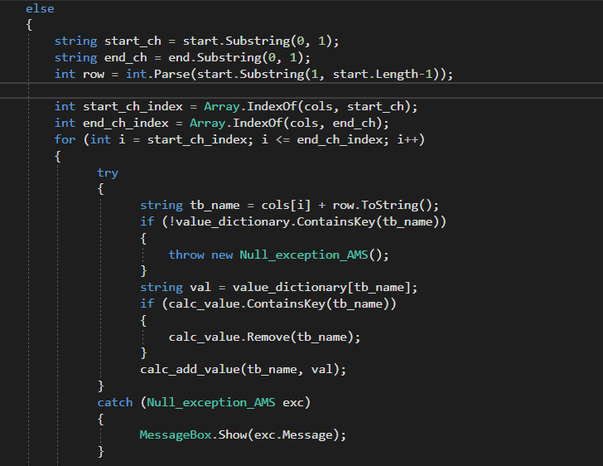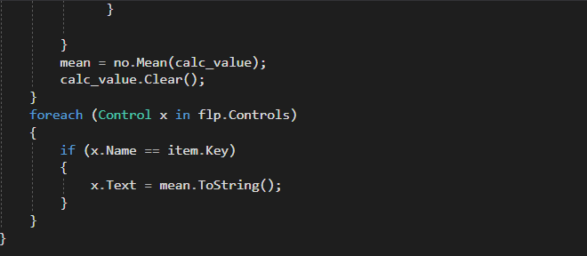

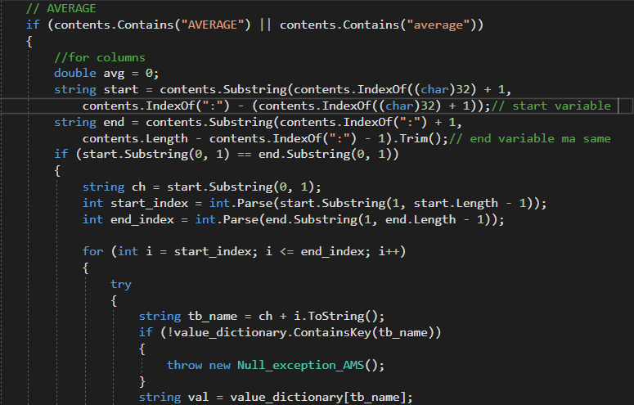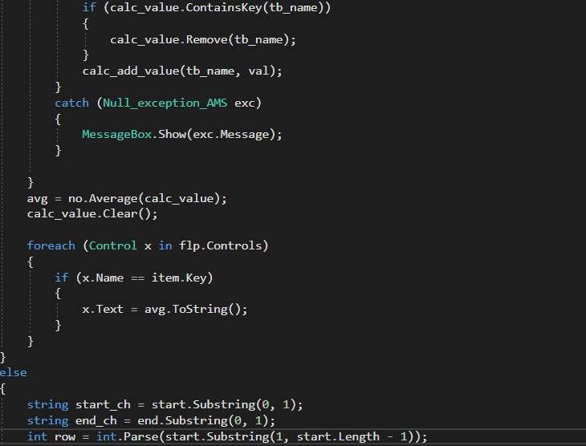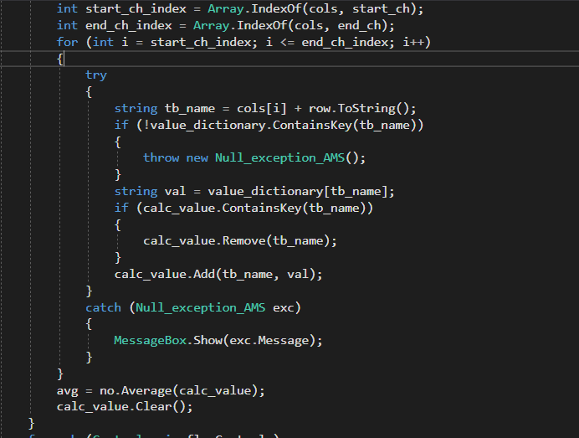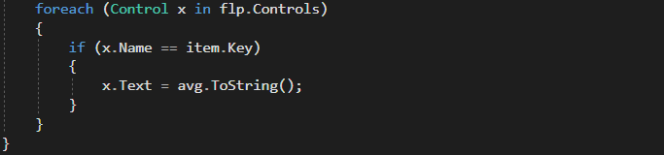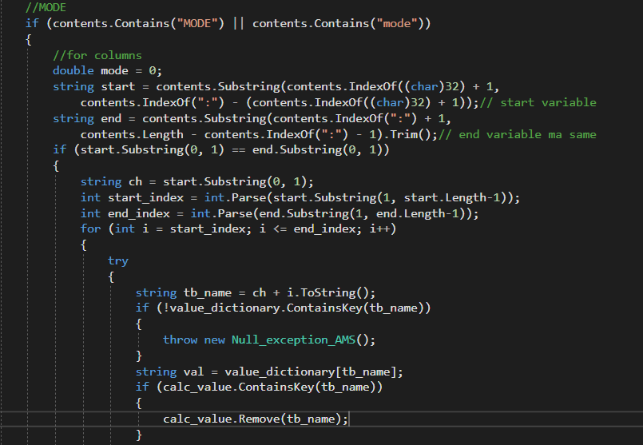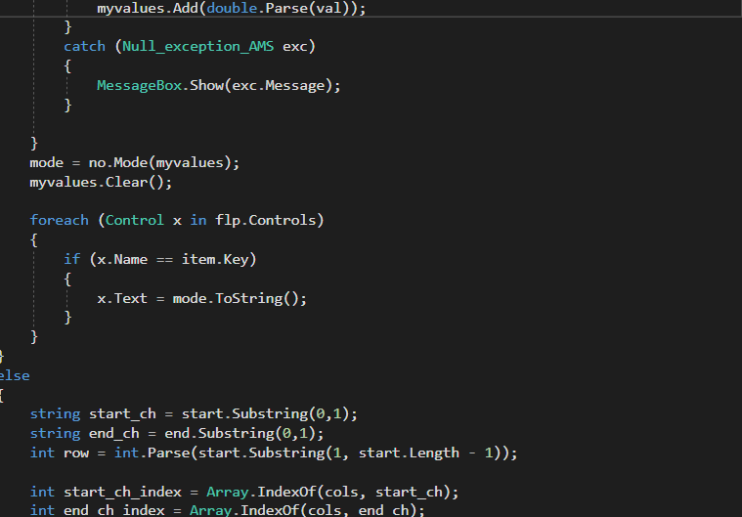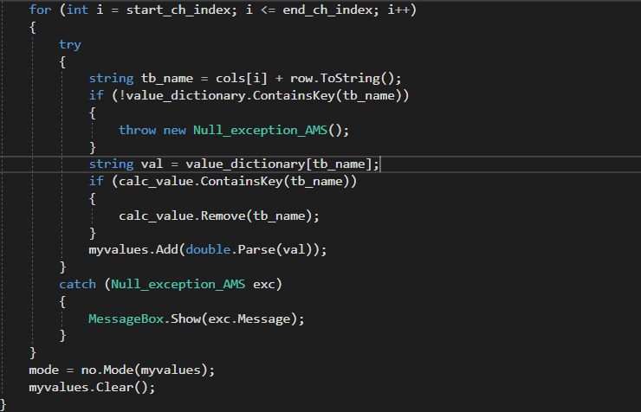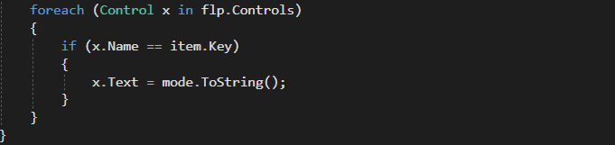

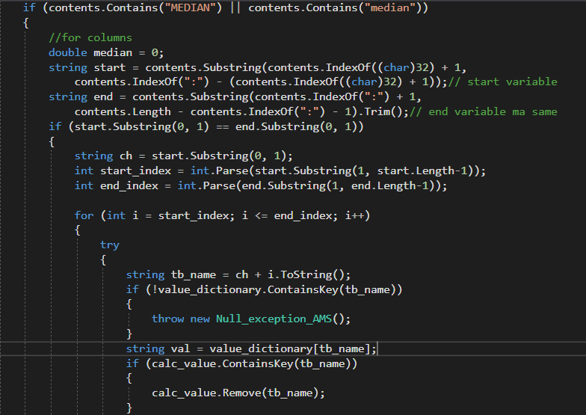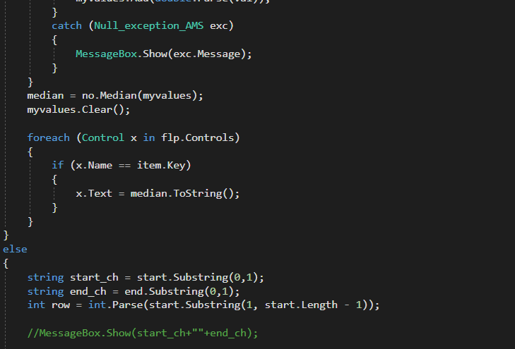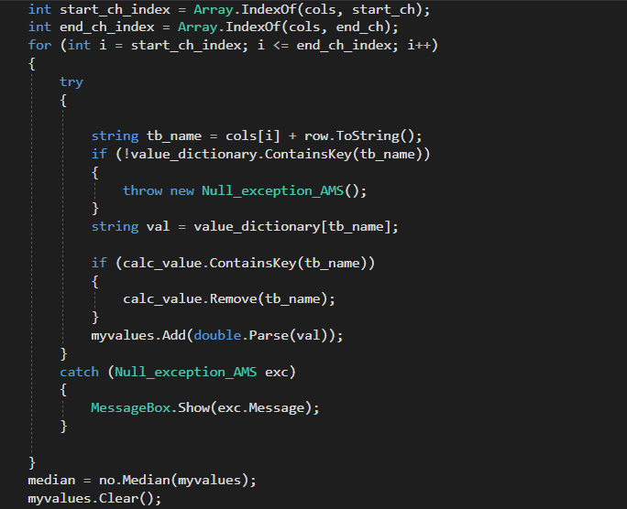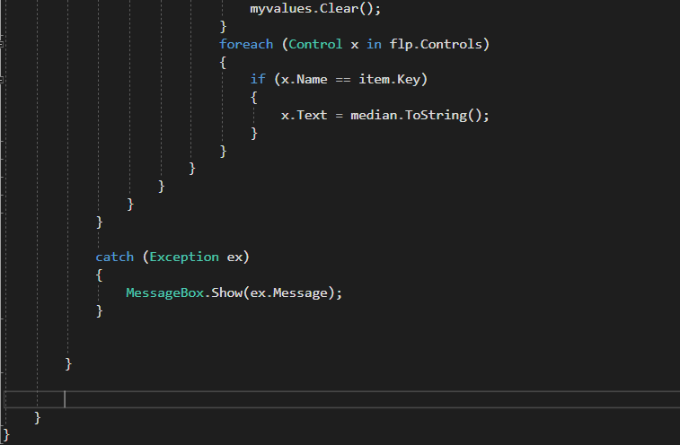

## Numerical_Op_AMS Class: (Source codes)

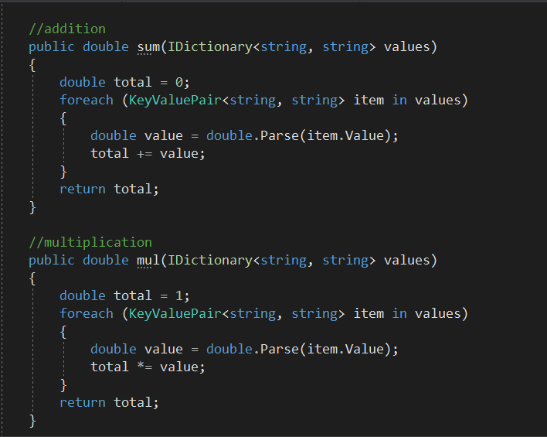

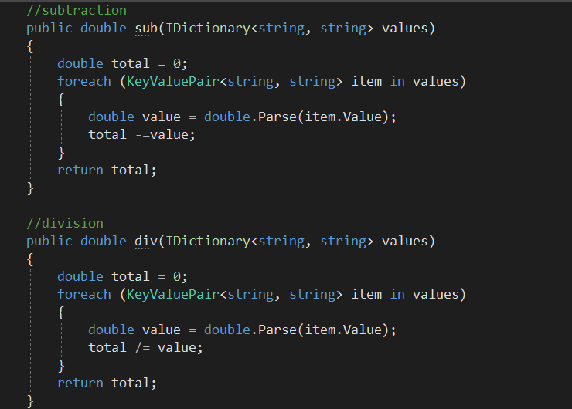

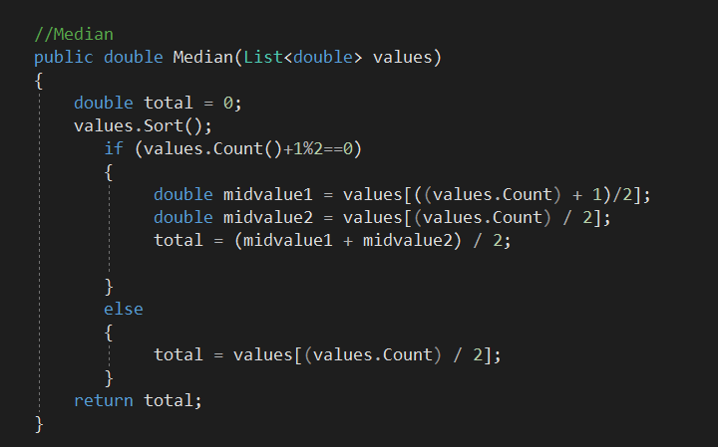

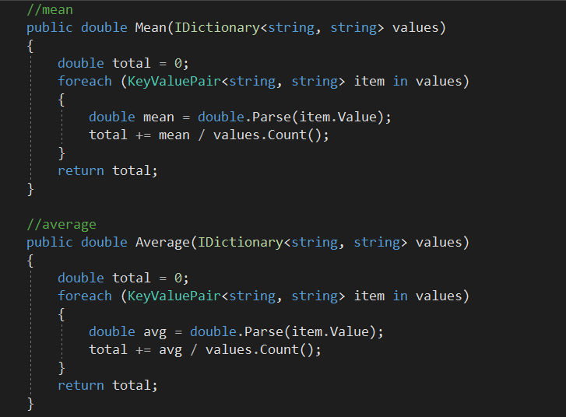

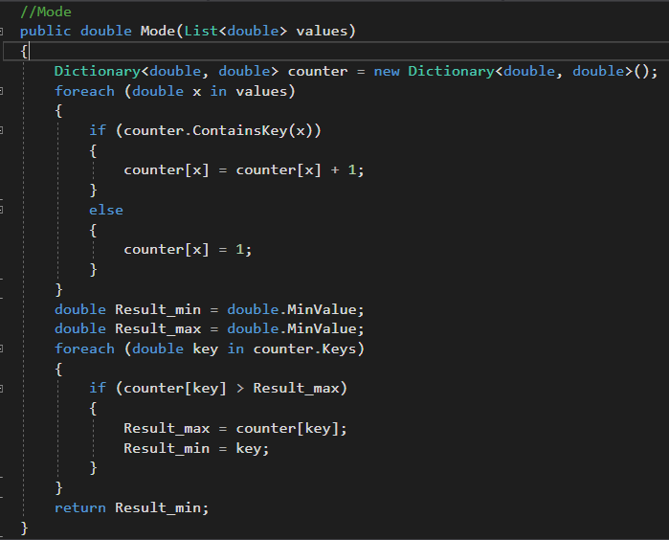

## Null exception Class (Source code):

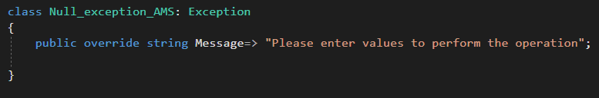

## Grid_AMS Class (Source code):

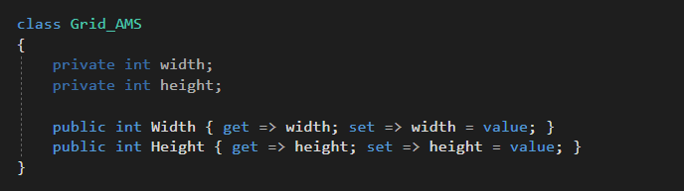

## Barchart_Aadarsha Class (Source Code):

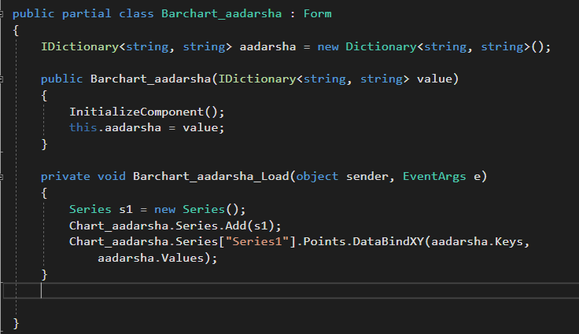

## Barchart_aadarsha (GUI):

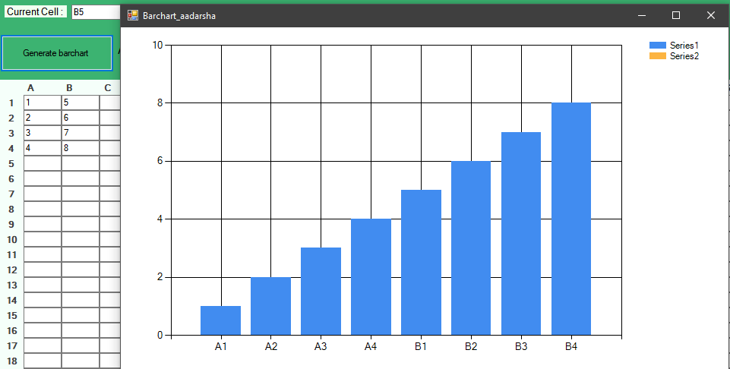

# Task-2

## Black box testing

|  |  |  |  |  |  |
| --- | --- | --- | --- | --- | --- |
| **Test ID** | **Description** | **Test values** | **Expected result** | **Actual result** | **Remarks** |
| AMS_001 | Testing sum function by inserting positive values in cell A1,A2,A3 | 10,20,10 | 40 | 40 | Pass |

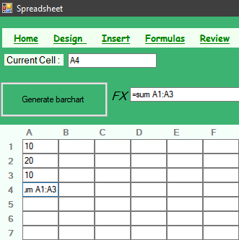 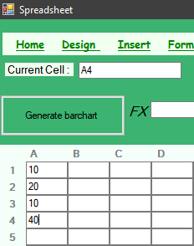

Screenshot : Execution test AMS_001

|  |  |  |  |  |  |
| --- | --- | --- | --- | --- | --- |
| **Test ID** | **Description** | **Test values** | **Expected result** | **Actual result** | **Remarks** |
| AMS_002 | Testing sum function by inserting negative values in cell A1,A2,A3 | 10,-20,-10 | -20 | -20 | Pass |

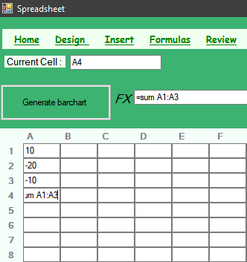 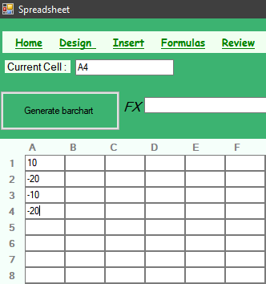

Screenshot : Test AMS_002

|  |  |  |  |  |  |
| --- | --- | --- | --- | --- | --- |
| **Test ID** | **Description** | **Test values** | **Expected result** | **Actual result** | **Remarks** |
| AMS_003 | Testing sum function by leaving cells A1,A2 null | Null | Message box showing “Please enter values to perform the operation” | Message box is displayed | Pass |

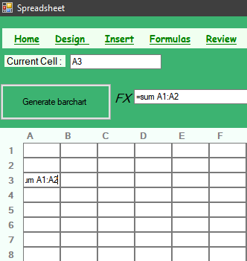 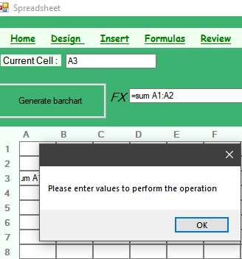

Screenshot : Testing Null Exception

|  |  |  |  |  |  |
| --- | --- | --- | --- | --- | --- |
| **Test ID** | **Description** | **Test values** | **Expected result** | **Actual result** | **Remarks** |
| AMS_004 | Testing Mean function by inserting values in cells A1,B1,C1,D1 | 1,2,3,2 | 2 | 2 | Pass |

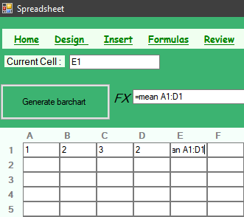 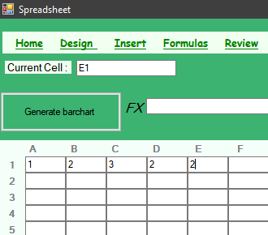

Screenshot : Testing Mean

|  |  |  |  |  |  |
| --- | --- | --- | --- | --- | --- |
| **Test ID** | **Description** | **Test values** | **Expected result** | **Actual result** | **Remarks** |
| AMS_005 | Testing Mode function by inserting values in cells A2,B2,C2,D2 | 1,2,4,2 | 2 | 2 | Pass |

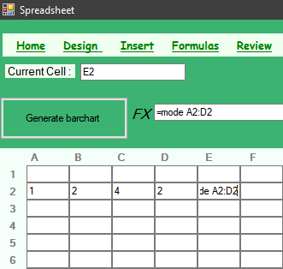 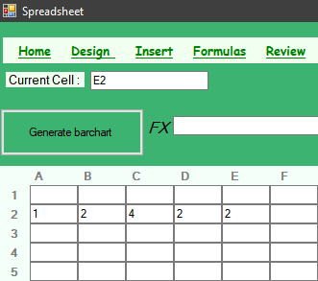

Screenshot : Testing Mode

|  |  |  |  |  |  |
| --- | --- | --- | --- | --- | --- |
| **Test ID** | **Description** | **Test values** | **Expected result** | **Actual result** | **Remarks** |
| AMS_006 | Testing Average function by inserting values in cells A10,A11,A12,A13 | 2,3,4,5 | 3.5 | 3.5 | Pass |

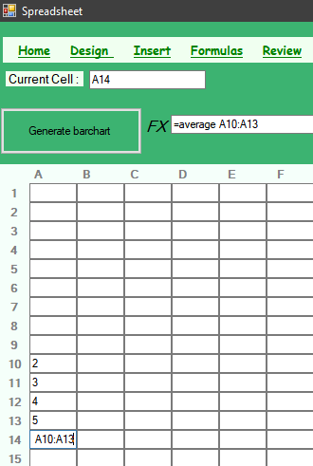 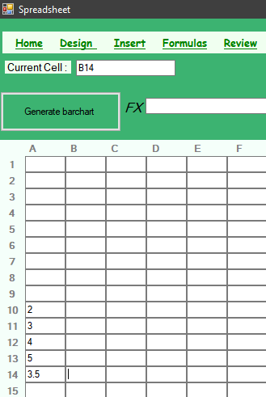

Screenshot : Testing Average

|  |  |  |  |  |  |
| --- | --- | --- | --- | --- | --- |
| **Test ID** | **Description** | **Test values** | **Expected result** | **Actual result** | **Remarks** |
| AMS_007 | Testing median function by inserting values in cells B1,B2,B3,B4 | 1,2,3,4 | 3 | 3 | Pass |

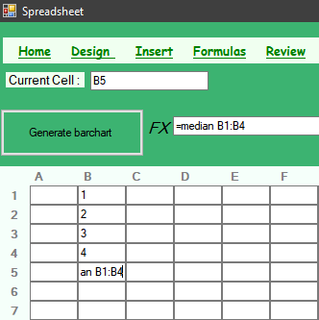 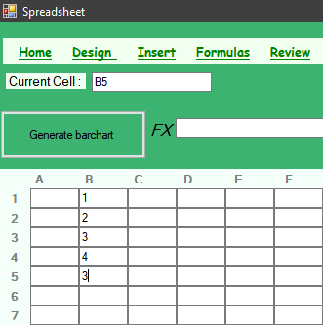

Screenshot : Testing Median

|  |  |  |  |  |  |
| --- | --- | --- | --- | --- | --- |
| **Test ID** | **Description** | **Test values** | **Expected result** | **Actual result** | **Remarks** |
| AMS_008 | Testing basic arithmetic function(multiply) by inserting values in cells A5and A6  (i.e. A5*A6) | 12,13 | 156 | 156 | Pass |

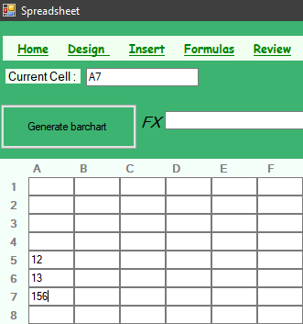 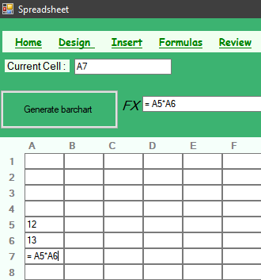

Screenshot 8: Testing arithmetic function(multiply)

## White box testing

### Unit testing 1 : Average

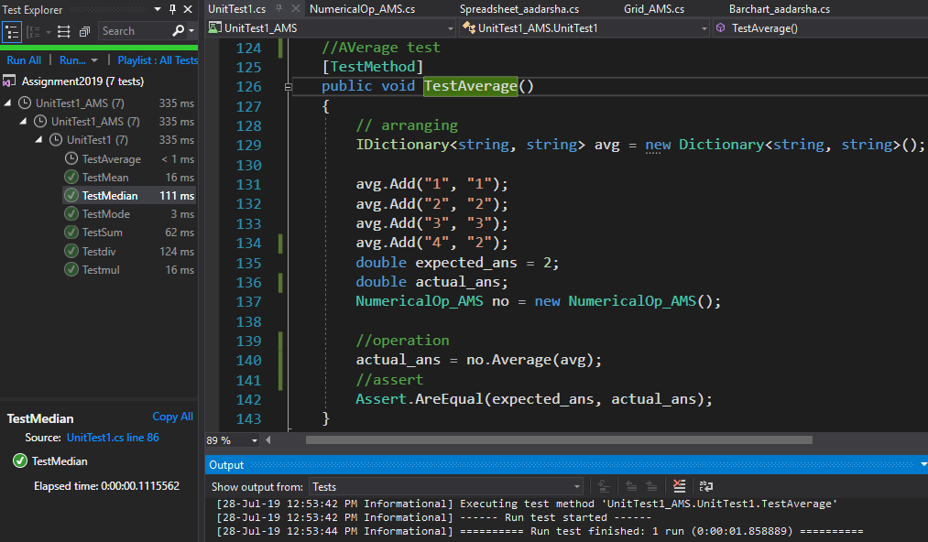

### Unit testing 2: Division

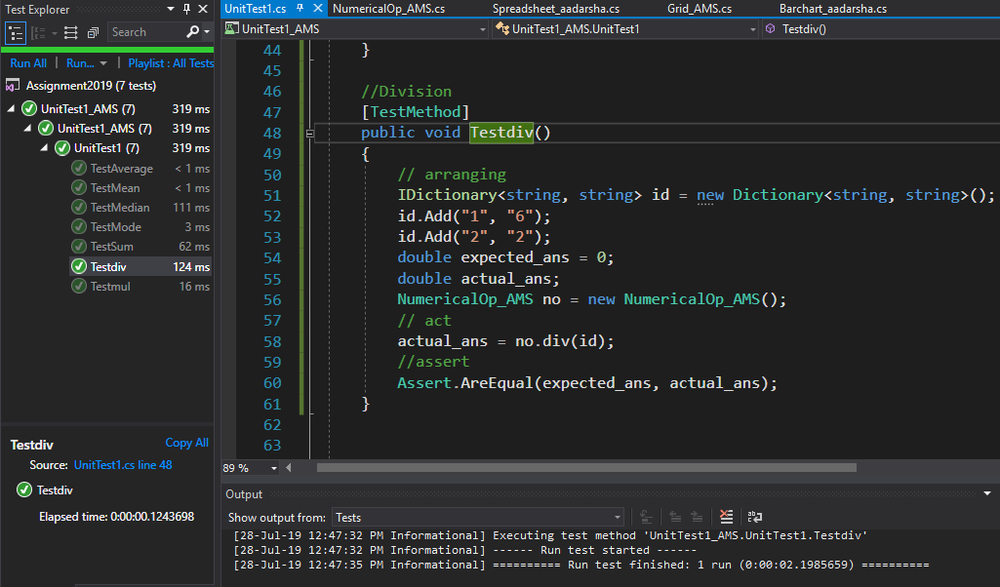

### Unit testing 3: Mean

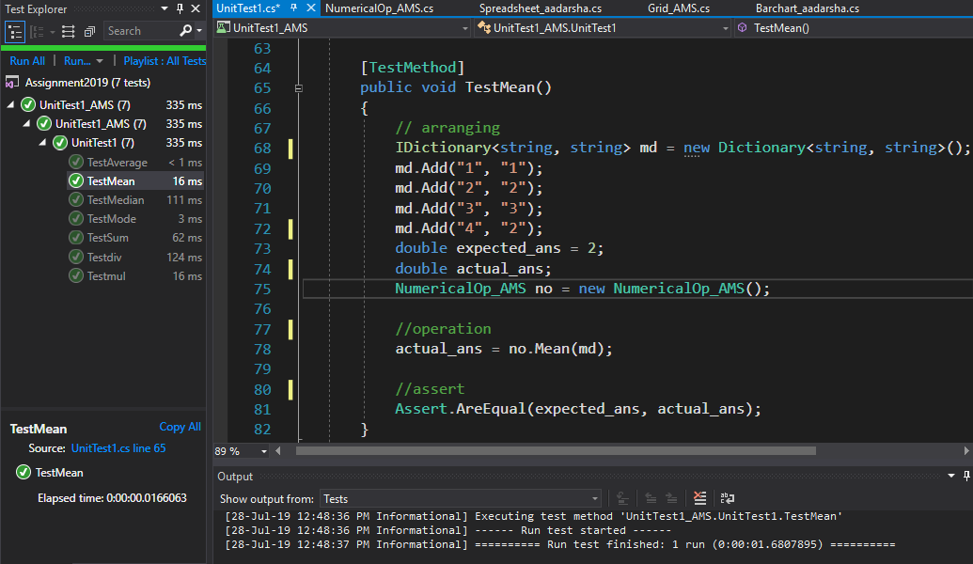

### Unit testing 4: Median

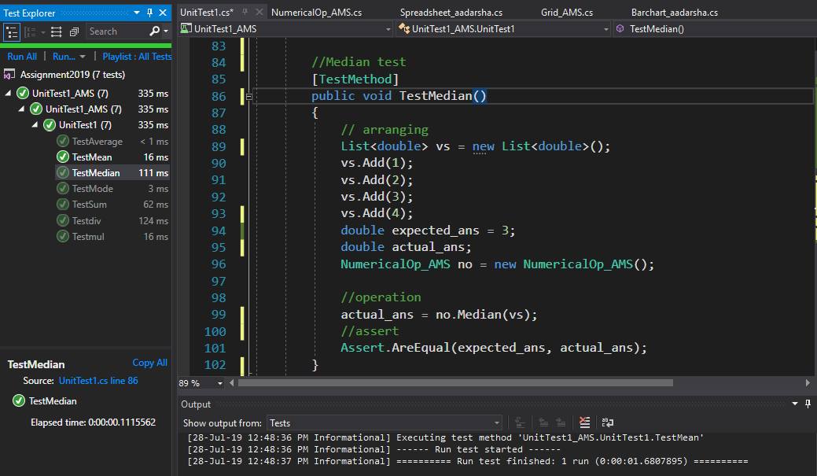

### Unit testing 5: Multiplication

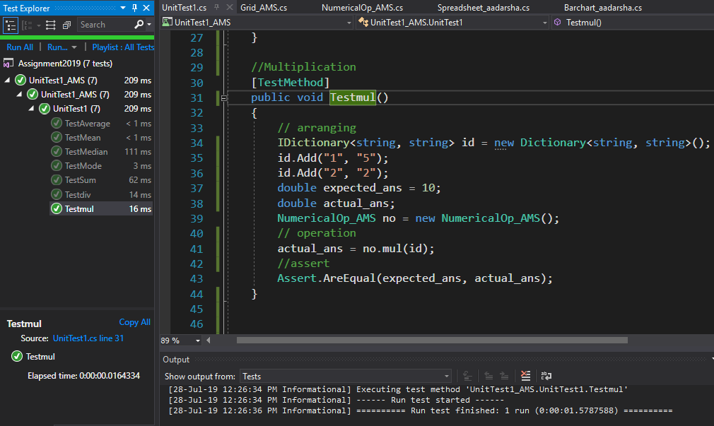

### Unit testing 6 : Sum

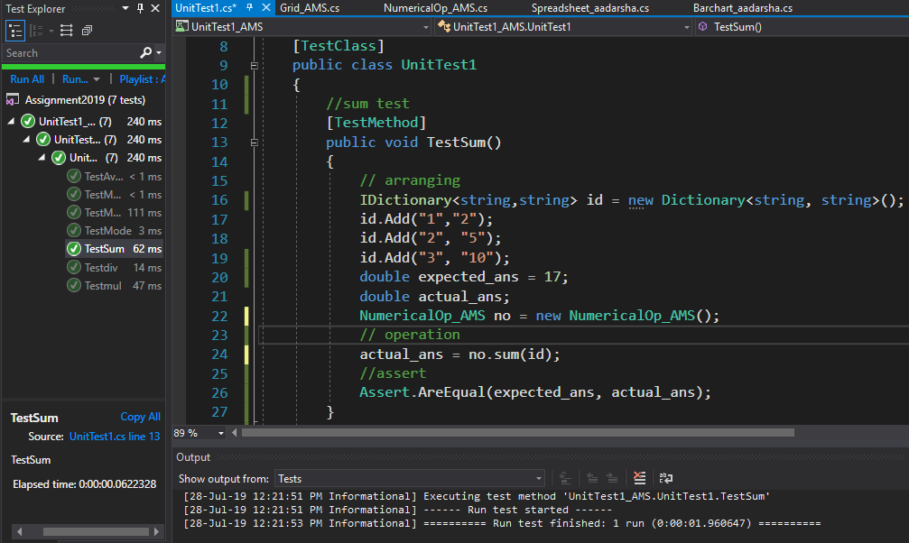

# Task 3: Class-Diagram

Class Diagram is a representation of all the classes in a software in a graphical format as to show the relationship between them.

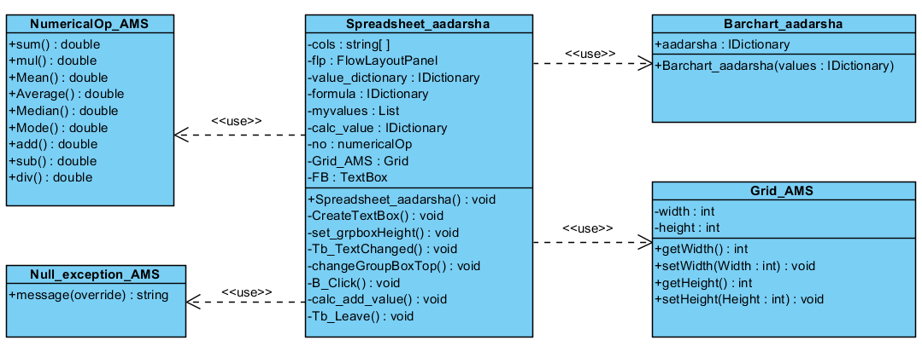

Screenshot : Class Diagram

# Conclusion

Thus, using Visual Studio IDE and C# language the prototype was developed and all the necessary requirements were fulfilled. The prototype was tested for all the possible scenarios.

Black box, white box, unit testing were performed on the data selected carefully.