**AML 2203 – Advanced Python AI and ML Tools**

**PYTHON PROJECT - 6**

**Aadarsha Chapagain**

**Ganesh chaulagain**

**Piyush Bhatia**

**Rishi Phaneendra Varma**

**PART-1 Customer or Employee Creator**

Create an object-oriented program that allows you to enter data for customers and employees.

Create a **Person** class that provides attributes for first name, last name, and email address. This class should provide a property or method that returns the person’s full name.

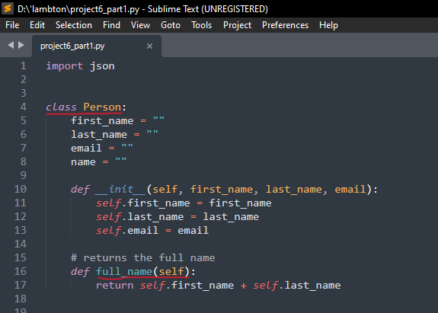

Create a **Customer** class that inherits the **Person** class. This class should add an attribute for a customer number.

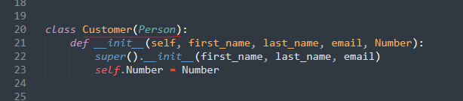

Create an **Employee** class that inherits the **Person** class. This class should add an attribute for a social security number (SSN).

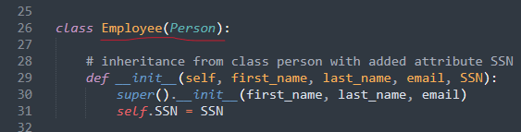

Returning instances of customer and employee through **Create_Customer()** and **Create_Employee()** functions.

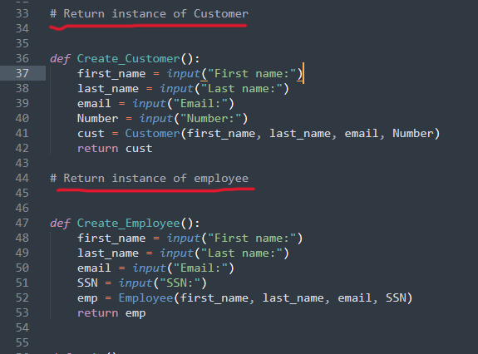

Main function

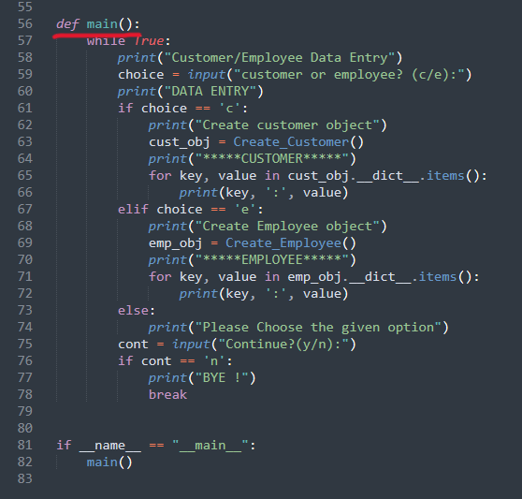

Output

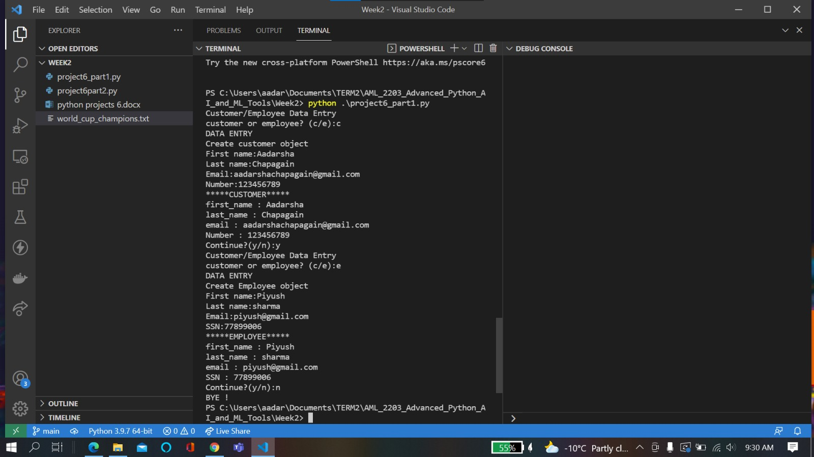

**PART-2 Champion Counter**

Create a program that reads a text file that contains a list of FIFA World Cup champions and determines the country that has won the most championships.

When the program starts, it should read the text file and use a dictionary to store the required data using the name of each country that has won the World Cup as the key

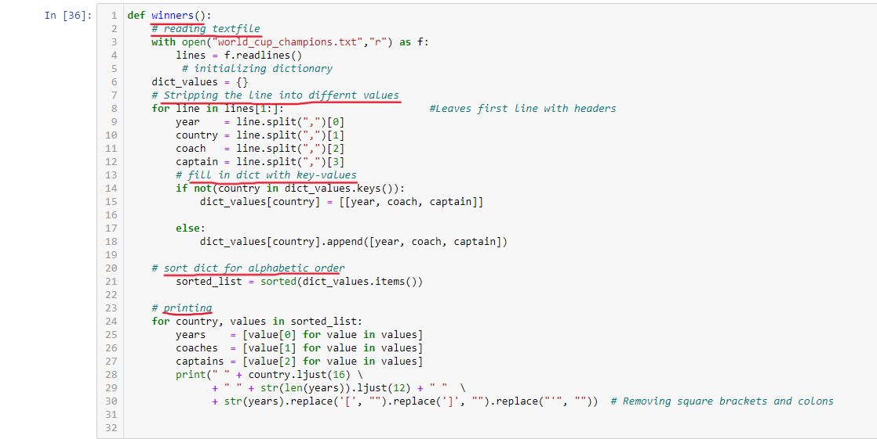

Main function

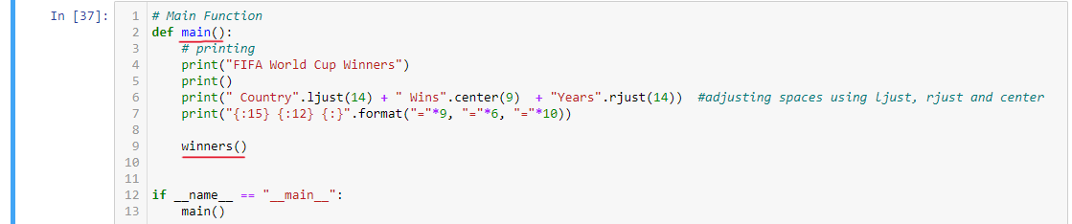

Output

