Problem: Modus Toolbox IDE 2.0 & 2.1 doesn’t support CY8CPROTO_064_SB Hardware

References:

1. [CY8CPROTO-064S1-SB](https://drive.google.com/file/d/15PMbyu3MMhZh24irEjmYxpOleFsmGQPs/view?usp=sharing) PSoC 64S1 Secure Boot Prototyping Kit
2. [Secure Boot SDK User Guide](https://www.cypress.com/documentation/software-and-drivers/psoc-64-secure-mcu-secure-boot-sdk-user-guide)
3. [Cypress Community Post](https://community.cypress.com/message/231509#231509)

Description:

|  |  |
| --- | --- |
| Working | Not Working |
| 1. We were Able to use Mbed-CLI to compile and flash the example blinky project mentioned in the [CY8CPROTO-064S1-SB](https://drive.google.com/file/d/15PMbyu3MMhZh24irEjmYxpOleFsmGQPs/view?usp=sharing) manual. | 1. when we create a new application as given in the manual [Secure Boot SDK User Guide](https://www.cypress.com/documentation/software-and-drivers/psoc-64-secure-mcu-secure-boot-sdk-user-guide) (Pg 24-26) , there is no BSP for CY8CPROTO_064_SB Board. The board does not get detected itself. Hence we are not able to import any example project supported for this board. |
| 1. Edited the blinking frequency in the example project using text editor, then build and flashed using Mbed –CLI, Then opened the Modus Toolbox 2.1 followed the steps in in [Secure Boot SDK User Guide](https://www.cypress.com/documentation/software-and-drivers/psoc-64-secure-mcu-secure-boot-sdk-user-guide) (PG 20-22) We were able to debug the code using the steps. | 1. We are not able to build , clean, flash or erase in the Modus Toolbox IDE 2.1,   We were **only** able to debug. We need to separately build and flash from mbed-cli before debugging it in Modus Toolbox IDE. |

**Exporting Application from mbed cli to modustoolbox :**

To export the Mbed application for use in the ModusToolbox IDE, we need to use the Mbed CLI export command:

mbed export -i eclipse_gcc_arm -m <TARGET_BOARD>

This command works fine for the boards that are supported by modustoolbox such as CY8CKIT_062_WIFI_BT, but not for our board [CY8CPROTO-064S1-SB](https://drive.google.com/file/d/15PMbyu3MMhZh24irEjmYxpOleFsmGQPs/view?usp=sharing)

Screenshot:

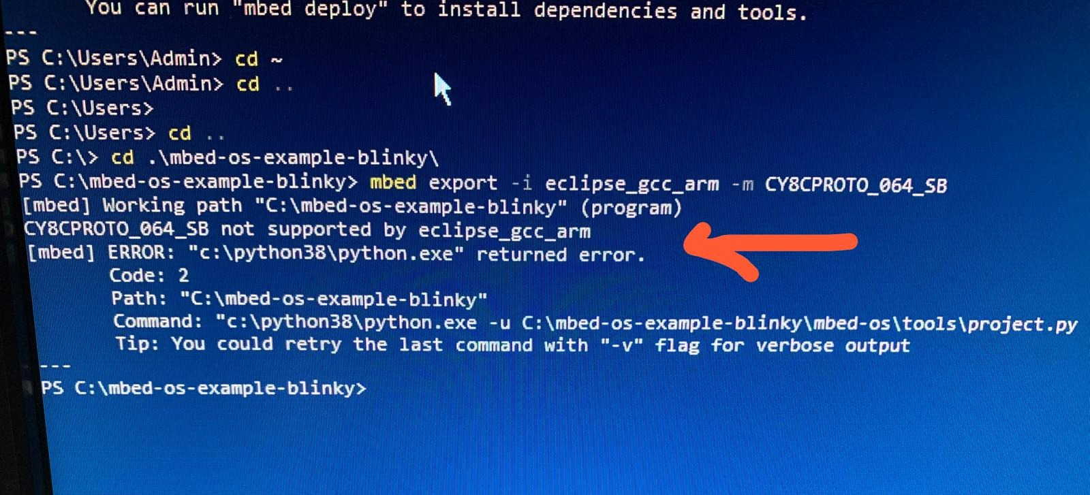

Reference : [ModusToolbox_IDE_User_Guide](https://www.cypress.com/file/455211/download) (Page 20)