Problem: Device Datasheet, Technical Reference manual not available for the CY8CPROTO_064_SB hardware

References: [CY8CPROTO-064S1-SB](https://drive.google.com/file/d/15PMbyu3MMhZh24irEjmYxpOleFsmGQPs/view?usp=sharing) PSoC 64S1 Secure Boot Prototyping Kit

Screenshot:

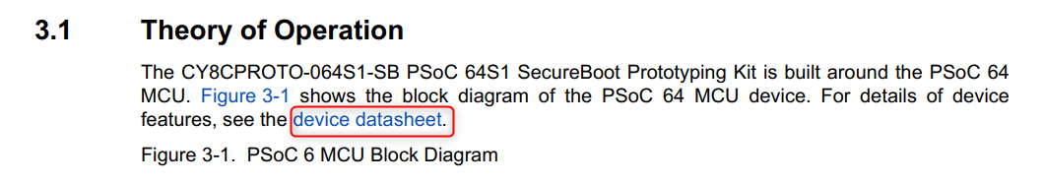

Description:

We tried to look for datasheet of the device, but on clicking the link it opens datasheet for [PSoC63](https://www.cypress.com/documentation/datasheets/psoc-6-mcu-psoc-63-ble-datasheet-programmable-system-chip-psoc) BLE Kit. We were not able to get the technical manual, data sheets or application notes for this kit .  
Referred the link: <https://www.cypress.com/products/32-bit-arm-cortex-m4-cortex-m0-psoc-6>  
  
There are few documents like [PSoC 64 MCU: Secure Device Management with Arm Pelion](https://www.cypress.com/documentation/product-overviews/secure-device-management-psoc-64-secure-mcus-and-arm-pelion),[PSoC 64 MCU: Secure Device Management with AWS IoT Core](https://www.cypress.com/documentation/product-overviews/secure-device-management-psoc-64-secure-mcus-and-aws-iot-core), but these are for the CY8CKIT-064B0S2-4343W board BLE and in the [CY8CPROTO-064S1-SB](https://drive.google.com/file/d/15PMbyu3MMhZh24irEjmYxpOleFsmGQPs/view?usp=sharing) manual (Pg 8 ) its mentioned that OS examples won’t work specifically the examples using external communication functions such as WiFi/BT/BLE.

We are not sure what we are capable of doing with this board, please provide us some application notes, manual or references.