Embedded Security Showcase using PSoC64
Bug Report

Author: | Aadarsh Kumar Singh ( aadarsh.k.singh@stud.h-da.de )
Title: | Exporting Makefile project for PSoC64 MCU (CY8CPROTO-064S1) to Eclipse IDE throws an error: CY8CPROTO-064S1 is not a supported MCU.
Screenshot:
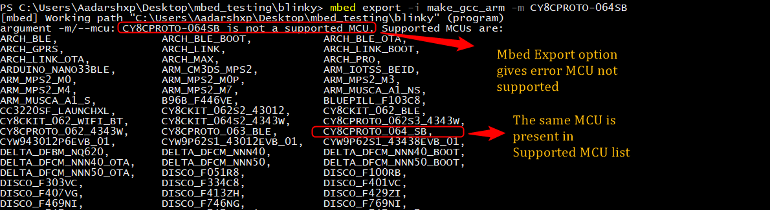

Description and temporary fix:

- The result of the verbose output is attached below, the error is thrown from the script project.py.
The file is present in the path <root>\mbed-os\tools.

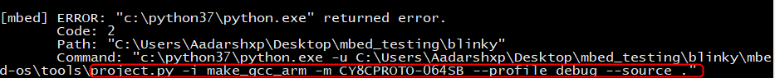

- On debugging the project.py script found the script throws error while trying to export at this point , In screenshot at 385 line , we see that exporter object is created and contains all the exporter toolchain and MCU list. Further debugging (step into operation) found it returns some error values from exporter.py python script. (<root>\mbed-os\tools\export\exporter.py)
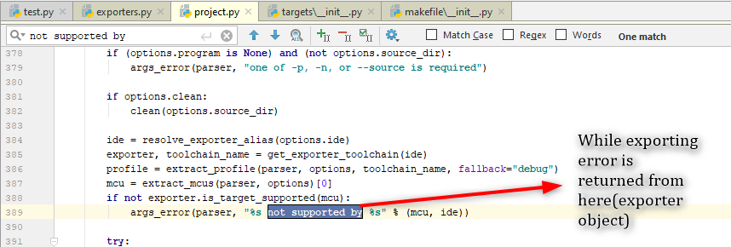

- On debugging the exporter.py found that in the API apply_supported_whitelist the toolchain was supported , and the attribute for the MCU (CY8CPROTO-064SB) was present but in the last API binary hook returned False, on changing this value to true , i was successfully able to import the makefile project for CY8CPROTO-064SB board in Eclipse IDE.

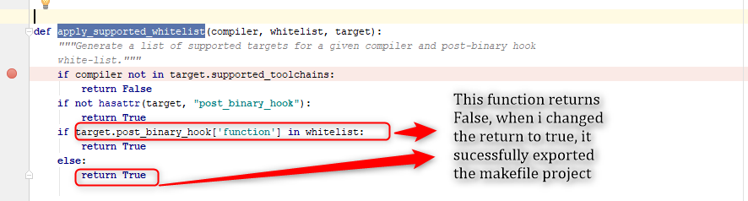
- The expected return and Actual return value for the post binary hook API is attached below :
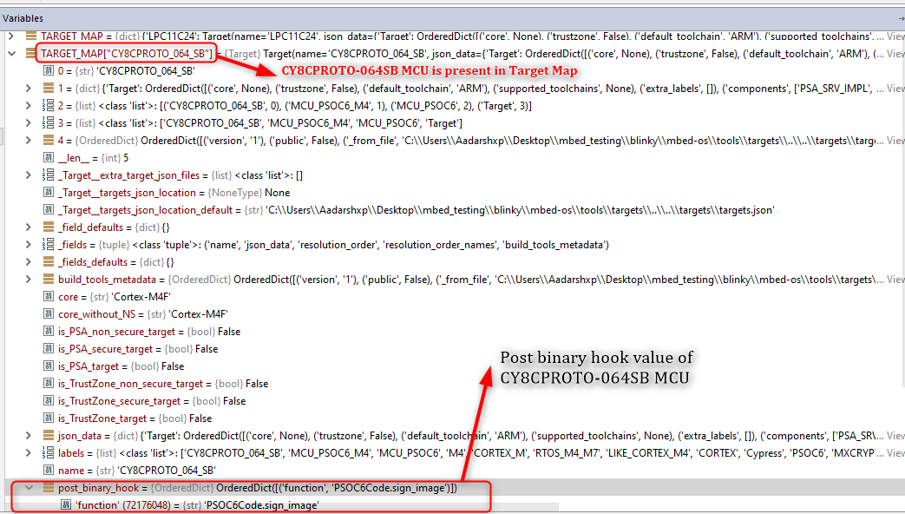

Expected Post binary hook value in whitelist :

