**INDIAN INSTITUTE OF INFORMATION TECHNOLOGY**

**BHOPAL**



MINOR PROJECT

ON

**SUDOKU SOLVER**

SUBMITTED IN PARTIAL FULFILLMENT FOR THE DEGREE OF BACHELOR OF TECHNOLOGY

|  |  |  |
| --- | --- | --- |
| **SUBMITTED BY:-** | **SUBMITTED TO:-** | **UNDER THE GUIDANCE OF:-** |
|  |  |  |
|  |  |  |
|  |  |  |
|  |  |  |

**SESSION 2019-2020**

**INDIAN INSTITUTE OF INFORMATION TECHNOLOGY**

**BHOPAL**



**DEPARTMENT OF COMPUTER SCIENCE AND ENGINEERING**

**CERTIFICATE**

This is to certify that **Alok Kaushik (17U01026), Subhodeep Debroy (17U01027), Aadarsh Siddha (17U01028),** students of B.Tech 3rd year(ELECTRONICS AND COMMUNICATION ENGINEERING),have successfully completed their project “**SUDOKU SOLVER**” in partial fulfilment of their minor project in Electronics & Communication Engineering.

**Dr. Bupendra Singh Kirar Mr. Praveen Pawar**

(Project Mentor) (Project Coordinator)

**SESSION 2019-20**

**INDIAN INSTITUTE OF INFORMATION TECHNOLOGY**

**BHOPAL**



**DEPARTMENT OF COMPUTER SCIENCE AND ENGINEERING**

**DECLARATION**

We, hereby, declare that the following report which is being presented in the Minor Project “SUDOKU SOLVER” is the partial fulfilment of the requirements of the third year (sixth semester) Minor Project in the field of Electronics and Communication Engineering. It is an authentic documentation of our original work carried out under the able guidance of **Dr. Bupendra Singh Kirar** and the dedicated co-ordination of **Mr. Praveen Pawar.** The work has been carried out entirely at Maulana Azad National Institute of Technology, Bhopal. The following project and its report, in part or whole, has not been presented or submitted by us for any purpose in any other institute or organization.

We, hereby, declare that the facts mentioned above are true to best of our knowledge. In case of any unlikely discrepancy that may possibly occur, we will be the ones to take responsibility.

ALOK KAUSHIK (17U01026)

SUBHODEEP DEBROY (17U01027)

AADARSH SIDDHA (17U01028)

AREA OF WORK

Our project is based on detecting and recognizing a “Sudoku Puzzle” from an image using IMAGE RECOGNIZATION and MACHINE LEARNING, converting it into a multi-dimensional array matrix, and using a hard-coded algorithm to provide its solution.

ACKNOWLEDGEMENT

With due respect, we express our deep sense of gratitude to our respected guide Dr. Bhupendra Singh Kirar, for his invaluable support and guidance. We are thankful for the encouragement that he has given us in completing this project successfully. His rigorous evaluation and constructive criticism was of great assistance.

It is imperative for us to mention the fact that this minor project could not have been without the periodic suggestion and advice of our project co-ordinator Mr. Praveen Pawar.

We are also grateful to our respected Director Dr. Narendra Singh Raghuvanshi for permitting us to utilize all the necessary facilities of the college. Needless to mention is the additional help and support extended by our respected Nodal Officer, Dr. Meenu Chawla, in allowing us to use the department laboratories and other services.

We are also thankful to professor in charge examination Dr. Dheeraj K. Agrawal who continuously supported and encouraged us by his advices and also helped us in our project presentation that has improved our presentation skills.

We are also thankful to Student Welfare in charge Dr. Jaytrilok Choudhary for constantly motivating us to work harder for the completion of the project. We extend our sincere thanks to Dr. Amit Bhagat who co-operated with us nicely for smooth development of this project. We would also like to thank all the other faculty, staff members and laboratory attendants of our department for their kind co-operation and help. Last but certainly not the least, we would like to express our deep appreciation towards our family members and batch mates for providing the much needed support and encouragement.

ABSTRACT

This is a report of the project we created to recognize Sudoku puzzles containing both handwritten and printed digits from images taken.

The lines of the grid are detected with a Hough transform. The grid is then recomposed from the lines. The digits position are extracted from the grid and finally, each character is recognized using a Deep Belief Network (DBN).

Our model proved successful on our dataset (MINST), achieving 97.5% of correct detection on the testing set and on average, it can provide solution in less than 100ms.

TABLE OF CONTENTS

|  |  |
| --- | --- |
| Title | Page No. |
| Certificate | i |
| Declaration | ii |
| Area of work | iii |
| Acknowledgement | iv |
| Abstract | v |
| Chapter 1. Introduction | 1 |
| Chapter 2. Literature review | 2 |
| Chapter 3. Methodology & Work Description | 4 |
| Chapter 4. Tools & Technology Used | 7 |
| Chapter 5. Implementation & Coding | 8 |
| Chapter 6. Result Analysis | 10 |
| Chapter 7. Conclusion & Future Scope | 13 |
| References | 14 |

LIST OF FIGURES

|  |  |  |
| --- | --- | --- |
| Fig No | Description | Page no. |
| 1 | Types of Machine Learning Technique | 3 |
| 2 | Example of Dense Layer | 5 |
| 3 | Screenshot of Code 1 | 8 |
| 4 | Screenshot of code 2 | 9 |
| 5 | Initial image of the Maze | 10 |
| 6 | Image of the Maze after thresholding | 11 |
| 7 | Image of the Maze after contour and number detection | 11 |
| 8 | Final solution of the Maze | 12 |

Chapter 1

INTRODUCTION

Deep Learning solutions have proved very successful on scanner-based digit recognition. They have also shown good capability to handle complex inputs such as object recognition. The scientific question that we are trying to address in this research is whether such deep learning systems are able to handle mixed contents, for example recognizing both handwritten and printed inputs without separating them in two distinct problems, recognizing the edges if the maze etc.

The Sudoku puzzle is a famous Japanese game. It is a logic, number-based puzzle. The standard Sudoku is played on a 9 × 9 grid. Each cell can either be empty or contain a digit from 1 to 9. The game begins with a partially filled grid and the goal is to fill every row, column and sub 3 × 3 square with numbers, so that each number is present only once.,

To make this project work , we used thresholding to make the input image more recognizable . Then we used contouring to detect the edges and isolate individual digit. Used our already trained model with MNIST dataset to detect those digits .Lastly used a basic algorithm to traverse and solve the puzzle.

While improvements can certainly be brought to the detection part, the overall system is offering good overall performance in spite of the difficulties inherent to pixel image based inputs including variabilities of illumination, exposure ,autofocus artefacts (blurred parts), skewed and rotated inputs.

Chapter 2

LITERATURE REVIEW

Over past years an enormous number of ML algorithms was introduced. Only some of them were able to solve the problem so they replaced by another one.

**1.1 Methods used in Machine Learning**

There are three ML algorithms for example unsupervised learning and reinforcement learning, supervised learning, which are

displayed in the following fig 1.

* + 1. **Supervised learning**

It consists of a given set of input variables (training data) which are pre-labelled and target data. Using the input variables it generate a mapping function to map inputs to required outputs. Parameter adjustment procedure continues until the system acquired a suitable accuracy extent regarding the teaching data.

* + 1. **Unsupervised learning**

In this algorithm we only have training data rather a outcome data. That input data is not previously labelled. It is used in classifiers by recognizing existing patterns or cluster in the input datasets.

* + 1. **Reinforcement learning**

Applying this algorithm machine is trained to map action to a specific decision hence the reward or feedback Signals are generated. The machine trained itself to find the most rewarding actions by reward and punishment using past experience

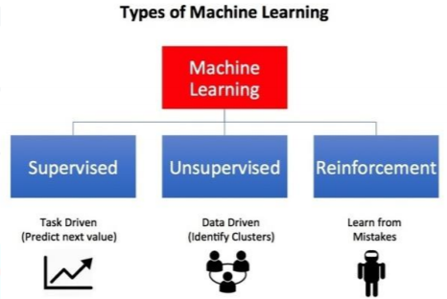

Fig 1

**2.. Regression algorithms**

In Regression algorithms predictions are made by the model with modelling the relationship between variables using a measure of error. Continuously varying value is predicted by the Regression technique. The variable can be a price, a temperature. The favoured regression algorithms are as follows:

• Linear Regression algorithm

• Ordinary Least Squares Regression

• Multivariate Adaptive Regression Splines

• Logistic Regression

• Locally Estimated Scatter plot Smoothing

• Stepwise Regression

Chapter 3

METHODOLOGY AND WORK

DESCRIPTION

The problems we encountered during this project were mainly related to either selection of right image manipulation technique or opting the right regeression model and neural network to get the job done efficiently .

1. **Selection of Approach:**
   1. **Related to Image Processing**
      1. **Image Augmentation:** It is a technique used to expand the size of your data set by manipulating the orientation of the image , such as rotation by 90,180 degrees , flipping, zooming in or out. Ofcourse since we were dealing set of numbers , we cant use all of the since flipping and rotating of 6 or 1 can make them look like 7 or 9 and vise versa.
      2. **Thesholding:** It is a technique used on images with uneven lighting and exposure , to make them more recognizable .We reduced pixel color of those pixels having hex value less than 127 to 0 and those greater than 127 to 255. Hence totally black and white image.
      3. **Contour Detection:** aka edge detection have many different methods within it self. The one we used is step detection .How it works is ,it looks for change in image brightness in the vicinity of the image. And since because of thresholding , it applies good on the maze.
   2. **Related to Machine Learning and Neural Network**
      1. **Rectified Linear Unit:** ReLU is a type of activation function. There several of these functions (ReLU, Sigmoid, tanh, ELU), but ReLU is used most commonly and serves as a good default. It allows a model to solve nonlinear problems.
      2. **Splitting Dataset:** We seprated our data set into 2 parts , training dataset and testing data set. This allows us to train our model as well as test it’s accuracy time to time.

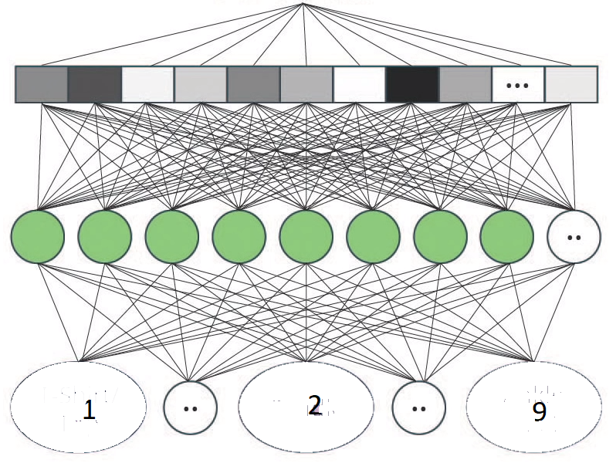

**Input Layer**

**Dense Layer**

**Output layer**

Fig 2

1. **Application of Selected Approach**
   1. **Flattening:** It is the process of an Image which is a 2D array of pixels to a single 1D array before feeding it to our neural network. MNIST data contains images with 28 x 28 pixels hence on flattening it gives a array of 784 pixels.
   2. **Dense Layer:** It is a type of neural network which contains single array of neurons such that each neuron in dense layer is connected to each and every input of input layer. Since it depends on us to select the number of neurons in dense layer , therefore we selected it to be 128 units.
   3. **Output Layer :** it’s the last layer of our neural network .It contains 10 options ie number from 0 to 9. Atlast we obtain the probability distribution of different number provided by our trained model among which highest probability one is selected .

Chapter 4

TOOLS AND TECHNOLOGY

USED

Tools makes machine learning swift and rapid. Machine learning tools provides interface to the machine learning programming language. They provide best practices for process and implementation .Machine learning tools contains platforms which provides capabilities to run a module or project. We used **Python 3.7** (Latest version) to implement our project.

Machine learning tools contains various libraries which provides all capabilities to complete a project and libraries provides various algorithms. Some of libraries are :

* Scikit Learn : It contains MNIST dataset which we used primiarly .
* NumPy : Used this for 2D array related oprations.
* Mathplot Lib : Used thid to plot accuracy curve and detect over fitting or under fitting.
* OpenCV : Used for implementing maze recognization algorithem.
* TensorFlow: Used this to create a convolutional neural network (CNN).

Appart from these , we used **JuPyter Notebook** as our IDE.

Chapter 5

IMPLEMENTATION AND CODING

Here is the screenshot of how we trained our model on MNIST dataset :-

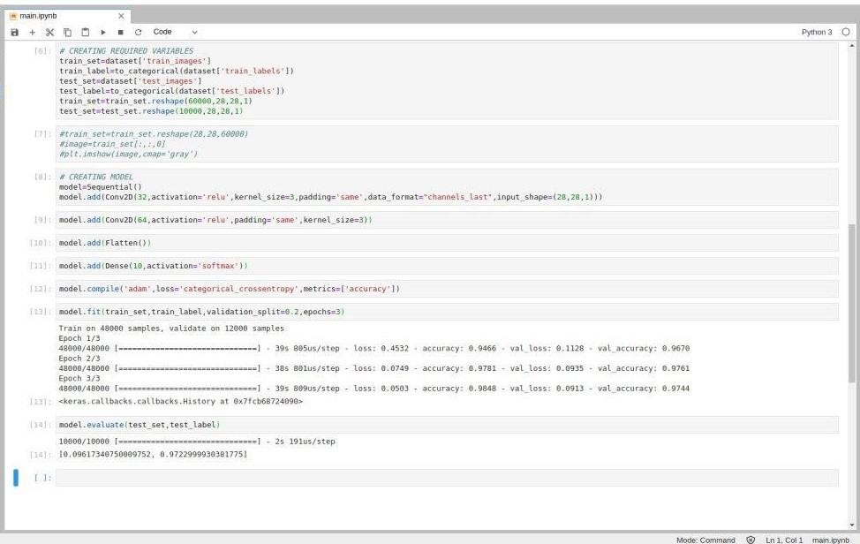

Fig 3

Here is a screenshot of how we created a Dense layer to create our model :-

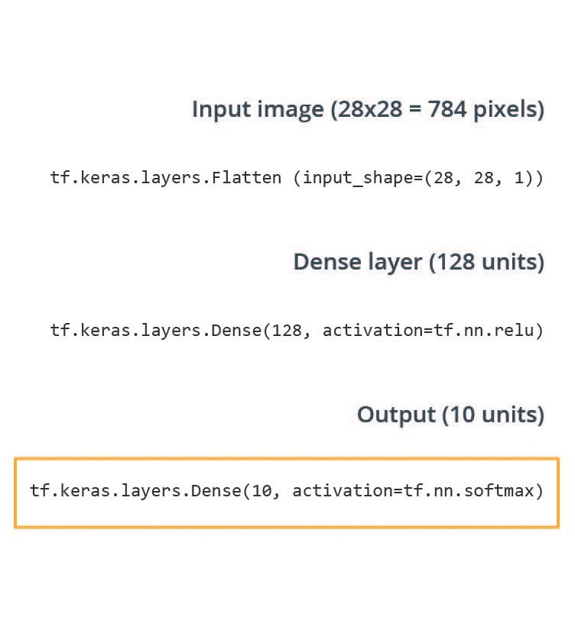

Fig 4

Chapter 6

RESULT ANALYSIS

The figure 5 below shows the accuracy we achived by training our model on MNIST dataset.

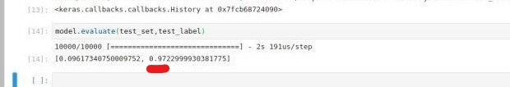

Fig 5

We were able to achive 97.22% of accuracy on this dataset,

Now Step-by-step analysis of our project

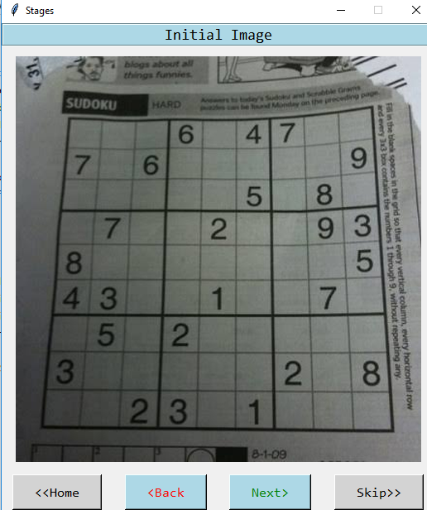 Fig 6: Initial image of the Maze

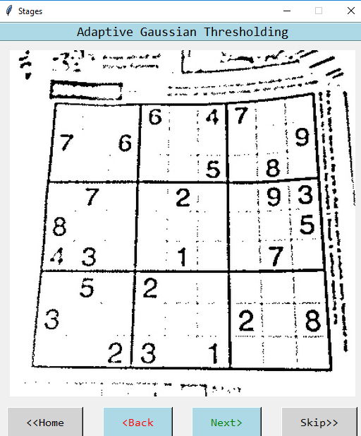 Fig 7: Image of the Maze after thresholding

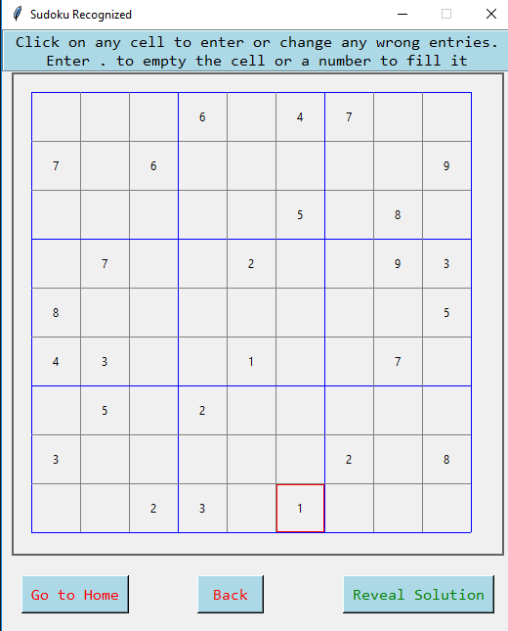

Fig 8: Image of the Maze after contour and number detection

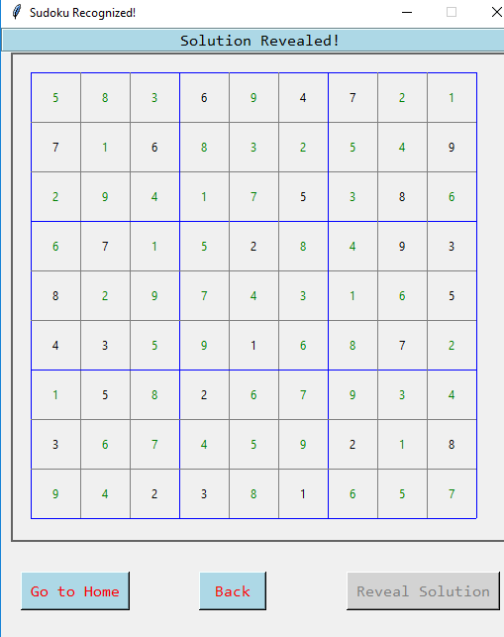

Fig 9: Final solution of the Maze

Chapter 7

CONCLUSION AND FUTURE SCOPE

We designed and implemented a complete solution to detect and recognize a Sudoku grids containing printed digits. The grid and cell detection part is using various image processing techniques including Thresholding and Contour Detection. The recognition part is based on a feature-driven CNN trained in a supervised way on printed inputs, and on a SVM classifier. While improvements can certainly be brought to the detection part, the overall system is offering good overall performance in spite of the difficulties inherent to camerabased inputs including variabilities of illumination, autofocus artefacts (blurred parts), skewed and rotated inputs. An interesting result is in the capability of CNN to handle inputs and extract relevant features on printed inputs.

While our system gives promising results, we foresee several extensions for this work:

* Our project can be further extended to implement on various other puzzles like tik-tak-to, Minesweeper ,crosswords etc.
* Overfitting could remain a problem in our case. More care should be put in ensuring that the weights of the CNNs are not too tightly coupled to the training set. Generating more training examples could help limit overfitting.

**References**

1. A. Van Horn, “Extraction of sudoku puzzles using the hough transform,” University of Kansas, Department of Electrical Engineering and Compute Science, Tech. Rep., 2012.
2. P. Simha, K. Suraj, and T. Ahobala, “Recognition of numbers and position using image processing techniques for solving sudoku puzzles,” in Advances in Engineering, Science and Management (ICAESM), 2012. IEEE, 2012, pp. 1–5.
3. S. Impedovo, L. Ottaviano, and S. Occhinegro, “Optical character recognition—a survey,” International Journal of Pattern Recognition and Artificial Intelligence, vol. 5, no. 01n02, pp. 1–24, 1991.
4. Wicht, Baptiste. (2015). Mixed handwritten and printed digit recognition in Sudoku with Convolutional Deep Belief Network. 10.1109/ICDAR.2015.7333884.
5. Wicht, Baptiste & Hennebert, Jean. (2015). Camera-based Sudoku recognition with deep belief network. 6th International Conference on Soft Computing and Pattern Recognition, SoCPaR 2014. 83-88. 10.1109/SOCPAR.2014.7007986.