TBC Assignment 1: Accounting
(Due: Saturday 11:59 PM)
Note: Don't worry if you find some of these questions confusing and/or don't know the answers. They are intended to help you flesh out where there might be gaps in your understanding of accounting; they are not intended as a test. Simply try to work your way through them and collect any questions you have to ask your discussion leader when you meet on the weekend. As a reminder, when it comes to assignments, we care about effort/thoughtfulness, not correctness.
Required Readings:
- How to Read a 10-K
- Corporate Finance (Chapter 2)
- Financial Shenanigans (Chapters 1 & 2)
Case – Familiarizing yourself with reading financial statements
Login into BamSEC (https://www.bamsec.com). The username is chicagobluechips@gmail.com and the password is valueinvesting. Open Coke (KO’s) 2014 10-K. Except where otherwise stated, you only need the Financial Statements section to answer these questions.
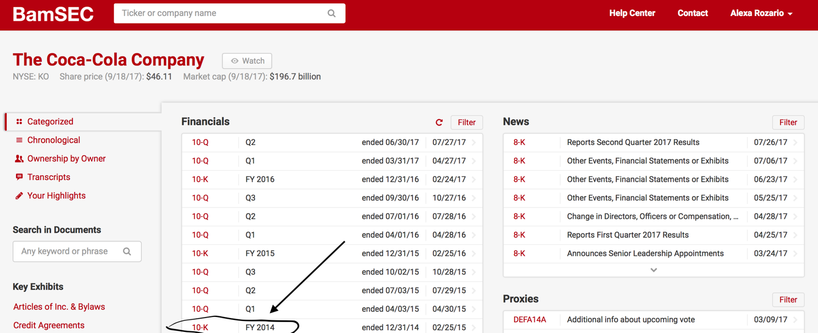

Preliminary
- Summarize Coca Cola’s business and recent history in a short paragraph (6-7 sentences). What are some pertinent (read: company specific) risks that Coca Cola faces?
(Hint: This information is present at the beginning of the 10-K in Item 1 Business and Item 1A Risk Factors)
Coca Cola currently is the largest beverage company in the world, being extremely reliant on three things for the production of their beverages essentially: their distribution system, relationship with their bottlers, and the raw material itself. In terms of the distribution, operations are split up into eight different segments with six for different regions of the world. They have around 130k employees involved in this entire process with their main raw ingredient in this process being water followed by HCFS. Their trade secrets or “technology” is well protected particualry the formulae for their beverages. All of these functions thus together constitute the largest beverage distribution system in the world. They have furthered this through acquisitions- the most recent being of their north American bottlers- coca cola enterprises. Also using mergers to adapt to consumer preferences, as they created for their customers with Keurig. In terms of what they sell most and where, Mexico and then China were the two largest markets outside USA – here they sold 74% towards sparkling beverages as compared to the 68% in the US for the same. There is a difference in the bottler’s agreements for these countries outside the US. Pepsico is the primary competitor with the main factor affecting this competition being pricing, advertising and product innovation- including things like the introduction of new packaging. The main risks that they face in the future- obesity concerns could reduce the demand for their products based on a growing concern being pedaled by health professionals. Water scarcity could worsen their costs and capacity. They need to address evolving business consumer preferences- which seems like a risk for primarily any consumer business.

Balance Sheet (Use Consolidated Balance Sheet)
- What was the total value of Coca Cola’s Assets, Liabilities and Shareholder’s Equity as of December 31, 2014?
92,023 + 92,023 = $ 184,046 (in millions)
- As of December 31, 2014, Coca Cola had $4,466M of Accounts Receivables. What are Accounts Receivables?
Accounts receivable are the payments that Coca Cola is yet to receive from parties that they have already sold their goods and services to. It is a form of credit.
- What was the total value of Coca Cola’s ‘Property, plant and equipment, net’ as of December 31, 2014? List four types of property and equipment that Coca Cola owned at the time.
(Hint: Look at Note 7 in the Footnotes to the Financial Statements.)
$14,633 millions. 1) Land 2) Buildings and improvements 3) machinery, equipment and vehicle fleet, 4) construction in process.
- What was the total value of Coca Cola’s ‘Inventory’ as of December 31, 2014? What is the breakdown of the inventory? List the three major accounts.
(Hint: Look at the Balance Sheet and then Note 4: Inventories).
$3,100 millions. Raw materials and packaging- $1615 millions, finished goods- $1,134 millions, other - $351 millions
- A Coca Cola’s customer owing $2M for products it already received declares bankruptcy, leaving no possibility that Coca Cola will ever receive payment. Which items in Coca Cola’s balance sheet are affected and by how much? (For simplicity, ignore any tax consequences)
Reduction in the accounts receivable. The capital surplus of the shareholders equity would also decrease for tallying.
Income Statement
- What % of operating revenues come from concentrate and what % from finished products?
(Hint: The Income Statement is consolidated and simplified, so go down to Note 19!)
Concentrate- 38% and finished- 62%
- Coca Cola’s ‘Cost of goods sold’ accounts for the company’s largest cost. How much was this expense? What is included in Coca Cola’s ‘cost of goods sold’?
$ 17,889 millions. 1) beverage concentrates 2) finished sparkling and still beverages
- How much of ‘SG&A’ did Coca Cola incur in the fiscal year of 2014?
$17,218 millions
- What was Coca Cola’s operating income in 2014?
$9,708 millions
- Calculate the effective tax rate for the fiscal years of 2013 and 2014. Show your calculations.
Effective tax rate= Provision for Income Taxes/ Earnings before Taxes
2013: 2851/11477 = 24.84 %
2014: 2201/9325 = 23.60%
Cash Flow Statement
- What was the net cash provided by operating, investing and financing activities in 2014? State the 3 numbers.
Operating activities- $10,615 millions, interest activities – $(7506) millions, financing- $(3631) millions
Net: 10,615 – 7506 – 3631 = ($522) millions
- What were Coca Cola’s capital expenditures (CapEx) in 2014?
(Hint: This is under a different name on the cash flow statement. Think about what CapEx is)
$(2406) millions
- How much did Coca Cola spend on acquisitions in 2014? Can you name the names of some of the acquisitions (what companies/entities)?
Spent $389 million. Acquisitions- Green Mountain Coffee Roasters, Coca-Cola Erfrischungsgetränke AG
- How much D&A did Coca Cola incur in 2014?
$1976 millions
Ratios
- Calculate the gross and operating margins for the fiscal year of 2014. Compare them to those for Pepsi Co, Inc. Which firm was more profitable in 2014?
(Hint: You can find Pepsi’s financial statements on Bamsec in the same way you found Coca Cola’s)
Gross margin= Gross profit/ Revenue
Operating Margin= Operating Income (EBIT) / Revnue
Coca Cola: Gross Margin= 28109/ 45998 = 61.1% and Operating Margin= 9325/45998 = 20.27%
Pepsio Co: Gross Margin = 35799/66683= 53.69% and Operating Margin = 9581/66683 = 14.37%
Hence, Coca Cola was more profitable.

- Coca Cola’s market cap was $184 billion on January 1, 2015. Calculate Coca Cola’s price-to-book ratio on that date. What are three reasons why Coca Cola might have been trading at above book value?
(Hint: the price-to-book ratio is calculated by dividing a company’s market value of equity by its book value of equity)
Book Value= Accounting Assets – Accounting Liabilities = Shareholders equity
Price to book ratio= Market Value/ Book Value = 184/ 30.561=6.02
- Difference in the value of economic assets and the accounting assets. The former are included in the market value and inflate their value as compared to the latter which is part of the book value.
- Assets of Coca Cola which do appear on the balance are usually recorded at a value which is based on historical cost and not necessarily an accurate reflection of their economic/market value
- Investors in Coca Cola will pay more for the expectation of profitable future growth- this expectation of growth doesn’t appear anywhere on the balance sheet
Lecture
- Apple pays $300 to its manufacturing partner for a completed iPhone. How does this transaction affect the three financial statements? Apple proceeds to sell this iPhone for $1000 to a customer who pays with cash. How does this transaction affect the three financial statements?
(For simplicity, ignore the effects of any taxes)
First Example:
Income statement: No affect as the revenues and expenses have to be recorded together. The revenue for the product would be realized only when it is sold, this is not in that situation so not affecting the income statement.
Cash Flow Statement: Inventory goes up by $300 as the cash flow from operations decrease by $300 due to the increase in the working capital by $300 which is subtracted from the cash flow.
Balance Sheet: Cash goes down by $300, Inventory goes up by $300.
Second Example:
Income statement: $1,000 total revenue, cost 300, net income 700, which then goes in cash flow.
Cash Flow Statement: $300 out of inventory, therefore the working capital decreases by $300 and hence the cash flow from operations increases by $300, which is added to the net income flowing from the income statement of $ 700 to make the net cash flow $ 1,000.
Balance Sheet: Assets are increasing by $1000 increase in cash - $300 decrease in inventory = $700. This is tallied on the other side by the shareholders equity increase by $700 – from the net income.
- What are capital investments? Why do companies make these? Choose three companies (one from each of the following sectors: Energy, Consumers (Retail), Technology). What are the types of capital investments these companies must make?
Capital investments are CapEx or the expenditures by companies on assets like property, plant, and equipment that it needs for the growth and sustainability of its business. Energy- JSW Power- construction and upgrading of Energy plants. Consumers- Apple – retail stores. Technology- Meta – IP rights.
- A company buys a piece of equipment for $100. It estimates that the equipment has a useful life of 4 years and a salvage value of $20. (You can assume straight-line depreciation). Explain how this transaction affects the three financial statements 1) when the company first buys the equipment and 2) over the next 4 years.
- When buying the equipment
Income Statement: No effect
Cash Flow Statement: Decrease the cash flow from investment by $100
Balance Sheet: The cash decreases by $100 as does the assets, the pp&e goes up by $100 to match this
- Over the next four years
Income Statement: The depreciation $20 is subtracted from the gross profit each year.
Cash Flow Statement: This $20 is added back to the cash flow from operations each year because it is a non-cash expense.
Balance Sheet: Every year the value of the pp&e asset decreases by $20, and the shareholder equity decreases by 20 bucks each year.
Readings
- In Financial Shenanigans, Howard Schilit describes 7 specific techniques a company can use to mislead investors. What are these 7 techniques?
The seven techniques are:
- Recording revenue of a questionable quality or recording it too soon
- Recording Bogus Revenue
- Boosting income with one-time gains
- Shifting current expenses to later or earlier period
- Failing to record or improperly reducing liabilities
- Shifting current revenue to a later revenue
- Shifting Future Expenses to the Current Period as a Special Charge
Discussion
- A manufacturing company and a tech company both have the same book value of equity. If you had to guess based only on this information, which would you be willing to pay more for and why?
Tech company - much more scope for growth because the manufacturing companies are not as easy to scale because of more CAPEX. To increase revenue, you can spend less CAPEX for the tech compabies. For example, does not cost Facebook much to increase their number of users purely based on this economies of scale, and the lesser per user can be made up by the scaling possibilities for the volume.
- Why is it risky for a company to have a high a debt/equity ratio? When judging whether a debt/equity ratio is too high, investors have different standards depending on the type of business being evaluated. What characteristics of a business would make you comfortable with it having a high debt/equity ratio? What characteristics of a business would make you particularly uncomfortable with a high debt/equity ratio?
Debt/ equity ratio = total liabilities/ total shareholders equity. Thus a high ratio means the method of financing is heavily reliant on the debt which expose it to risks in the form of inability to meet its short term obligations and long term obligations.
Characteristics for making comfortable: If the company has valuable assets that it could encash, if there is low risk for a reputable company with a stable cash flow
Making less comfortable: Not many valuable assets, lack of a steady cash flow, no visibility for future earning sources, risky industry which is known to have downturns.

