- Boeing
- Executive Summary

- Company Overview
- Products Offered: Deeper Dive
- Products Offered: Industry and Global Expansion
- Quick Figures
- Stock Analysis: Boeing’s Past, Present, and Future
- Crisis Handling 101: Don’t Fly Boeing

- Industry Overview
- Aerospace/ acc: Competitive Landscape
- Aerospace/ acc: Specific Competitive Focus
- Airplane Manufactures: Boeing- Airbus Duopoly
- Airplane Manufacturers: Industry Stagnation

- Investment Thesis
- Thesis Overview
- Thesis 1
- Thesis Slide
- Thesis Slide
- Thesis Slide
- Thesis 2
- Thesis Slide
- Thesis Slide
- Thesis Slide
- Thesis 3
- Thesis Slide
- Thesis Slide
- Thesis Slide

- Valuation
- Constant Assumptions
- DCF Valuation Summary
- Sensitivity Table
- Valuation Drivers
- Margin of Safety
- Risk Mitigation
- Questions
- TBC

Revenue Build: Project out each and every airplane and also the airplanes etc. And then standardized some of the other models – include this in the slides. THE D&A and the Capex have to be equal in the terminal year. Is the industry cyclical then do we need to calculate the mid cycle earnings by any chance?
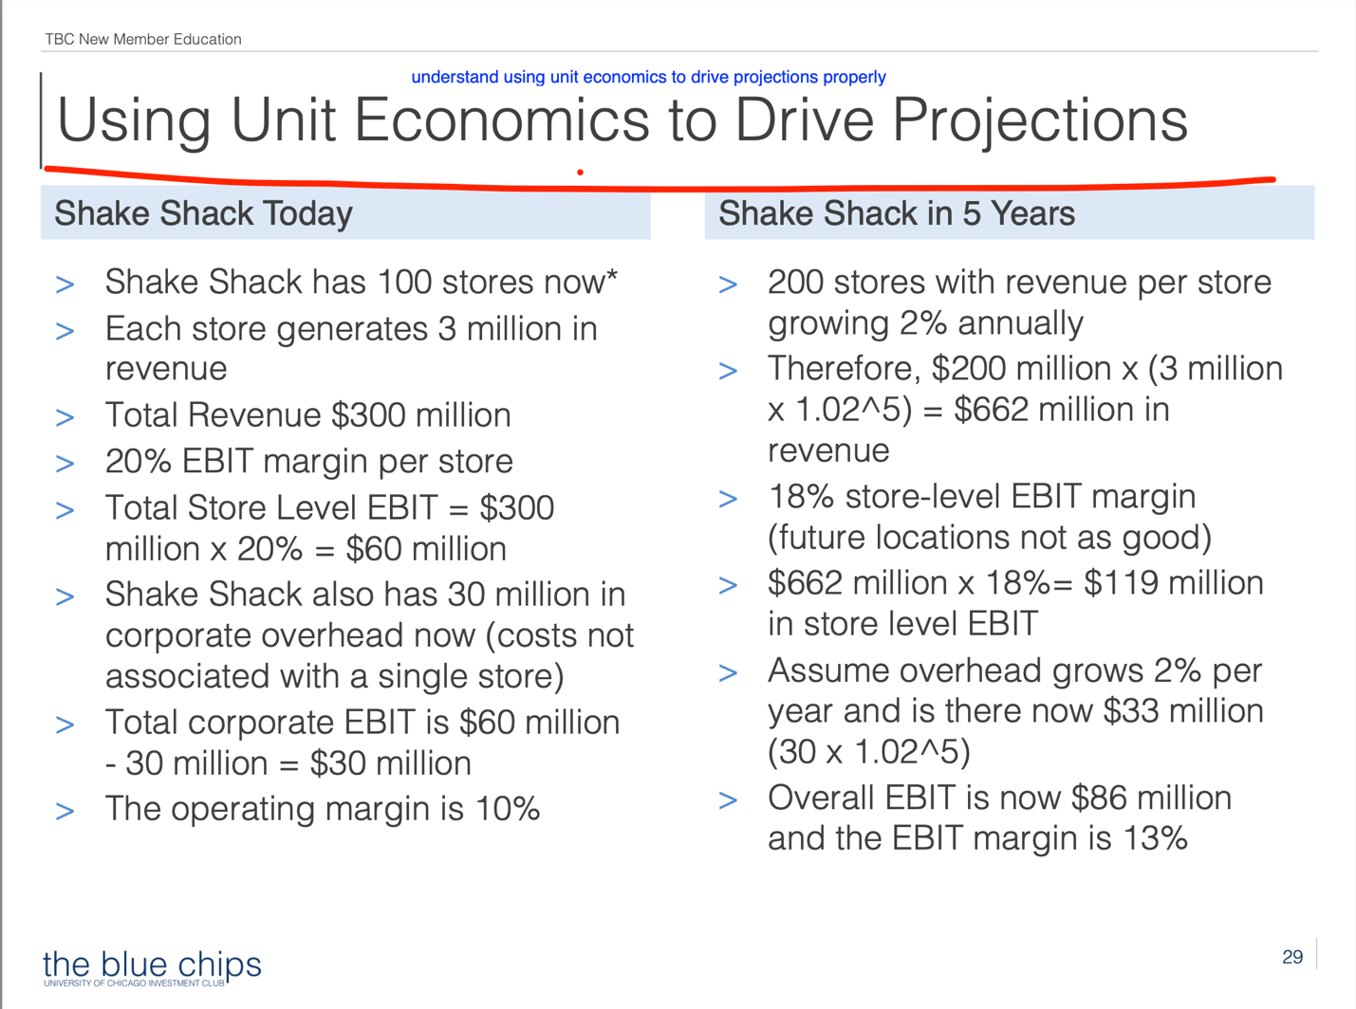
Possible Investment Thesis
- Capital Barriers to Entry
- Glorified Industry Outlook: Deep Tech 101
- Favourable Positioning and Supply/ Demand Dynamics
- Market Mispricing
- Value Add Programs
- Joint Ventures/ De Novo Openings / Sub Verticals in addition to the growth in the other markets
- Recently bought spirit aerosystems
- Demand Trends
- Barriers to Entry and Pure Play Advantages
- COVID Labour Shortage mitigants/ revival- advantage over airbus as well/ suppliers situation
- Management Overhaul/ New CEO, The Old Guard is Out
- Market Sentiment vs Reality
- Long term value: don’t fly boeing right now
- The too big to fail hypothesis/ these fiascos will not dissuade their main buyers (the demand is basically to the moon) : one of the three companies in the dow jones average- considered a dow jones bell weather company essentially
- Think about this: this is a company that everyone needs, it has to survive whether one likes it or not- it has to thrive, because there is no way that any other company can come on and take the role without initially bearing more expenses than Boeing is itself
- The only real risk I see is some sort of quantum leap in flying and aerospace tech in general, something that’s like a once in a millenea thing to displace Boeing. There is no other way that this company can fail
- The bad financials: would be 100x worse for anyone else who would have to do it. This isn’t a consumer business where bad financials translate to shutting down or being defeated, that simply is not the option here so bad financials will translate to management overhaul, cleaning up of the financials, and new outlooks. Which is what is happening.
- Non earning assets : makes it in its entirety a great business that just needs to be run well and cleaned up, for the sake of the the world, the latter has to happen.

TRADING AT AN EXTREMELY EXPENSIVE MULTIPLE BECAUSE THE CURRENT EARNINGS ARE NOT REPRESENTATIVE OF THE EARNINGS POWER.
++ PRICING POWER
++ Reflexivity of price affecting the fundamentals?
++ Catalysts: what is the thing according to me that is going to stop the erosion between the price and the value?
++ The risk price relation- the lower we purchase an asset for the lower the chance of capital loss

- Expansion of Addressable Market followed by + Under Monetized Revenue Streams + A likely driver of Near Term Growth
- Other market expansion potential: India and China
- Market Underappreciates invaluable assets/ subsidiary companies
- AI Wave as a growth driver for new use cases
- Under monetized revenue streams?
- Likely drivers of near term growth?
- Moat: Intangible Assets/ Competitive Advantage in terms of barriers to entry
- Deleveraging
- Unlike Other Aerospace players, presidential election scenarios pose no severe risk (for airbus etc with trade is related, and other defense is related to defense spending budget costs etc)
- Sustained Capital for Reinvestment and Return
- Backlog of orders
- Large Regulatory Barriers
- Additionally, Huge upfront costs and you get paid in the end, who could possibly start this
- No New Entrants in the Short Term
- Underperforming vs undervalued is an important difference to understand
- The fundamentals of this company will make you want to cry, and if you look at this from a very technical standpoint you are honestly going to want to sell instantly, probably short. But there is a reason that no one wants to. - Boeing’s customers are not going anywhere- airbus booked out until then next decade, komac or whatever is Chinese and that opens a whole world of problems.
- The worst case argument that you can make is that this is what the true value of the stock is, it cannot in any way go below this and stabilize.
- The market is focusing on the wrong thing: untapped potential in emerging markets

- Anyone pitching boeing is going to tell you a bunch of things, firstly that they have the most goated moat on the planet, but that in and of itself is not the reason that the market is undervaluing boeing, and rather imo it should be focusing on what this goat moat translates to in terms of what it makes available for everyone.
- The real goat moat
- The old guard that can never leave.
- What the real problem with Boeing is: It is not a safety issue, neither a cash issue, but a manufacturing problem. These are things that get fixed, no new physics.
- The basic business model: fly safe planes?
- Boeing needs to get their shit together and they will get their shit together because they basically have no other option.
- The real goat moat for Boeing imo is their untapped aerospace business- ULA, Dreamliner and everything that comes with it: the fact that they are also involved in the manufacturing of parts directory is imo a huge benefit like the new company that they recently bought.
- This is literally all competitive advantages in one business model
- Its literally EARNINGS POWER VS CURRENT EARNINGS
- Just based on the similarities between the trading for Boeing and Airbus we can see that the former is less valued even tho the avenues that it is open to is so much more than Airbus
- Cyclicality, Operating Leverage, Unit Economics

- What the internship people had to say
Fear : “Be fearful when others are greedy and greedy only when others are fearful.”

Things to check at the end

- America maps
- Sources
- Catalyst; street is mispricing X because of Y. Revenue Build what are the changes that are going to happen.
- Differentiated view, something that other people are not considering

- Add Funny Things
- Logo on every page
- Notes within slides removed

