*Harvest Hub Insights*

**Case Study-**

8. Case Study on Quick Commerce Vegetable Business in Delhi:

* What is the market size and potential for the quick commerce vegetable business in Delhi?
* What landscape for is the competitive quick commerce vegetable business in Delhi?
* What are the key challenges faced by the quick commerce vegetable business in Delhi?
* What are the key success factors for the quick commerce vegetable business in Delhi?
* How can the quick commerce vegetable business in Delhi leverage technology to improve their operations and customer experience?

Case Study: Quick Commerce Vegetable Business in Delhi

**Market Size and Potential:**

The market size for quick commerce vegetable business in Delhi is substantial, driven by the city's large population, busy lifestyle, and increasing demand for convenient and timely delivery of fresh produce.



The potential for growth is high as more consumers are opting for online shopping and quick delivery services, especially for daily essentials like vegetables.

**Competitive Landscape:**

The competitive landscape in Delhi is dynamic, with several players competing for market share. This includes both established e-commerce giants and specialized quick-commerce startups focusing on fresh produce.

1. Market Research Reports: Look for market research reports that focus on the grocery delivery or quick commerce sector in India or specifically in Delhi.

2. Company Websites: Visit the official websites of major quick commerce and grocery delivery companies operating in Delhi.

3. Networking: Connect with professionals in the industry through networking platforms like LinkedIn. Engaging with industry experts and professionals can provide you recommendations.

**Challenges:**

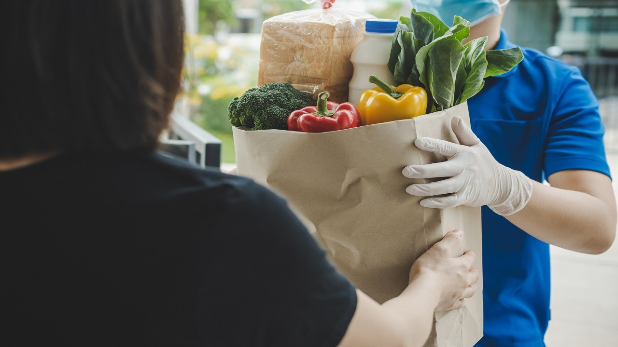

Time Management: Ensuring timely delivery of fresh vegetables without compromising quality is a significant challenge.

Quality Control: Maintaining the freshness and quality of vegetables during storage.

Customer Trust: Building and maintaining trust in the quality of the produce and reliability of delivery services.

Regulatory Compliance: Adhering to health and safety regulations related to food handling and delivery.

**Key Success Factors:**

Efficient Logistics: Establishing a strong and healthy supply chain to ensure quick and reliable delivery.

Quality Assurance: Implementing stringent quality control measures to guarantee fresh and high-quality vegetables.

Customer Engagement: Building strong customer relationships through excellent customer service and personalized experiences.



Partnerships: Collaborating with local farmers and suppliers to ensure a consistent and diverse supply of fresh produce.

**Leveraging Technology:**

Mobile Apps and Websites: User-friendly platforms for easy ordering and tracking of deliveries.

Data Analytics: Utilizing data analytics to understand customer preferences, optimize inventory, and enhance overall operations.

IoT Devices: Using sensors and IoT devices for real-time monitoring of storage conditions to ensure freshness.

Digital Payments: Convenient digital payment options for a seamless transaction experience.

In conclusion, the quick commerce vegetable business in Delhi holds significant potential but faces challenges related to logistics, quality control, and customer trust. Success in this market requires a focus on efficient operations, quality assurance, customer engagement, innovation, and leveraging technology to enhance the overall customer experience.