# **Introduction**

Blockchain has emerged as a transformative force in various industries, spanning from healthcare, finance, agriculture to supply chain management. Blockchain as a dynamic tool solves the security bottlenecks arising/emanating from centralization storage and management by third-party applications as well as cloud servers. Blockchain as a dynamic tool solves the subsisting security bottlenecks in current systems. Therefore, it is a trustworthy system that promotes in a distributed environment such that two parties are not allowed to communicate without validating the transactions. Prior, to the emergence of blockchain / Before the existence of blockchain/ Before blockchain existence, several systems commonly depended on third party application and cloud servers for data storage and management. Additionally, blockchain promises to provide security to user’s data. For instance, in a traditional banking institution, the bank operates via a central office that uses a single centralization authority mechanism to run the banking operations. Thus, all financial transactions such as account opening, customer data management and other similar operations are all controlled by this central authority. Such approach constitutes several delimiting factors such as lack of transparency, system failure, inefficiency and privacy and security concerns. We span across the above raised issues into the following points.

1. System failure: The dependence on the central bank for system operations can lead to single point of failure if the central authority’s system becomes compromised.
2. Lack of transparency: Banking customers have limited to no visibility of the banking operations or how the transactions are processed. Moreover, they have no idea how their banking information and personalized credentials are handled or kept discrete from third party sources.
3. Security breaches and Data compromise: Banking institutions process large customer data. Unauthorized access to the banking files can cause significant privacy and security breachers
4. Inefficiency: Centralized systems can be inefficient, leading to delays in transaction processing, high operational costs, and slow response times to customer needs. The problems involved with centralization makes blockchain a viable solution to centralized systems. The blockchain narrative has become appealing to many systems due to the possession of several characteristics like decentralization, tamper resistance, immutability and freshness. As a decentralized medium, data is stored in blocks and kept in several dispersed nodes that are distributed across the entire network. The data block is appended ledger that qualifies it to be tamper resistant such that data recorded on the block cannot be altered or modified. The timestamp appended to each block ensures the freshness of each data as they arrive to the blocks according to Figure.1

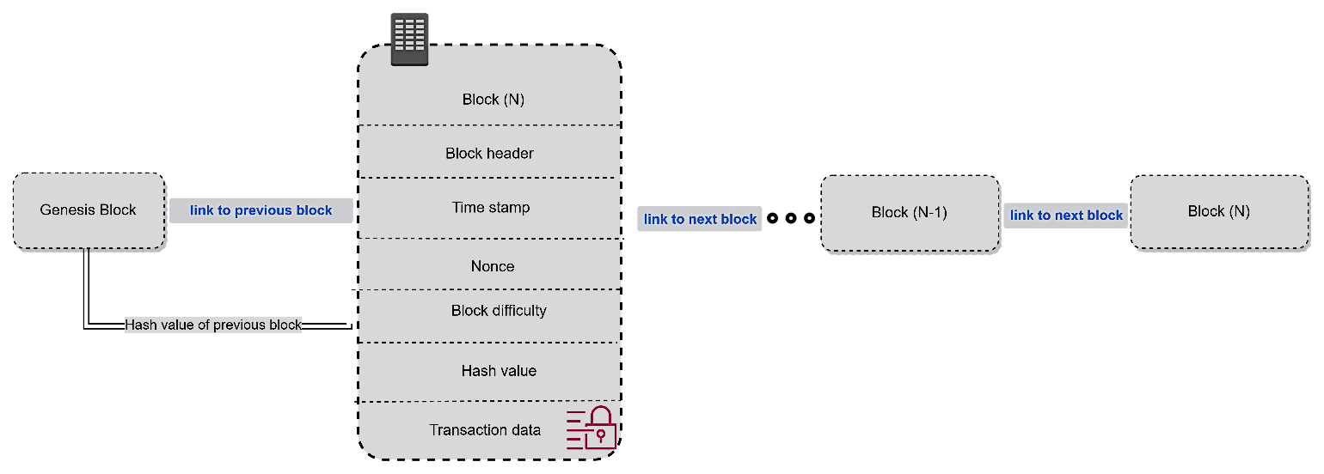

Figure 1. Structure of Block diagram of a blockchain

Blockchain sharding is a technique to scale up the performance of a distributed ledger system by dividing the network into smaller partitions, called shards, that can process transactions in parallel. However, sharding also introduces some challenges, such as:

- How to ensure the security and consistency of the whole system when each shard only has a fraction of the nodes and the data?

- How to coordinate the communication and synchronization among different shards without creating too much overhead or latency?

- How to handle cross-shard transactions that involve multiple shards and require atomicity and isolation guarantees?

- How to balance the workload and resources among different shards to avoid bottlenecks or hotspots?

These are some of the open problems that blockchain sharding faces and that researchers and developers are trying to solve.

thanks for your interests in our research lab. i have reviewed your cv, and to be frank, one of the current issues is the lack of publications in high-level conferences or journals. Especially, there are no publications in A-class journals or conferences recommended by the China Computer Federation (CCF), which is a significant drawback. However, we have taken into consideration the development of the team and how your research background aligns well. Therefore, if you could provide a detailed research plan for the postdoctoral stage, including scientific problems existing in the blockchain field and how to address them, it would greatly enhance your application.