Software Requirements Specification

For

Secure Chat Application

06.03.2025

Prepared by

|  |  |  |
| --- | --- | --- |
| Specialization | SAP ID | Name |
| B.Tech CSE-CSF | 500106290 | Aadeesh Jain |
| B.Tech CSE-CSF | 500105717 | Abhinav Saini |
| B.Tech CSE-CSF | 500106838 | Aman Anand |
| B.Tech CSE-CSF | 500107436 | Deepanshu Chowdhury |



School Of Computer Science

UNIVERSITY OF PETROLEUM & ENERGY STUDIES,

DEHRADUN- 248007. Uttarakhand

Table of Contents

|  |  |  |
| --- | --- | --- |
| Topic | | Page No |
| Table of Content | | 2 |
| Revision History | | 3 |
| 1 | Introduction | 4 |
|  | 1.1 Purpose of the Project | 4 |
|  | 1.2 Target Beneficiary | 4 |
|  | 1.3 Project Scope | 4 |
|  | 1.4 References | 4 |
| 2 | Project Description | 4 |
|  | 2.1 Reference Algorithm | 4 |
|  | 2.2 Data/ Data structure | 5 |
|  | 2.3 SWOT Analysis | 5 |
|  | 2.4 Project Features | 6 |
|  | 2.5 User Classes and Characteristics | 6 |
|  | 2.6 Design and Implementation Constraints | 6 |
|  | 2.7 Assumption and Dependencies | 6 |
|  | 2.8 Design Diagrams | 7 |
| 3 | System Requirements | 13 |
|  | 3.1 User Interface | 13 |
|  | 3.2 Software Interface | 13 |
|  | 3.3 Database Interface | 13 |
|  | 3.4 Protocols | 13 |
| 4 | Non-functional Requirements | 13 |
|  | 4.1 Performance requirements | 13 |
|  | 4.2 Security requirements | 14 |
|  | 4.3 Software Quality Attributes | 14 |
| 5 | Other Requirements | 14 |
| Appendix A: Glossary | | 15 |
| Appendix B: Analysis Model | | 15 |
| Appendix C: Issues List | | 15 |

Revision History

|  |  |  |  |
| --- | --- | --- | --- |
| Date | Change | Reason for Changes | Mentor Signature |
|  |  |  |  |
|  |  |  |  |
|  |  |  |  |
|  |  |  |  |

1. INTRODUCTION
   1. Purpose of the Project

This project aims to develop a secure chat application utilizing AES encryption to ensure reliable and encrypted communication between users. The primary problem addressed is the need for secure real-time communication that safeguards the confidentiality and integrity of messages while ensuring reliable delivery.

* 1. Target Beneficiary

The project is aimed at organizations, individuals, and groups seeking secure communication channels to protect sensitive conversations from unauthorized access, whether for personal use, or business applications.

* 1. Project Scope

The encrypted chat application will enable users to send messages securely by encrypting the content using AES. It will include user-friendly features like chat history, user authentication, and secure storage of messages and encryption keys. The project deliverables include the encrypted chat system, system documentation, user manuals, and testing reports.

* 1. References :

Developing a Real-Time Secure Chat Application:

* + This article discusses the development of a secure chat application similar to WhatsApp and Signal. It covers end-to-end encryption, security protocols, and more:
  + [Developing a Real-Time Secure Chat Application like WhatsApp w& Signal](https://www.qed42.com/insights/developing-a-real-time-secure-chat-application-like-whatsapp-signal-with-end-to-end-encryption)

1. PROJECT DESCRIPTION

2.1 Reference Algorithm

- AES Encryption Algorithm: This is used for encrypting and decrypting the messages

exchanged between users.

2.2 Data/Data Structures

The application will use a combination of data structures:

* HashMap: For storing user credentials and session data securely.
* Encrypted Message Structure: Data structure for holding encrypted messages and corresponding metadata (sender, receiver, timestamp).
  1. SWOT Analysis

Strength:

-Secure messaging platforms prioritize data protection and privacy.

- End-to-End Encryption (E2EE): Ensures that only authorized parties can read messages.

- Standardization: Adherence to industry standards enhances interoperability.

Weaknesses:

-Complexity: Implementing robust security features can lead to complexityin code and system architecture.

-Key Management: Proper key management is essential for E2EE but can be challenging.

-Performance Overhead: Strong encryption may impact performance, especially on resource-constrained devices.

Opportunities:

-User Trust: Platforms that prioritize security gain user trust and loyalty.

-Market Demand: Growing awareness of privacy concerns drives demand for secure messaging.

-Innovation: Opportunities exist for novel features, integrations, and user experiences.

Threats:

-Emerging Algorithms: As encryption algorithms evolve, platforms must stay updated to maintain security.

-Implementation Flaws: Vulnerabilities in code or configuration can compromise security.

-Regulatory Challenges: Compliance with data protection laws and regulations poses challenges.

* 1. Project Features

- End-to-end encryption using AES.

- Multi-device access with synchronized encrypted chat data.

* 1. User Classes and Characteristics

- General Users: Individuals using the app for personal communication.

- Enterprise Users: Employees or businesses requiring secure channels for business related communication.

* 1. Design and Implementation Constraints

- Memory and processing power requirements for AES encryption

- Integration with multiple platforms.

- Data transfer rate and communication latency constraints.

* 1. Assumption and Dependencies

- Assumes proper AES key management and secure storage of user credentials.

USE-Case:

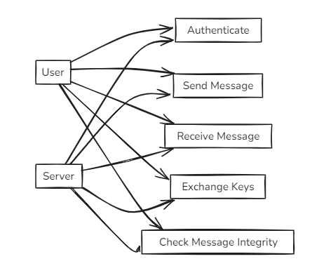

Class Diagram:

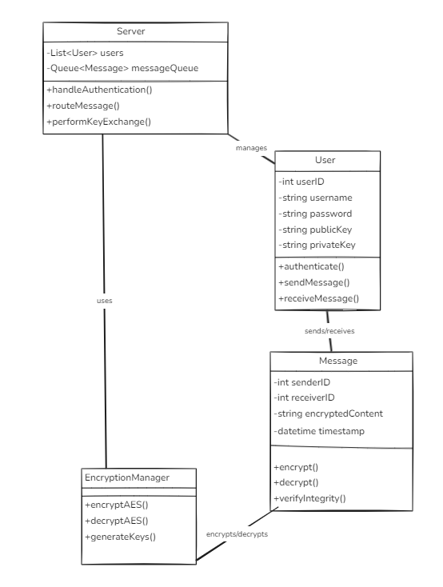

Activity:

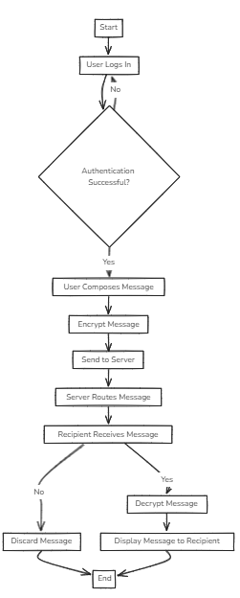

Sequence:

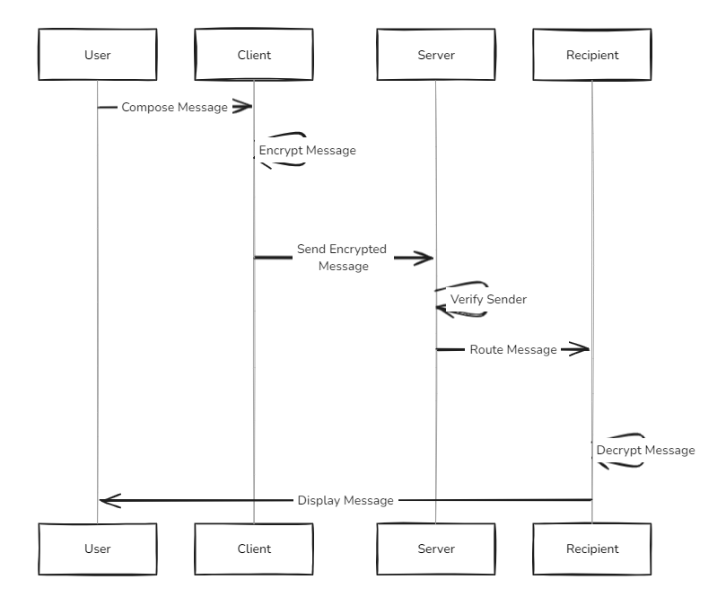

Data Flow diagram

State Diagram.

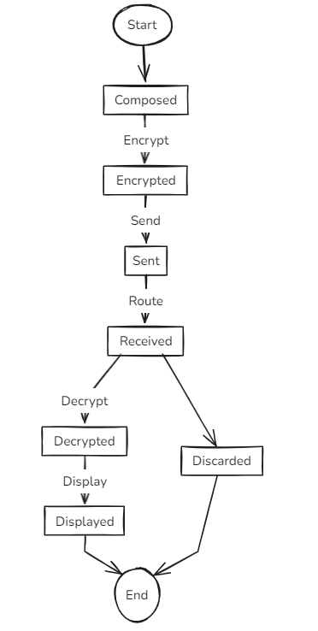

1. SYSTEM REQUIREMENTS

3.1 User Interface

* Chat Window: A window where users can send and receive messages in real-time.
* User Options:
  + Login functionality for secure access.
  + Chat history management, allowing users to view past conversations (encrypted).

3.2 Software Interface

* Encryption Module: Provides AES encryption and decryption functionality for ensuring secure message transmission.

3.3 Database Interface

* Database:
  + Stores user credentials (hashed for security), encryption keys, and chat history (encrypted to maintain confidentiality).

3.4 Protocols

* AES (Advanced Encryption Standard): For encryption and decryption of messages, ensuring confidentiality and data integrity.

4. NON-FUNCTIONAL REQUIREMENTS

4.1 Performance Requirements

* The system must handle multiple concurrent users without degrading performance.
* Messages should be delivered within 2 seconds to ensure real-time communication.

4.2 Security Requirements

* AES Encryption: All messages must be securely encrypted before transmission and decrypted upon receipt.
* Authentication: User authentication mechanisms (such as username and password, or two-factor authentication) must be implemented to ensure that only authorized users can access the system.
* Data Integrity:
  + Implement mechanisms like message digests or checksums to detect tampering or corruption of messages during transit.

4.3 Software Quality Attributes

* Reliability:
  + The system must ensure reliable message delivery, with no loss of data, even during network interruptions.
* Maintainability:
  + The system should be designed in a modular way to allow easy updates (such as adopting new encryption algorithms or protocols).
* Usability:
  + The user interface should be designed to be simple and intuitive, even for non-technical users. Features like tooltips, error messages, and easy navigation should be included.

5.OTHER REQUIREMENTS

-External Integrations:

* Support for integrating cloud services to enable seamless file storage and sharing directly from cloud storage providers like Google Drive or Dropbox.
* Future plans include integration with authentication services (e.g., OAuth) for user identity management.

Appendix A: Glossary

* AES: Advanced Encryption Standard, a symmetric encryption algorithm widely used for securing data.
* Encryption: The process of converting plain text into a secure format to prevent unauthorized access.

Appendix B: Analysis Model

* This section can include diagrams such as Data Flow Diagrams (DFD), Activity Diagrams, or Sequence Diagrams that will help validate the design and functionality of the system.

Appendix C: Issues List

* Keep track of open issues or unresolved requirements, such as:
  + Potential performance bottlenecks when scaling the application.
  + Future updates to encryption algorithms or protocols.
  + Possible user interface enhancements (e.g., dark mode, accessibility features).