Clustering Analysis — Customer Segment Interpretations
Customer Churn Analysis for Telecommunications Company
Prepared by: Adesh Kumar | Role: Data Analyst (Clustering) | Date: 13 September 2026

Overview
Using the K-Means clustering algorithm, 6,741 telecommunications customers were segmented into 4 distinct groups based on 12 behavioural and demographic features (tenure, monthly charges, contract type, internet service, dependents, senior citizen status, and phone usage). The optimal number of clusters was determined using the Elbow Method: inertia decreases sharply up to k=4 and then flattens, marking k=4 as the point of diminishing returns. A Silhouette Score analysis was run alongside as a cross-check — it peaks at k=2 (a coarse, less informative split) before settling around 0.17 for k≥4, confirming that k=4 offers the best balance between statistical separation and business interpretability. Each resulting cluster represents a distinct customer profile with different behaviours, characteristics, and churn risk levels.

Cluster 3 — "At-Risk New High-Spend Customers" (2,146 customers) ⚠ URGENT
This is the most critical cluster and the largest segment in the customer base, requiring urgent attention. These customers have short tenure yet pay above-average monthly charges, and they carry the highest proportion of senior citizens of any cluster. Despite representing under two years' average relationship with the company, this group has a churn rate of 48.8% — nearly half of these customers are leaving.
Key Characteristics:
- Short tenure — well below the customer-base average
- Above-average monthly charges despite the short relationship
- Highest Senior Citizen share of any cluster — 24.3%
- Lowest share with dependents — 18.1% — mostly individual customers
- Churn Rate: 48.8% — HIGHEST of all clusters ⚠
- 2,146 customers — 31.8% of total customer base — the single largest segment
Business Insight:
This group is the company's biggest churn problem, combining both the highest churn rate and the largest customer count — meaning it drives the majority of lost revenue. The company should urgently introduce senior-specific pricing plans, dedicated onboarding and support for new customers, and proactive retention outreach targeting this segment before contracts lapse.

Cluster 0 — "New, Budget-Conscious Customers" (1,589 customers)
This cluster represents newer customers who pay the lowest monthly charges of any group. They have short average tenure and a fairly even mix of contract types, including a large month-to-month share. With a churn rate of 24.8%, this group carries moderate risk typical of customers still early in their relationship with the company.
Key Characteristics:
- Short tenure — below the customer-base average
- Lowest monthly charges of all clusters
- Low Senior Citizen share — 7.2%
- Mixed contract types — about half (50.8%) on month-to-month plans
- Churn Rate: 24.8% — moderate risk
- 1,589 customers — 23.6% of total customer base
Business Insight:
These customers are price-sensitive and still forming loyalty. The company should focus on onboarding experience, early engagement, and incentives to move them onto longer contracts before month-to-month plans expire.

Cluster 2 — "High-Value Established Customers" (1,882 customers)
This cluster has the second-lowest churn rate at 15.7%, reflecting a stable, established customer base. Customers here have the longest average tenure of any cluster and pay the highest monthly charges, alongside the highest proportion of senior citizens. Virtually all customers in this group have phone service.
Key Characteristics:
- Longest average tenure of all clusters
- Highest monthly charges of all clusters
- Highest Senior Citizen share — 21.7%
- Nearly universal phone service — 99.7%
- Churn Rate: 15.7% — low–moderate risk
- 1,882 customers — 27.9% of total customer base
Business Insight:
This is a valuable, long-standing segment that the company should protect. Maintaining service quality and offering loyalty or senior-specific perks will help sustain this group's low churn and high revenue contribution.

Cluster 1 — "Loyal Long-Tenure Customers" (1,124 customers)
This cluster has the lowest churn rate of all groups at just 4.8%, making them by far the most loyal segment. Customers here have long tenure, pay below-average monthly charges, and have the highest share of customers with dependents — suggesting a stable, family-oriented customer profile.
Key Characteristics:
- Most loyal group — lowest churn rate of 4.8%
- Long average tenure — well above the customer-base average
- Below-average monthly charges
- Highest share with dependents — 44.8%
- Churn Rate: 4.8% — LOWEST of all clusters
- 1,124 customers — 16.7% of total customer base
Business Insight:
The company should reward this group with loyalty programs and family bundle plans to maintain their satisfaction. This segment represents the most stable, reliable source of long-term revenue and requires the least intervention.

Key Findings Summary
Cluster | Label | Customers | Churn Rate | Priority
Cluster 3 | At-Risk New High-Spend Customers | 2,146 (31.8%) | 48.8% | Urgent
Cluster 0 | New, Budget-Conscious Customers | 1,589 (23.6%) | 24.8% | Medium
Cluster 2 | High-Value Established Customers | 1,882 (27.9%) | 15.7% | Low–Medium
Cluster 1 | Loyal Long-Tenure Customers | 1,124 (16.7%) | 4.8% | Low

Main Recommendation
The most critical finding from this clustering analysis is that Cluster 3 — At-Risk New High-Spend Customers — is both the largest segment (31.8% of the customer base) and has by far the highest churn rate at 48.8%, more than ten times the rate of Cluster 1 (4.8%). This combination of scale and risk means the company is losing a substantial share of its customer base and associated revenue from this single group.
Recommended Actions:
- Launch proactive retention campaigns targeting Cluster 3 customers as the top priority
- Introduce senior-specific pricing plans and dedicated support, given the high senior share in Clusters 2 and 3
- Improve onboarding and early-tenure engagement for Cluster 0 and Cluster 3 to build loyalty sooner
- Offer long-term contract incentives and discounts to shift customers off month-to-month plans
- Maintain service quality for Clusters 1 and 2 to sustain their already-low churn
- Provide loyalty and family bundle offers to reinforce retention in Cluster 1
— End of Clustering Analysis Report —

Cluster Analysis Visualisations

Figure 1: Elbow Method & Silhouette Score — Determining the Optimal Number of Clusters
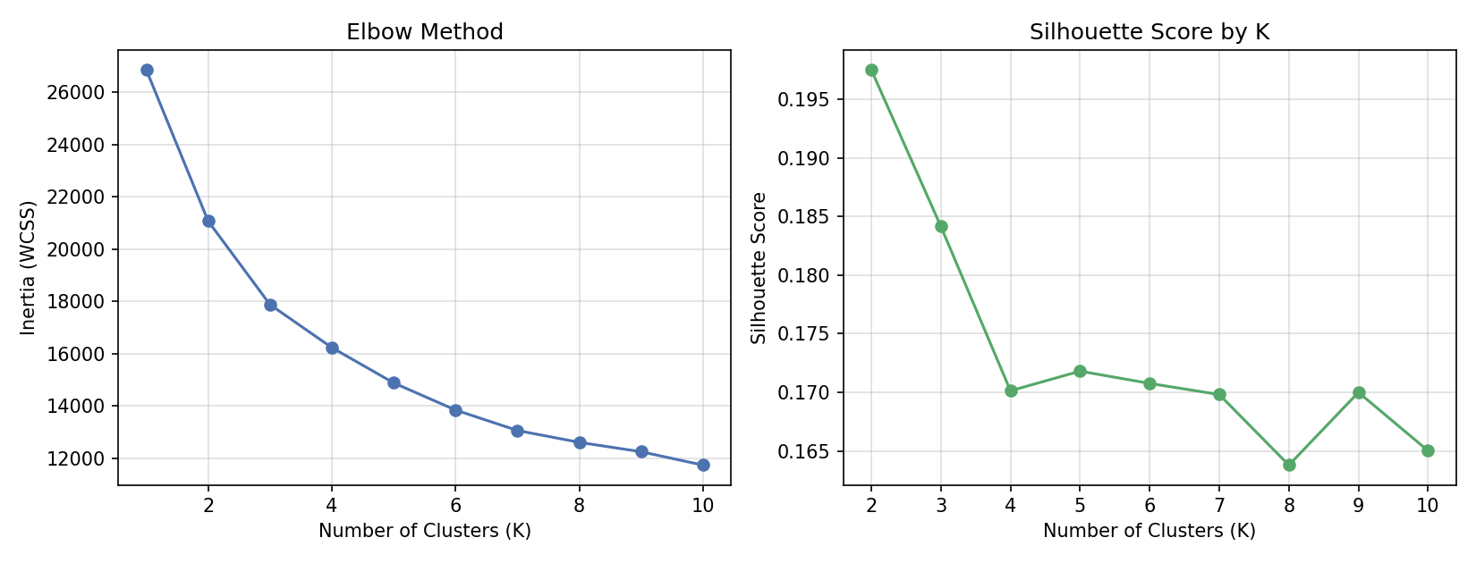
The left chart shows WCSS (inertia) declining steadily and flattening after k=4. The right chart shows the Silhouette Score, which peaks at k=2 but stabilises around 0.17 from k=4 onward — supporting 4 as the optimal, most interpretable number of customer segments.

Figure 2: Customer Segments — PCA Projection
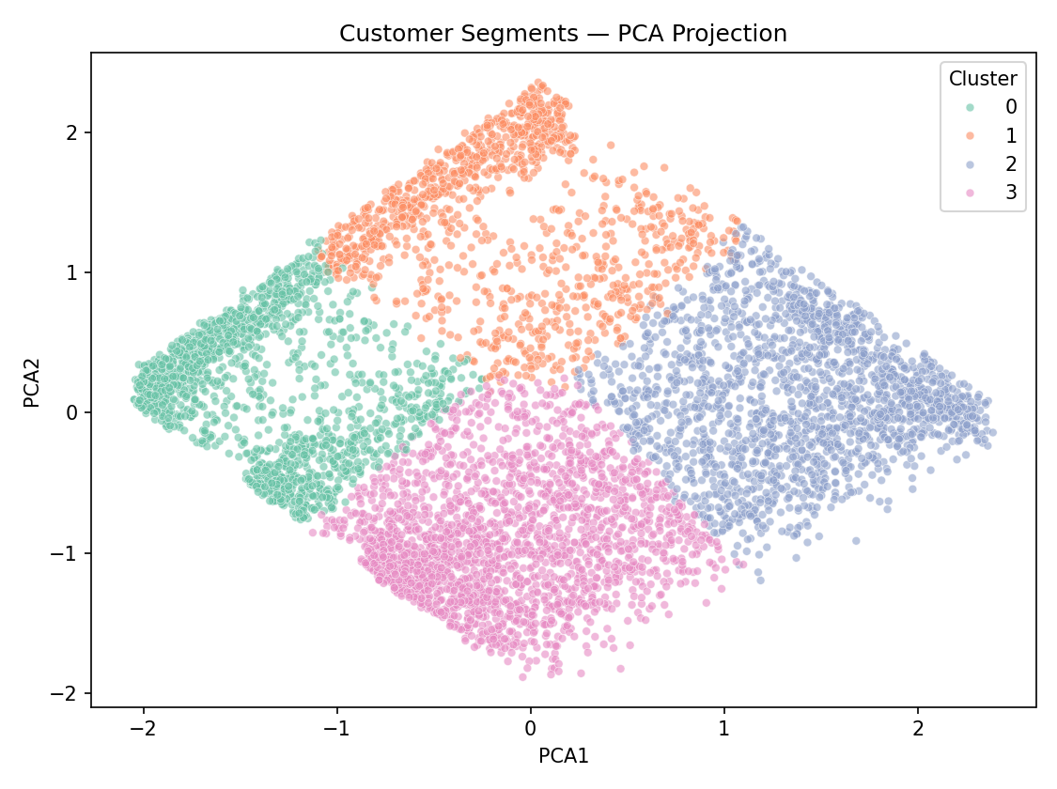
All 6,741 customers grouped into 4 distinct clusters, projected into 2 dimensions using PCA (49.8% of variance explained). Each colour represents a different customer segment based on behavioural features (tenure, charges, senior status, dependents, and service usage).

Figure 3: Churn Rate by Cluster
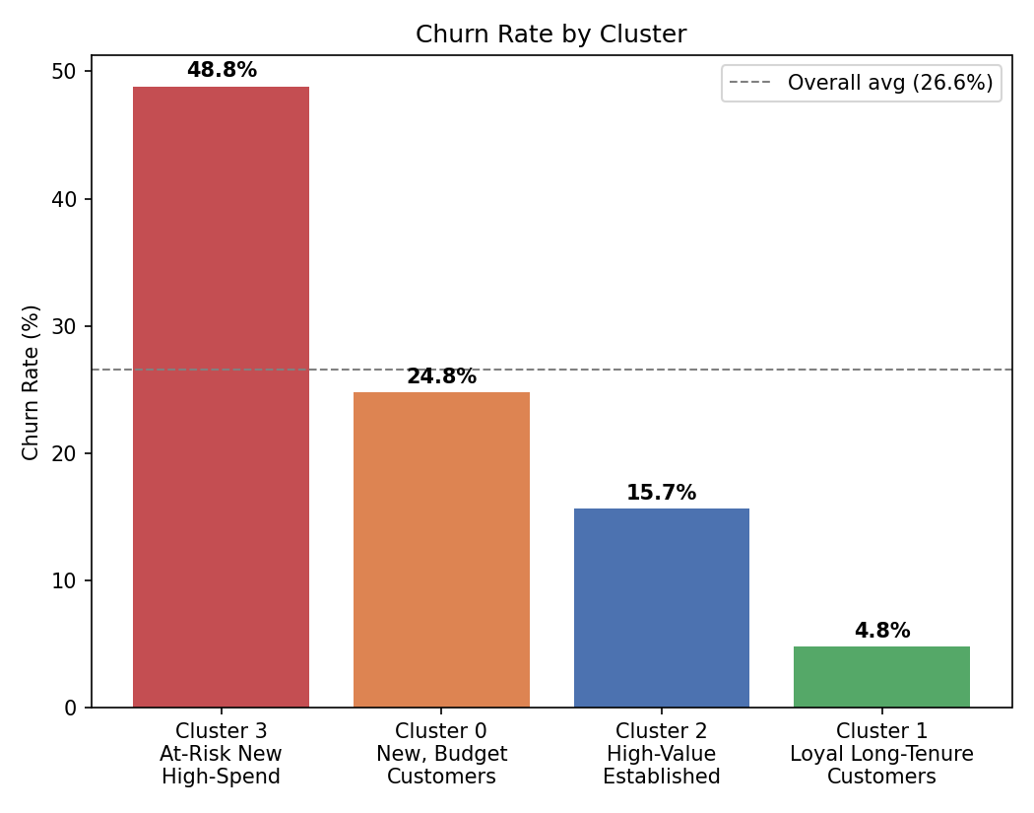
Cluster 3 (At-Risk New High-Spend Customers) stands out sharply with a 48.8% churn rate, compared to just 4.8% for Cluster 1 (Loyal Long-Tenure Customers) — the clearest actionable signal in this analysis.
— End of Clustering Analysis Report —

