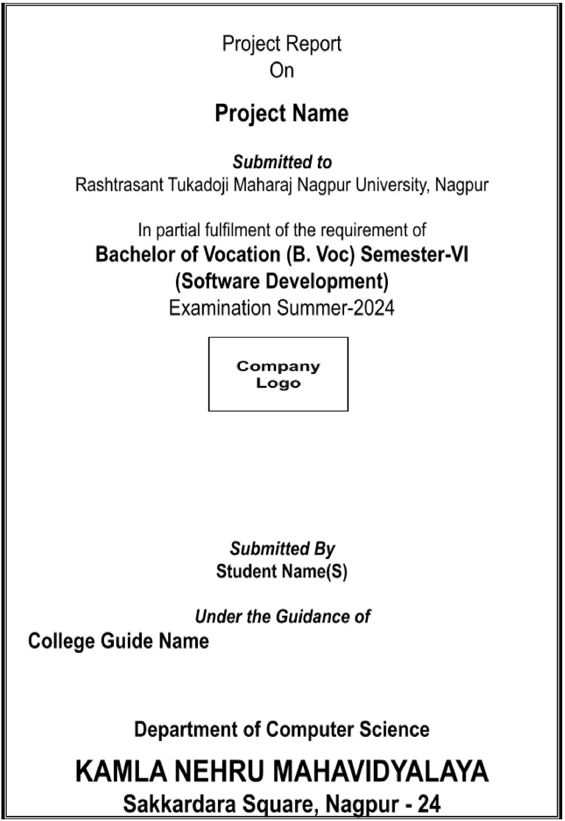

ICE Computers

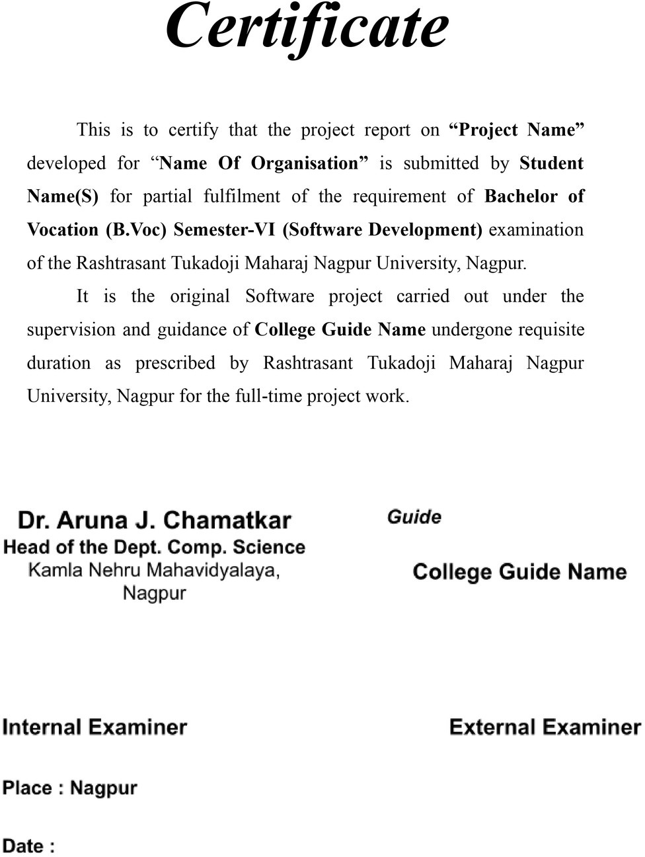



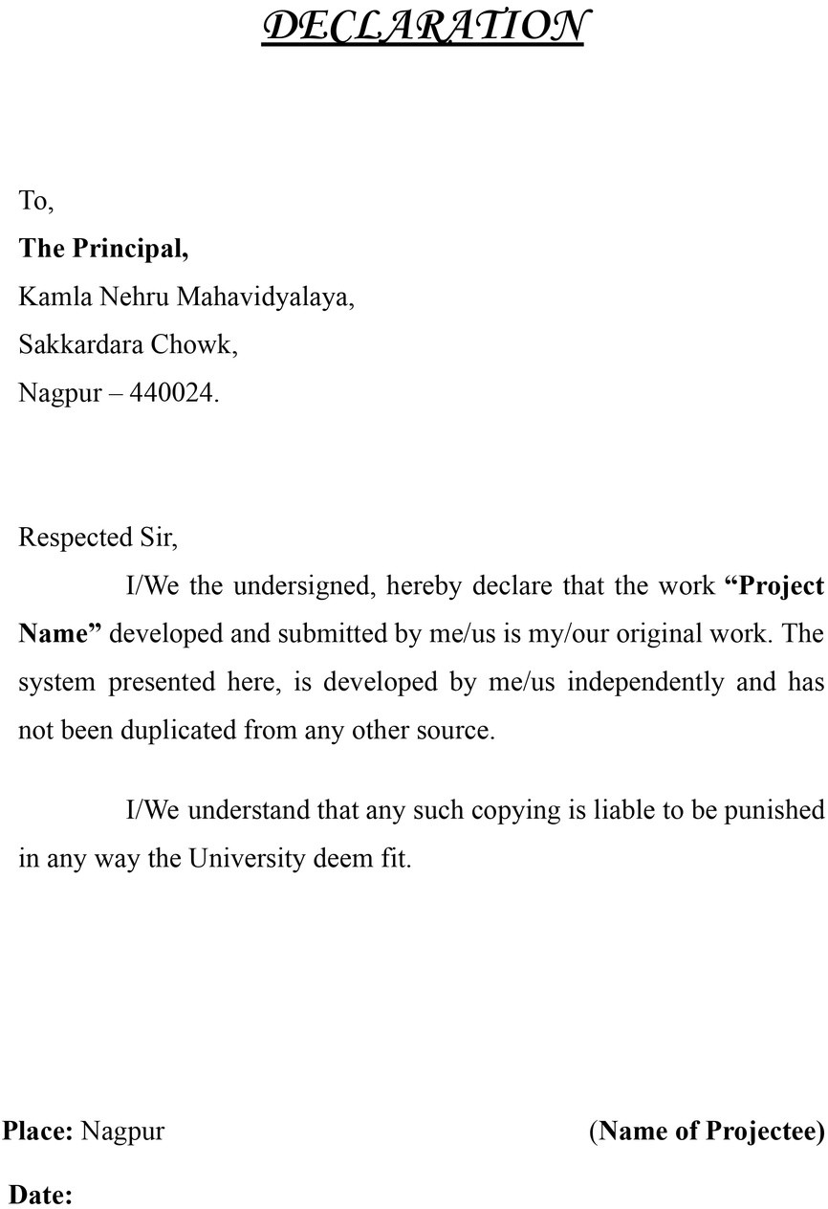

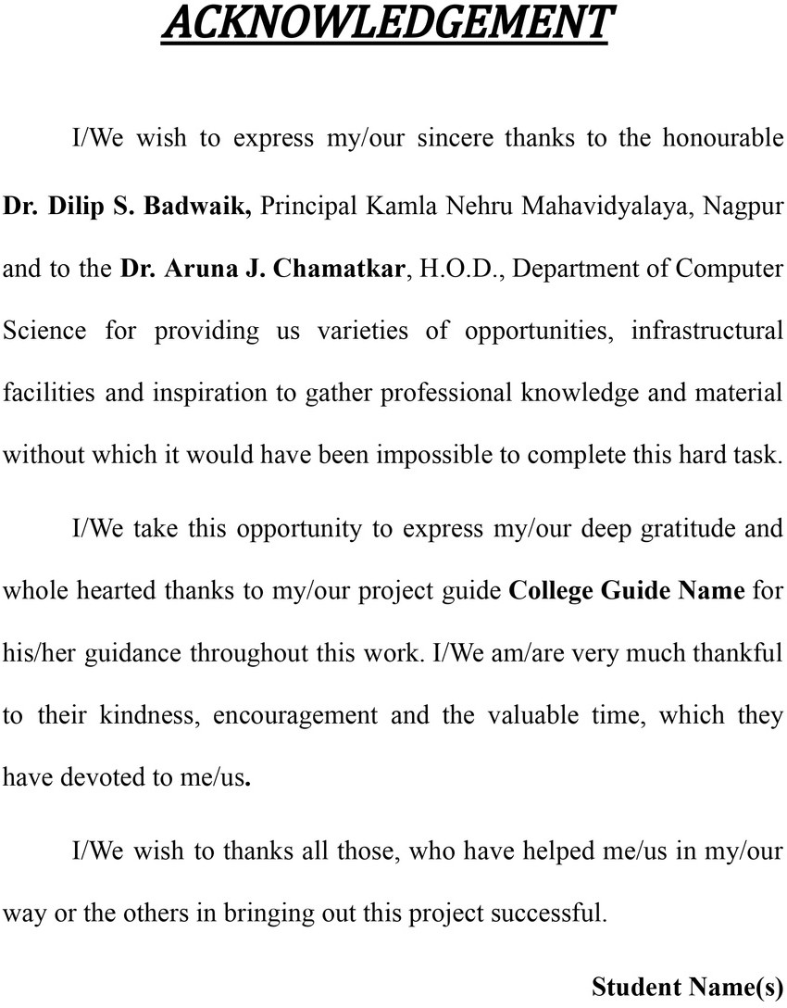

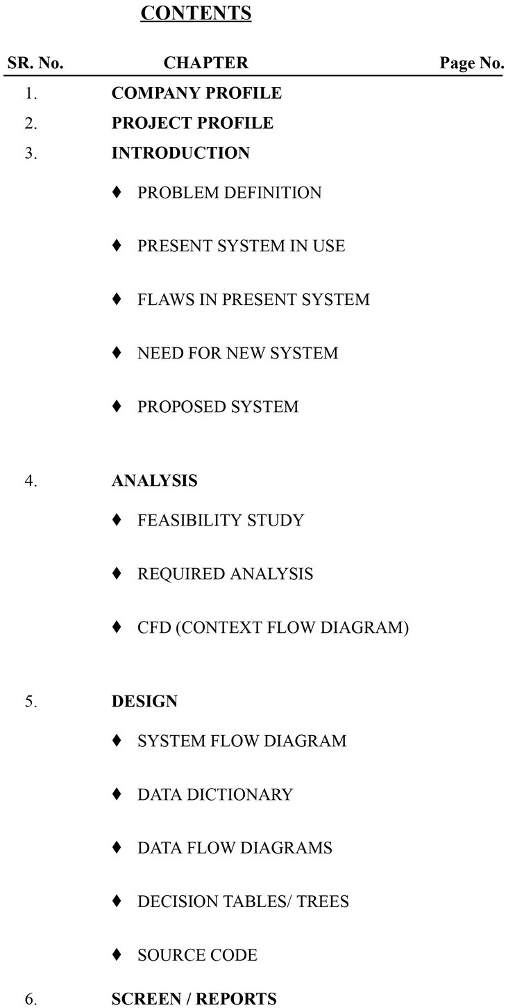

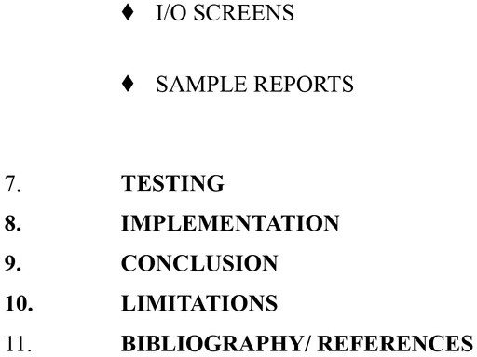



# Chapter 1 : Compony Profile

## Introduction:

Sampurv Technologies is a leading software and web development company that specializes in providing innovative solutions to businesses and individuals. With a strong focus on quality, innovation, and customer satisfaction, Sampurv Technologies has established itself as a trusted partner for clients seeking cutting-edge technology solutions.

## Services Offered:

Sampurv Technologies offers a comprehensive range of services to meet the diverse needs of its clients. These services include:

1. **Software Development:** Sampurv Technologies provides custom software development services tailored to meet the specific requirements of its clients. The company's team of experienced developers uses the latest technologies and best practices to deliver high-quality software solutions that drive business growth.
2. **Web Development:** Sampurv Technologies specializes in creating visually appealing and highly functional websites that engage users and deliver a seamless browsing experience. The company offers a range of web development services, including responsive web design, e- commerce solutions, and content management systems.
3. **Training Services:** Sampurv Technologies offers training programs designed to equip individuals with the skills needed to succeed in the digital age. These training programs cover a wide range of topics, including programming languages, web development frameworks, and software development methodologies.

## Vision and Mission:

Sampurv Technologies' vision is to revolutionize the digital landscape by providing innovative technology solutions that empower businesses and individuals. The company's mission is to deliver high-quality, cost-effective services that exceed customer expectations and drive business success.

## Core Values:

Sampurv Technologies is guided by the following core values:

1. **Innovation:** The company is committed to innovation, constantly exploring new ideas and technologies to deliver cutting-edge solutions to its clients.
2. **Integrity:** Sampurv Technologies operates with the highest standards of integrity, ensuring transparency and honesty in all its dealings.
3. **Excellence:** The company is dedicated to excellence in everything it does, striving to deliver the highest quality services to its clients.

# Chapter 2 : Project Profile

## Introduction:

The ICE Computers website is a static online platform designed to showcase the courses and services offered by ICE Computers, an offline computer institute located in Nagpur, India. The website serves as an informational hub for prospective students and provides details about the programming courses available at ICE Computers.

## Project Objectives:

The primary objectives of the ICE Computers website project are as follows:

1. **Course Information:** Provide detailed information about the programming courses offered by ICE Computers, including course descriptions, schedules, and fees.
2. **Contact Information:** Display contact details for ICE Computers, including address, phone number, and email, to allow prospective students to get in touch easily.
3. **Institute Overview:** Provide an overview of ICE Computers, including its history, mission, and values, to give prospective students a better understanding of the institute.

## Key Features:

The ICE Computers website project includes the following key features:

1. **Course Catalog:** A catalog of programming courses offered by ICE Computers, including detailed course descriptions and schedules.
2. **Contact Form:** A contact form that allows prospective students to send inquiries directly to ICE Computers.
3. **Interactive Map:** An interactive map that displays the location of ICE Computers' institute, making it easier for prospective students to find.
4. **Testimonials:** Testimonials from past students, highlighting their experiences at ICE Computers and the impact it had on their careers.

## Technology Stack:

The ICE Computers website is built using HTML, CSS, and JavaScript. The website is hosted on a web server.