**‘My Medical Secretary’**

**Mobile Application**

**Business Plan**

Prepared By: Susan Pickering

**Table of Contents**

**1. Business Plan 3**

**1.1 Business Overview 3**

**1.2 Product/Service Features/Production 5**

**1.3 Market Analysis 8**

**1.4 Market Strategy 10**

**1.5 Key Financial Objectives 12**

**1.6 Business Structure 13**

**1.7 Management & Ownership 14**

**1.8 Key Objectives 15**

**1.9 The Competitor 16**

**2. Financial plan 17**

**2.1 Key Objectives and Financial Review 17**

**2.2 Establishment Costs 18**

**2.3 Profit and Loss 19**

**2.4 Cash Flow 20**

**2.5 Balance Sheet 21**

**2.6 Breakdown of Costs 22**

**3. Supporting Documentation 23**

**4. Action Plan 24**

**5. References……………………………………………...………………………25**

1. **Business Summary**
   1. **Business Overview**

‘My Medical Secretary’ (MMS) is a mobile application designed for iOS, android and tablet users. It is being designed for patients who have been diagnosed with a serious illness, such as Cancer, and help them organise and understand all of the information and appointments surrounding their diagnosis, which, in return, will reduce patient confusion and queries.

The app is also being designed for medical clinics to enable them to present clear and concise information to their patients and their families in an efficient and effective manner. It is designed to help clinics reduce the increasing costs of running a business by reducing expenses such as, SMS credits, printing, paperwork and postage and increase the efficiency of the business.

Victoria has a range of healthcare services available to patients:

* Local General Practitioners (GPs), for non-emergency and preventative care during business hours.
* Specialist Doctors
* 24-hour telephone service – Nurse on Call for immediate advice from a registered nurse, 24 hours a day, 7 days a week.
* Private and public hospitals, for in-patient hospital care and follow-up outpatient services.

The healthcare system in Australia can be a confusing one for many people. People are often confused about what their private health fund will and won’t cover, what is covered by Medicare, why they need a referral, what is considered inpatient and outpatient services and so on. A lot of working on the frontline, in the health sector, is helping patients to understand how the system and processes work.

There are many illnesses and diseases that affect Australian’s. One such illness is Cancer. Cancer is the second-most common cause of death in Australia, after cardiovascular disease. According to the Cancer Council of Australia -

* An estimated 145,000 new cases of cancer will be diagnosed in Australia this year, with that number set to rise to 150,000 by 2020.
* 1 in 2 Australian men and 1 in 3 Australian women will be diagnosed with cancer by the age of 85.
* An estimated 50,000 people died from cancer in 2019. Cancer accounted for about 3 in 10 deaths in Australia.
* Around 25,000 more people die each year compared to 1982, this is due mainly to population growth and aging.  However, the death rate (number of deaths per 100,000 people) has fallen by more than 24%.
* The survival rate in the 1980’s was 50%. Now almost 7 out of 10 Australians survive at least 5 years after their diagnosis and in some cases it’s as high as 90%.
* The most common cancers in Australia (excluding non-melanoma skin cancer) are prostate, breast, [colorectal (bowel)](http://www.cancer.org.au/about-cancer/types-of-cancer/bowel-cancer.html), [melanoma](http://www.cancer.org.au/about-cancer/types-of-cancer/skin-cancer/melanoma.html) and [lung cancer.](http://www.cancer.org.au/about-cancer/types-of-cancer/lung-cancer.html) These five cancers account for over 60% of all cancers diagnosed in Australia
* Cancer costs more than $4.5 billion in direct health system costs (6.9%).
* In 2016 – 2018, $252 million in funding was provided for cancer research and programs in Australia.

Most people in Australia will be touched by Cancer at some point in their lives, either through family, friends or personally.

The app is designed for the use of patients and their family members (if the patient desires) who find themselves needing care from a doctor, specialist or allied health provider. It will help to keep everyone informed of the patient’s appointments, instructions and information.

The app can be used by patients of all ages. Any patient or family member who uses an iOS, android or tablet can access this app for free. The cost for the app will fall on the medical clinic offering this product to its patients. The clinic will pay a license fee to use the software for the app that currently integrates with the medical software called ‘Genie Solutions’. The cost for the clinic will be minimal and they will find they are actually saving money on other expenses that this app negates.

The MMS app can be adapted to many different clinical settings and modalities, it is not just aimed purely at cancer patients. It has the ability to be far reaching in terms of the number of patients and medical clinics that can utilise the app.

The point of difference for this app is that it requires minimal effort from the patient and the clinic for it to work effectively. Many apps require the patient to enter in information themselves. With the MMS app, patients don’t have to enter any of the information themselves (unless they want to add extra information). They can have all the information sent direct to their app from their doctor’s clinic. The information is personalized to them and their needs/requirements.

One of many aims for this app is to have it be the most well-known and utilized medical mobile app for both clinics and patients in Australia. This app does have the potential to go global.

|  |
| --- |
|  |
|  |
|  |
|  |

* 1. **Product/Service Features/Production**

‘My Medical Secretary’ app is offering a product and a service for both patients and clinics:

For clinics, the app will provide the following product and service -

**Product**

The product offered to clinics is a useful tool in the form of a mobile application that they can offer to their patients for free. This can help the clinics to interact with their patients and offer them a specialised product that is unique to them. This product will help improve the communication between clinic and patient.

**Service**

The service provided will be to offer clinics useful software that they can utilise in order to improve the efficiency and effectiveness in the day to day running of their clinic. It will help to reduce patient queries as the information sent to the patient is clear and easy to understand. This will mean less ‘drop-ins’, phone calls and emails that receptionists/secretaries have to attend to. As the app includes appointment reminders and confirmations, this will reduce the cost of the clinics buying the SMS’ to send to patients. It will also reduce cost in the amount of paperwork that is normally printed and given or sent to a patient. It will reduce the need to re-print lost paperwork by the patient. This will reduce costs in time, thus improving efficiency, paper, ink, envelopes and stamps etc.

For the patient, the app will provide the following –

**Product**

The patient will be offered a free mobile application from their medical clinic that they can download to their smartphone or tablet. This product will help to increase their understanding of what to do, and when, in terms of appointments and any tests they need to have done.

**Service**

The service provided to the patient will be a product that offers them better communication between them and their doctors/medical clinics.

The mobile app will do the following for patients –

* All information available in one easy to understand app.
* Automatically enters appointments for patients, rather than them entering them in manually.
* This app will send the patient reminders and confirm their appointments.
* Shows all appointments in date order (past and future)
* Links with calendar on phone.
* Shows location in maps.
* Share Doctor/Appointments/Resource information with family/friends.
* Space to jot down questions for the doctor
* List valuable resources for the patient, i.e. links
* Doctor/Hospital/Radiology/Pathology details easily accessible.
* Doctor/Hospital/Radiology/Pathology details shown in web links and maps.
* Make phone calls to Doctors/Hospital/Pathology/Radiology directly and save in phone book.
* Send updates – referral reminders/resources.
* Important notes to remind patients what they need to do prior to an appointment.
* Copy of documents, i.e. Pathology or scan request forms attached to appointment information in app.

For patients, when they are first diagnosed with an illness such as cancer, there are many appointments that need to be organised for them, a lot of paperwork they need to fill out and send back and information they are given to read and understand. For example:

* Port or Picc Line insertion (minor procedure)
* First Chemotherapy booking
* Consent forms, hospital admission forms, DVD to watch, other paperwork
* Education session to attend
* Review appointment with Doctor
* Referral to another specialist (possible radiation treatment)
* Blood test (multiple)
* CT/MRI scans
* Information to be given to the patients to read

This is a lot of information to take in and understand. It often takes patients weeks or months to understand how it all works and what they need to have done and when. Even then ‘chemo brain’ can add to the confusion for many patients. The app aims to set this out in a way that is easy to understand for the patient. Ideally, they will be able to look at their next appointment and know exactly what they need to do, such as have a blood test 2 days prior and have that form easily accessible in their app.

Having forms accessible within the app will massively reduce loss of paperwork and increase efficiency.

There is a DVD on ‘what to expect ‘that the hospitals like the patients to watch and return to the hospital, which on this app can be a simple link to a YouTube video which will make it quick and easy for the patient to view. They can also choose to share a link like this with family members/carers. It will also save the hospital money on producing the DVDs and eliminate the cost of unreturned DVDs. These are just a few of the benefits of the app.

This app will reduce the running costs of the clinic and increase the efficiency of procedures. The way the app has been designed, it integrates perfectly the medical software called ‘Genie Solutions’ which makes it easy to use for staff. The only detail required for its use is the patients email address.

‘Genie Solutions was established in 1995. It is Australian owned, developed, and supported. It is used by around 50% of Australian specialists, making it by far the largest provider of specialist software in Australia. Our customer base continues to grow strongly, because Genie is fully-featured, competitively priced, and supported locally.

Genie was originally written by a doctor, and is now developed and supported by over 80 staff with many years of experience in medical practice, practice management and IT.’ (<https://www.geniesolutions.com.au/>)

The fact that everything can be done through this app will save the clinics money in terms of less paper, ink, envelopes, and stamps and so on. To give an idea, Consulting Rooms in Heidelberg currently spend $1000 a month on stamps alone. A lot of clinics send SMS appointment reminders to patients which are purchased through software providers such as Genie Solutions. For example -

* 500+ is $0.22 per SMS = $110.00
* 1000+ is $0.20 per SMS = $200.00
* 2500+ is $0.18 per SMS = $450.00

MMS app will do this for free. The app will also use this reminder as an appointment confirmation also.

The app will reduce confusion and patient queries as everything will be clear for the patient. That means less phone calls received for the clinic. Less patients coming in with queries, which will allow more time for reception staff to focus on other tasks.

As mentioned previously, the point of difference and uniqueness with this app is that all the information is put in the app for the patient. Most apps you need to enter appointments and information yourself. This app, they only need to add information if they want to. Otherwise, everything is done for them and this can also sync with their calendar on their device.

Another benefit of this app is that it can be adapted to any specialist or doctors rooms. This app does not have to be purely for oncology patients. At this stage the app only works in conjunction with the software Genie but should be able to be adapted to other medical software. With Genie owning 50% of the market, it makes the potential for the app far reaching. The app may also be appropriate for some hospital departments. The potential for the integration of this app is huge with the right people behind it.

**Production**

Required for the production and development of this app will be the skills of multiple designers and app developers.

The designers and developers will be people who fully understand the concept and what we are trying to achieve. They will understand the importance of getting this product right for the patient using the app and also for the clinics offering this product to their patients.

The app will be developed with its own branding, so it can easily be used by any clinic or modality. The vision is to have the app designed so that it is clear and easy to understand and to use as possible. It needs to be easy to use for all people, those used to using such technology and those that are not.

There will need to be ongoing product and service development in order to keep this app relevant. We will openly listen and accept any feedback from patients and clinics and make adjustments where necessary.

There may be a need for ongoing technical support for clinics using the app. This should be minimal as once the app is set up initially, there shouldn’t be any problems with how it operates, but this will be something that may be discovered more as we enter that phase of development.

* 1. **Market Analysis**

According to the Bureau of Statistics, in 2011 there were: (file:///C:/Users/Niall%20Tebbutt/Downloads/Medical-Board---Report---Registration-data-table---September-2020.PDF)

1. More than 120,000 medical practitioners in Australia
2. 43,400 are General Practitioners and 25,400 Specialists
3. That’s an annual increase of 3.1% and 4.8% respectively
4. The majority of Australia’s specialists (85%) work in major cities.

According to IBISWorld, Specialist Medical Services in Australia: Market Research Report, ‘The Specialist Medical Services industry has grown strongly over the past five years due to substantial government assistance and Australia's ageing population…Industry revenue is forecast to grow by a compound annual 4.8% over the five years through 2015-16, to reach $10.9 billion’ It also states that employment in this area is 35,004 with 14,444 businesses.

Below is a google map search of Medical Centres in Melbourne CBD.

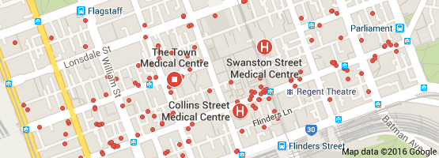

The potential reach for medical apps such as MMS in Australia is huge with so many smart phone users and with the medical industry in growth.

The website <http://www.statista.com/statistics/274677/forecast-of-mobile-phone-users-inaustralia/> states that ‘For 2017 the number of mobile phone users is expected to rise to 19.4 million’.

In a recent article it showed that smart phones, iOS and Android take up 92% of all phone used in Australia in 2015 – (Read more at: <http://australiaonlinenews.com/android-vs-ios-market-share-2015-pros-cons-216/>)

‘According to latest Google’s Our Mobile Planet research, on average Australians have downloaded 33 apps on their smartphone, with 11 of them paid apps.’ (<https://www.ebpearls.com.au/mobile-stats/>)

With smart phone, app usage and the medical industry all in growth, there is great potential to take advantage in this industry right now as it is only forecast to grow further in the future.

The market in medical and health apps is huge. It can be hard to filter through all the different apps out there. Many similar with only slight variations. According to an article written by Statista in the US ‘the number of mobile app buyers in the United States is projected to reach 85 million 2019’ and ‘As of June 2015, more than [100 billion mobile apps](http://www.statista.com/topics/1002/mobile-app-usage/263794) had been downloaded from the Apple App Store.’ (Statista)

‘Leading Analyst firm Gartner predicts, the global mobile app market is set to triple from $24.5 Billion in 2013 to $74 billion in 2016. It is also predicted that by 2017, 25% of all enterprises will have an app store.’ (www.ebpearls.com.au/mobile-stats/).

There are many apps regarding oncology for patients but many seem to be more about providing easy ways for patients to access information or to help track, in-depth, their treatment and progress.

Many apps are US based. Australia is a little behind in the use of medical apps, although it is making progress, with many hospitals making apps available for both patients and doctors.

From research, there isn’t an app on the market like ‘My Medical Secretary’. The point of difference is that we create the information and send it to the patient’s app. It is individually tailored to each patient.

With cancer affecting so many people and families in Australia, along with many other illnesses, it would be highly beneficial to have an app specifically tailored for patients that can take the stress out of co-ordinating appointments and keeping track of information.

The user of this app would be any patient who suffers from a serious illness or condition that requires a lot of medical appointments. In saying that, the app can still be used by patients who do not suffer from a serious illness but just have medical appointments, such as the GP, dentist, physio etc. These patients would need to possess and iOS, Android or tablet. Even if an elderly patient doesn’t possess such a device, you can be sure they will often have a family member who does. Elderly people often have carer’s, who are family members, who will possess one of these devises.

The MMS app aims to bring something new and innovative to the mobile app market. More importantly, it is going to bring something useful for the patient and the clinics.

Although this app has the potential to reach a lot of patients, it really comes down to the patients who own a smart phone. Smartphones are not exactly cheap to own and use, so these patients will be patients with an income that is greater than a low income earner. They are both male and females aged between 16 and 80. These people may or may not have private health insurance as everyone in Australia can access healthcare whether in the private system or the public system. Some patients see specialists privately and some see them publicly. Some also see them publicly for treatment but see them privately for consultations. Many Australians also access allied health services and general practitioners on a regular basis. All of these modalities can use this app for the benefit of their businesses and their patients.

This app definitely has the potential to be used Australia wide. It also has the potential to go global. As long as the development of this app is protected, can grow with the requirements of other software systems and has the right people behind it, developing it, then there is no reason why it shouldn’t. Also, with apps being sold on international platforms such as the iTunes store, apps can go global very quickly.

* 1. **Market Strategy**

|  |  |
| --- | --- |
| **Strengths**   * Unique - Information is sent to the app for the patient * Incorporates free features that clinics normally pay for * Innovative technology * Large reach of clinic and patients * Saving money for clinics * Reduce patient queries and misunderstandings * App increasing convenience * Patent protection * Not reliant on environmental factors * Smart phone/app usage increasing | **Weaknesses**   * Medical app market saturated * Financial backing * Reliance on existing technology * Low funds for advertising |
| **Opportunities**   * App technology and consumer usage expanding * Expanding into new markets – app adaption. * Local market, national market and global market potential | **Threats**   * Other clinics developing a similar app (patent protection) * Other medical software developing a similar app (patent protection) |

The MMS app will be free for patients to obtain and use. This is obviously a great selling point for patients as it costs them nothing to utilise the app, all they need to do is download it. The cost falls on the clinic that offers this to patients.

Many apps make money by ‘in-app advertising’ where ads pop up during the usage of the app which can be annoying and distracting for users. By having the clinics pay for the use of the app, we can avoid this, so it becomes a smooth running app for the patients.

The clinics will promote the app and inform patients of the availability and provide basic information on how it works. This information on how it works (possibly a step by step guide) will be produced by MMS. The receptionists and/or doctors can briefly explain what the patient needs to do in order to get the app up and running and, in return, what the clinic will do for them.

The app can also be promoted by other means, such as clinics advertising the app on their websites, in their clinics, advertise in medical and health magazines, word of mouth, and advertising on social media.

According to Think with Google, what really boosts app usage among smartphone users is if it simplifies life and the ease of use. Attributes associated with frequently used apps are the following –

* Make my life easier – 63%
* Clear instructions for using app – 63%
* Appealing design and aesthetic – 57%
* Consistent experience on multiple devices – 57%
* Always has new content – 45%
* Brand I interact with offline – 43%

Also, according to Think with Google, apps are often discovered outside the app store. Sources of awareness of smartphone apps are -

* Friends, family and colleagues – 52%
* Browse the app store – 40%
* Company Website – 24%

(https://www.thinkwithgoogle.com/articles/mobile-app-marketing-insights.html)

The app will be branded in a way that is appealing, clear and easy to use for the patient. It will have no affiliation with a certain clinic or modality. As research has suggested, an app that is clear, easy to use, and that patients can understand, will be one that is utilised over and over by the user. Especially as everything is done for them. There would be no reason for the patient to not utilise the app once they have downloaded it for free. They will receive notifications for everything new added to their personalised app.

The branding of the app will make it easily recognisable to the consumer, especially when it is being advertised to the public. A clear colour or colours, app name and logo will become easily recognised by people.

A basic website will be set up where patients and clinics can go to find out more information regarding the app, how to obtain it and how to use it. This will be a useful tool in helping to sell the product and service.

* 1. **Key Financial Objectives**

The key financial objectives are:

1. Be a fully sustainable business by the end of 2021
2. Average cost of a clinic utilizing the app per month is $120 + GST for a license.
3. Make a profit in the first half of 2022.
   1. **Business Structure**

‘My Medical Secretary’ operates as a Sole Trader under Susan Pickering for the following reasons:

* Susan is the owner and creator of the app with no other involvement to date.
* It is a simple structure to control initially.
* This will be the structure until the business starts making adequate income and/or employees/developers are hired, investors are on board and then will become a company, so personal assets will be protected.
* Patent protection will be obtained.
  1. **Management & Ownership**

**Director – Susan Pickering**

Susan Pickering has worked in the medical industry for over 20 years. Starting out as a receptionist at a General Practice whilst studying a diploma of Health Science – Remedial Therapies at The Melbourne College of Natural Medicine. Through her experiences as a Remedial Therapist, she found she had a passion to help people and make a difference in people’s lives.

Susan also has a marketing and management background. Susan has a Bachelor of Business in Management/Marketing from Monash University and has had previous employment in marketing for a range of different products and innovations. She has also done business consulting for various medical clinics to help them improve their day to day running of the business, including accounting, reducing costs, increase staff efficiency, implement new technologies and help clinics with accreditation.

Susan has found that her greatest fulfilment comes from helping patients with whatever they require. She sees it as extremely important to make their experience through the health system a positive a seamless one.

Susan is combining all of her skills and passion into this business by utilising her medical industry experience and management and marketing skills to work with clinics and patients in order to help improve the communication between medical clinics and their patients.

**Staff**

There are currently no other staff members. There will be contracted developers of the mobile application. As the business grows, Susan will be looking to employ staff to help with an ever increasing workload. Susan will endeavour to employ staff that possess the same passion that she possesses for improving the medical industry and more importantly improving the experience of the patient.

**Investors**

The app will require investment for the initial start-up of the business. This will include the cost of the design and development of the app. It will also include the start-up advertising materials needed to get clinics and patients utilising the app.

Susan will provide the initial investment and is open to further investment by other parties.

* 1. **Key Objectives**

The objectives for MMS mobile application are to:

* To be the best and most widely known medical/health mobile application in

Australia

* To be the most convenient patient mobile application in Australia.
* Be the most widely used mobile application by medical clinics in Australia.
* Maintain a financially healthy business by exceeding break-even targets by at

least 30% in the first year.

* Achieve monthly and yearly sales target.
  1. **The Competitor**

The mobile app market is huge. There are millions of apps available for people to download to their smart phones.

There are a lot of apps out there for ‘the patient’. Providing them with information regarding certain illnesses. There are also plenty of apps that allows the patient to record their treatment and appointments, where they enter in all the information themselves, but I have not come across one app that sends all of this information to the patient, individually tailored for them.

If we want to talk about similar apps then there are quite a few. These are the apps where patients need to enter in all of the details. A few examples of such apps are –

* My Medi Stuff – lets you record all your medical appointments, past and future, whether with doctor, dentist, and physio. This is an app developed in the UK. It is listed under ‘Lifestyle’ on iTunes.
* Women’s Health Appointments – Keeps track of medical appointments, simplifies the procedure of making new ones. Keeps medical contacts, such a pharmacy and insurance rep etc. Not Australian developed.
* MedDate – Links all your doctor’s appointments, medical providers and family appointments in one place. Reminders and appointments linked with iCal. Patient needs to enter details. American based app.
* HotDoc – Books appointments with Doctors. Checks you in and sees your place in queue when you arrive. Gives notifications for appointments. Confirms your appointment via email. Keeps track of appointments.

MMS will have the competitive edge over other apps in 3 major ways -

* Firstly, the information is being sent to the patient’s app without any effort required on the patient’s behalf. There seems to be no other app out their currently doing this.
* The app is saving running costs for the clinics.
* The fact that it is beneficial for both the patient and the clinic is unique.

A benefit of this app is that it is being used as tool to improve the running of medical clinics. The clinics themselves will be helping to ‘sell’ this app to their patients. This requires less marketing on our behalf, to patients specifically. Our job will be getting the clinics on board and then them getting the patients using the app. From here, we would hope that patients utilizing the app, and finding it beneficial, will then ask other clinics they are attending if they use the app, ideally getting these clinics that are not, on board too. Clinics will then be approaching us to get ‘signed up’ as it is not only beneficial for the patient but for the clinic and their running costs also. Word of mouth from Doctors utilizing the app will be beneficial also.

MMS app has a unique offering to both the patient and clinic and is not comparable to any other app currently available on the market. The hardest part of differentiating itself and getting noticed by clinics and patients will be how well it is marketed. It needs to cut through all the ‘noise’ of the app world and be easily obtained by both patients and clinics. This will come down to the detailed marketing and advertising campaign chosen. Word of mouth will also be highly beneficial to the business.

|  |
| --- |
|  |

**2. Financial plan**

* 1. **Key Objectives and Financial Review**

**Sales & Marketing:**

1. to build brand awareness
2. to grow market share
3. to enter new markets/modalities

**Finance:**

1. to increase sales every quarter
2. to increase profit every quarterly
3. reduce production costs
   1. **Establishment Costs**

|  |  |  |  |  |  |  |  |  |  |  |  |  |  |  |  |  |  |  |  |  |  |  |  |  |  |  |  |  |  |  |  |  |  |  |  |  |  |  |  |  |  |  |  |  |  |  |  |  |  |  |  |  |  |  |  |  |  |  |  |  |  |  |  |  |  |  |  |  |  |  |  |  |  |  |
| --- | --- | --- | --- | --- | --- | --- | --- | --- | --- | --- | --- | --- | --- | --- | --- | --- | --- | --- | --- | --- | --- | --- | --- | --- | --- | --- | --- | --- | --- | --- | --- | --- | --- | --- | --- | --- | --- | --- | --- | --- | --- | --- | --- | --- | --- | --- | --- | --- | --- | --- | --- | --- | --- | --- | --- | --- | --- | --- | --- | --- | --- | --- | --- | --- | --- | --- | --- | --- | --- | --- | --- | --- | --- | --- |
| |  |  | | --- | --- | |  | | | **START-UP COSTS** | **Cost ($)** | | **Registrations** |  | | Business name |  | | Licenses |  | | Permits |  | | Domain names | $80 | | Trade marks/designs/patents |  | | Vehicle registration |  | | Design/Development Fees | $25,000 | | Accountant fees |  | | Solicitor fees | $500 | | Rental lease cost (Rent advance/deposit) |  | | Utility connections & bonds |  | | Phone connection |  | | Internet connection |  | | Computer software |  | | Training |  | | Wages |  | | Stock/raw materials |  | | **Insurance** |  | | Building & contents |  | | Vehicle |  | | Public liability |  | | Professional indemnity |  | | Product liability |  | | Workers compensation |  | | Business assets |  | | Business revenue |  | | Printing | $300 | | Stationery & office supplies | $200 | | Marketing & advertising | $5,000 | | **Total start-up costs** | **$41,080** | |  |  | | **Assumptions:** |  | | All figures are GST exclusive. |  | |  |  | |
|  |

* 1. **Profit and Loss**

|  |
| --- |
|  |
| See Attachment 1 |

* 1. **Cash Flow**

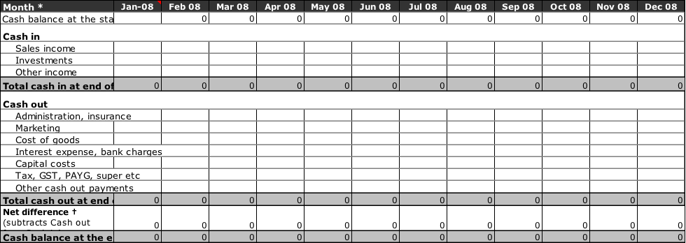

* 1. **Balance Sheet**

|  |
| --- |
|  |
|  |

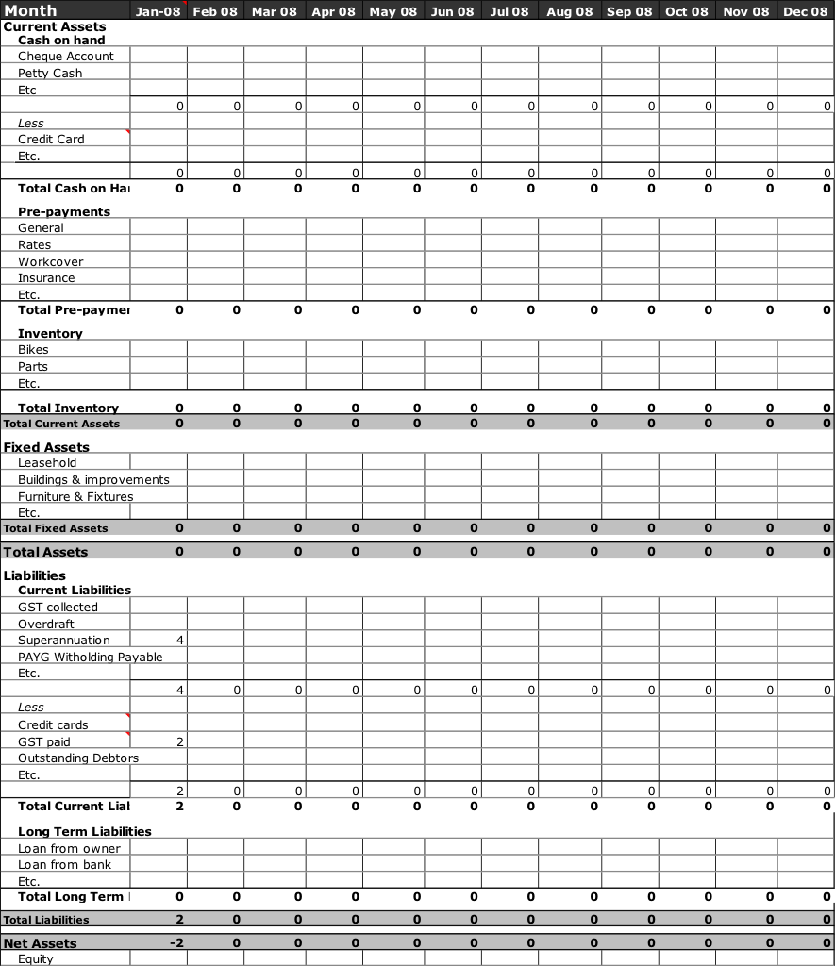

* 1. **Breakdown of Cost**

|  |  |
| --- | --- |
|  | |
|  | |
| Revenue per Doctor charged monthly: | $130.00 + GST = $143.00 |
| Expected Sales (unit) for 12 months | 30 (12mths sign up = $51,480.00). |
| Set up and Installation charged: | $130 + GST (2 hours) = $143.00 x 30 = $4,290 |
| Average month’s fixed support charged:  ___________________________________________________  **Total predicted income (based on 12mths)**  Cost of design and development  Cost if initial advertising | $40 + GST = $15,840.00 p.a.  _________________________  **$71,610.00**  $25,000  $5,000 |
| **Total cost of development** | **$30,000** |

**Total revenue predicted in first 12 months**  **$41,610.00**

(Refer to profit and loss – Attachment 1)

**3. Supporting Documentation**

|  |  |
| --- | --- |
|  | |
|  | |
| **Attachment Number** | **Document Name** |
| Attachment 1: | Profit & Loss 2017 |
| Attachment 2: | Screen Grabs of Application |
|  |  |

|  |  |  |  |
| --- | --- | --- | --- |
|  | | | |
| **4. Action Plan** | | | |
| **Key Objectives** | **Task** | **By Whom** | **By When** |
| **MARKETING** |  |  |  |
| Determine Launch Plan | Outline Plan | SP |  |
|  | Agreement and decision on implementation | SP/SF |  |
| Create design/logo | Agree concept | SP/SF |  |
|  | Approval of copy | SP/SF |  |
|  | Print | SF |  |
| Creation of web design | Design and web layout | SP/SF |  |
| Creation of website |  |  |  |
| **FINANCE** |  |  |  |
| Finalise Cash Flow Plan | Review P&L with Managers |  |  |
|  | Complete Cash Flow Plan |  |  |
| Finalise Initial Finance | Review finance documents |  |  |
|  | Sign by |  |  |

|  |
| --- |
|  |
| **5. References**  Cancer Council Australia (retrieved 7th March 2016) <http://www.cancer.org.au/about-cancer/what-is-cancer/facts-and-figures.html> |

<https://www.geniesolutions.com.au/>

(Read more at: <http://australiaonlinenews.com/android-vs-ios-market-share-2015-pros-cons-216/>)

(http://www.abs.gov.au/AUSSTATS/abs@.nsf/Lookup/4102.0Main+Features20April+2013)

Statista - <http://www.smartinsights.com/mobile-marketing/mobile-marketing-analytics/mobile-marketing-statistics/>

<https://www.ebpearls.com.au/mobile-stats/>

<https://www.thinkwithgoogle.com/articles/mobile-app-marketing-insights.html>

[**http://www.ibisworld.com.au/industry/default.aspx?indid=612**](http://www.ibisworld.com.au/industry/default.aspx?indid=612)

**Attachment 1**

**Attachment 2**