# 

BRS for DownBeat

(Hybrid)

Version: 1.0

Date: January 16th 2020

**Table of Contents**

1. Project Goal 3

2. Features (Scope of Work) 3

3. Assumptions 15

4. App Credential: 16

# Project Goal

The goal of this app is to help music lovers where they can find the places where live music is performed. It also helps music lovers to know if there is a valet parking available at the place and do they serve food, is there any happy hour available and is it for all ages or 18+ or 21 and up, is this band going to be somewhere close tomorrow or next weekend.

Further application will have below user types:

User types in the application.

1. Registered user (mobile app): they are the music lovers of the application who would like to explore nearby bands places available to pass a quality time with their friends and family members.
2. Bands (mobile app): they are the user type registered in the application as ‘Brands’. The registration process will remain same as that of the registered user with an addition that they will select ‘Brand’ during their registration process. Once inside the application they will be able to edit their profile information. Please note that email will note be editable since it will be kept as a unique identity for the registered user. The other information like name, phone no., password etc. can be updated.
3. Places (Web panel): we will have a web panel that allows places to send their request to super admin and once confirmed by super admin they will be viewed in the application.
4. Add brands: Places will add ‘Bands’ by sending a request to band and band will accept the request to get associated with the place.
5. Add tickets: Places will be able to generate QR Code for tickets and also able to define price for these tickets.
6. Super administrator: will be able to monitor the registered user, brands and places in the application.

# Features (Scope of Work)

1. **Splash**

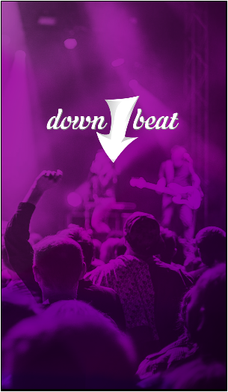

1. **Join:** User can join the application by entering details.

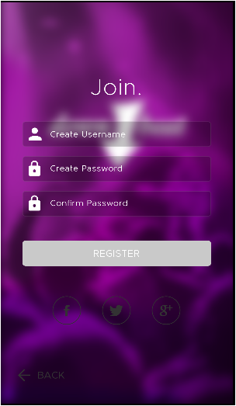

1. **Sign In:** User can sign in to enter the application.

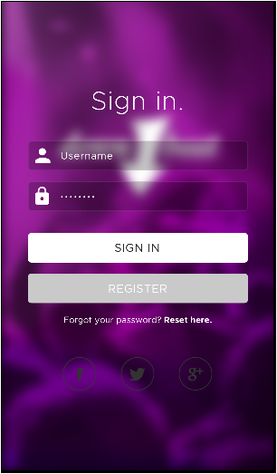

1. **Forgot Password:** User can recover the password by providing the email id. The verification link will be send to the entered email id.

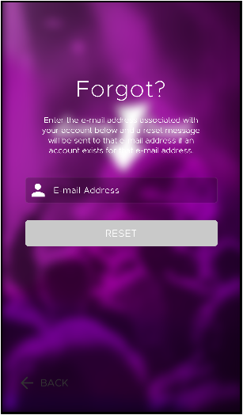

1. **Reset Password:** User enter the username and create new password.

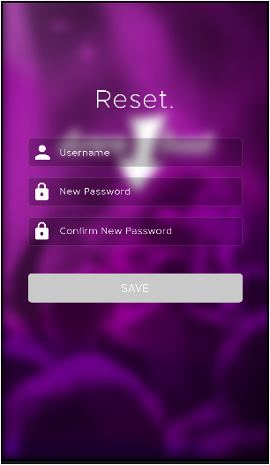

1. **Menu:** User can navigate to various section of the application through the menu.

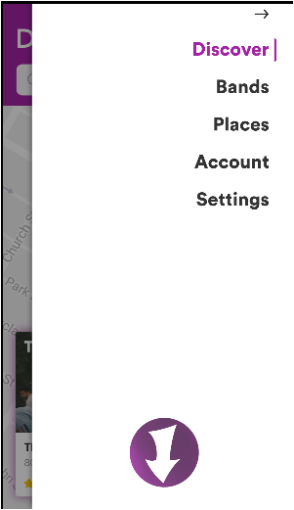

1. **Discover/ Map- Place:** the top right icon is the option to open the menu bar.
   1. Search bar: allow user to search the place by entering the name. The available place will be displayed on the map with the name, address and star rating.
   2. ‘+’ icon: clicking on this icon will expend the details of the respective place and users will be able to view more information about the place like cover / entry, parking facility, food / beverages.
   3. Comment icon: will display the comments added by user in the application on the respective place.

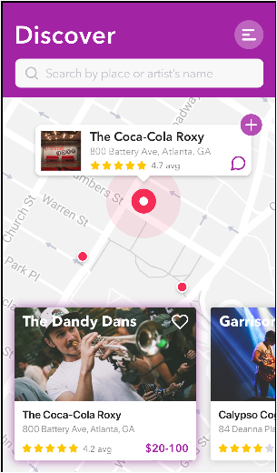 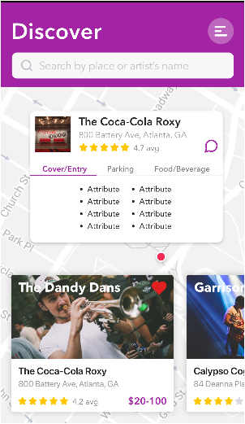 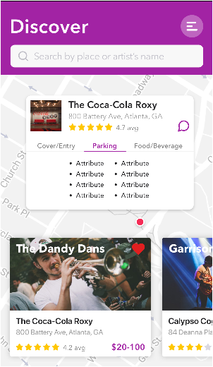

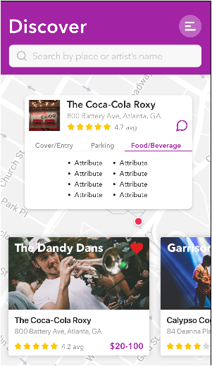

1. **Create Info/ Entry:** these are the information added by the ‘Places’ whereby they will add name of the ‘Band’ with the show date and other details. These are the text information available for user to view in the application front side as added by the ‘Places’ from their web panel.

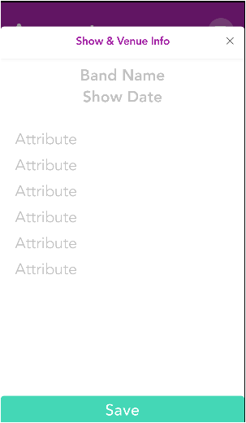

1. **Comment:** ability for user to add a comment on the place.

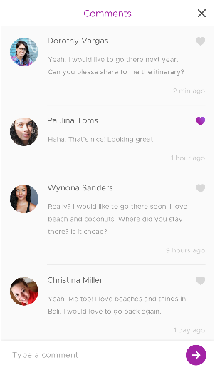 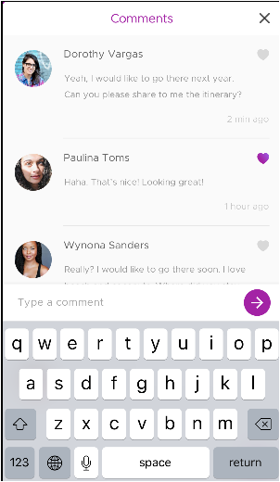

1. **Discover/ Map- Band:** User can discover the bands and their details listed on the application.
   1. Search bar: allow user to search the brands by entering the name. The available brands will be displayed on the map with the name, address and star rating of the Place they are performing.
   2. Shows: it will display the shows that brands are performing with the ticket value as added by the place.
   3. Parking: will display the information of the parking facility availability.
   4. Food / beverages: will display the information of the food and beverages available at the Place.

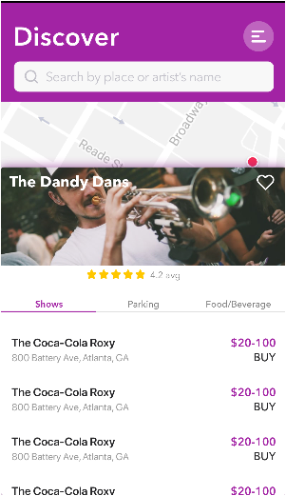 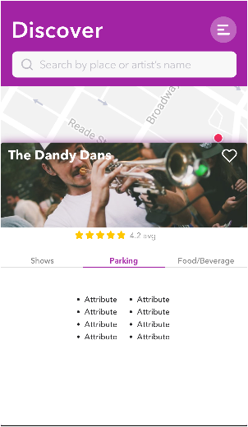 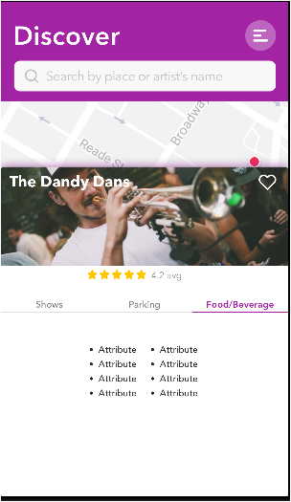

1. **Ticket Purchase:** User can book ticket by selecting the show and making the payment.

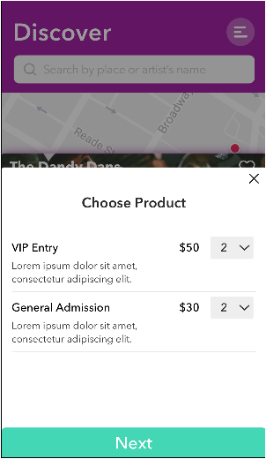 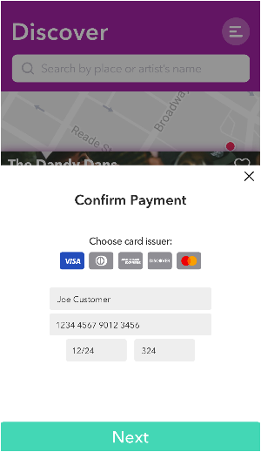 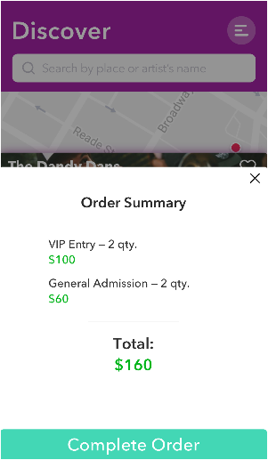

1. **Bands:** allow user to search the brands with the brand name. Once a brand is selected it will display the available show they are performing at the location with the ticket value and other information like parking, food/beverages etc.

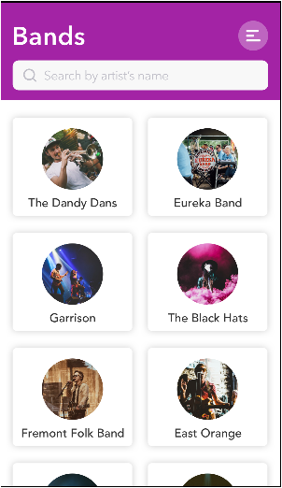 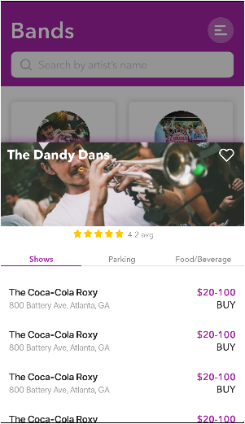

1. **Places:** allow user to search the place with the place name. Once a brand is selected it will display the place information that includes name of the place, address of place, cover/entry, parking and food/beverages information.

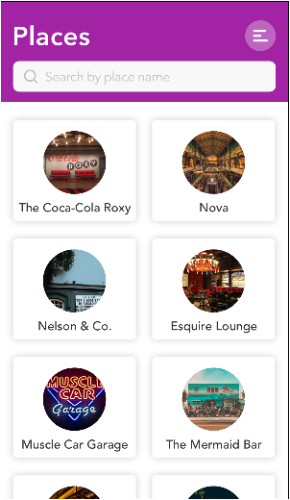 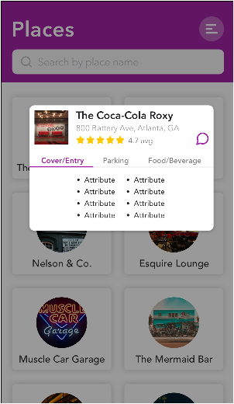

1. **Account:** this is the settings screen for the user and the brands. They will be able to update their Brand name, address, phone no, payment info and web URL. The email id will be grayed out and is restricted to change once an account is created.

**Choose your interest:** these are the key words that a brand will be able to add once they create their profile. This will help users to search for a brand with the specific music they want to hear like jazz, classic, pop, rock or any other music category

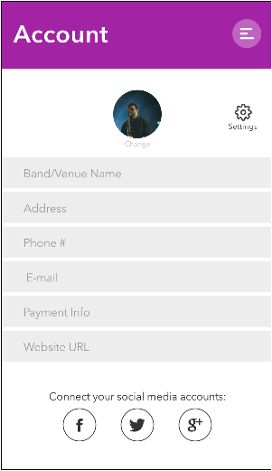 **`**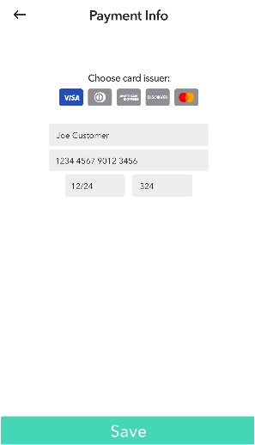 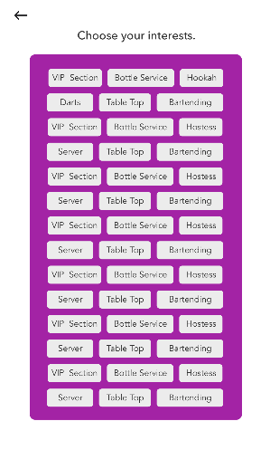

1. **Setting:** this screen will allow user to toggle the push notifications or access to contacts information

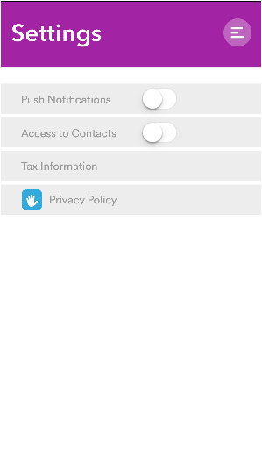

# Assumptions

1. All the copyright information like content, images, text etc. will be provided by client.
2. Application will be developed in English language only.
3. Application will be developed in portrait mode only.
4. All 3rd party api access shall be provided by client.
5. Apple follow their own guidelines for app stores iTunes. Thus in case any changes being recommended by them to make the app live then we need to abide by them since we have dependency and have no control at our end. Also this may lead to change the way app works in iOS app.

# App Credential:

Client to share below credentials while approving the document.

|  |  |  |  |
| --- | --- | --- | --- |
| S. No. | Description | Username | Password |
| 1 | Server hosting details |  |  |
| 2 | Apple store account login details |  |  |
| 3 | Duns Number with Company Account |  |  |
| 4 | Google Play Store credentials |  |  |
| 5 | Facebook for social login |  |  |
| 6 | Google for social login |  |  |
| 7 | Twitter for social login |  |  |
| 8 | Send grid details |  |  |
| 9 | Domain details |  |  |
| 10 | Twilio details |  |  |

Please feel free to contact us for any queries. We would be happy to discuss over the BRS in detail. Thank You!

**☺--- END OF DOCUMENT ---☺**