Testing image insertion below:
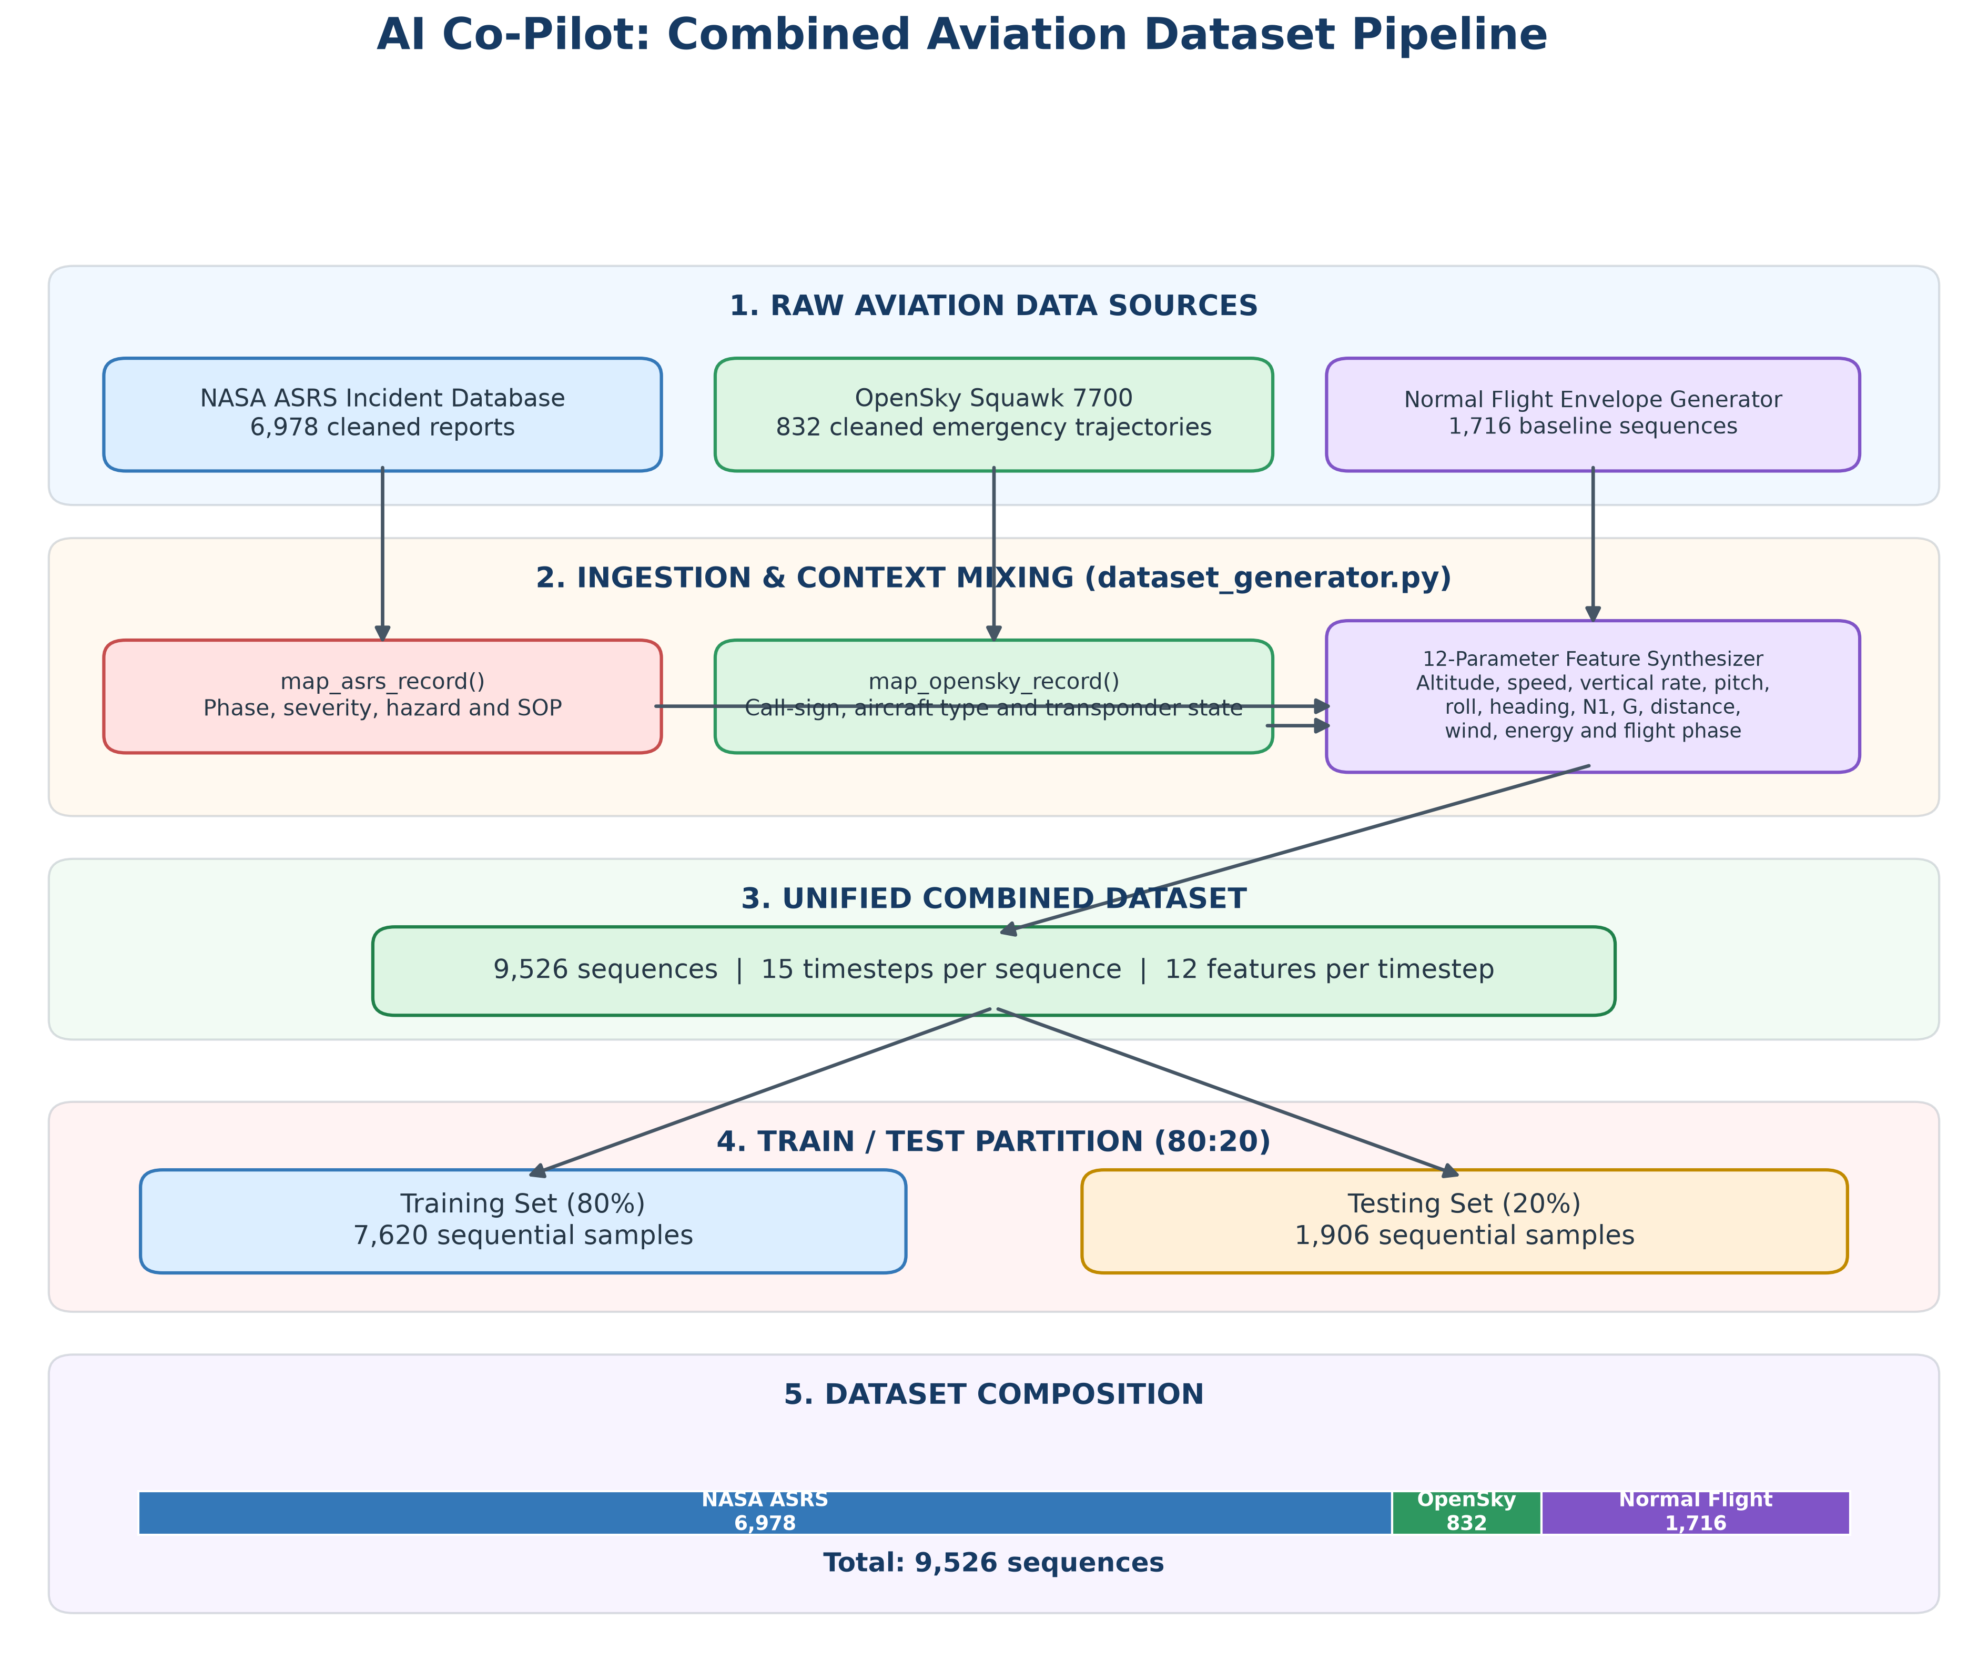
Figure 1 caption here.

