WLC-200 Nightly HIL Report, 2026-10-06
Bench HIL-2 · software 2.4.0-rc3 · spec ADS-WLC200-SRS v1.3 · 9 passed, 3 failed of 12 runs
Draft. The text was written with AI assistance from the fact sheet; tables and charts were made by code, and every number in the text was checked against the data.

Summary
Night 2026-10-06, software 2.4.0-rc3, spec ADS-WLC200-SRS v1.3, bench HIL-2: 12 runs, 9 passed, 3 failed. TC-CAN-01 (R09) is a new failure. TC-AP-04 (R04) and TC-TH-03 (R10) have failed on all 10 nights in the history. Two passing runs have values near their limits (R05, R12).

Results
Run | Test | Title | Result | Key value
R01 | TC-AP-01 | Pinch detection at nominal voltage | PASS | stop latency ms = 6 ms
R02 | TC-AP-02 | Pinch detection at low voltage | PASS | stop latency ms = 7 ms
R03 | TC-AP-03 | Pinch detection at high voltage | PASS | stop latency ms = 4 ms
R04 | TC-AP-04 | Pinch detection when cold | FAIL | stop latency ms = 14 ms
R05 | TC-AP-05 | Pinch detection when hot | PASS | stop latency ms = 6 ms
R06 | TC-AP-06 | Pinch protection in manual and express mode | PASS | stop latency ms = 5 ms
R07 | TC-MV-05 | Full close time | PASS | close time s = 3.816 s
R08 | TC-MV-01 | Manual movement and stop on release | PASS | stop after release close ms = 62 ms
R09 | TC-CAN-01 | WLC_Status timing and content | FAIL | period max ms = 112 ms
R10 | TC-TH-03 | Opening blocked when hot | FAIL | max current above 130C a = 15.16 A
R11 | TC-PW-03 | Motor stop at undervoltage | PASS | stop after undervoltage ms = 21 ms
R12 | TC-DG-01 | Hall sensor loss | PASS | dtc code = B1A01

Failures
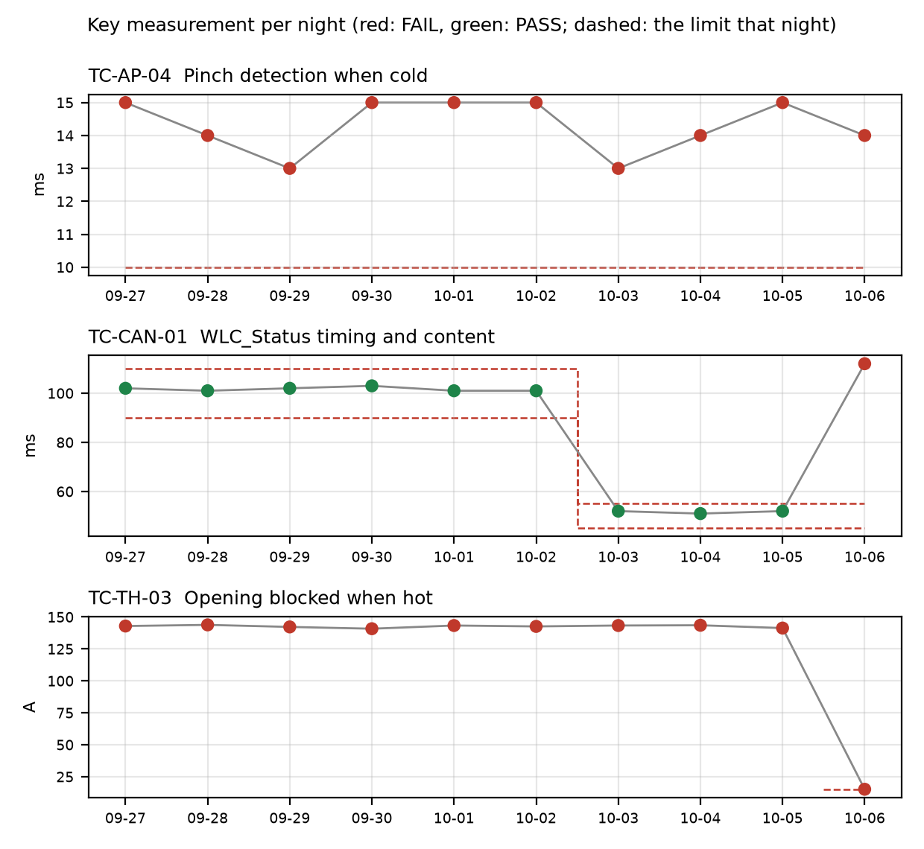

TC-AP-04
R04, Pinch detection when cold: stop_latency_ms was 14 ms against a limit of <= 10 ms. Not new: it has failed on 10 of 10 nights in the history (history range 13 to 15 ms), under both v1.2 and v1.3, with the same <= 10 limit each night. reversal_mm was 158 mm and passed. Open defect DR-1001 (S1, Pinch reversal late at -30 °C). The run also flagged that the temperature estimate at start was -22 C with the chamber set to -30 C.

TC-CAN-01
R09, WLC_Status timing and content: period_max_ms was 112 ms against the v1.3 limit of 45 to 55 ms. New failure tonight: it failed on 1 of 10 nights. It passed on 2026-10-03, 2026-10-04 and 2026-10-05 at 52, 51 and 52 ms under the same v1.3 limit. Before v1.3 it passed at 101 to 103 ms against the v1.2 limit of 90 to 110. The log shows a 112 ms gap between t=6383 and t=6495 ms, so a frame was probably skipped. period_min_ms was 49 ms and passed. No open defect is linked.

TC-TH-03
R10, Opening blocked when hot: two criteria failed. max_current_above_130C_a was 15.16 A against a limit of <= 15 A, with 13 samples above 15 A while the estimate was above 130 C (first at t=39110 ms, 134.0 C), attributed to end-stop stalls. opening_starts_above_140C was 1 against a limit of 0: opening started at t=57050 ms (143.9 C) and the controller completed full opening travel above 140 C with no inhibit. Not new: failed on 10 of 10 nights. Earlier nights failed on opening above 140 C (history range up to 143.8 C). Tonight's history entry is the current-limit failure, 15.16 A against <= 15. Open defect DR-1012 (S3, Opening possible above 140 °C). closing_possible_above_140C passed with 2 movements.

Anomalies on passing runs
- R05 (TC-AP-05, PASS): reversal_mm was 151 mm against a min of 150 mm, a margin of 1 mm.
- R05: temperature estimate at start was 93 C with the chamber set to 85 C (soak not complete or estimate offset).
- R04 (TC-AP-04): temperature estimate at start was -22 C with the chamber set to -30 C (soak not complete or estimate offset). This is the same kind of mismatch as in R05.
- R12 (TC-DG-01, PASS): stop_after_hall_loss_ms was 203 ms against a min of 200 ms. The Hall interval is 4 ms, so the true latency is 199 to 203 ms and the 200 ms lower limit cannot be confirmed with certainty.
- R10 (TC-TH-03): the log starts at about 112 C and was never cooled, so 'opening possible below 120 C' is not covered by this run. Sampling was 10 ms.
- R07 (TC-MV-05, PASS): end-stop stall current was 18.1 A, with the stall lasting 42 ms. This test has no limit for it. Close time was 3.816 s.

Recommendations
- TC-CAN-01 (R09): Open a defect for the 112 ms WLC_Status gap at t=6383 to 6495 ms. Check the R09 log for a skipped frame, and check whether bench HIL-2 or the 2.4.0-rc3 software caused it. Rerun TC-CAN-01 to see if it repeats; it passed on the three previous v1.3 nights.
- TC-AP-04 (R04): Escalate DR-1001 (S1). It has failed on all 10 nights at 13 to 15 ms against <= 10 ms. Check the chamber soak at -30 C, because the start estimate was -22 C, and confirm the failure is not an artifact of that offset.
- TC-TH-03 (R10): Update DR-1012 (S3) with tonight's data: opening started at 143.9 C and full opening travel completed above 140 C. Also record the new current failure (15.16 A against <= 15 A, with 13 samples above 15 A). Consider whether the end-stop stall current needs its own defect, and whether DR-1012's S3 severity still fits given 10 failing nights.
- TC-TH-03: Add a cool-down step to the run so 'opening possible below 120 C' is covered. The log started at about 112 C and was never cooled.
- TC-AP-05 (R05): Check the 1 mm margin on reversal_mm (151 mm against a min of 150 mm), and check the soak, since the start estimate was 93 C with the chamber at 85 C.
- TC-DG-01 (R12): Decide whether the 4 ms Hall-interval uncertainty is acceptable for the 200 ms lower limit. If not, use a finer measurement or review the limit with the spec owner.
- TC-MV-05 (R07): Ask the spec owner whether the 18.1 A end-stop stall current needs a limit, since the test has none.

Checks on this report
All numbers and IDs in the text match the fact sheet.

