WLC-200 Nightly HIL Report, 2026-10-07
Bench HIL-2 · software 2.4.0-rc4 · spec ADS-WLC200-SRS v1.3 · 10 passed, 2 failed of 12 runs
Draft. The text was written with AI assistance from the fact sheet; tables and charts were made by code, and every number in the text was checked against the data.

Summary
Night 2026-10-07, software 2.4.0-rc4, spec ADS-WLC200-SRS v1.3, bench HIL-2: 12 runs, 10 passed, 2 failed (TC-AP-03 in R03, TC-AP-04 in R04). TC-AP-03 is a new failure. TC-AP-04 has failed on all 11 nights in the history and is linked to open defect DR-1001. Several passing runs are close to their limits (see anomalies).

Results
Run | Test | Title | Result | Key value
R01 | TC-AP-01 | Pinch detection at nominal voltage | PASS | stop latency ms = 6 ms
R02 | TC-AP-02 | Pinch detection at low voltage | PASS | stop latency ms = 7 ms
R03 | TC-AP-03 | Pinch detection at high voltage | FAIL | stop latency ms = 12 ms
R04 | TC-AP-04 | Pinch detection when cold | FAIL | stop latency ms = 13 ms
R05 | TC-AP-05 | Pinch detection when hot | PASS | stop latency ms = 5 ms
R06 | TC-AP-06 | Pinch protection in manual and express mode | PASS | stop latency ms = 6 ms
R07 | TC-MV-05 | Full close time | PASS | close time s = 3.816 s
R08 | TC-MV-01 | Manual movement and stop on release | PASS | stop after release close ms = 62 ms
R09 | TC-CAN-01 | WLC_Status timing and content | PASS | period min ms = 49 ms
R10 | TC-TH-03 | Opening blocked when hot | PASS | max current above 130C a = 14.76 A
R11 | TC-PW-03 | Motor stop at undervoltage | PASS | stop after undervoltage ms = 21 ms
R12 | TC-DG-01 | Hall sensor loss | PASS | dtc code = B1A01

Failures
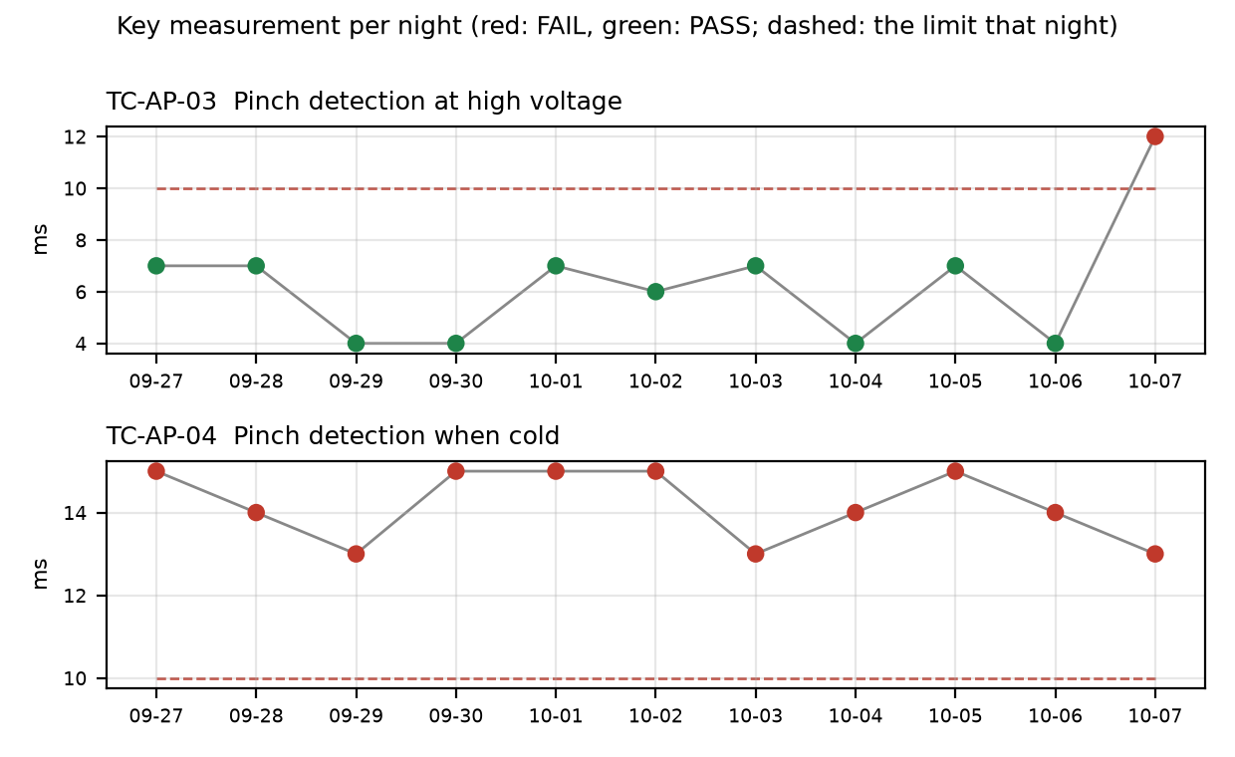

TC-AP-03
R03 (Pinch detection at high voltage): stop_latency_ms was 12 ms against a limit of <= 10 ms on v1.3. reversal_mm passed at 163 mm. This is a NEW failure: it failed on 1 of 11 nights, and the previous 10 nights passed. History range is 4 ms to 12 ms, so tonight is the highest value on record. The run also logged a peak pinch force of 103.2 N, above 100 N (reportable per TP-AP-01). No open defect is linked.

TC-AP-04
R04 (Pinch detection when cold): stop_latency_ms was 13 ms against a limit of <= 10 ms on v1.3. reversal_mm passed at 158 mm. This is NOT new: it has failed on 11 of 11 nights, under both v1.2 and v1.3, and the limit was <= 10 ms every night. History range is 13 ms to 15 ms. Open defect DR-1001 (S1, open): Pinch reversal late at -30 °C. The run also logged that the temperature estimate at start was -22 C while the chamber was set to -30 C.

Anomalies on passing runs
- R03 (TC-AP-03): peak pinch force 103.2 N is above 100 N, reportable per TP-AP-01.
- R04 (TC-AP-04): temperature estimate at start was -22 C but the chamber was set to -30 C (soak not complete, or estimate offset). The 13 ms result may not reflect true -30 C conditions.
- R05 (TC-AP-05): temperature estimate at start was 93 C but the chamber was set to 85 C (soak not complete, or estimate offset). reversal_mm = 151 mm against a min of 150 mm (margin 1 mm).
- R07 (TC-MV-05): end-stop stall current of 18.2 A, lasting 42 ms. This test has no limit for it.
- R10 (TC-TH-03): max_current_above_130C_a = 14.76 A against a max of 15 A (margin 0.24 A), with 2 samples within 2% of the limit. closing_possible_above_140C = 1 movement against a min of 1 (margin 0). The log starts at about 112 C and was never cooled, so 'opening possible below 120 C' is not covered by this run. Sampling was 10 ms.
- R12 (TC-DG-01): stop_after_hall_loss_ms = 203 ms against a min of 200 ms (margin 3 ms). Hall loss time is only known to within one Hall interval (4 ms), so true latency is 199..203 ms and the 200 ms lower limit cannot be confirmed with certainty.

Recommendations
- TC-AP-03: open a defect for the new stop_latency_ms failure (12 ms vs <= 10 ms) and check whether it relates to the 103.2 N peak pinch force reportable per TP-AP-01. Re-run R03 on HIL-2 to see whether it repeats.
- TC-AP-03: check what changed in 2.4.0-rc4 or on the bench before this run, since the previous 10 nights passed with values of 4 ms to 7 ms.
- TC-AP-04: keep the failure attached to DR-1001 (S1, open) and add tonight's 13 ms result. Escalate in line with its S1 status, since it has failed on all 11 nights.
- TC-AP-04: check the chamber soak and the temperature estimate offset (-22 C estimated vs -30 C set) before treating tonight's value as a true -30 C result.
- TC-AP-05: check the hot-soak and temperature estimate offset (93 C vs 85 C set), and review the 1 mm reversal margin (151 mm vs min 150 mm).
- TC-TH-03: review the 14.76 A peak current against the 15 A limit and the zero margin on closing movements above 140 C. Add a cooled run to cover 'opening possible below 120 C'.
- TC-DG-01: decide whether the 4 ms Hall interval resolution is acceptable for the 200 ms lower limit, or capture the Hall loss time at finer resolution.

Checks on this report
All numbers and IDs in the text match the fact sheet.

