WLC-200 Nightly HIL Report, 2026-10-06
Bench HIL-2 · software 2.4.0-rc3 · spec ADS-WLC200-SRS v1.3 · 9 passed, 3 failed of 12 runs
Draft. The text was written with AI assistance from the fact sheet; tables and charts were made by code, and every number in the text was checked against the data.

Summary
Night 2026-10-06, software 2.4.0-rc3, bench HIL-2, spec ADS-WLC200-SRS v1.3: 12 runs, 9 passed, 3 failed (R04 TC-AP-04, R09 TC-CAN-01, R10 TC-TH-03). R04 and R10 have failed on all 10 nights in the history, and each has an open defect. R09 (TC-CAN-01) is a new failure tonight. Two passing runs (R05, R12) are close to their limits.

Results
Run | Test | Title | Result | Key value
R01 | TC-AP-01 | Pinch detection at nominal voltage | PASS | stop_latency_ms = 6 ms
R02 | TC-AP-02 | Pinch detection at low voltage | PASS | stop_latency_ms = 7 ms
R03 | TC-AP-03 | Pinch detection at high voltage | PASS | stop_latency_ms = 4 ms
R04 | TC-AP-04 | Pinch detection when cold | FAIL | stop_latency_ms = 14 ms
R05 | TC-AP-05 | Pinch detection when hot | PASS | stop_latency_ms = 6 ms
R06 | TC-AP-06 | Pinch protection in manual and express mode | PASS | stop_latency_ms = 5 ms
R07 | TC-MV-05 | Full close time | PASS | close_time_s = 3.816 s
R08 | TC-MV-01 | Manual movement and stop on release | PASS | stop_after_release_close_ms = 62 ms
R09 | TC-CAN-01 | WLC_Status timing and content | FAIL | period_max_ms = 112 ms
R10 | TC-TH-03 | Opening blocked when hot | FAIL | max_current_above_130C_a = 15.16 A
R11 | TC-PW-03 | Motor stop at undervoltage | PASS | stop_after_undervoltage_ms = 21 ms
R12 | TC-DG-01 | Hall sensor loss | PASS | dtc_code = B1A01

Failures
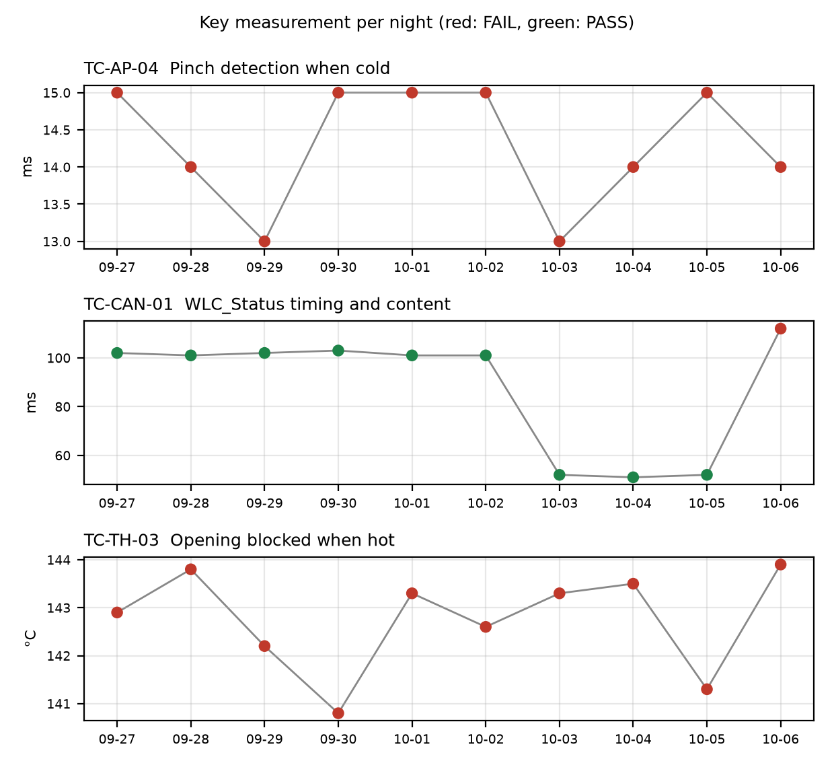

TC-AP-04 (R04)
Pinch detection when cold. stop_latency_ms was 14 ms against a max of 10 ms. reversal_mm was 158.0 mm and passed. Not new: it has failed on 10 of 10 nights in the history, with values of 13 to 15 ms. Open defect DR-1001 (S1, 'Pinch reversal late at -30 °C'). Anomaly: the temperature estimate at start was -22 C but the chamber was set to -30 C, so the soak may not have finished or the estimate may be offset.

TC-CAN-01 (R09)
WLC_Status timing. period_max_ms was 112 ms against a 45 to 55 ms window. period_min_ms was 49 ms and passed. New failure tonight: it passed on the previous 9 nights, failed_nights is 1. The gap was 112 ms between t=6383 and t=6495 ms, and a frame was probably skipped. Period max was 101 to 103 ms on 2026-09-27 to 2026-10-02, then 52, 51 and 52 ms on 2026-10-03 to 2026-10-05. No open defect is linked.

TC-TH-03 (R10)
Opening blocked when hot. Two criteria failed. max_current_above_130C_a was 15.16 A against a max of 15 A (13 samples above 15 A, first at t=39110 ms at 134.0 C, described as end-stop stalls). opening_starts_above_140C was 1 against a max of 0: opening started at t=57050 ms at 143.9 C, and the controller completed full opening travel above 140 C with no inhibit. closing_possible_above_140C was 2 movements and passed. Not new: it has failed on 10 of 10 nights, with opening-start temperatures of 140.8 to 143.9 °C. Open defect DR-1012 (S3, 'Opening possible above 140 °C'). The run log starts at about 112 C and was never cooled, so 'opening possible below 120 C' is not covered.

Anomalies on passing runs
- R05 (TC-AP-05, PASS): reversal_mm was 151 mm against a min of 150 mm, a margin of 1 mm, which is within 2% of the limit.
- R05: the temperature estimate at start was 93 C but the chamber was set to 85 C (soak not complete or estimate offset).
- R04: the temperature estimate at start was -22 C but the chamber was set to -30 C. R04 and R05 both show estimate-versus-chamber mismatches.
- R12 (TC-DG-01, PASS): stop_after_hall_loss_ms was 203 ms against a min of 200 ms, a margin of 3 ms. The Hall interval is 4 ms, so true latency is 199 to 203 ms and the 200 ms lower limit cannot be confirmed with certainty.
- R07 (TC-MV-05, PASS): end-stop stall current was 18.1 A, lasting 42 ms. This test has no limit for it. Close time was 3.816 s.
- R10: the TC-TH-03 log was sampled at 10 ms and was never cooled, so part of the test intent is not exercised.

Recommendations
- TC-CAN-01 (R09): open a new defect for the 112 ms WLC_Status gap at t=6383 to 6495 ms on 2026-10-06. Check the bus log for a skipped frame and compare it with the 2026-10-03 to 2026-10-05 runs, where period max was 51 to 52 ms.
- TC-CAN-01: look at why period max was 101 to 103 ms on 2026-09-27 to 2026-10-02 yet passed against a 55 ms limit. Check the criterion or the data used in those runs.
- TC-AP-04 (R04): check the chamber soak and temperature estimate offset (-22 C against -30 C set) before using this result for DR-1001. Add the 2026-10-06 value of 14 ms to DR-1001.
- TC-TH-03 (R10): add the 143.9 C opening start and 15.16 A peak current to DR-1012. DR-1012 covers opening above 140 °C. Check whether the stall current above 15 A needs its own defect or is already covered.
- TC-TH-03: change the test so the log is cooled and 'opening possible below 120 C' is covered.
- TC-AP-05 (R05): check the 1 mm margin on reversal_mm (151 mm against a 150 mm min), and check the 93 C against 85 C start offset.
- TC-DG-01 (R12): review how the 200 ms lower limit is judged given the 4 ms Hall interval (true latency 199 to 203 ms). Decide whether the limit or the measurement method needs to change.
- TC-MV-05 (R07): decide whether the 18.1 A end-stop stall current needs a limit in this test.

Checks on this report
Problems found: failure TC-AP-04 not discussed; failure TC-CAN-01 not discussed; failure TC-TH-03 not discussed

