WLC-200 Nightly HIL Report, 2026-10-06
Bench HIL-2 · software 2.4.0-rc3 · spec ADS-WLC200-SRS v1.3 · 9 passed, 3 failed of 12 runs
Draft. The text was written with AI assistance from the fact sheet; tables and charts were made by code, and every number in the text was checked against the data.

Summary
Night 2026-10-06, software 2.4.0-rc3, spec ADS-WLC200-SRS v1.3, bench HIL-2: 12 runs, 9 passed, 3 failed. TC-AP-04 (R04) and TC-TH-03 (R10) have failed on all 10 nights in the history. TC-CAN-01 (R09) is a new failure tonight.

Results
Run | Test | Title | Result | Key value
R01 | TC-AP-01 | Pinch detection at nominal voltage | PASS | stop_latency_ms = 6 ms
R02 | TC-AP-02 | Pinch detection at low voltage | PASS | stop_latency_ms = 7 ms
R03 | TC-AP-03 | Pinch detection at high voltage | PASS | stop_latency_ms = 4 ms
R04 | TC-AP-04 | Pinch detection when cold | FAIL | stop_latency_ms = 14 ms
R05 | TC-AP-05 | Pinch detection when hot | PASS | stop_latency_ms = 6 ms
R06 | TC-AP-06 | Pinch protection in manual and express mode | PASS | stop_latency_ms = 5 ms
R07 | TC-MV-05 | Full close time | PASS | close_time_s = 3.816 s
R08 | TC-MV-01 | Manual movement and stop on release | PASS | stop_after_release_close_ms = 62 ms
R09 | TC-CAN-01 | WLC_Status timing and content | FAIL | period_max_ms = 112 ms
R10 | TC-TH-03 | Opening blocked when hot | FAIL | max_current_above_130C_a = 15.16 A
R11 | TC-PW-03 | Motor stop at undervoltage | PASS | stop_after_undervoltage_ms = 21 ms
R12 | TC-DG-01 | Hall sensor loss | PASS | dtc_code = B1A01

Failures
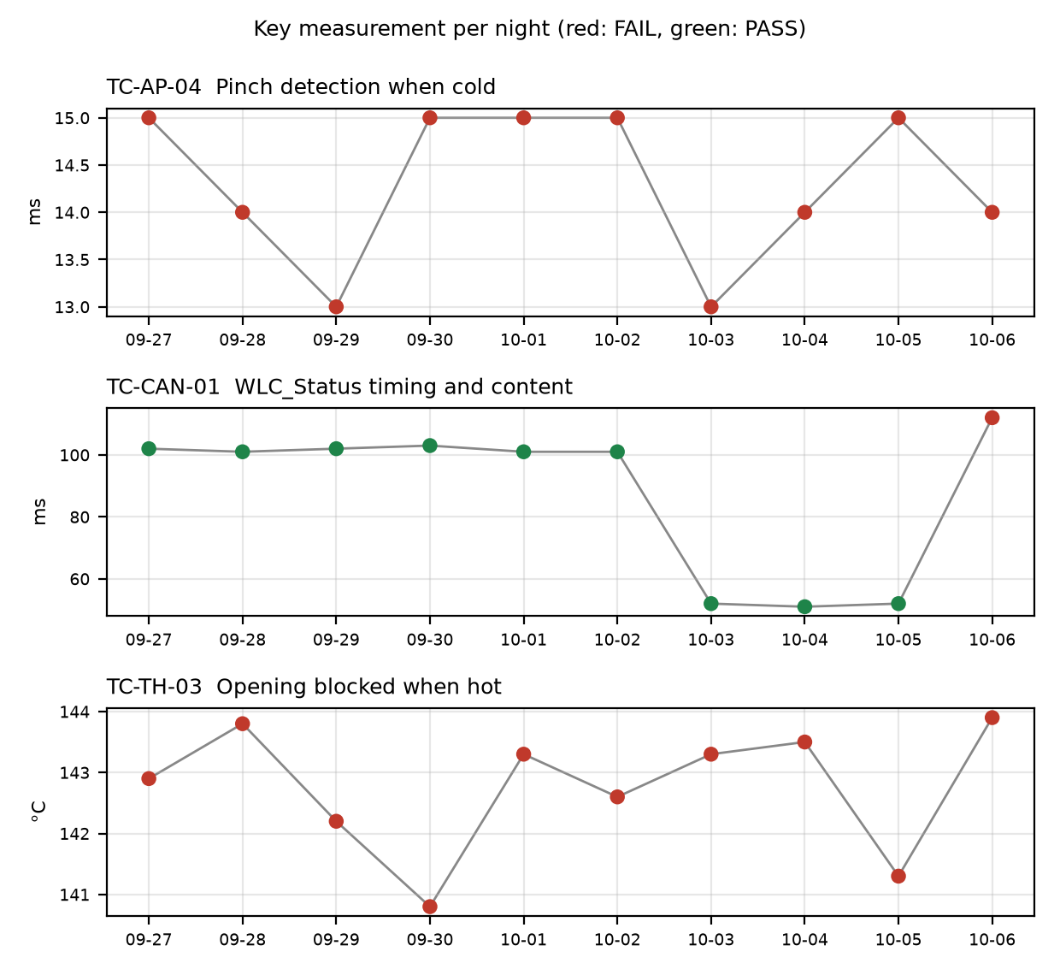

TC-AP-04
R04, Pinch detection when cold: stop_latency_ms was 14 ms against a limit of <= 10 ms. reversal_mm passed at 158.0 mm. This is not new. It has failed on 10 of 10 nights, under both v1.2 and v1.3, and the limit was <= 10 on every night. Values over the history ran from 13.0 to 15.0 ms. Open defect DR-1001 (S1, 'Pinch reversal late at -30 °C') is linked. The run also logged that the temperature estimate at start was -22 C while the chamber was set to -30 C.

TC-CAN-01
R09, WLC_Status timing and content: period_max_ms was 112 ms against the v1.3 limit of 45 to 55 ms. period_min_ms passed at 49 ms. This is a new failure tonight (1 failed night of 10). It passed on 2026-10-03, 2026-10-04 and 2026-10-05 at 52.0, 51.0 and 52.0 ms. The log shows a 112 ms gap between t=6383 and t=6495 ms, and a frame was probably skipped. No open defect is linked.

TC-TH-03
R10, Opening blocked when hot: two criteria failed. max_current_above_130C_a was 15.16 A against a limit of <= 15 A. There were 13 samples above 15 A while the estimate was above 130 C. The first was at t=39110 ms at 134.0 C, and they are described as end-stop stalls. opening_starts_above_140C was 1 against a limit of 0. Opening started at t=57050 ms at 143.9 C, and the controller completed full opening travel above 140 C with no inhibit. closing_possible_above_140C passed at 2 movements. This is not new. It has failed on 10 of 10 nights, under v1.2 and v1.3 with the same limit of no opening above 140. The opening-start temperature ran from 140.8 to 143.9 C over the history. Open defect DR-1012 (S3, 'Opening possible above 140 °C') is linked.

Anomalies on passing runs
- R04 (TC-AP-04): temperature estimate at start was -22 C but the chamber was set to -30 C. The soak may not have completed, or the estimate may be offset.
- R05 (TC-AP-05, PASS): temperature estimate at start was 93 C but the chamber was set to 85 C. The soak may not have completed, or the estimate may be offset.
- R05 (TC-AP-05, PASS): reversal_mm was 151 mm against a minimum of 150 mm, a margin of 1 mm.
- R12 (TC-DG-01, PASS): stop_after_hall_loss_ms was 203 ms against a minimum of 200 ms, a margin of 3 ms. Hall loss time is only known to within one Hall interval (4 ms), so the true latency is 199..203 ms and the 200 ms lower limit cannot be confirmed with certainty.
- R07 (TC-MV-05, PASS): end-stop stall current was 18.1 A, with a stall of 42 ms. This test has no limit for it.
- R10 (TC-TH-03): sampling was 10 ms. The log starts at about 112 C and was never cooled, so 'opening possible below 120 C' is not covered by this run.
- R09 (TC-CAN-01): the history switched from 90 to 110 ms under v1.2 to 45 to 55 ms under v1.3 on 2026-10-03. Tonight's 112 ms is outside both ranges.

Recommendations
- TC-CAN-01 (R09): open a defect for the 112 ms WLC_Status gap between t=6383 and t=6495 ms. Check the bus log for a skipped frame, and re-run on HIL-2 to see whether it repeats.
- TC-AP-04 (R04): raise the 10-night failure with the owner of DR-1001 (S1). Include that the stop latency stayed at 13.0 to 15.0 ms against <= 10 ms under both spec versions.
- TC-AP-04 (R04): check the chamber soak and the temperature-estimate offset on HIL-2. The start estimate was -22 C against a -30 C setpoint, so confirm the test ran at the intended temperature.
- TC-TH-03 (R10): add tonight's results to DR-1012: opening started at 143.9 C with full travel and no inhibit, and current peaked at 15.16 A against <= 15 A. Consider whether the current-over-limit finding needs its own defect, since DR-1012 covers only opening above 140 °C.
- TC-TH-03 (R10): extend the run to cool the unit so 'opening possible below 120 C' is covered.
- TC-AP-05 (R05): check the 93 C start estimate against the 85 C chamber setpoint, and re-check the 1 mm reversal margin (151 mm against a minimum of 150 mm).
- TC-DG-01 (R12): review the 203 ms result against the 200 ms lower limit given the 4 ms Hall interval. Decide whether the measurement resolution is acceptable for this limit.
- TC-MV-05 (R07): ask the requirements owner whether the 18.1 A end-stop stall current needs a limit.

Checks on this report
All numbers and IDs in the text match the fact sheet.

