WLC-200 Nightly HIL Report, 2026-10-06
Bench HIL-2 · software 2.4.0-rc3 · spec ADS-WLC200-SRS v1.3 · 9 passed, 3 failed of 12 runs
Draft. The text was written with AI assistance from the fact sheet; tables and charts were made by code, and every number in the text was checked against the data.

Summary
Night 2026-10-06, software 2.4.0-rc3, spec ADS-WLC200-SRS v1.3, bench HIL-2: 12 runs, 9 passed, 3 failed. TC-AP-04 (R04) and TC-TH-03 (R10) have failed on all 10 nights in the history. TC-CAN-01 (R09) is a new failure tonight, after passing on the 3 earlier nights under the v1.3 limit.

Results
Run | Test | Title | Result | Key value
R01 | TC-AP-01 | Pinch detection at nominal voltage | PASS | stop_latency_ms = 6 ms
R02 | TC-AP-02 | Pinch detection at low voltage | PASS | stop_latency_ms = 7 ms
R03 | TC-AP-03 | Pinch detection at high voltage | PASS | stop_latency_ms = 4 ms
R04 | TC-AP-04 | Pinch detection when cold | FAIL | stop_latency_ms = 14 ms
R05 | TC-AP-05 | Pinch detection when hot | PASS | stop_latency_ms = 6 ms
R06 | TC-AP-06 | Pinch protection in manual and express mode | PASS | stop_latency_ms = 5 ms
R07 | TC-MV-05 | Full close time | PASS | close_time_s = 3.816 s
R08 | TC-MV-01 | Manual movement and stop on release | PASS | stop_after_release_close_ms = 62 ms
R09 | TC-CAN-01 | WLC_Status timing and content | FAIL | period_max_ms = 112 ms
R10 | TC-TH-03 | Opening blocked when hot | FAIL | max_current_above_130C_a = 15.16 A
R11 | TC-PW-03 | Motor stop at undervoltage | PASS | stop_after_undervoltage_ms = 21 ms
R12 | TC-DG-01 | Hall sensor loss | PASS | dtc_code = B1A01

Failures
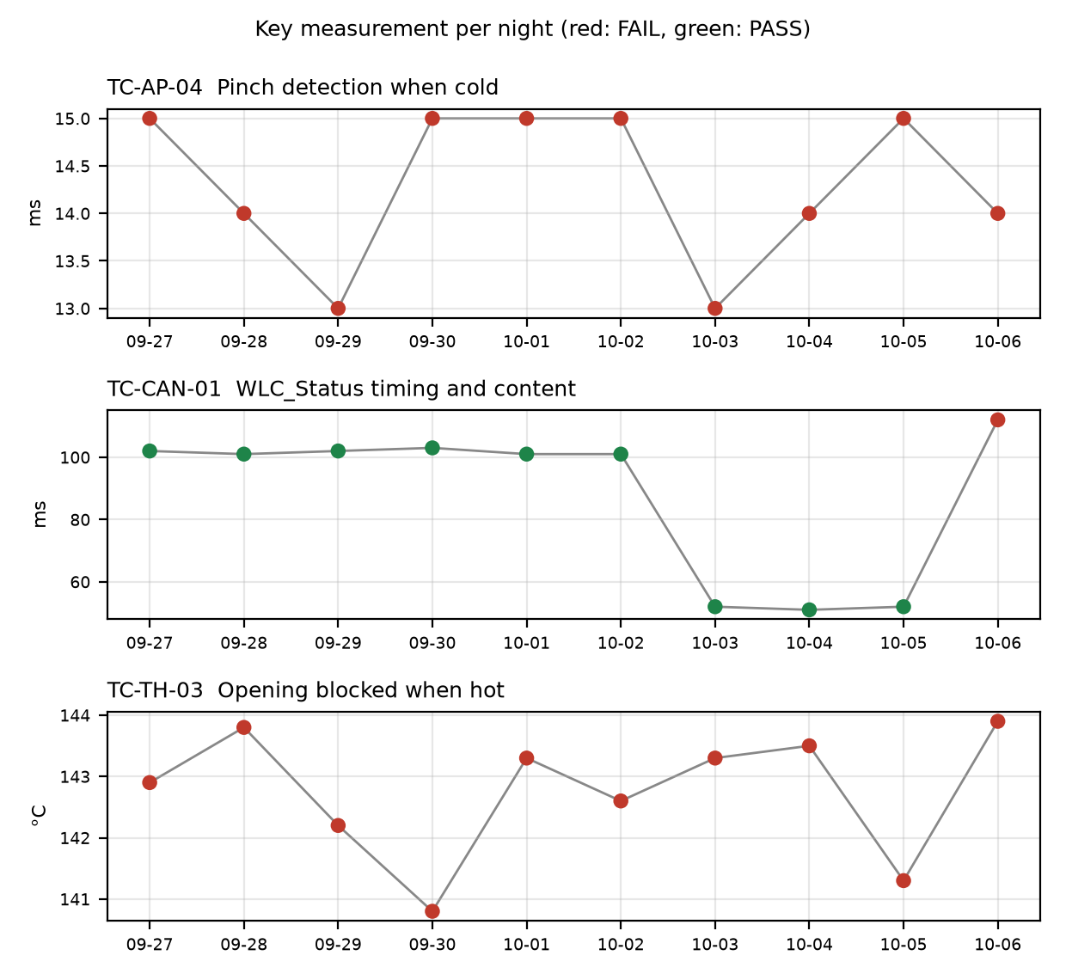

TC-AP-04
R04, Pinch detection when cold: stop_latency_ms was 14 ms against a limit of <= 10 ms. reversal_mm was 158.0 mm and passed. This is not new. It has failed on 10 of 10 nights, with values of 13 to 15 ms under both v1.2 and v1.3, and the limit was <= 10 on every night. Open defect: DR-1001 (S1, Pinch reversal late at -30 °C). The run's temperature estimate at start was -22 C with the chamber set to -30 C, so the soak may not have completed or the estimate may be offset.

TC-CAN-01
R09, WLC_Status timing and content: period_max_ms was 112 ms against the v1.3 limit of 45 to 55 ms. period_min_ms was 49 ms and passed. This is a new failure tonight (1 failed night of 10). It passed on 2026-10-03, 10-04 and 10-05 under v1.3 with 52, 51 and 52 ms. The log shows a 112 ms gap between t=6383 and t=6495 ms, and a frame was probably skipped. No open defect is linked.

TC-TH-03
R10, Opening blocked when hot: two criteria failed. max_current_above_130C_a was 15.16 A against a limit of <= 15 A, with 13 samples above 15 A while the estimate was above 130 C (first at t=39110 ms, 134.0 C), described as end-stop stalls. opening_starts_above_140C was 1 against a limit of 0: opening started at t=57050 ms at 143.9 C, and the controller completed full opening travel above 140 C with no inhibit. closing_possible_above_140C passed with 2 movements. This is not new. It has failed on 10 of 10 nights, with opening-start temperatures of 140.8 to 143.9 C against a limit of no opening above 140 on every night. Open defect: DR-1012 (S3, Opening possible above 140 °C).

Anomalies on passing runs
- R04 (TC-AP-04): temperature estimate at start was -22 C but the chamber was set to -30 C (soak not complete or estimate offset?).
- R05 (TC-AP-05, passed): temperature estimate at start was 93 C but the chamber was set to 85 C. reversal_mm was 151 mm against a min of 150 mm, a margin of 1 mm.
- R07 (TC-MV-05, passed): end-stop stall current was 18.1 A, lasting 42 ms. This test has no current limit.
- R10 (TC-TH-03): the log has 10 ms sampling and starts at about 112 C. It was never cooled, so 'opening possible below 120 C' is not covered by this run.
- R12 (TC-DG-01, passed): stop_after_hall_loss_ms was 203 ms against a min of 200 ms, a margin of 3 ms. Hall loss time is only known to within one Hall interval (4 ms), so the true latency is 199..203 ms and the 200 ms lower limit cannot be confirmed.

Recommendations
- TC-CAN-01 (R09): open a new defect for the 112 ms WLC_Status gap at t=6383 to 6495 ms. Check the bench log for a skipped frame and rerun tonight's configuration to see whether it repeats.
- TC-AP-04 (R04): raise the priority of DR-1001 (S1). The test has failed on all 10 nights. Check the chamber soak and the temperature estimate offset (-22 C against -30 C set) so the cold result is attributable to the software and not the bench.
- TC-TH-03 (R10): update DR-1012 (S3) with tonight's data: opening at 143.9 C, a peak of 15.16 A, and full opening travel with no inhibit. Because opening was not inhibited for 10 nights, review whether S3 is the right severity.
- TC-TH-03 (R10): add a cool-down segment to the test so that 'opening possible below 120 C' is covered, since the log starts at about 112 C.
- TC-AP-05 (R05): check the 93 C start estimate against the 85 C chamber setting. Recheck reversal_mm (151 mm, min 150 mm), because the margin is 1 mm.
- TC-DG-01 (R12): check the 203 ms result against the 200 ms lower limit. The 4 ms Hall interval means the limit cannot be confirmed. A finer timing resolution or a clarification of how the limit applies would settle this.

Checks on this report
All numbers and IDs in the text match the fact sheet.

