WLC-200 Nightly HIL Report, 2026-10-06
Bench HIL-2 · software 2.4.0-rc3 · spec ADS-WLC200-SRS v1.3 · 9 passed, 3 failed of 12 runs
Draft. The text was written with AI assistance from the fact sheet; tables and charts were made by code, and every number in the text was checked against the data.

Summary
Night 2026-10-06, software 2.4.0-rc3, spec ADS-WLC200-SRS v1.3, bench HIL-2: 12 runs, 9 passed, 3 failed. TC-AP-04 (R04) and TC-TH-03 (R10) have failed on all 10 nights in the history. TC-CAN-01 (R09) is a new failure tonight.

Results
Run | Test | Title | Result | Key value
R01 | TC-AP-01 | Pinch detection at nominal voltage | PASS | stop latency ms = 6 ms
R02 | TC-AP-02 | Pinch detection at low voltage | PASS | stop latency ms = 7 ms
R03 | TC-AP-03 | Pinch detection at high voltage | PASS | stop latency ms = 4 ms
R04 | TC-AP-04 | Pinch detection when cold | FAIL | stop latency ms = 14 ms
R05 | TC-AP-05 | Pinch detection when hot | PASS | stop latency ms = 6 ms
R06 | TC-AP-06 | Pinch protection in manual and express mode | PASS | stop latency ms = 5 ms
R07 | TC-MV-05 | Full close time | PASS | close time s = 3.816 s
R08 | TC-MV-01 | Manual movement and stop on release | PASS | stop after release close ms = 62 ms
R09 | TC-CAN-01 | WLC_Status timing and content | FAIL | period max ms = 112 ms
R10 | TC-TH-03 | Opening blocked when hot | FAIL | max current above 130C a = 15.16 A
R11 | TC-PW-03 | Motor stop at undervoltage | PASS | stop after undervoltage ms = 21 ms
R12 | TC-DG-01 | Hall sensor loss | PASS | dtc code = B1A01

Failures
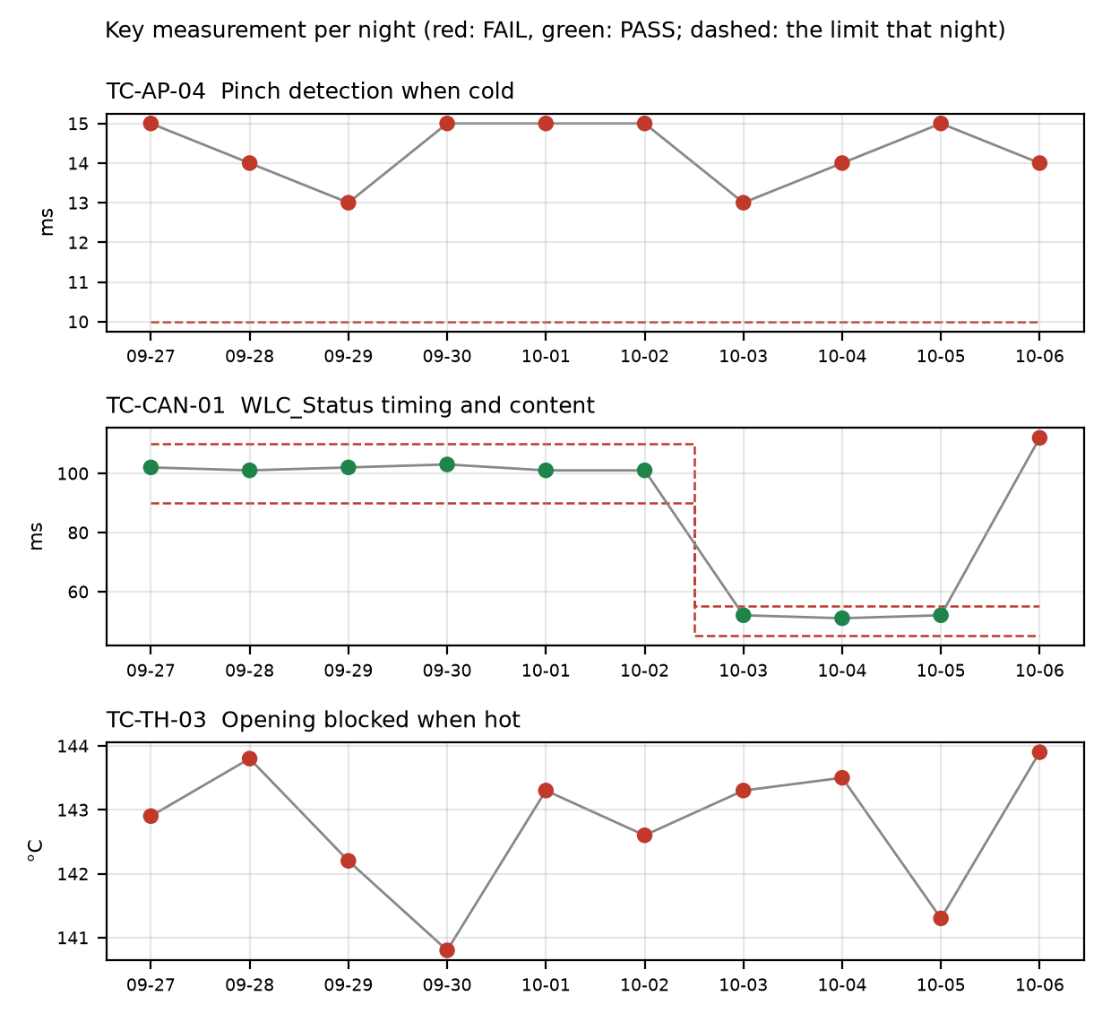

TC-AP-04
R04, Pinch detection when cold: stop_latency_ms was 14 ms against a limit of <= 10 ms. reversal_mm passed at 158.0 mm. This is not new: it has failed on 10 of 10 nights, on both v1.2 and v1.3, against the same <= 10 limit each night. Historical values range from 13.0 to 15.0 ms. Open defect DR-1001 (S1, 'Pinch reversal late at -30 °C') covers it. The run's start temperature estimate was -22 C against a chamber setpoint of -30 C, so the soak may not have been complete or the estimate may be offset.

TC-CAN-01
R09, WLC_Status timing and content: period_max_ms was 112 ms against the v1.3 limit of 45 to 55 ms. period_min_ms was 49 ms and within limits. This is a new failure tonight, after passes on 2026-10-03, 2026-10-04 and 2026-10-05 (51 to 52 ms on v1.3). The log shows a 112 ms gap between t=6383 and t=6495 ms, so a frame was probably skipped. No open defect is linked.

TC-TH-03
R10, Opening blocked when hot: three findings. (1) max_current_above_130C_a was 15.16 A against a limit of <= 15 A, with 13 samples above 15 A while the estimate was above 130 C (first at t=39110 ms at 134.0 C). The log notes these as end-stop stalls. (2) Opening started above 140 C at t=57050 ms (143.9 C), and the controller completed full opening travel with no inhibit. (3) closing_possible_above_140C passed with 2 movements. This is not new: the opening-above-140 C failure has occurred on 10 of 10 nights, with start temperatures from 140.8 to 143.9 C, against the same 'no opening above 140' limit on v1.2 and v1.3. Open defect DR-1012 (S3, 'Opening possible above 140 °C') covers it. The history does not show the current-limit failure, so whether it is new is not established.

Anomalies on passing runs
- R04 (TC-AP-04): temperature estimate at start was -22 C with the chamber set to -30 C (soak not complete or estimate offset).
- R05 (TC-AP-05, passed): temperature estimate at start was 93 C with the chamber set to 85 C (soak not complete or estimate offset).
- R05 (TC-AP-05, passed): reversal_mm was 151 mm against a min of 150 mm, a margin of 1 mm.
- R12 (TC-DG-01, passed): stop_after_hall_loss_ms was 203 ms against a min of 200 ms, a margin of 3 ms. Hall loss time is only known to within one Hall interval (4 ms), so the true latency is 199..203 ms and the 200 ms lower limit cannot be confirmed with certainty.
- R07 (TC-MV-05, passed): end-stop stall current was 18.1 A, with a stall of 42 ms. This test has no current limit.
- R10 (TC-TH-03): sampling was 10 ms and the log starts at about 112 C and was never cooled, so 'opening possible below 120 C' is not covered by this run.

Recommendations
- TC-CAN-01 (R09): open a defect for the 112 ms WLC_Status gap at t=6383 to 6495 ms. Check the bus log on HIL-2 and the 2.4.0-rc3 build for a skipped frame. Rerun to see whether it repeats.
- TC-AP-04 (R04): the failure has persisted for 10 nights under DR-1001 (S1). Add tonight's 14 ms result to the defect. Check the cold-soak and temperature-estimate offset (-22 C against -30 C) so the setup is ruled out as a contributor.
- TC-TH-03 (R10): add tonight's result (opening at 143.9 C, full travel without inhibit) to DR-1012. Consider whether S3 still fits, given 10 straight nights of failure with no inhibit above 140 C.
- TC-TH-03 (R10): decide whether the 15.16 A current finding (end-stop stalls above 130 C) belongs under DR-1012 or needs its own defect.
- TC-TH-03 (R10): change the test so the log is cooled and covers 'opening possible below 120 C'. Tonight's run does not check it.
- TC-DG-01 (R12): review the 203 ms result against the 200 ms lower limit, since the 4 ms Hall interval leaves the true latency at 199..203 ms. Decide whether the measurement resolution is acceptable.
- TC-AP-05 (R05): check the 151 mm reversal against the 150 mm min limit (1 mm margin), and the 93 C start estimate against the 85 C chamber setting.

Checks on this report
All numbers and IDs in the text match the fact sheet.

