WLC-200 Nightly HIL Report, 2026-10-06
Bench HIL-2 · software 2.4.0-rc3 · spec ADS-WLC200-SRS v1.3 · 9 passed, 3 failed of 12 runs
Draft. The text was written with AI assistance from the fact sheet; tables and charts were made by code, and every number in the text was checked against the data.

Summary
Night 2026-10-06, software 2.4.0-rc3, spec ADS-WLC200-SRS v1.3, bench HIL-2: 12 runs, 9 passed, 3 failed. TC-AP-04 (R04) and TC-TH-03 (R10) have failed on all 10 nights in the history. TC-CAN-01 (R09) is a new failure tonight.

Results
Run | Test | Title | Result | Key value
R01 | TC-AP-01 | Pinch detection at nominal voltage | PASS | stop latency ms = 6 ms
R02 | TC-AP-02 | Pinch detection at low voltage | PASS | stop latency ms = 7 ms
R03 | TC-AP-03 | Pinch detection at high voltage | PASS | stop latency ms = 4 ms
R04 | TC-AP-04 | Pinch detection when cold | FAIL | stop latency ms = 14 ms
R05 | TC-AP-05 | Pinch detection when hot | PASS | stop latency ms = 6 ms
R06 | TC-AP-06 | Pinch protection in manual and express mode | PASS | stop latency ms = 5 ms
R07 | TC-MV-05 | Full close time | PASS | close time s = 3.816 s
R08 | TC-MV-01 | Manual movement and stop on release | PASS | stop after release close ms = 62 ms
R09 | TC-CAN-01 | WLC_Status timing and content | FAIL | period max ms = 112 ms
R10 | TC-TH-03 | Opening blocked when hot | FAIL | max current above 130C a = 15.16 A
R11 | TC-PW-03 | Motor stop at undervoltage | PASS | stop after undervoltage ms = 21 ms
R12 | TC-DG-01 | Hall sensor loss | PASS | dtc code = B1A01

Failures
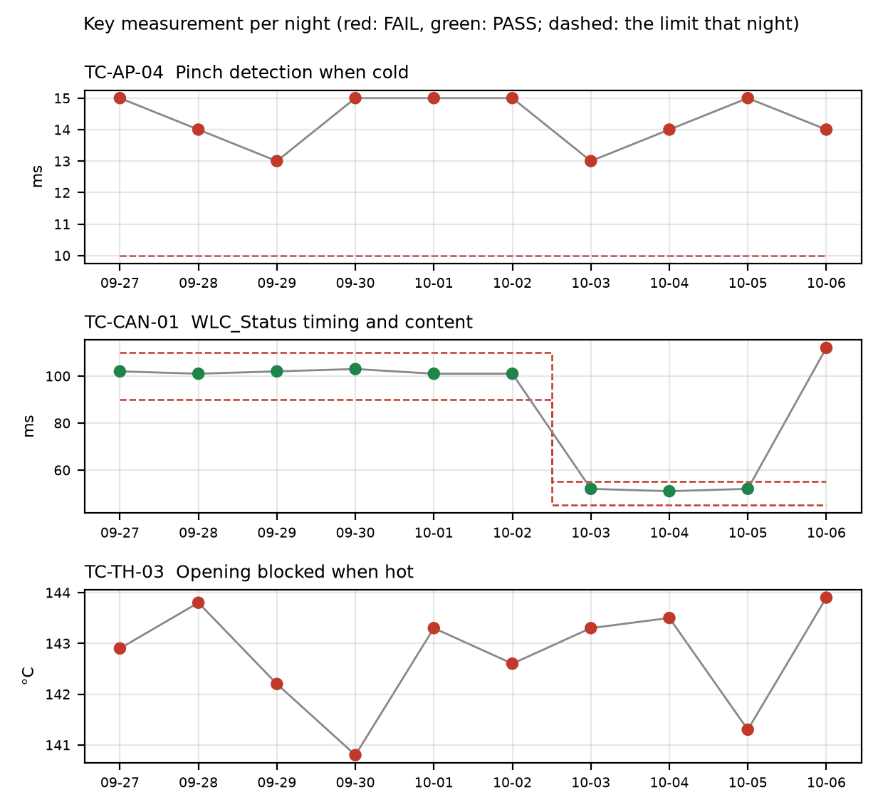

TC-AP-04
R04, Pinch detection when cold: stop_latency_ms was 14 ms against a limit of <= 10 ms. reversal_mm passed at 158.0 mm. This is not new: it has failed on 10 of 10 nights, on both v1.2 and v1.3, against the same <= 10 limit each night. Values over the history ran from 13.0 to 15.0 ms. Open defect DR-1001 (S1, 'Pinch reversal late at -30 °C') covers it. The run also notes the temperature estimate at start was -22 C with the chamber set to -30 C.

TC-CAN-01
R09, WLC_Status timing and content: period_max_ms was 112 ms against the v1.3 limit of 45 to 55 ms. period_min_ms passed at 49 ms. This is a new failure tonight: it passed on the previous 9 nights, 6 on v1.2 against 90 to 110 and 3 on v1.3 against 45 to 55. The v1.3 values on 2026-10-03, 10-04 and 10-05 were 52.0, 51.0 and 52.0 ms. The log shows a 112 ms gap between t=6383 and t=6495 ms, and a frame was probably skipped. No open defect is linked.

TC-TH-03
R10, Opening blocked when hot: two criteria failed. max_current_above_130C_a was 15.16 A against a limit of <= 15 A, with 13 samples above 15 A while the estimate was above 130 C (first at t=39110 ms at 134.0 C), described as end-stop stalls. opening_starts_above_140C was 1 against a limit of 0: opening started at t=57050 ms at 143.9 C, and the controller completed full opening travel with no inhibit. This is not new: the opening-above-140 C check has failed on 10 of 10 nights, with values from 140.8 to 143.9 C, against 'no opening above 140' each night. Open defect DR-1012 (S3, 'Opening possible above 140 °C') covers it. The history sheet does not give the current criterion's history. closing_possible_above_140C passed with 2 movements.

Anomalies on passing runs
- R05 (TC-AP-05, PASS): reversal_mm of 151 mm is within 2% of its 150 mm minimum (margin 1 mm).
- R05 (TC-AP-05): temperature estimate at start was 93 C with the chamber set to 85 C (soak not complete or estimate offset).
- R04 (TC-AP-04): temperature estimate at start was -22 C with the chamber set to -30 C. Same pattern as R05, in the cold direction.
- R12 (TC-DG-01, PASS): stop_after_hall_loss_ms of 203 ms is close to its 200 ms minimum (margin 3 ms). Hall loss time is only known to within one Hall interval (4 ms), so true latency is 199..203 ms and the 200 ms limit cannot be confirmed with certainty.
- R07 (TC-MV-05, PASS): end-stop stall current of 18.1 A, lasting 42 ms. This test has no current limit.
- R10 (TC-TH-03): the log starts at about 112 C and was never cooled, so 'opening possible below 120 C' is not covered by this run. Sampling was 10 ms.

Recommendations
- TC-CAN-01 (R09): Open a defect for the 112 ms WLC_Status gap at t=6383 to 6495 ms in R09. Check the bench CAN log and HIL-2 load at that time to tell a skipped frame in the controller from a logging artefact. Then compare with R09 on the next night, since this is the first failure on v1.3.
- TC-AP-04 (R04): Raise the priority of DR-1001 (S1). The test has failed on all 10 nights at 13.0 to 15.0 ms against a limit of <= 10 ms, and the limit did not change with v1.3. Also check the cold soak: the estimate at start was -22 C against the -30 C chamber setting, so confirm the test actually ran at -30 C.
- TC-TH-03 (R10): Add tonight's findings to DR-1012: opening started at 143.9 C, full travel was completed, and the current peaked at 15.16 A against the 15 A limit. Consider whether the end-stop stalls above 130 C need their own defect, since none is linked.
- TC-TH-03 (R10): Rerun with a cool-down so that 'opening possible below 120 C' is covered.
- TC-AP-05 (R05): Check the 151 mm reversal margin against its 150 mm limit, and check the 93 C start estimate against the 85 C chamber setting. Do the same for TC-DG-01 (R12) and its 203 ms result against the 200 ms limit, with the 4 ms Hall interval in mind.

Checks on this report
All numbers and IDs in the text match the fact sheet.

