Please enter a MongoDB connection string (Default: mongodb://localhost/):

Current Mongosh Log ID: 6618eda6de6220de619f9909

Connecting to: mongodb://127.0.0.1:27017/?directConnection=true&serverSelectionTimeoutMS=2000&appName=mongosh+2.2.2

Using MongoDB: 7.0.7

Using Mongosh: 2.2.2

For mongosh info see: https://docs.mongodb.com/mongodb-shell/

------

The server generated these startup warnings when booting

2024-04-12T08:35:48.893+05:30: Access control is not enabled for the database. Read and write access to data and configuration is unrestricted

------

Warning: Found ~/.mongorc.js, but not ~/.mongoshrc.js. ~/.mongorc.js will not be loaded.

You may want to copy or rename ~/.mongorc.js to ~/.mongoshrc.js.

test> use student

switched to db student

student> db.student.insertmany([{name:"aditya",street:"kuruppanthara",city:"kottayam",department:"mca"}])

TypeError: db.student.insertmany is not a function

student> db.student.insertMany([{name:"aditya",street:"kuruppanthara",city:"kottayam",department:"mca"}])

{

acknowledged: true,

insertedIds: { '0': ObjectId('6618f0c4de6220de619f990a') }

}

student> db.student.insertMany([{name:"abin",street:"elanji",city:"eranalkkulam",department:"mca"}])

{

acknowledged: true,

insertedIds: { '0': ObjectId('6618f103de6220de619f990b') }

}

student> db.student.insertMany([{name:"afna",street:"vazhamattam",city:"erattupetta",department:"mca"}])

{

acknowledged: true,

insertedIds: { '0': ObjectId('6618f138de6220de619f990c') }

}

student> db.student.insertMany([{name:"abhirami",street:"poovarani",city:"plalai",department:"mca"}])

{

acknowledged: true,

insertedIds: { '0': ObjectId('6618f1e6de6220de619f990d') }

}

student> db.student.insertMany([{name:"ajay",street:"elanji",city:"eranakulam",department:"mca"}])

{

acknowledged: true,

insertedIds: { '0': ObjectId('6618f221de6220de619f990e') }

}

student> db.student.insertMany([{name:"ananthan",street:"ayarkunnam",city:"kottayam",department:"mca"}])

{

acknowledged: true,

insertedIds: { '0': ObjectId('6618f2b9de6220de619f990f') }

}

**student> db.student.find()**

[

{

_id: ObjectId('6618f0c4de6220de619f990a'),

name: 'aditya',

street: 'kuruppanthara',

city: 'kottayam',

department: 'mca'

},

{

_id: ObjectId('6618f103de6220de619f990b'),

name: 'abin',

street: 'elanji',

city: 'eranalkkulam',

department: 'mca'

},

{

_id: ObjectId('6618f138de6220de619f990c'),

name: 'afna',

street: 'vazhamattam',

city: 'erattupetta',

department: 'mca'

},

{

_id: ObjectId('6618f1e6de6220de619f990d'),

name: 'abhirami',

street: 'poovarani',

city: 'plalai',

department: 'mca'

},

{

_id: ObjectId('6618f221de6220de619f990e'),

name: 'ajay',

street: 'elanji',

city: 'eranakulam',

department: 'mca'

},

{

_id: ObjectId('6618f2b9de6220de619f990f'),

name: 'ananthan',

street: 'ayarkunnam',

city: 'kottayam',

department: 'mca'

}

]

**student> db.student.updateMany({},{$set:{salary:10000}})**

{

acknowledged: true,

insertedId: null,

matchedCount: 6,

modifiedCount: 6,

upsertedCount: 0

}

**student> db.student.updateOne({name:"ajay"},{$set:{salary:25000}})**

{

acknowledged: true,

insertedId: null,

matchedCount: 1,

modifiedCount: 1,

upsertedCount: 0

}

**student> db.student.updateOne({name:"ananthan"},{$set:{salary:35000}})**

{

acknowledged: true,

insertedId: null,

matchedCount: 1,

modifiedCount: 1,

upsertedCount: 0

}

**student> db.student.updateOne({name:"afna"},{$set:{salary:30000}})**

{

acknowledged: true,

insertedId: null,

matchedCount: 1,

modifiedCount: 1,

upsertedCount: 0

}

**student> db.student.updateOne({name:"aditya"},{$set:{salary:40000}})**

{

acknowledged: true,

insertedId: null,

matchedCount: 1,

modifiedCount: 1,

upsertedCount: 0

}

student>

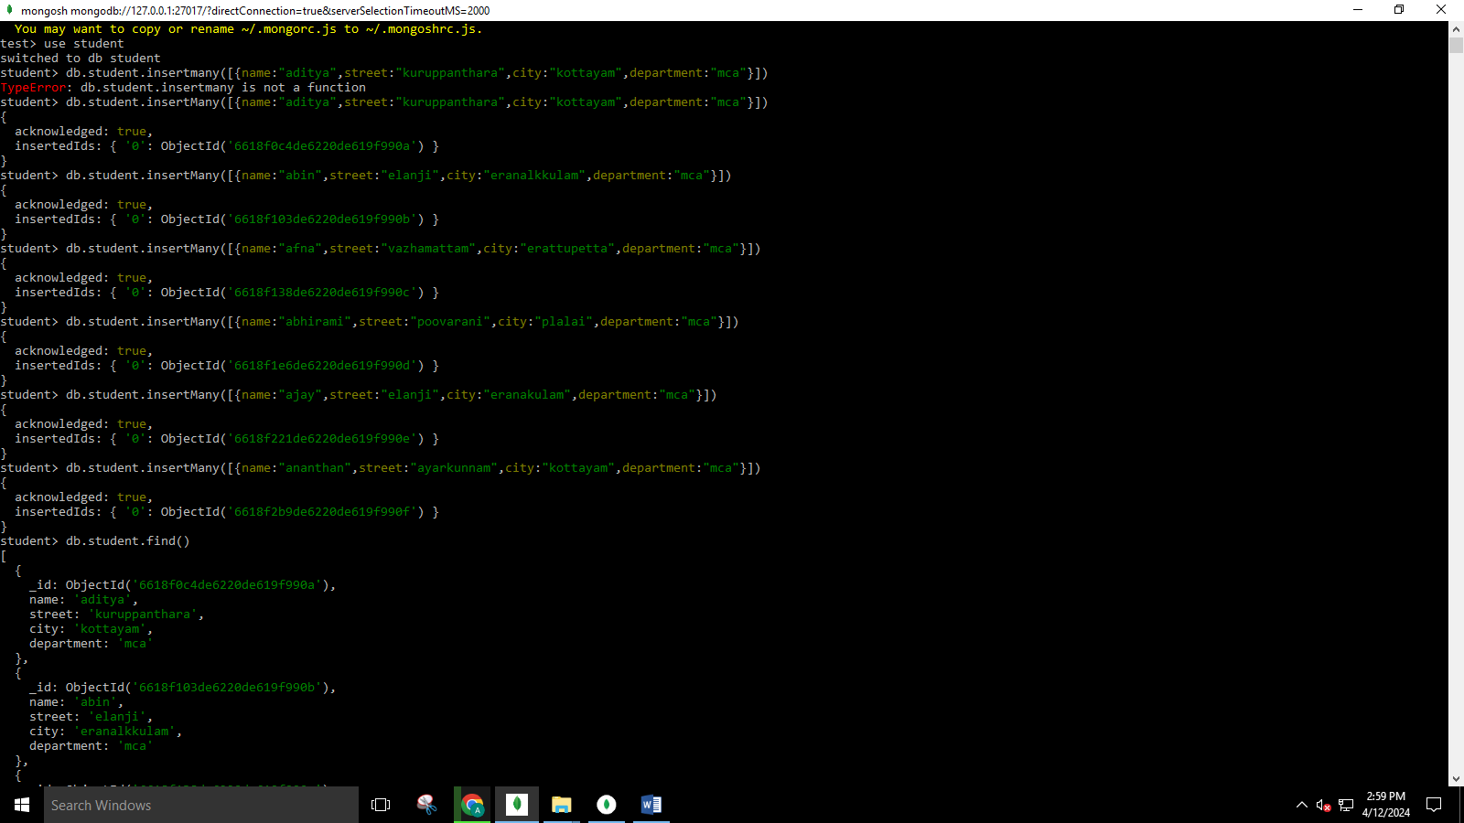

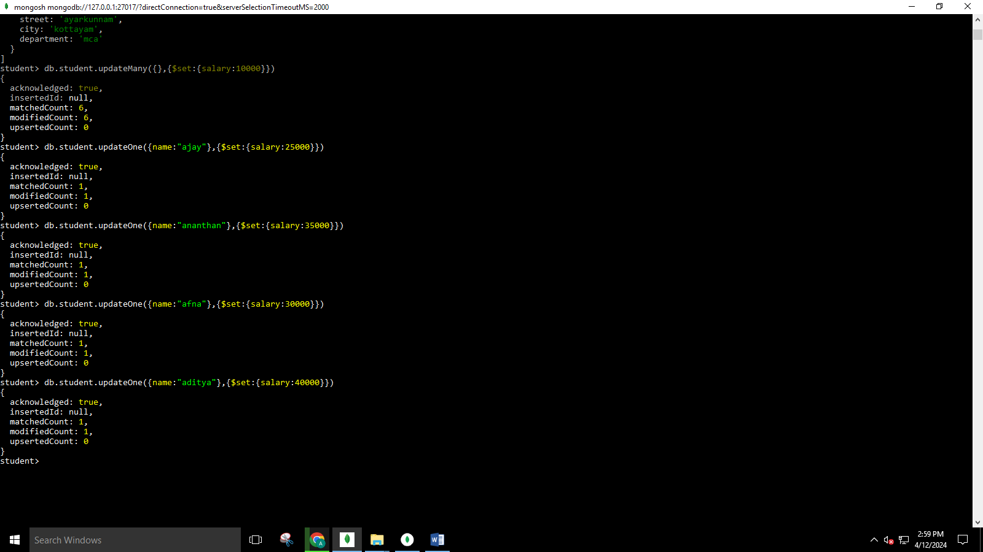

**student> db.student.find()**

[

{

_id: ObjectId('6618f0c4de6220de619f990a'),

name: 'aditya',

street: 'kuruppanthara',

city: 'kottayam',

department: 'mca',

salary: 40000

},

{

_id: ObjectId('6618f103de6220de619f990b'),

name: 'abin',

street: 'elanji',

city: 'eranalkkulam',

department: 'mca',

salary: 10000

},

{

_id: ObjectId('6618f138de6220de619f990c'),

name: 'afna',

street: 'vazhamattam',

city: 'erattupetta',

department: 'mca',

salary: 30000

},

{

_id: ObjectId('6618f1e6de6220de619f990d'),

name: 'abhirami',

street: 'poovarani',

city: 'palai',

department: 'mca',

salary: 10000

},

{

_id: ObjectId('6618f221de6220de619f990e'),

name: 'ajay',

street: 'elanji',

city: 'eranakulam',

department: 'mca',

salary: 25000

},

{

_id: ObjectId('6618f2b9de6220de619f990f'),

name: 'ananthan',

street: 'ayarkunnam',

city: 'kottayam',

department: 'mca',

salary: 35000

}

]

**student> db.student.deleteOne({salary:10000})**

{ acknowledged: true, deletedCount: 1 }

student> db.student.find()

[

{

_id: ObjectId('6618f0c4de6220de619f990a'),

name: 'aditya',

street: 'kuruppanthara',

city: 'kottayam',

department: 'mca',

salary: 40000

},

{

_id: ObjectId('6618f138de6220de619f990c'),

name: 'afna',

street: 'vazhamattam',

city: 'erattupetta',

department: 'mca',

salary: 30000

},

{

_id: ObjectId('6618f1e6de6220de619f990d'),

name: 'abhirami',

street: 'poovarani',

city: 'palai',

department: 'mca',

salary: 10000

},

{

_id: ObjectId('6618f221de6220de619f990e'),

name: 'ajay',

street: 'elanji',

city: 'eranakulam',

department: 'mca',

salary: 25000

},

{

_id: ObjectId('6618f2b9de6220de619f990f'),

name: 'ananthan',

street: 'ayarkunnam',

city: 'kottayam',

department: 'mca',

salary: 35000

}

]

**student> db.student.find().sort({salary:-1})**

[

{

_id: ObjectId('6618f0c4de6220de619f990a'),

name: 'aditya',

street: 'kuruppanthara',

city: 'kottayam',

department: 'mca',

salary: 40000

},

{

_id: ObjectId('6618f2b9de6220de619f990f'),

name: 'ananthan',

street: 'ayarkunnam',

city: 'kottayam',

department: 'mca',

salary: 35000

},

{

_id: ObjectId('6618f138de6220de619f990c'),

name: 'afna',

street: 'vazhamattam',

city: 'erattupetta',

department: 'mca',

salary: 30000

},

{

_id: ObjectId('6618f221de6220de619f990e'),

name: 'ajay',

street: 'elanji',

city: 'eranakulam',

department: 'mca',

salary: 25000

},

{

_id: ObjectId('6618f1e6de6220de619f990d'),

name: 'abhirami',

street: 'poovarani',

city: 'palai',

department: 'mca',

salary: 10000

}

]

**student> db.student.find().sort({name:1})**

[

{

_id: ObjectId('6618f1e6de6220de619f990d'),

name: 'abhirami',

street: 'poovarani',

city: 'palai',

department: 'mca',

salary: 10000

},

{

_id: ObjectId('6618f0c4de6220de619f990a'),

name: 'aditya',

street: 'kuruppanthara',

city: 'kottayam',

department: 'mca',

salary: 40000

},

{

_id: ObjectId('6618f138de6220de619f990c'),

name: 'afna',

street: 'vazhamattam',

city: 'erattupetta',

department: 'mca',

salary: 30000

},

{

_id: ObjectId('6618f221de6220de619f990e'),

name: 'ajay',

street: 'elanji',

city: 'eranakulam',

department: 'mca',

salary: 25000

},

{

_id: ObjectId('6618f2b9de6220de619f990f'),

name: 'ananthan',

street: 'ayarkunnam',

city: 'kottayam',

department: 'mca',

salary: 35000

}

]

**student> db.student.find().sort({name:-1})**

[

{

_id: ObjectId('6618f2b9de6220de619f990f'),

name: 'ananthan',

street: 'ayarkunnam',

city: 'kottayam',

department: 'mca',

salary: 35000

},

{

_id: ObjectId('6618f221de6220de619f990e'),

name: 'ajay',

street: 'elanji',

city: 'eranakulam',

department: 'mca',

salary: 25000

},

{

_id: ObjectId('6618f138de6220de619f990c'),

name: 'afna',

street: 'vazhamattam',

city: 'erattupetta',

department: 'mca',

salary: 30000

},

{

_id: ObjectId('6618f0c4de6220de619f990a'),

name: 'aditya',

street: 'kuruppanthara',

city: 'kottayam',

department: 'mca',

salary: 40000

},

{

_id: ObjectId('6618f1e6de6220de619f990d'),

name: 'abhirami',

street: 'poovarani',

city: 'palai',

department: 'mca',

salary: 10000

}

]

**student> db.student.find().sort({salary:-1}).limit(1)**

[

{

_id: ObjectId('6618f0c4de6220de619f990a'),

name: 'aditya',

street: 'kuruppanthara',

city: 'kottayam',

department: 'mca',

salary: 40000

}

]

**student> db.student.countDocuments()**

5

**student> db.student.find({},{name:1,salary:1}).sort({salary:-1}).limit(1)**

[

{

_id: ObjectId('6618f0c4de6220de619f990a'),

name: 'aditya',

salary: 40000

}

]

**student> db.student.find({},{name:1,salary:1})**

[

{

_id: ObjectId('6618f0c4de6220de619f990a'),

name: 'aditya',

salary: 40000

},

{

_id: ObjectId('6618f138de6220de619f990c'),

name: 'afna',

salary: 30000

},

{

_id: ObjectId('6618f1e6de6220de619f990d'),

name: 'abhirami',

salary: 10000

},

{

_id: ObjectId('6618f221de6220de619f990e'),

name: 'ajay',

salary: 25000

},

{

_id: ObjectId('6618f2b9de6220de619f990f'),

name: 'ananthan',

salary: 35000

}

]

**student> db.student.find({},{_id:0,name:1,salary:1})**

[

{ name: 'aditya', salary: 40000 },

{ name: 'afna', salary: 30000 },

{ name: 'abhirami', salary: 10000 },

{ name: 'ajay', salary: 25000 },

{ name: 'ananthan', salary: 35000 }

]

LAB PROGRAM

test> use Amrutha

switched to db Amrutha

Amrutha> db.createCollection('Student');

{ ok: 1 }

Amrutha> db.Student.insert({'Rno':'1','Name':'piyush','Class':'TE COMP'});

DeprecationWarning: Collection.insert() is deprecated. Use insertOne, insertMany, or bulkWrite.

{

acknowledged: true,

insertedIds: { '0': ObjectId('661cfd2dca6de759f09f990a') }

}

Amrutha> db.Student.insert({'Rno':'2','Name':'Abhi','Class':'TE COMP'});

{

acknowledged: true,

insertedIds: { '0': ObjectId('661cfdd1ca6de759f09f990b') }

}

Amrutha> db.Student.insert({'Rno':'3','Name':'Ashley','Class':'TE COMP'});

{

acknowledged: true,

insertedIds: { '0': ObjectId('661cfe24ca6de759f09f990c') }

}

Amrutha> db.Student.insert({'Rno':'4','Name':'Hitesh','Class':'TE COMP'});

{

acknowledged: true,

insertedIds: { '0': ObjectId('661cfe60ca6de759f09f990d') }

}

Amrutha> db.Student.insert({'Rno':'5','Name':'Pratik','Class':'TE COMP'});

{

acknowledged: true,

insertedIds: { '0': ObjectId('661cfe8fca6de759f09f990e') }

}

Amrutha> db.Student.find();

[

{

_id: ObjectId('661cfd2dca6de759f09f990a'),

Rno: '1',

Name: 'piyush',

Class: 'TE COMP'

},

{

_id: ObjectId('661cfdd1ca6de759f09f990b'),

Rno: '2',

Name: 'Abhi',

Class: 'TE COMP'

},

{

_id: ObjectId('661cfe24ca6de759f09f990c'),

Rno: '3',

Name: 'Ashley',

Class: 'TE COMP'

},

{

_id: ObjectId('661cfe60ca6de759f09f990d'),

Rno: '4',

Name: 'Hitesh',

Class: 'TE COMP'

},

{

_id: ObjectId('661cfe8fca6de759f09f990e'),

Rno: '5',

Name: 'Pratik',

Class: 'TE COMP'

}

]

Amrutha> db.Student.find().pretty();

[

{

_id: ObjectId('661cfd2dca6de759f09f990a'),

Rno: '1',

Name: 'piyush',

Class: 'TE COMP'

},

{

_id: ObjectId('661cfdd1ca6de759f09f990b'),

Rno: '2',

Name: 'Abhi',

Class: 'TE COMP'

},

{

_id: ObjectId('661cfe24ca6de759f09f990c'),

Rno: '3',

Name: 'Ashley',

Class: 'TE COMP'

},

{

_id: ObjectId('661cfe60ca6de759f09f990d'),

Rno: '4',

Name: 'Hitesh',

Class: 'TE COMP'

},

{

_id: ObjectId('661cfe8fca6de759f09f990e'),

Rno: '5',

Name: 'Pratik',

Class: 'TE COMP'

}

]

Amrutha> db.Student.update({'Name':'Hitesh'},{$set: {'Name':'Henry'}});

DeprecationWarning: Collection.update() is deprecated. Use updateOne, updateMany, or bulkWrite.

{

acknowledged: true,

insertedId: null,

matchedCount: 1,

modifiedCount: 1,

upsertedCount: 0

}

Amrutha> db.Student.find().pretty();

[

{

_id: ObjectId('661cfd2dca6de759f09f990a'),

Rno: '1',

Name: 'piyush',

Class: 'TE COMP'

},

{

_id: ObjectId('661cfdd1ca6de759f09f990b'),

Rno: '2',

Name: 'Abhi',

Class: 'TE COMP'

},

{

_id: ObjectId('661cfe24ca6de759f09f990c'),

Rno: '3',

Name: 'Ashley',

Class: 'TE COMP'

},

{

_id: ObjectId('661cfe60ca6de759f09f990d'),

Rno: '4',

Name: 'Henry',

Class: 'TE COMP'

},

{

_id: ObjectId('661cfe8fca6de759f09f990e'),

Rno: '5',

Name: 'Pratik',

Class: 'TE COMP'

}

]

Amrutha> db.Student.remove({'Rno':'1'});

{ acknowledged: true, deletedCount: 1 }

Amrutha> db.Student.find();

[

{

_id: ObjectId('661cfdd1ca6de759f09f990b'),

Rno: '2',

Name: 'Abhi',

Class: 'TE COMP'

},

{

_id: ObjectId('661cfe24ca6de759f09f990c'),

Rno: '3',

Name: 'Ashley',

Class: 'TE COMP'

},

{

_id: ObjectId('661cfe60ca6de759f09f990d'),

Rno: '4',

Name: 'Henry',

Class: 'TE COMP'

},

{

_id: ObjectId('661cfe8fca6de759f09f990e'),

Rno: '5',

Name: 'Pratik',

Class: 'TE COMP'

}

]

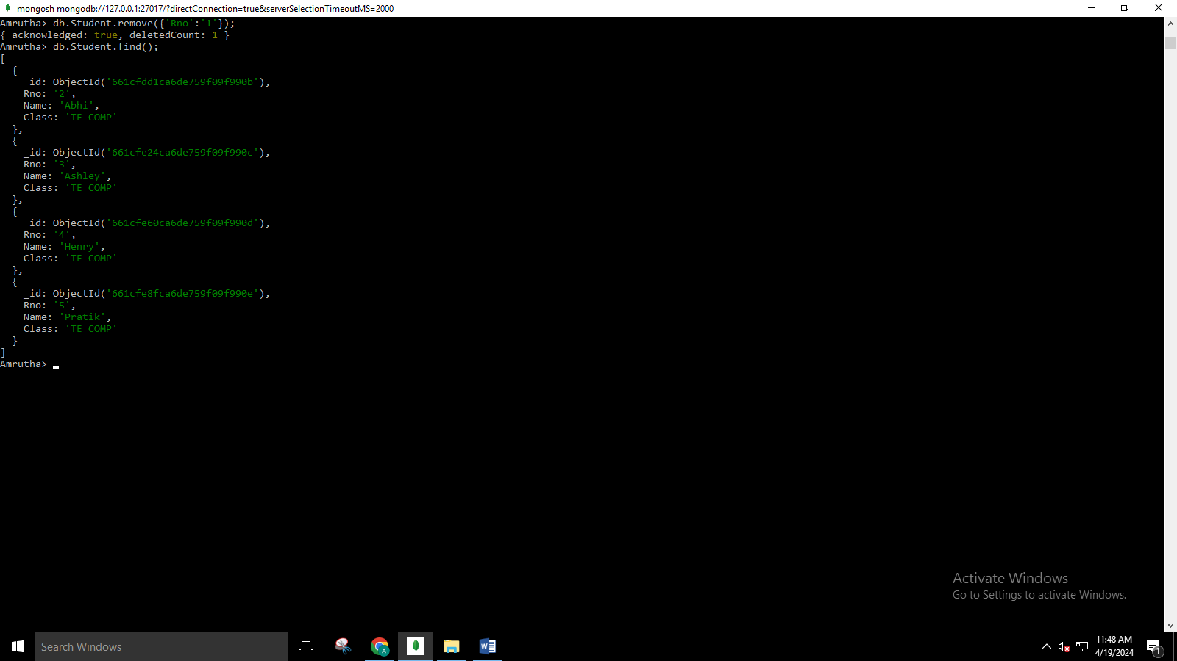

Amrutha> db.Student.find({$and:[{"Name":"Pratik"}, {"Rno":"5"}]}).pretty();

[

{

_id: ObjectId('661cfe8fca6de759f09f990e'),

Rno: '5',

Name: 'Pratik',

Class: 'TE COMP'

}

]

Amrutha> db.Student.find({$or:[{"Name":"Pratik"},{"Rno":"2"}]}).pretty();

[

{

_id: ObjectId('661cfdd1ca6de759f09f990b'),

Rno: '2',

Name: 'Abhi',

Class: 'TE COMP'

},

{

_id: ObjectId('661cfe8fca6de759f09f990e'),

Rno: '5',

Name: 'Pratik',

Class: 'TE COMP'

}

]

