SQL*Plus: Release 12.1.0.1.0 Production on Fri Feb 9 15:23:02 2024

Copyright (c) 1982, 2013, Oracle. All rights reserved.

Enter user-name: c23mca004@oracle

Enter password:mca

Last Successful login time: Fri Feb 09 2024 09:59:05 +05:30

Connected to:

Oracle Database 12c Enterprise Edition Release 12.1.0.2.0 - 64bit Production

With the Partitioning, OLAP, Advanced Analytics and Real Application Testing options

SQL> CREATE TABLE EMPLOY(EMPNO NUMBER(10),ENAME VARCHAR(20),JOB VARCHAR(20),SAL NUMBER(10));

Table created.

SQL> INSERT INTO EMPLOY VALUES(&EMPNO,'&ENAME','&JOB',&SAL);

Enter value for empno: 123

Enter value for ename: ANNA

Enter value for job: ANALYST

Enter value for sal: 250000

old 1: INSERT INTO EMPLOY VALUES(&EMPNO,'&ENAME','&JOB',&SAL)

new 1: INSERT INTO EMPLOY VALUES(123,'ANNA','ANALYST',250000)

1 row created.

SQL> INSERT INTO EMPLOY VALUES(&EMPNO,'&ENAME','&JOB',&SAL);

Enter value for empno: 124

Enter value for ename: AADHI

Enter value for job: CEO

Enter value for sal: 500000000

old 1: INSERT INTO EMPLOY VALUES(&EMPNO,'&ENAME','&JOB',&SAL)

new 1: INSERT INTO EMPLOY VALUES(124,'AADHI','CEO',500000000)

1 row created.

SQL> INSERT INTO EMPLOY VALUES(&EMPNO,'&ENAME','&JOB',&SAL);

Enter value for empno: 125

Enter value for ename: JAYA

Enter value for job: CLERK

Enter value for sal: 12000000

old 1: INSERT INTO EMPLOY VALUES(&EMPNO,'&ENAME','&JOB',&SAL)

new 1: INSERT INTO EMPLOY VALUES(125,'JAYA','CLERK',12000000)

1 row created.

SQL> SELECT * FROM EMPLOY;

EMPNO ENAME JOB SAL

---------- -------------------- -------------------- ----------

123 ANNA ANALYST 250000

124 AADHI CEO 500000000

125 JAYA CLERK 12000000

SQL> DESC EMPLOY

Name Null? Type

----------------------------------------- -------- ----------------------------

EMPNO NUMBER(10)

ENAME VARCHAR2(20)

JOB VARCHAR2(20)

SAL NUMBER(10)

SQL> ALTER TABLE EMPLOY ADD(COMMISION VARCHAR(20));

Table altered.

SQL> UPDATE EMPLOY SET SAL='5000000' WHERE EMPNO=124;

1 row updated.

SQL> INSERT INTO EMPLOY VALUES(&EMPNO,'&ENAME','&JOB',&SAL,&COMMISION);

Enter value for empno: 126

Enter value for ename: AS

Enter value for job: SD

Enter value for sal: 120000

Enter value for commision: 120

old 1: INSERT INTO EMPLOY VALUES(&EMPNO,'&ENAME','&JOB',&SAL,&COMMISION)

new 1: INSERT INTO EMPLOY VALUES(126,'AS','SD',120000,120)

1 row created.

SQL> INSERT INTO EMPLOY VALUES(&EMPNO,'&ENAME','&JOB',&SAL,&COMMISION);

Enter value for empno: 127

Enter value for ename: ABHI

Enter value for job: QA

Enter value for sal: 230000

Enter value for commision: 12000

old 1: INSERT INTO EMPLOY VALUES(&EMPNO,'&ENAME','&JOB',&SAL,&COMMISION)

new 1: INSERT INTO EMPLOY VALUES(127,'ABHI','QA',230000,12000)

1 row created.

SQL> INSERT INTO EMPLOY VALUES(&EMPNO,'&ENAME','&JOB',&SAL,&COMMISION);

Enter value for empno: 128

Enter value for ename: AFNA

Enter value for job: ECONO

Enter value for sal: 3400000

Enter value for commision: 26000

old 1: INSERT INTO EMPLOY VALUES(&EMPNO,'&ENAME','&JOB',&SAL,&COMMISION)

new 1: INSERT INTO EMPLOY VALUES(128,'AFNA','ECONO',3400000,26000)

1 row created.

SQL> DELETE EMPLOY WHERE EMPNO=127;

1 row deleted.

SQL> SET LINESIZE 200

SQL> SELECT * FROM EMPLOY;

EMPNO ENAME JOB SAL COMMISION

---------- -------------------- -------------------- ---------- --------------------

123 ANNA ANALYST 250000

124 AADHI CEO 5000000

125 JAYA CLERK 12000000

126 AS SD 120000 120

128 AFNA ECONO 3400000 26000

SQL> SELECT ENAME FROM EMPLOY;

ENAME

--------------------

ANNA

AADHI

JAYA

AS

AFNA

SQL> SELECT ENAME FROM EMPLOY WHERE SAL > 4500000;

ENAME

--------------------

AADHI

JAYA

SQL> DESC EMPLOY

Name Null? Type

----------------------------------------- -------- ----------------------------

EMPNO NUMBER(10)

ENAME VARCHAR2(20)

JOB VARCHAR2(20)

SAL NUMBER(10)

COMMISION VARCHAR2(20)

SQL> CREATE TABLE DEP(DE_ID NUMBER(10) PRIMARY KEY,DENAME VARCHAR(20));

Table created.

SQL> INSERT INTO DEP VALUES (&DE_ID,'&DENAME');

Enter value for de_id: 111

Enter value for dename: MCA

old 1: INSERT INTO DEP VALUES (&DE_ID,'&DENAME')

new 1: INSERT INTO DEP VALUES (111,'MCA')

1 row created.

SQL> INSERT INTO DEP VALUES (&DE_ID,'&DENAME');

Enter value for de_id: 112

Enter value for dename: MCA

old 1: INSERT INTO DEP VALUES (&DE_ID,'&DENAME')

new 1: INSERT INTO DEP VALUES (112,'MCA')

1 row created.

SQL> INSERT INTO DEP VALUES (&DE_ID,'&DENAME');

Enter value for de_id: 201

Enter value for dename: MBA

old 1: INSERT INTO DEP VALUES (&DE_ID,'&DENAME')

new 1: INSERT INTO DEP VALUES (201,'MBA')

1 row created.

SQL> INSERT INTO DEP VALUES (&DE_ID,'&DENAME');

Enter value for de_id: 202

Enter value for dename: MBA

old 1: INSERT INTO DEP VALUES (&DE_ID,'&DENAME')

new 1: INSERT INTO DEP VALUES (202,'MBA')

1 row created.

SQL> ALTER TABLE DEP ADD(LOCATION VARCHAR(20));

Table altered.

SQL> UPDATE DEPARTMENT SET LOCATION='KOTTAYAM' WHERE DE_ID=9;

UPDATE DEPARTMENT SET LOCATION='KOTTAYAM' WHERE DE_ID=9

*

ERROR at line 1:

ORA-00942: table or view does not exist

SQL> UPDATE DEP SET LOCATION='KOTTAYAM' WHERE DE_ID=9;

0 rows updated.

SQL> UPDATE DEP SET LOCATION='KOTTAYAM' WHERE DENAME='MBA';

2 rows updated.

SQL> UPDATE DEP SET LOCATION='KOTTARAMATTAM' WHERE DENAME='MCA';

2 rows updated.

SQL> ALTER TABLE DEP RENAME COLUMN LOCATION TO PLACE;

Table altered.

SQL> DESC DEP;

Name Null? Type

----------------------------------------- -------- ----------------------------

DE_ID NOT NULL NUMBER(10)

DENAME VARCHAR2(20)

PLACE VARCHAR2(20)

SQL> ALTER TABLE EMPLOY DROP(COMMISION);

Table altered.

SQL> DESC EMPLOY

Name Null? Type

----------------------------------------- -------- ----------------------------

EMPNO NUMBER(10)

ENAME VARCHAR2(20)

JOB VARCHAR2(20)

SAL NUMBER(10)

SQL> DESC DEP

Name Null? Type

----------------------------------------- -------- ----------------------------

DE_ID NOT NULL NUMBER(10)

DENAME VARCHAR2(20)

PLACE VARCHAR2(20)

SQL> INSERT INTO DEP VALUES (&DE_ID,'&DENAME','&PLACE');

Enter value for de_id: 301

Enter value for dename: PHY

Enter value for place: KOLLAM

old 1: INSERT INTO DEP VALUES (&DE_ID,'&DENAME','&PLACE')

new 1: INSERT INTO DEP VALUES (301,'PHY','KOLLAM')

1 row created.

SQL> INSERT INTO DEP VALUES (&DE_ID,'&DENAME','&PLACE');

Enter value for de_id: 302

Enter value for dename: PHY

Enter value for place: KOLLAM

old 1: INSERT INTO DEP VALUES (&DE_ID,'&DENAME','&PLACE')

new 1: INSERT INTO DEP VALUES (302,'PHY','KOLLAM')

1 row created.

SQL> INSERT INTO DEP VALUES (&DE_ID,'&DENAME','&PLACE');

Enter value for de_id: 303

Enter value for dename: PHY

Enter value for place: KOTTARAKARA

old 1: INSERT INTO DEP VALUES (&DE_ID,'&DENAME','&PLACE')

new 1: INSERT INTO DEP VALUES (303,'PHY','KOTTARAKARA')

1 row created.

SQL> SELECT * FROM DEP;

DE_ID DENAME PLACE

---------- -------------------- --------------------

111 MCA KOTTARAMATTAM

112 MCA KOTTARAMATTAM

201 MBA KOTTAYAM

202 MBA KOTTAYAM

301 PHY KOLLAM

302 PHY KOLLAM

303 PHY KOTTARAKARA

7 rows selected.

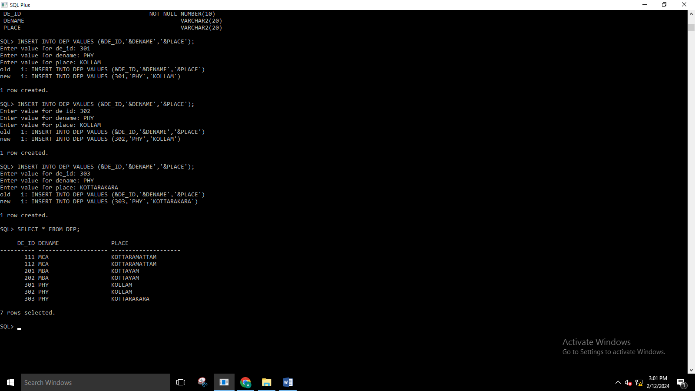

SQL> DELETE DEP WHERE DE_ID=303;

1 row deleted.

SQL> SELECT * FROM DEP;

DE_ID DENAME PLACE

---------- -------------------- --------------------

111 MCA KOTTARAMATTAM

112 MCA KOTTARAMATTAM

201 MBA KOTTAYAM

202 MBA KOTTAYAM

301 PHY KOLLAM

302 PHY KOLLAM

6 rows selected.

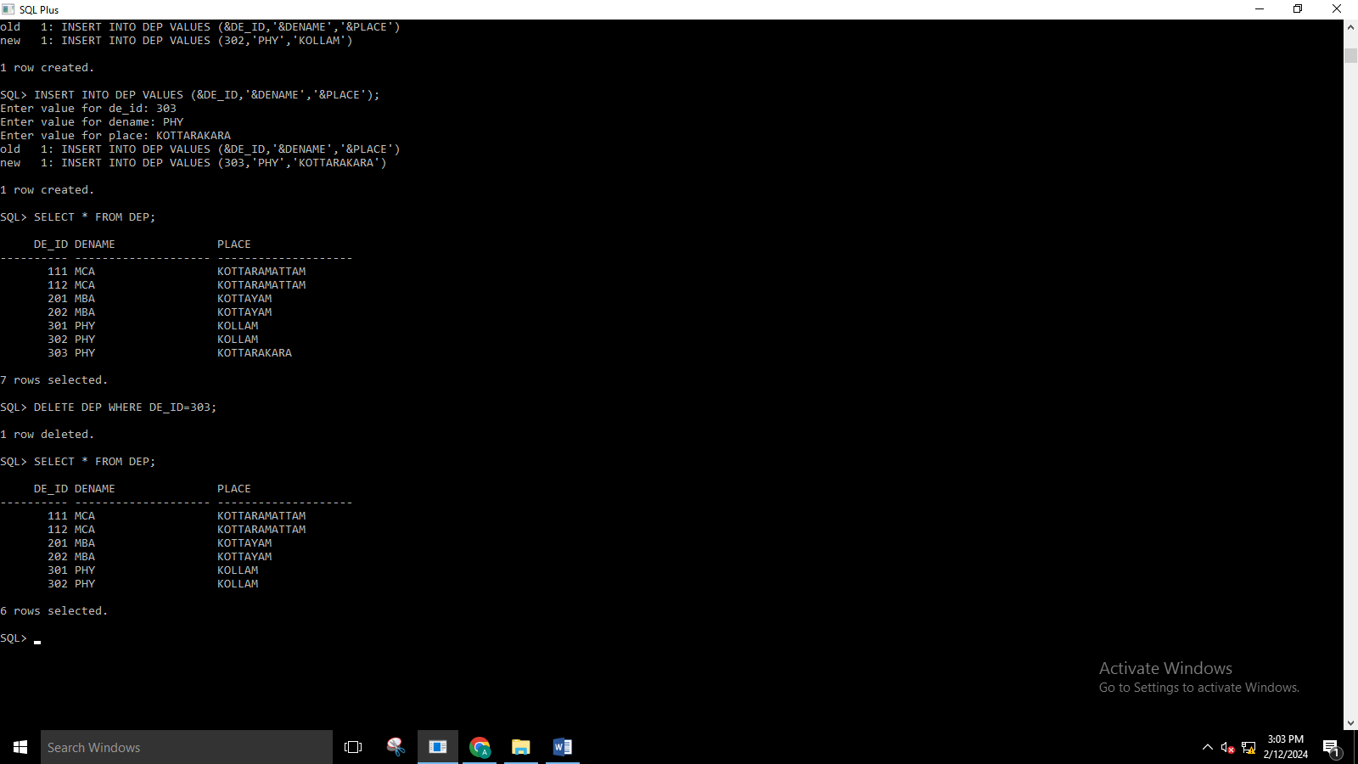

SQL> SELECT COUNT (DE_ID),DENAME FROM DEP GROUP BY DENAME;

COUNT(DE_ID) DENAME

------------ --------------------

2 MBA

2 PHY

2 MCA

SQL> SELECT COUNT (DE_ID),PLACE FROM DEP GROUP BY PLACE;

COUNT(DE_ID) PLACE

------------ --------------------

2 KOTTAYAM

2 KOLLAM

2 KOTTARAMATTAM

**SET-1**

1. .CREATE AN EMP1 TABLE WITH GIVEN FIELDS

**CODE**

SQL> CREATE TABLE EMP1(EMPNO NUMBER(4) PRIMARY KEY, ENMAE VARCHAR(25),JOB VARCHAR(25),SALARY NUMBER(10,2),COMMISSION NUMBER(7,2),DEPNO NUMBER(2));

Table created.

SQL> DESC EMP1

Name Null? Type

----------------------------------------- -------- ----------------------------

EMPNO NOT NULL NUMBER(4)

ENMAE VARCHAR2(25)

JOB VARCHAR2(25)

SALARY NUMBER(10,2)

COMMISSION NUMBER(7,2)

DEPNO NUMBER(2)

1. INSERT VALUES

SQL> INSERT INTO EMP1 VALUES(&EMPNO,'&ENAME','&JOB',&SALARY,&COMMISION,&DEPNO);

Enter value for empno: 100

Enter value for ename: AD

Enter value for job: DEVELOPER

Enter value for salary: 5000000

Enter value for commision: 1000

Enter value for depno: 10

old 1: INSERT INTO EMP1 VALUES(&EMPNO,'&ENAME','&JOB',&SALARY,&COMMISION,&DEPNO)

new 1: INSERT INTO EMP1 VALUES(100,'AD','DEVELOPER',5000000,1000,10)

1 row created.

SQL> INSERT INTO EMP1 VALUES(&EMPNO,'&ENAME','&JOB',&SALARY,&COMMISION,&DEPNO);

Enter value for empno: 101

Enter value for ename: JAYA

Enter value for job: DA

Enter value for salary: 300000

Enter value for commision: 2000

Enter value for depno: 11

old 1: INSERT INTO EMP1 VALUES(&EMPNO,'&ENAME','&JOB',&SALARY,&COMMISION,&DEPNO)

new 1: INSERT INTO EMP1 VALUES(101,'JAYA','DA',300000,2000,11)

1 row created.

SQL> INSERT INTO EMP1 VALUES(&EMPNO,'&ENAME','&JOB',&SALARY,&COMMISION,&DEPNO);

Enter value for empno: 102

Enter value for ename: SURESH

Enter value for job: ML

Enter value for salary: 305000

Enter value for commision: 200

Enter value for depno: 12

old 1: INSERT INTO EMP1 VALUES(&EMPNO,'&ENAME','&JOB',&SALARY,&COMMISION,&DEPNO)

new 1: INSERT INTO EMP1 VALUES(102,'SURESH','ML',305000,200,12)

1 row created.

SQL> INSERT INTO EMP1 VALUES(&EMPNO,'&ENAME','&JOB',&SALARY,&COMMISION,&DEPNO);

Enter value for empno: 103

Enter value for ename: ADARSH

Enter value for job: AI

Enter value for salary: 540000

Enter value for commision: 3000

Enter value for depno: 13

old 1: INSERT INTO EMP1 VALUES(&EMPNO,'&ENAME','&JOB',&SALARY,&COMMISION,&DEPNO)

new 1: INSERT INTO EMP1 VALUES(103,'ADARSH','AI',540000,3000,13)

1 row created.

1. DISPLAY

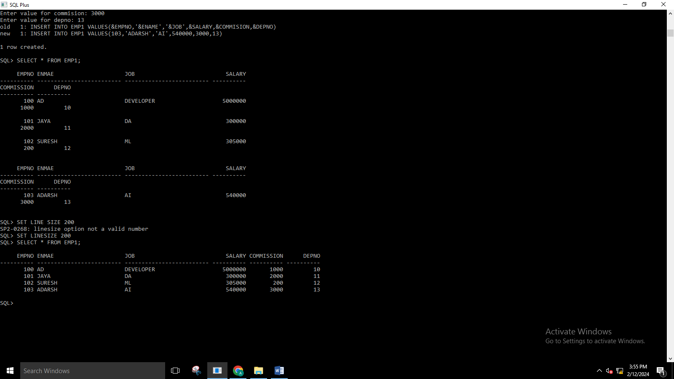

1. UPDATE

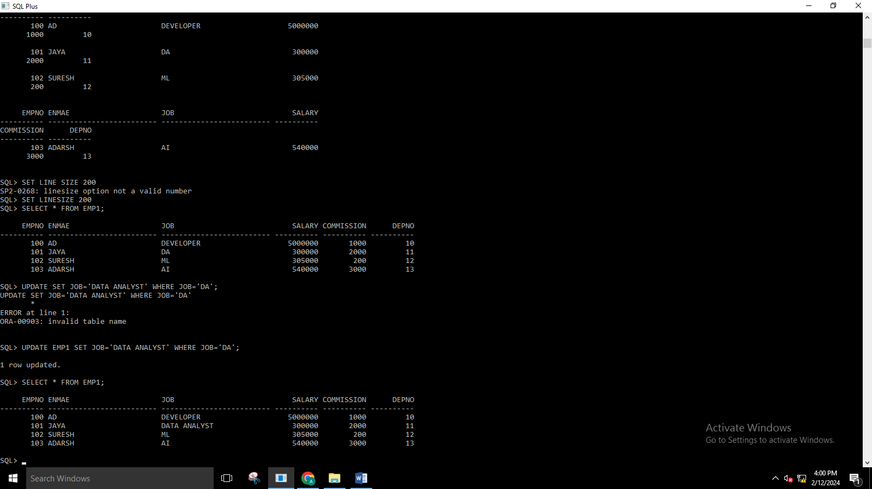

1. ALTER –ADD

SQL> ALTER TABLE EMP1 ADD(DATE_JOIN DATE);

Table altered.

1. SQL> UPDATE EMP1 SET DATE_JOIN='17-DEC-2024';

4 rows updated.

SQL> SELECT * FROM EMP1;

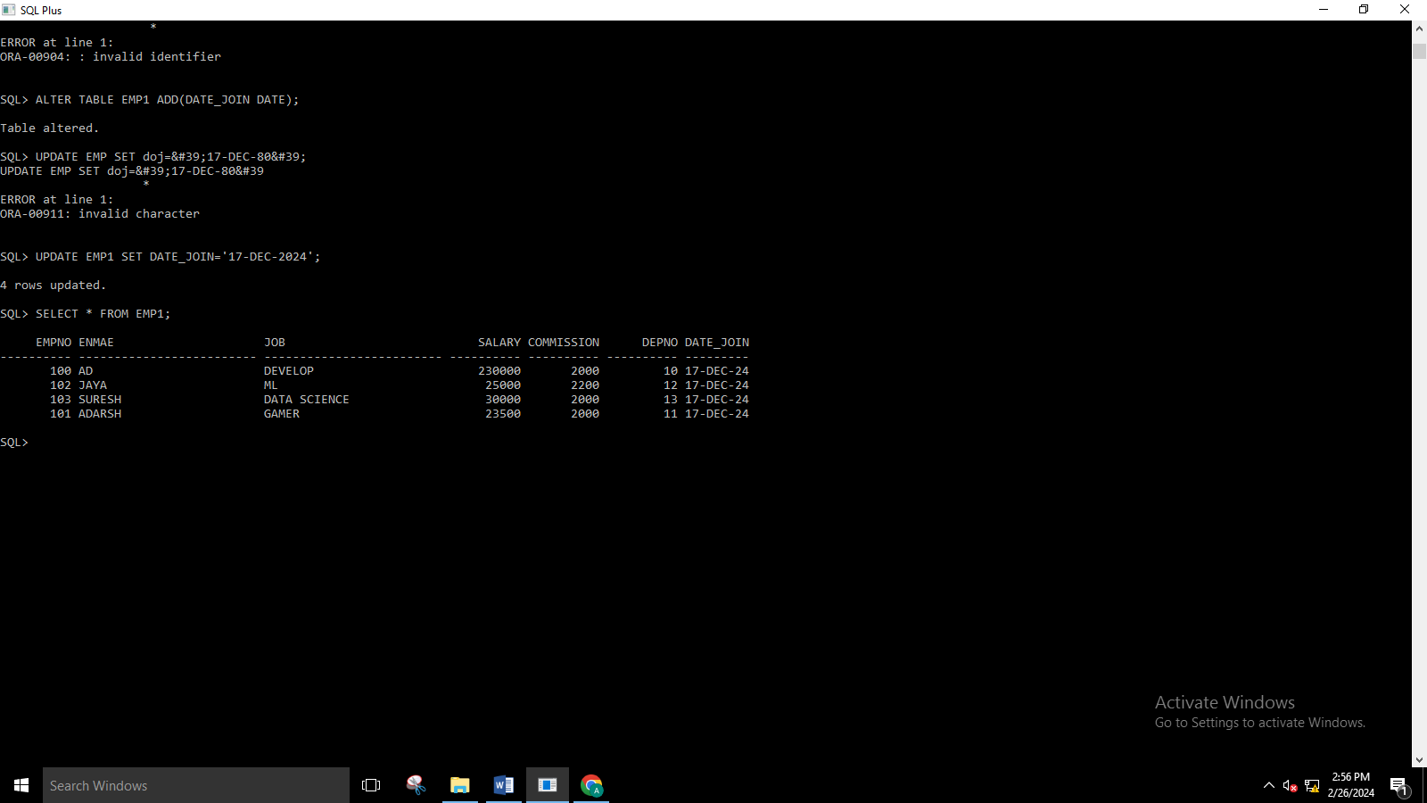

1. DISPLAY ALL DISTINCT JOB TYPE IN EMP1

SQL> SELECT DISTINCT JOB FROM EMP1;

JOB

-------------------------

GAMER

DATA SCIENCE

DEVELOP

ML

1. SQL> ALTER TABLE EMP1 RENAME COLUMN ENMAE TO ENAME;

Table altered.

1. DISPLAY NAME,JOB NUMBER FROM EMP1

SQL> SELECT EMPNO,ENAME,JOB FROM EMP1;

EMPNO ENAME JOB

---------- ------------------------- -------------------------

100 AD DEVELOP

102 JAYA ML

103 SURESH DATA SCIENCE

101 ADARSH GAMER

1. SQL> SELECT ENAME FROM EMP1 WHERE DEPNO=12;

ENAME

-------------------------

JAYA

1. SQL> SELECT ENAME FROM EMP1 WHERE DEPNO=12 OR DEPNO=13;

ENAME

-------------------------

JAYA

SURESH

1. FIND THE TOTAL SALARY OF ALL EMPLOYEE

SQL> SELECT SUM(SALARY) FROM EMP1;

SUM (SALARY)

-----------

308500

1. SQL> SELECT ENAME, SUM(SALARY+COMMISSION) FROM EMP1 GROUP BY ENAME;

ENAME SUM(SALARY+COMMISSION)

------------------------- ----------------------

JAYA 27200

AD 232000

ADARSH 25500

SURESH 32000

1. SQL> UPDATE EMP1 SET SALARY=SALARY+COMMISSION;

4 rows updated.



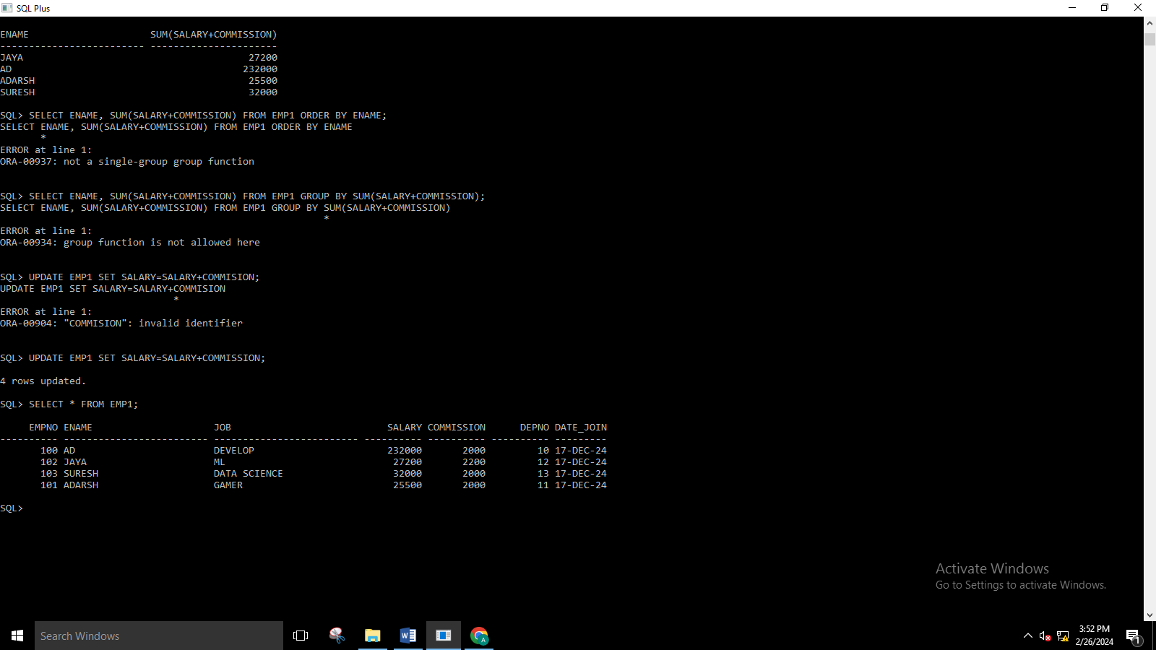



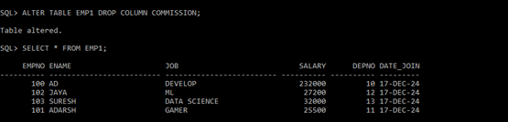

**AGGREGATE FUNCTION**

SQL> CREATE TABLE EM(E_ID NUMBER(10),E_NAME VARCHAR(15),AGE NUMBER(10),SALARY NUMBER(10));

Table created.

SQL> INSERT INTO EM VALUES(&E_ID,'&E_NAME',&AGE,&SALARY);

Enter value for e_id: 1

Enter value for e_name: ADITYA

Enter value for age: 20

Enter value for salary: 350000

old 1: INSERT INTO EM VALUES(&E_ID,'&E_NAME',&AGE,&SALARY)

new 1: INSERT INTO EM VALUES(1,'ADITYA',20,350000)

1 row created.

SQL> INSERT INTO EM VALUES(&E_ID,'&E_NAME',&AGE,&SALARY);

Enter value for e_id: 2

Enter value for e_name: SURESH

Enter value for age: 30

Enter value for salary: 340000

old 1: INSERT INTO EM VALUES(&E_ID,'&E_NAME',&AGE,&SALARY)

new 1: INSERT INTO EM VALUES(2,'SURESH',30,340000)

1 row created.

SQL> INSERT INTO EM VALUES(&E_ID,'&E_NAME',&AGE,&SALARY);

Enter value for e_id: 3

Enter value for e_name: JAYA

Enter value for age: 28

Enter value for salary: 300000

old 1: INSERT INTO EM VALUES(&E_ID,'&E_NAME',&AGE,&SALARY)

new 1: INSERT INTO EM VALUES(3,'JAYA',28,300000)

1 row created.

SQL> INSERT INTO EM VALUES(&E_ID,'&E_NAME',&AGE,&SALARY);

Enter value for e_id: 4

Enter value for e_name: ADARSH

Enter value for age: 26

Enter value for salary: 33000

old 1: INSERT INTO EM VALUES(&E_ID,'&E_NAME',&AGE,&SALARY)

new 1: INSERT INTO EM VALUES(4,'ADARSH',26,33000)

1 row created.

SQL> SELECT COUNT(E_NAME) FROM EM;

COUNT(E_NAME)

-------------

4

SQL> SELECT MAX(AGE) FROM EM;

MAX(AGE)

----------

30

SQL> SELECT MIN(AGE) FROM EM;

MIN(AGE)

----------

20

SQL> SELECT SUM(SALARY) FROM EM;

SUM(SALARY)

-----------

1023000

SQL> CREATE OR REPLACE VIEW EMPVIEW AS SELECT AGE,E_NAME FROM EM;

View created.

SQL> SELECT * FROM EMPVIEW;

AGE E_NAME

---------- ---------------

20 ADITYA

30 SURESH

28 JAYA

26 ADARSH

SQL> SELECT E_NAME,SALARY FROM EM ORDER BY SALARY DESC;

E_NAME SALARY

--------------- ----------

ADITYA 350000

SURESH 340000

JAYA 300000

ADARSH 33000

SQL> SELECT E_NAME,AGE FROM EM ORDER BY AGE;

E_NAME AGE

--------------- ----------

ADITYA 20

ADARSH 26

JAYA 28

SURESH 30

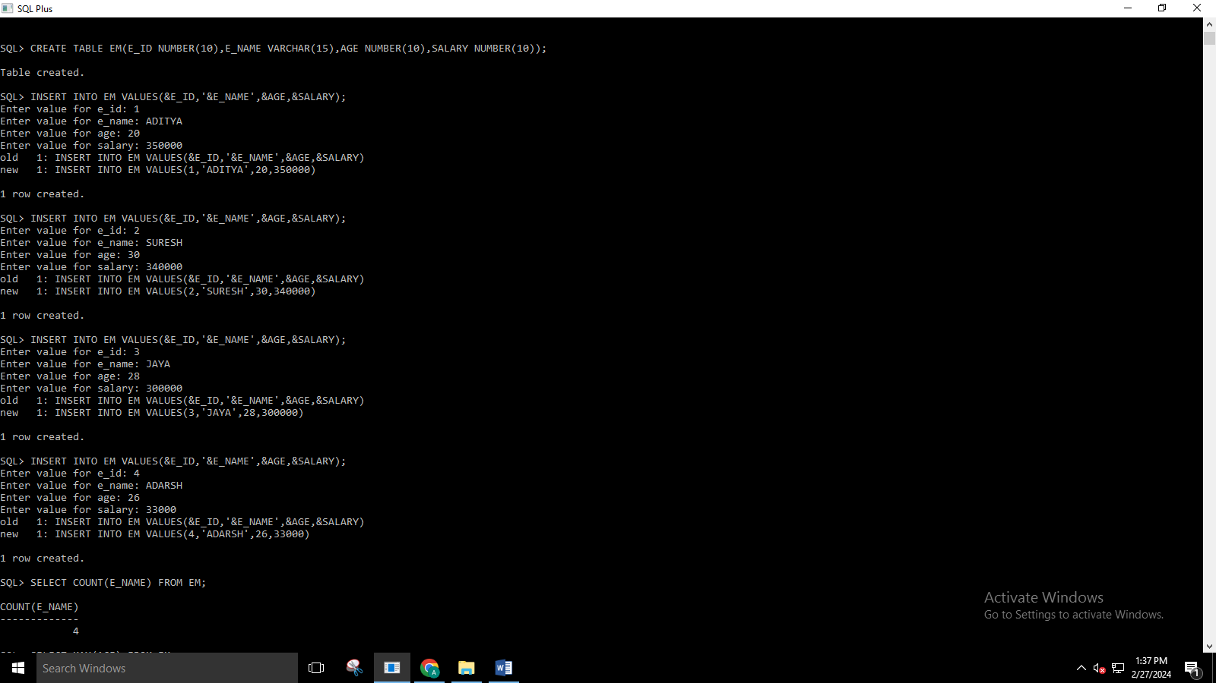

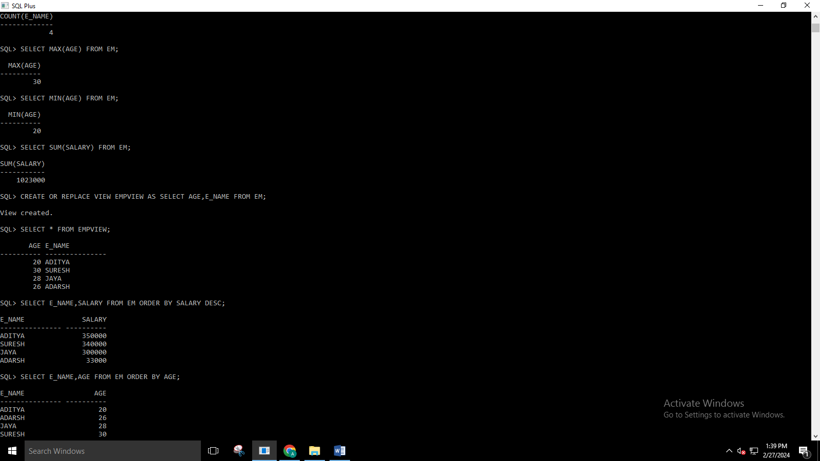

**SET2**

SQL> CREATE TABLE SAILORS(SID NUMBER(10)PRIMARY KEY,SNAME VARCHAR(20),RATING NUMBER(10),AGE NUMBER(10));

Table created.

SQL> INSERT INTO SAILORS VALUES(&SID,'&SNAME',&RATING,&AGE);

Enter value for sid: 22

Enter value for sname: DUSTIN

Enter value for rating: 7

Enter value for age: 45

old 1: INSERT INTO SAILORS VALUES(&SID,'&SNAME',&RATING,&AGE)

new 1: INSERT INTO SAILORS VALUES(22,'DUSTIN',7,45)

1 row created.

SQL> INSERT INTO SAILORS VALUES(&SID,'&SNAME',&RATING,&AGE);

Enter value for sid: 29

Enter value for sname: BRUTAS

Enter value for rating: 1

Enter value for age: 33

old 1: INSERT INTO SAILORS VALUES(&SID,'&SNAME',&RATING,&AGE)

new 1: INSERT INTO SAILORS VALUES(29,'BRUTAS',1,33)

1 row created.

SQL> INSERT INTO SAILORS VALUES(&SID,'&SNAME',&RATING,&AGE);

Enter value for sid: 31

Enter value for sname: LUBBER

Enter value for rating: 8

Enter value for age: 55

old 1: INSERT INTO SAILORS VALUES(&SID,'&SNAME',&RATING,&AGE)

new 1: INSERT INTO SAILORS VALUES(31,'LUBBER',8,55)

1 row created.

SQL> INSERT INTO SAILORS VALUES(&SID,'&SNAME',&RATING,&AGE);

Enter value for sid: 32

Enter value for sname: ANDY

Enter value for rating: 8

Enter value for age: 25

old 1: INSERT INTO SAILORS VALUES(&SID,'&SNAME',&RATING,&AGE)

new 1: INSERT INTO SAILORS VALUES(32,'ANDY',8,25)

1 row created.

SQL> INSERT INTO SAILORS VALUES(&SID,'&SNAME',&RATING,&AGE);

Enter value for sid: 58

Enter value for sname: RUSTY

Enter value for rating: 10

Enter value for age: 35

old 1: INSERT INTO SAILORS VALUES(&SID,'&SNAME',&RATING,&AGE)

new 1: INSERT INTO SAILORS VALUES(58,'RUSTY',10,35)

1 row created.

SQL> INSERT INTO SAILORS VALUES(&SID,'&SNAME',&RATING,&AGE);

Enter value for sid: 64

Enter value for sname: HORATIO

Enter value for rating: 7

Enter value for age: 35

old 1: INSERT INTO SAILORS VALUES(&SID,'&SNAME',&RATING,&AGE)

new 1: INSERT INTO SAILORS VALUES(64,'HORATIO',7,35)

1 row created.

SQL> INSERT INTO SAILORS VALUES(&SID,'&SNAME',&RATING,&AGE);

Enter value for sid: 71

Enter value for sname: ZORBA

Enter value for rating: 10

Enter value for age: 16

old 1: INSERT INTO SAILORS VALUES(&SID,'&SNAME',&RATING,&AGE)

new 1: INSERT INTO SAILORS VALUES(71,'ZORBA',10,16)

1 row created.

SQL> INSERT INTO SAILORS VALUES(&SID,'&SNAME',&RATING,&AGE);

Enter value for sid: 74

Enter value for sname: HORATIO

Enter value for rating: 9

Enter value for age: 35

old 1: INSERT INTO SAILORS VALUES(&SID,'&SNAME',&RATING,&AGE)

new 1: INSERT INTO SAILORS VALUES(74,'HORATIO',9,35)

1 row created.

SQL> INSERT INTO SAILORS VALUES(&SID,'&SNAME',&RATING,&AGE);

Enter value for sid: 85

Enter value for sname: ART

Enter value for rating: 3

Enter value for age: 26

old 1: INSERT INTO SAILORS VALUES(&SID,'&SNAME',&RATING,&AGE)

new 1: INSERT INTO SAILORS VALUES(85,'ART',3,26)

1 row created.

SQL> INSERT INTO SAILORS VALUES(&SID,'&SNAME',&RATING,&AGE);

Enter value for sid: 95

Enter value for sname: BOB

Enter value for rating: 3

Enter value for age: 64

old 1: INSERT INTO SAILORS VALUES(&SID,'&SNAME',&RATING,&AGE)

new 1: INSERT INTO SAILORS VALUES(95,'BOB',3,64)

1 row created.

SQL> SELECT * FROM SAILORS;

SID SNAME RATING AGE

---------- -------------------- ---------- ----------

22 DUSTIN 7 45

29 BRUTAS 1 33

31 LUBBER 8 55

32 ANDY 8 25

58 RUSTY 10 35

64 HORATIO 7 35

71 ZORBA 10 16

74 HORATIO 9 35

85 ART 3 26

95 BOB 3 64

10 rows selected.

**BOATS**

SQL> CREATE TABLE BOATS(BID NUMBER(10),BNAME VARCHAR(20),COLOR VARCHAR(20));

Table created.

SQL> INSERT INTO BOATS VALUES(&BID,'&BNAME','&COLOR');

Enter value for bid: 101

Enter value for bname: INTERLAKE

Enter value for color: BLUE

old 1: INSERT INTO BOATS VALUES(&BID,'&BNAME','&COLOR')

new 1: INSERT INTO BOATS VALUES(101,'INTERLAKE','BLUE')

1 row created.

SQL> INSERT INTO BOATS VALUES(&BID,'&BNAME','&COLOR');

Enter value for bid: 102

Enter value for bname: INTERLAKE

Enter value for color: RED

old 1: INSERT INTO BOATS VALUES(&BID,'&BNAME','&COLOR')

new 1: INSERT INTO BOATS VALUES(102,'INTERLAKE','RED')

1 row created.

SQL> INSERT INTO BOATS VALUES(&BID,'&BNAME','&COLOR');

Enter value for bid: 103

Enter value for bname: CLIPPER

Enter value for color: GREEN

old 1: INSERT INTO BOATS VALUES(&BID,'&BNAME','&COLOR')

new 1: INSERT INTO BOATS VALUES(103,'CLIPPER','GREEN')

1 row created.

SQL> INSERT INTO BOATS VALUES(&BID,'&BNAME','&COLOR');

Enter value for bid: 104

Enter value for bname: MARINE

Enter value for color: RED

old 1: INSERT INTO BOATS VALUES(&BID,'&BNAME','&COLOR')

new 1: INSERT INTO BOATS VALUES(104,'MARINE','RED')

1 row created.

SQL> SELECT * FROM BOATS;

BID BNAME COLOR

---------- -------------------- --------------------

101 INTERLAKE BLUE

102 INTERLAKE RED

103 CLIPPER GREEN

104 MARINE RED

SQL> ALTER TABLE BOATS ADD CONSTRAINT CLR_PRMRYKEY PRIMARY KEY(BID);

Table altered.

**RESERVES**

SQL> CREATE TABLE RESERVES (SID NUMBER (10) PRIMARY KEY, BID NUMBER (10), DAY DATE);

Table created.

SQL> ALTER TABLE RESERVES DROP PRIMARY KEY;

Table altered.

SQL> INSERT INTO RESERVES VALUES(&SID,&BID,TO_DATE('&DAY','YYYY-MM-DD'));

Enter value for sid: 22

Enter value for bid: 101

Enter value for day: 1998-10-10

old 1: INSERT INTO RESERVES VALUES(&SID,&BID,TO_DATE('&DAY','YYYY-MM-DD'))

new 1: INSERT INTO RESERVES VALUES(22,101,TO_DATE('1998-10-10','YYYY-MM-DD'))

1 row created.

SQL> INSERT INTO RESERVES VALUES(&SID,&BID,TO_DATE('&DAY','YYYY-MM-DD'));

Enter value for sid: 22

Enter value for bid: 102

Enter value for day: 1998-10-10

old 1: INSERT INTO RESERVES VALUES(&SID,&BID,TO_DATE('&DAY','YYYY-MM-DD'))

new 1: INSERT INTO RESERVES VALUES(22,102,TO_DATE('1998-10-10','YYYY-MM-DD'))

1 row created.

SQL> INSERT INTO RESERVES VALUES(&SID,&BID,TO_DATE('&DAY','YYYY-MM-DD'));

Enter value for sid: 22

Enter value for bid: 103

Enter value for day: 1998-08-10

old 1: INSERT INTO RESERVES VALUES(&SID,&BID,TO_DATE('&DAY','YYYY-MM-DD'))

new 1: INSERT INTO RESERVES VALUES(22,103,TO_DATE('1998-08-10','YYYY-MM-DD'))

1 row created.

SQL> INSERT INTO RESERVES VALUES(&SID,&BID,TO_DATE('&DAY','YYYY-MM-DD'));

Enter value for sid: 22

Enter value for bid: 104

Enter value for day: 1998-07-10

old 1: INSERT INTO RESERVES VALUES(&SID,&BID,TO_DATE('&DAY','YYYY-MM-DD'))

new 1: INSERT INTO RESERVES VALUES(22,104,TO_DATE('1998-07-10','YYYY-MM-DD'))

1 row created.

SQL> INSERT INTO RESERVES VALUES(&SID,&BID,TO_DATE('&DAY','YYYY-MM-DD'));

Enter value for sid: 31

Enter value for bid: 102

Enter value for day: 1998-10-11

old 1: INSERT INTO RESERVES VALUES(&SID,&BID,TO_DATE('&DAY','YYYY-MM-DD'))

new 1: INSERT INTO RESERVES VALUES(31,102,TO_DATE('1998-10-11','YYYY-MM-DD'))

1 row created.

SQL> INSERT INTO RESERVES VALUES(&SID,&BID,TO_DATE('&DAY','YYYY-MM-DD'));

Enter value for sid: 31

Enter value for bid: 103

Enter value for day: 1998-06-11

old 1: INSERT INTO RESERVES VALUES(&SID,&BID,TO_DATE('&DAY','YYYY-MM-DD'))

new 1: INSERT INTO RESERVES VALUES(31,103,TO_DATE('1998-06-11','YYYY-MM-DD'))

1 row created.

SQL> INSERT INTO RESERVES VALUES(&SID,&BID,TO_DATE('&DAY','YYYY-MM-DD'));

Enter value for sid: 31

Enter value for bid: 104

Enter value for day: 1998-12-11

old 1: INSERT INTO RESERVES VALUES(&SID,&BID,TO_DATE('&DAY','YYYY-MM-DD'))

new 1: INSERT INTO RESERVES VALUES(31,104,TO_DATE('1998-12-11','YYYY-MM-DD'))

1 row created.

SQL> INSERT INTO RESERVES VALUES(&SID,&BID,TO_DATE('&DAY','YYYY-MM-DD'));

Enter value for sid: 64

Enter value for bid: 101

Enter value for day: 1998-05-09

old 1: INSERT INTO RESERVES VALUES(&SID,&BID,TO_DATE('&DAY','YYYY-MM-DD'))

new 1: INSERT INTO RESERVES VALUES(64,101,TO_DATE('1998-05-09','YYYY-MM-DD'))

1 row created.

SQL> INSERT INTO RESERVES VALUES(&SID,&BID,TO_DATE('&DAY','YYYY-MM-DD'));

Enter value for sid: 64

Enter value for bid: 102

Enter value for day: 1998-08-09

old 1: INSERT INTO RESERVES VALUES(&SID,&BID,TO_DATE('&DAY','YYYY-MM-DD'))

new 1: INSERT INTO RESERVES VALUES(64,102,TO_DATE('1998-08-09','YYYY-MM-DD'))

1 row created.

SQL> INSERT INTO RESERVES VALUES(&SID,&BID,TO_DATE('&DAY','YYYY-MM-DD'));

Enter value for sid: 74

Enter value for bid: 103

Enter value for day: 1998-08-09

old 1: INSERT INTO RESERVES VALUES(&SID,&BID,TO_DATE('&DAY','YYYY-MM-DD'))

new 1: INSERT INTO RESERVES VALUES(74,103,TO_DATE('1998-08-09','YYYY-MM-DD'))

1 row created.

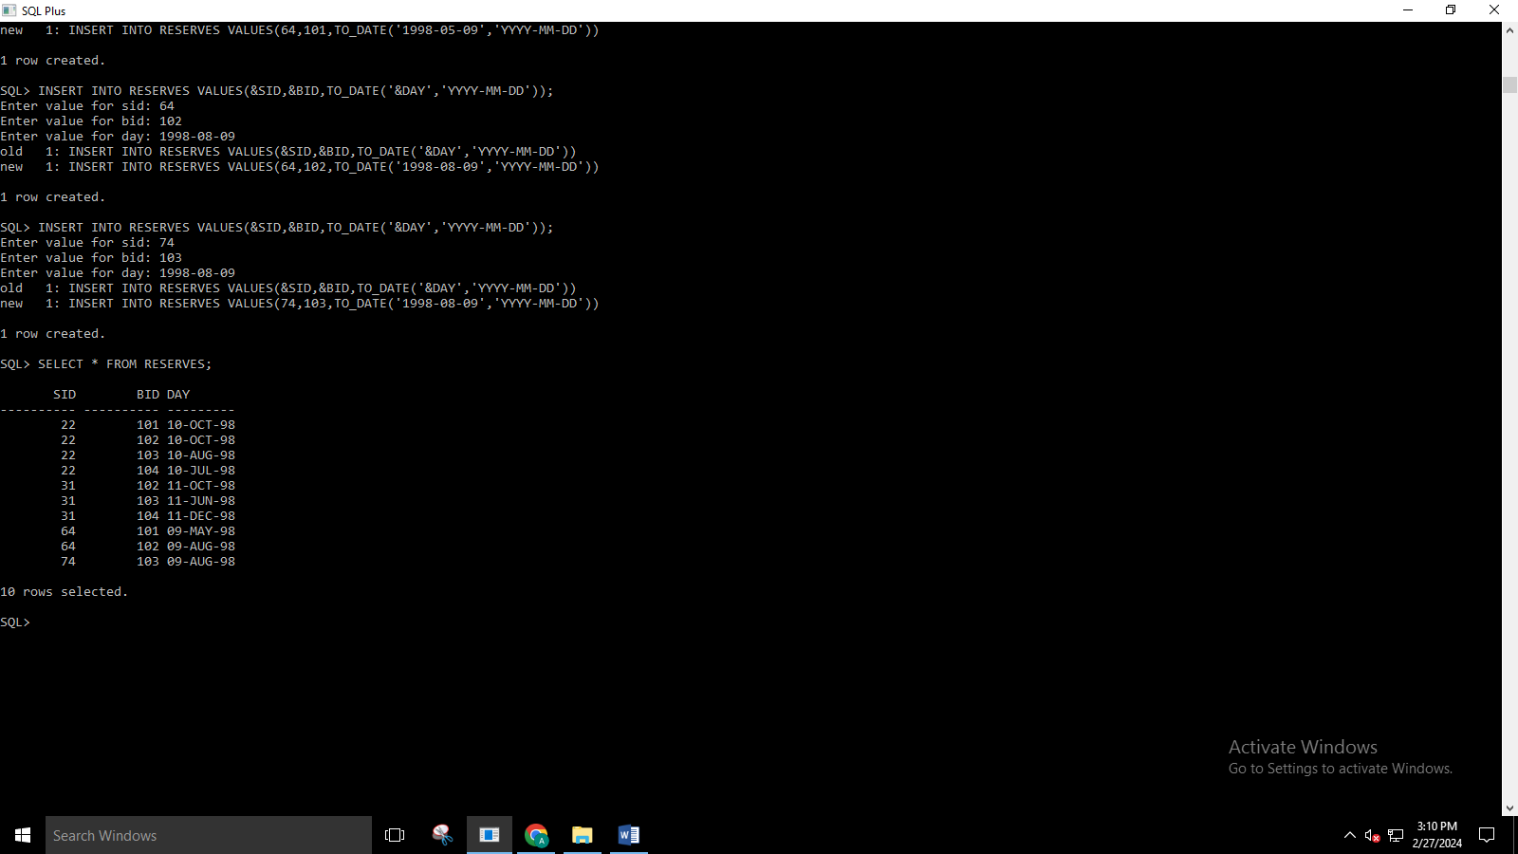

SQL> SELECT SNAME, AGE FROM SAILORS;

SNAME AGE

-------------------- ----------

DUSTIN 45

BRUTAS 33

LUBBER 55

ANDY 25

RUSTY 35

HORATIO 35

ZORBA 16

HORATIO 35

ART 26

BOB 64

10 rows selected.

SQL> SELECT * FROM SAILORS WHERE SID IN(SELECT SID FROM RESERVES WHERE BID=101);

SID SNAME RATING AGE

---------- -------------------- ---------- ----------

22 DUSTIN 7 45

64 HORATIO 7 35

SQL> SELECT * FROM SAILORS WHERE RATING >7;

SID SNAME RATING AGE

---------- -------------------- ---------- ----------

31 LUBBER 8 55

32 ANDY 8 25

58 RUSTY 10 35

71 ZORBA 10 16

74 HORATIO 9 35

SQL> SELECT SNAME FROM SAILORS WHERE SID IN(SELECT SID FROM RESERVES WHERE BID=103);

SNAME

--------------------

DUSTIN

LUBBER

HORATIO

SQL> SELECT SNAME FROM SAILORS JOIN RESERVES ON SAILORS.SID = RESERVES.SID JOIN BOATS ON RESERVES.BID = BOATS.BID WHERE BOATS.COLOR ='RED' ORDER BY SAILORS.AGE;

SNAME

--------------------

HORATIO

DUSTIN

DUSTIN

LUBBER

LUBBER

SQL> SELECT SNAME FROM SAILORS WHERE SID IN(SELECT SID FROM RESERVES WHERE BID IN(SELECT BID FROM BOATS WHERE COLOR='RED'))ORDER BY AGE;

SNAME

--------------------

HORATIO

DUSTIN

LUBBER

SQL> SELECT DISTINCT SNAME FROM SAILORS JOIN RESERVES ON SAILORS.SID = RESERVES.SID JOIN BOATS ON RESERVES.BID = BOATS.BID WHERE BOATS.COLOR ='RED' OR BOATS.COLOR='GREEN';

SNAME

--------------------

LUBBER

HORATIO

DUSTIN

