Front End Engineering-II

Project Report

Semester-III (Batch-2023)

**Fashion Webpage Using Parallax**



## Supervised By: Submitted By:

Dr. Ankit Khare 2310990117 Ansh Kaushal

**Department of Computer Science and Engineering Chitkara University Institute of Engineering & Technology,**

**Chitkara University, Punjab**

# Abstract

This project is a frontend implementation of an Instagram profile page, developed as a demonstration of modern web development practices with an emphasis on responsive design, user experience, and scalability. The interface mirrors the core elements of an Instagram profile, including user information, post thumbnails, follower and following counts, and navigable sections for posts, reels, and tagged content.

Using React.js as the primary JavaScript library, this project showcases component-based architecture to create reusable and modular UI elements. This approach enables efficient data handling and enhances page interactivity. To ensure seamless styling, CSS3 and Flexbox/Grid layouts are used for an adaptive and responsive design that adjusts smoothly across various screen sizes, simulating a real-world social media platform experience.

The project incorporates mock data to simulate user details and images, which are dynamically rendered, enabling efficient state management and an interactive, single-page application (SPA) experience. Components such as image galleries, tabbed navigation, and modals are included to align with the expected Instagram-like user interface, enhancing visual engagement and intuitiveness.

This project highlights skills in frontend development including state management, responsive design, and component-based UI creation. It serves as a practical foundation for further development, potentially integrating backend features like authentication, database interactions, and API integration to evolve into a fully functional profile page.

# Introduction

## Background

## In an era where digital presence defines personal and brand identities, social media platforms like Instagram are pivotal for user engagement. An Instagram profile page serves as a personal or brand hub, showcasing images, interactions, and user content. This project aims to replicate the essence of an Instagram profile page using modern web development practices, offering users an interactive and visually engaging experience similar to that of the popular social platform.

## Objective

The primary objectives of this project are:

* To develop an interactive and responsive web application that mirrors an Instagram profile page.
* To allow users to view profile details, posts, followers, and following lists in a user-friendly interface.
* To implement a seamless user interface with a focus on intuitive design and easy navigation.
* To create an adaptive design that ensures functionality and aesthetic appeal across devices.

## Significance

This project enhances the experience of users by:

* Providing a realistic simulation of an Instagram profile page layout.
* Showcasing the use of React.js to create interactive and dynamic UI components.
* Illustrating component-based design principles that ensure modularity, reusability, and scalability.
* Offering a foundation for further development, such as backend integration, for a more comprehensive social media platform experience.

# Problem Statement

Creating a frontend that resembles a sophisticated social media profile page can be challenging, requiring a balance between design, interactivity, and performance. This project addresses the challenge of developing a responsive, intuitive, and interactive profile interface, centralizing essential profile features in a single, user-friendly web page. It aims to simplify the user experience by providing an organized view of posts, information, and interactions

## Software Requirements

1. **Front-end**
   * HTML5 (Hypertext Markup Language 5)
   * CSS3 (Cascading Style Sheets 3)
   * JS (JavaScript)
   * ReactJS

## Text Editor /IDE

* + Visual Studio Code (version 1.57.1)

## Web Browser

* + Google Chrome (version 90.0.4430.212) or Mozilla Firefox (version 88.0.1)

## Hardware Requirements

* Client Devices:
* Desktop computers: Window / MACOS
* Laptops: Window / MACOS
* Mobile devices: Android / IOS

## Data Sets

* User Profile Data: Profile image, bio, post count, follower and following count.
* Post Data: Image URLs, captions, likes, and comments for each post.
* Mock User Interactions: Simulated interactions such as “follow,” “like,” and “comment” for enhanced user experience.

1. **Proposed Design and Methodology**

## Schematic Diagram

The website follows a multi-page structure, including the following pages:

* **Signup Page:** Features available are user login and signup page.
* **Home Page:** The main page includes the categories to explore from.
* **Accessories Page:** It include accessories such as handbags, watches, earrings and neckpieces.
* **Fragrance and Beauty Page:** It includes options such as perfumes and makeup products.
* **Sunglasses and Scarves Page:** It includes sunglasses and scarves.
* **Explore Page:** It has info about our brand.

## File Structure

The website files are organize as follows**:**

* index.html: The signup page.
* login.html: Login page.
* main.html: Main page.
* Accessories.html: This page includes product details and specifications.
* frag.html: This page includes product details and specifications.
* sunglasses.html: This page includes product details and specifications.
* explore.html: This page includes introduction to website.
* cart.html: This page includes the cart for the website.
* A Folder for the images.

**3. Proposed Design and Methodology**

* 1. **Schematic Diagram**

The website follows a single-page structure with sections for:

• Profile Header: Displays the user’s profile image, bio, and statistics.

• Posts Section: Contains thumbnails and a detailed view for each post.

• Navigation Tabs: Includes links to posts, reels, and tagged content.

**3.2 File Structure**

The project files are organized as follows:

• index.html: Main file for initial loading.

• App.js: Root component for rendering all other components.

• Profile.js: Component for profile details and stats.

• PostGrid.js: Component for displaying a grid of posts.

• NavTabs.js: Component for tab navigation between sections.

• Images folder: Stores placeholder images for the profile and posts.

* 1. **Considerations for Design and Methodology**

**3.3.1 User Experience (UX) Design**

**Profile Page Layout:**

* Clear headline and user bio displaying essential profile information.
* Tab navigation to improve accessibility to different sections like posts, reels, and tagged content.
* Posts Grid:
* Organized image grid for quick browsing, with easy access to post details.
* Responsive Design:
* Adaptive layouts for consistent user experience on desktops, tablets, and mobile devices.

**3.3.2 HTML Structure**

* Semantic HTML: Utilizes tags like <header>, <section>, and <footer> to structure the profile page for better accessibility.
* Responsive Design: Uses CSS media queries for optimal display on multiple screen sizes.

**3.3.3 CSS Styling**

* Visual Hierarchy: Effective use of size, color, and spacing for profile information and call-to-action buttons.
* Navigation: A sticky navigation bar enhances usability, allowing users to switch between sections.
* Typography: Selects readable and consistent fonts, enhancing both readability and brand identity alignment.
* Visual Aesthetics: Cohesive color schemes and layout to mimic Instagram’s design language, fostering familiarity and engagement.

**Our Project**

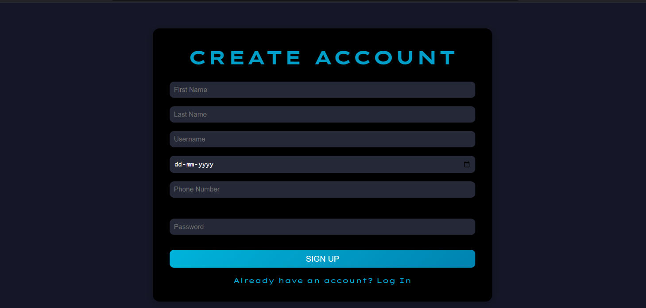

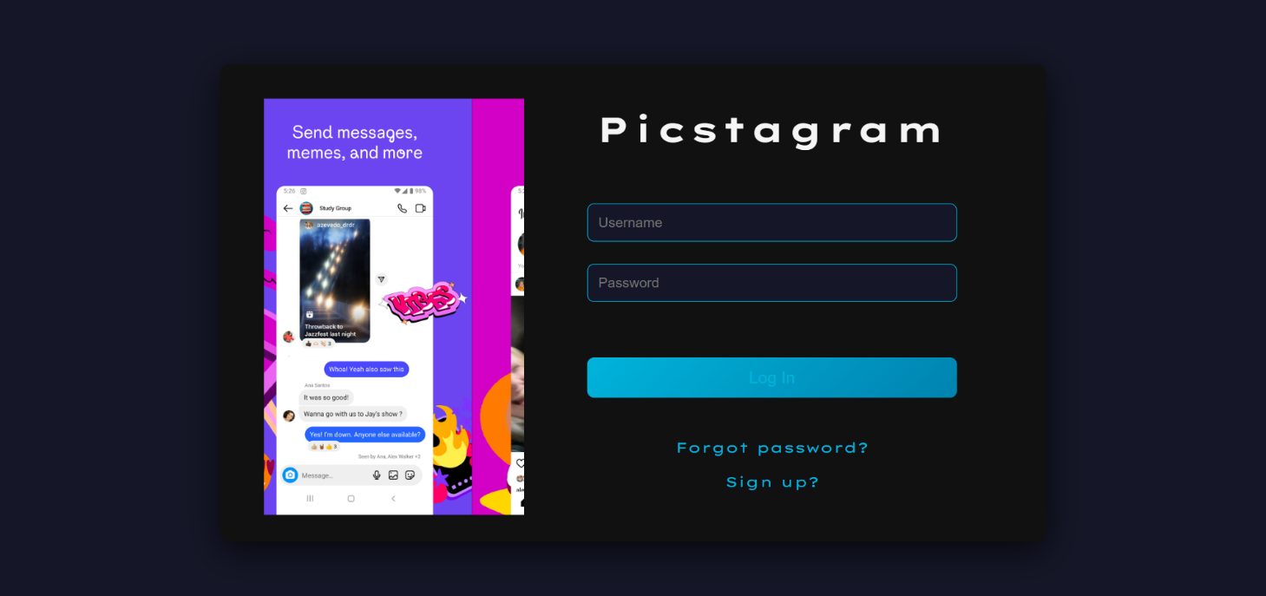

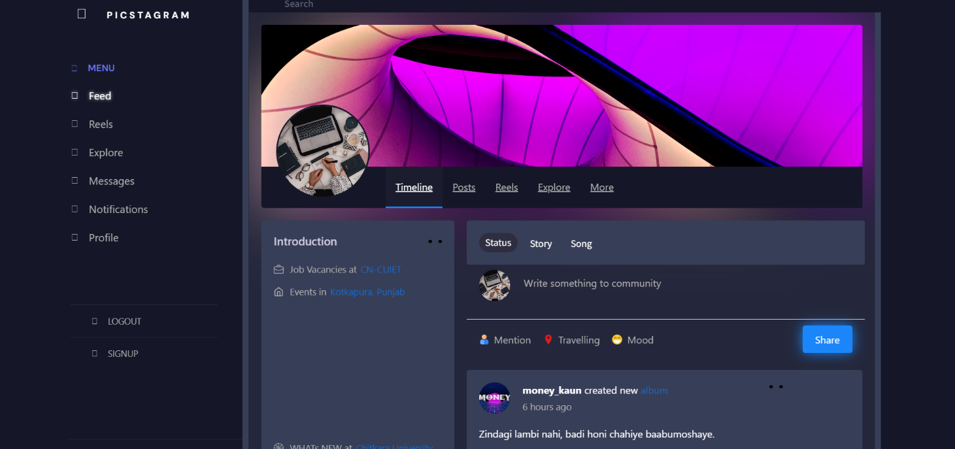

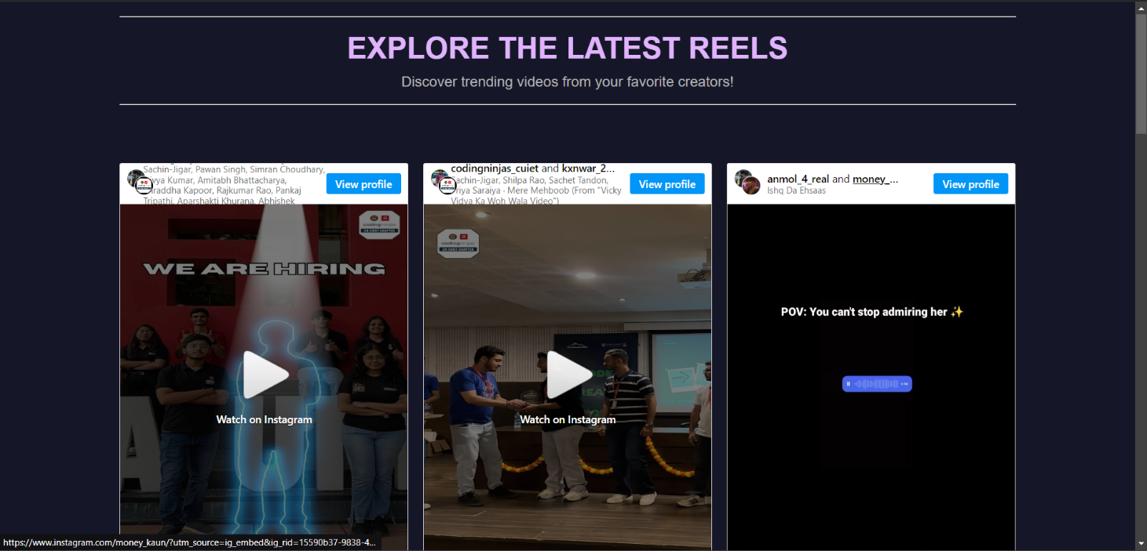

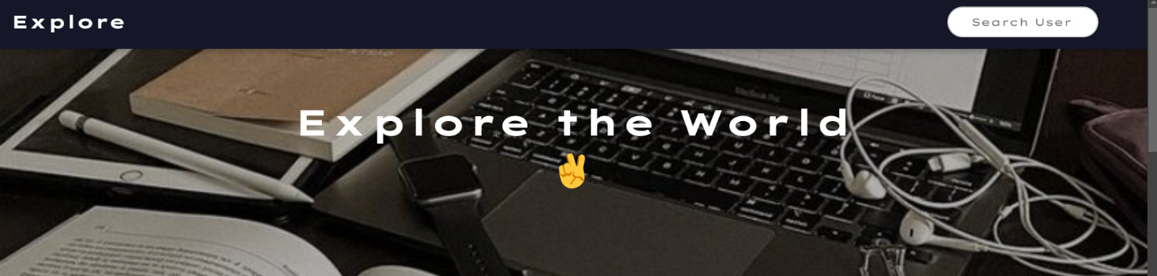

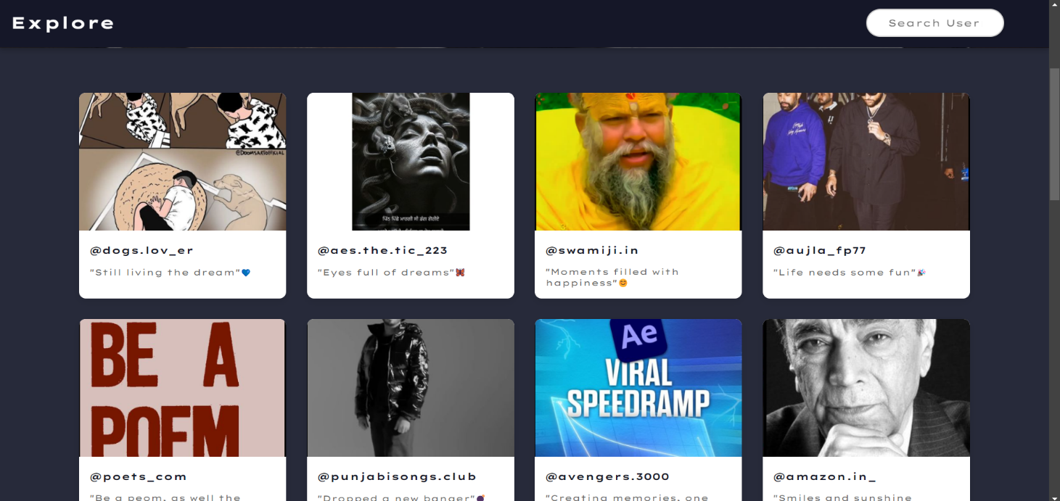

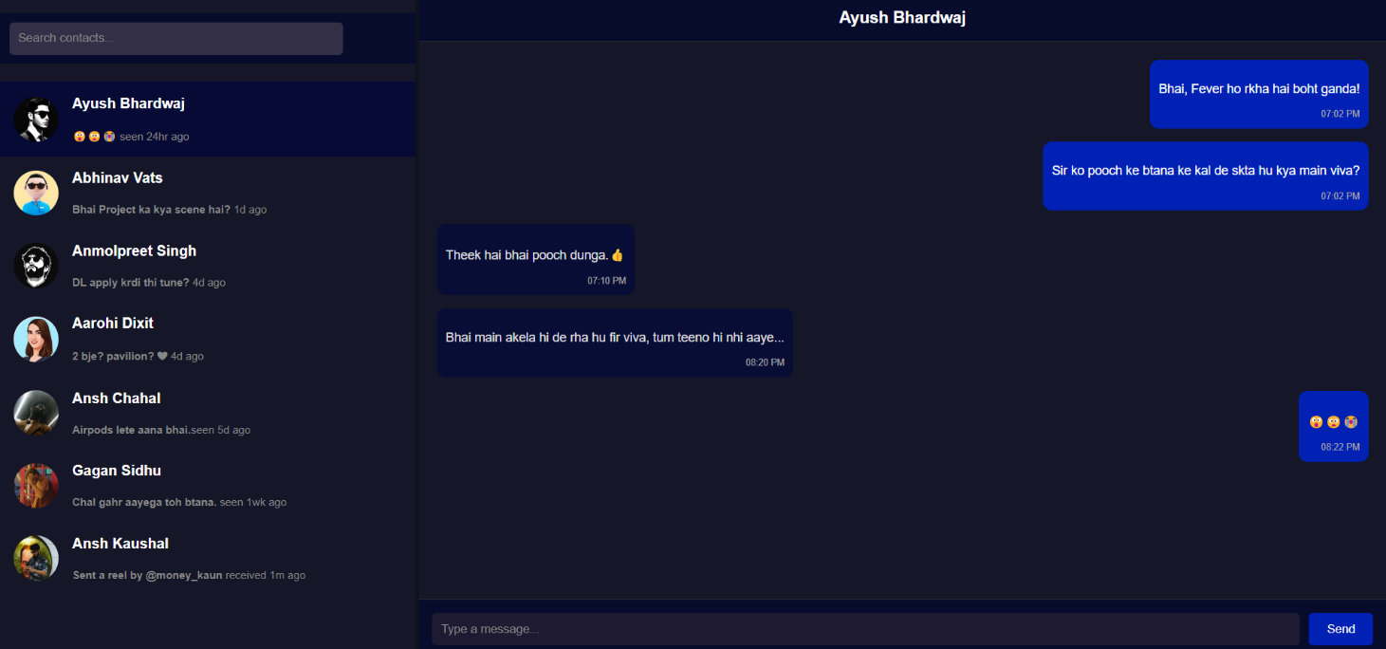

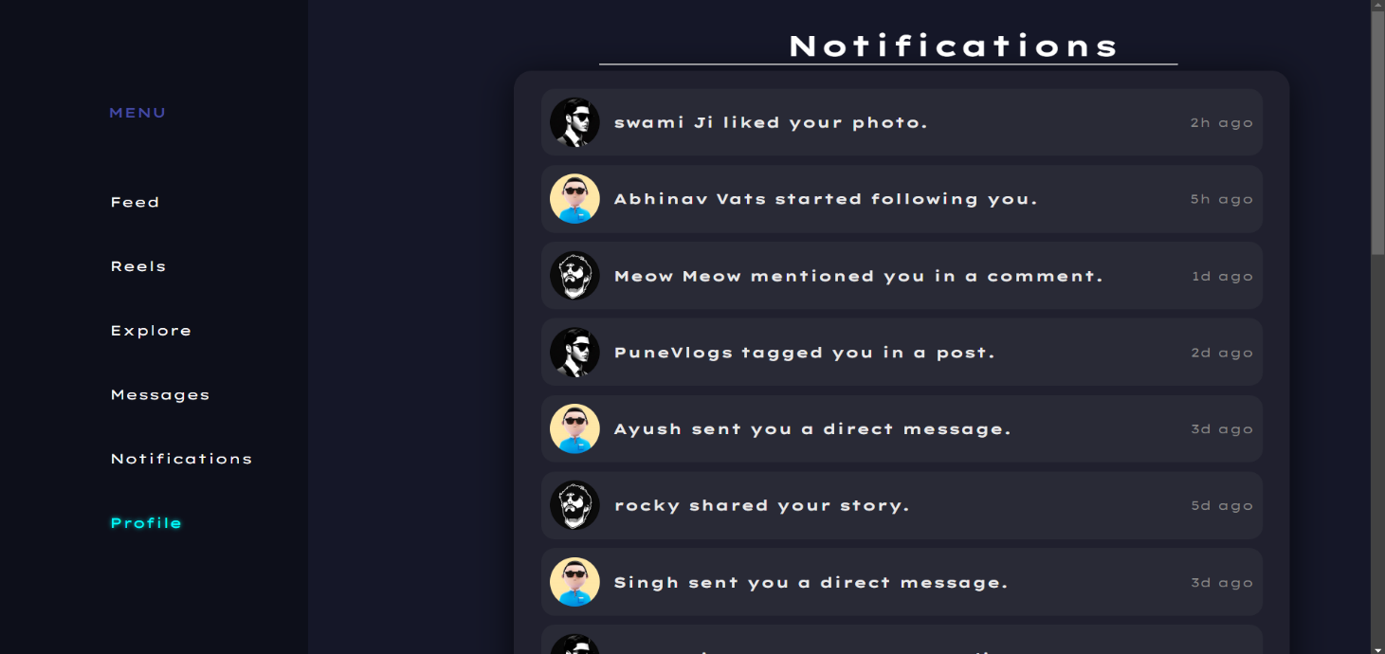

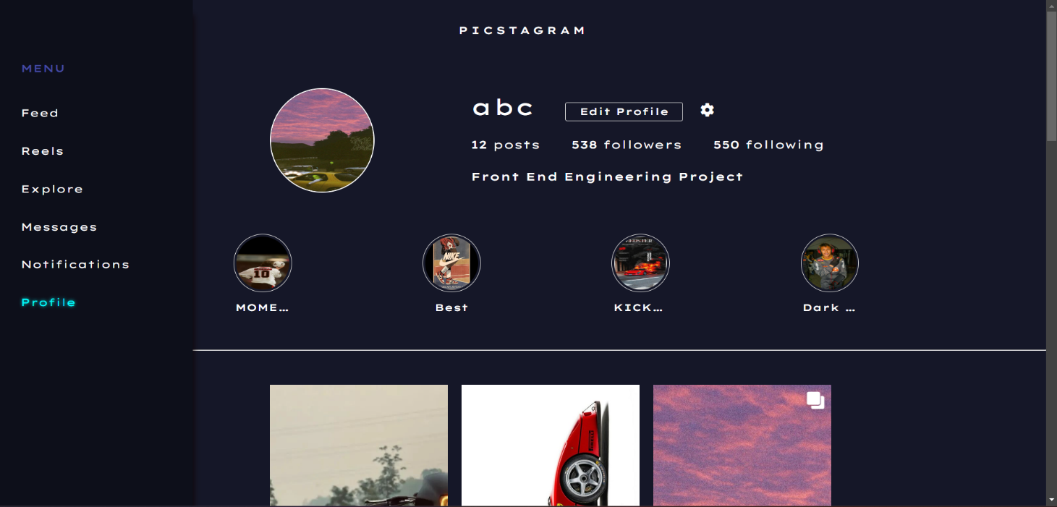

# References

1. <https://www.geeksforgeeks.org/javascript/>
2. <https://www.w3schools.com/html/>
3. <https://fonts.google.com/>