5CS037–

CONCEPTS AND TECHNOLOGIES OF AI

Predicting District-Level Crime Incidence in Malaysia Using Regression Analysis

Name: Aadhya Guragain Student ID: 2511782 Task: Regression
Module Leader: Aayush Regmi

Abstract

Purpose
This report aims to forecast the level of crime in the district of Malaysia with the help of regression. Evidence-based policy-making can be aided by accurate predictions of crime incidence which can be used to support Sustainable Development Goal 16: Peace, Justice, and Strong Institutions.

Dataset
The dataset will be the Malaysia District-level Crime Dataset on Kaggle, which has tens of thousands of entries in 2017-2023. The most important characteristics are the state, district, and type of crime, year, number of crimes recorded. This data set is relevant to UNSDG 16 because it allows providing information-driven ideas to empower safer societies and more productive governmental bodies.

Methodology
Exploratory Data Analysis (EDA) was used to learn the distributions and relationships, and then regression modelling was performed with a Neural Network (MLPregressor), and two traditional machine learning algorithms, Linear Regression and Random Forest Regressor. The
Hyper-parameter optimization was done to increase the performance of the model and the feature selection made sure that the most significant variables were considered. Mean squared error (MSE), root mean squared error (RMSE), mean absolute error (MAE), and R 2 were used to evaluate the models.

Results
The Rand. Forest Regressor was found to be the best model with a test set MSE of 53,397.65, RMSE of 231.08, MAE of 40.90 and R2 of 0.92. The Neural Network obtained a mediocre performance (MSE = 381,191.24, RMSE = 617.41, MAE = 155.49, R2 = 0.43), whereas the Linear Regression indicated the limited predictive capacity (R2 = 0.04).

Conclusion
The paper shows that non-linear models and specifically random forest are very useful in crime incidence prediction at the level of the district. The analysis findings reveal that there are temporal, geographical, and categorical characteristics that are important in interpreting trends in crime. These findings oﬀer grounds to use the information to base decisions and subsequent studies in crime prevention and the planning of public safety.

List of Figures
Figure 1: Total Crimes Reported per Year Figure 2: Crime Counts by Category Figure 3: Top 10 Districts by Total Crimes Figure 4: Distribution of Crime Counts
Figure 5: Crime Counts Over Time

Introduction

Problem Statement
The level of crime is a very significant measure of stability in society and the success of the institutions of the state. The comprehensive knowledge of the crime level diﬀerences in diﬀerent regions and in the course of the time is also a key to eﬀective decision-making in the planning of public safety and resource allocation. This project will solve the issue of regression analysis used to predict the trends of crime incidence at district level in Malaysia. In particular, the task will be to estimate the total number of recorded crimes according to the temporal, geographical, as well as crime-related attributes found in the data. The research will model the counts of crimes as a continuous target variable to oﬀer objective and data-driven information on the crime patterns that could be used in the development of evidence-based policies.

Dataset
The data on this analysis is a Malaysian district level crime dataset, which was acquired via Kaggle, an open data site primarily utilized in scholarly and machine learning studies. Its data base includes the years 2017-2023 and the information about reported crimes in several districts in Malaysia. The most important attributes are state, district, crime category, type of crime, date and the number of recorded crime incidents. The dataset has tens of thousands of records, which provides enough variability to do regression modelling and is computationally feasible. The

following dataset supports the United Nations Sustainable Development Goal 16 (Peace, Justice, and Strong Institutions) since it helps to analyze tendencies in crime and these two concepts are strongly interconnected with the most important aspects of safety of the population, eﬀectiveness of the criminal justice system, and eﬃciency of the institutional institutions.

Objective
This project aims at coming up with predictive regression models that are eﬀective in estimating the total cases of recorded crimes per district per year with the assistance of the available features in the dataset. The research is expected to establish useful correlations between the rates of crimes and the time, place, and nature of crimes. By doing so, the project shows that the regression-based techniques can be applied to aid the process of strategic planning of public safety, eﬀective resource distribution, and knowledgeable institutional decision-making.

Methodology

Data Preprocessing

The data used in constructing the regression models was well prepared before the actual construction, to avoid poor quality of data and inappropriateness of the data to be analyzed. The crime data was initially loaded in the form of a CSV file and examined in structural and summary functions, including measures of the dimensions of the dataset and data types and various columns, as well as identifiers of missing values. The check indicated that the variables needed in modelling were not missing and that no substantial missing values to the chosen features were detected.

The date feature was transformed to a datetime format so as to analyze the data over time. Based on this, a new attribute indicating the year of every record was obtained, which enabled crime trends to be studied across time. This change made it easier to make crime incidence aggregate and model it annually.

In order to narrow the study to the predictors of interest, a set of variables was chosen, such as state, district, type of crime, type of crime, year, and crimes recorded. A number of these variables were categorical in nature, hence, label encoding was used to encode them into a numerical format that is acceptable in regression modelling. Individual coded items were developed around state, district, category of crime, and type of crime.

Moreover, the target variable (number of crimes) was considered in terms of descriptive statistics to learn about its distribution and magnitude. These preprocess actions made sure that the data was formatted, steady, and prepared to be used in the further exploratory analysis and model construction.

Exploratory Data Analysis (EDA)
Exploratory Data Analysis (EDA) was conducted to understand the distribution of crime counts and the relationships between temporal, categorical, and geographical variables. Visualisations including line plots, box plots, bar charts, histograms, and scatter plots were used to examine patterns and trends within the data.
Key insights from EDA include:

    - Temporal variations in total crime incidence across years indicate the presence of time-based trends.

    - Crime counts diﬀer across crime categories, with some categories showing higher median values and greater variability.

    - Crime incidence is unevenly distributed geographically, with a few districts accounting for a large proportion of total recorded crimes.

    - The distribution of crime counts is right-skewed, suggesting high-crime districts or periods.

Figures
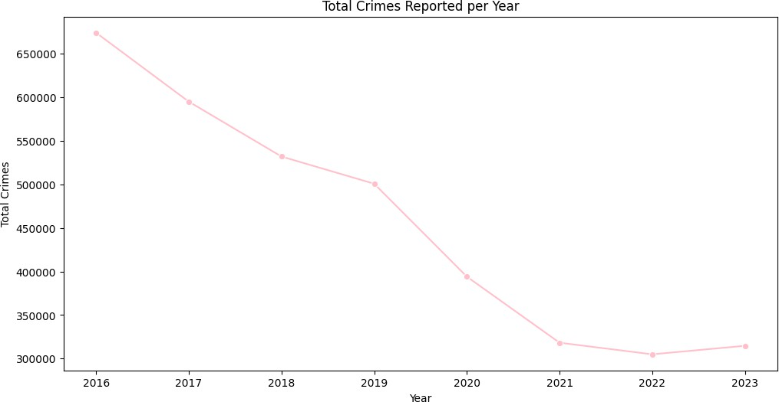
Figure 1: Total Crimes Reported per Year
Total crimes show a gradual decrease from 2016 to 2023, which may indicate policy changes, crime prevention eﬀorts, or variations in reporting.
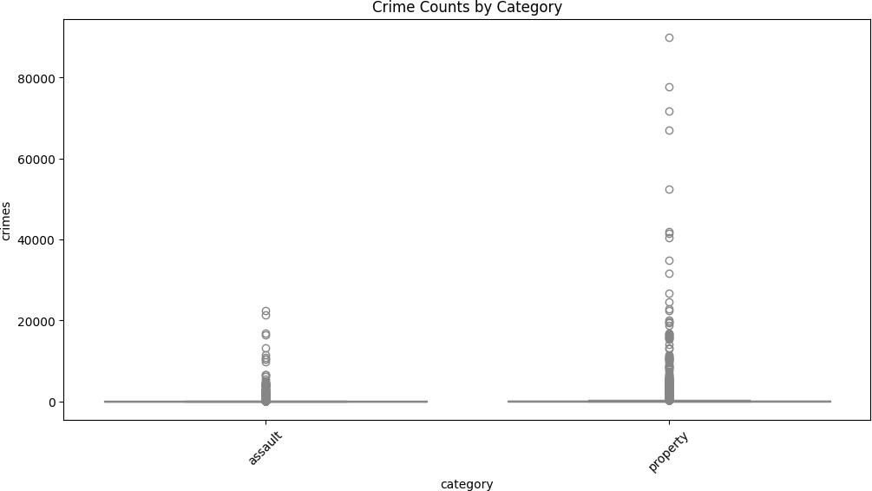

Figure 2: Crime Counts by Category
Assault and its subtypes, such as causing_injury, dominate crime counts. Variability across categories is high, suggesting category type is an important predictor.

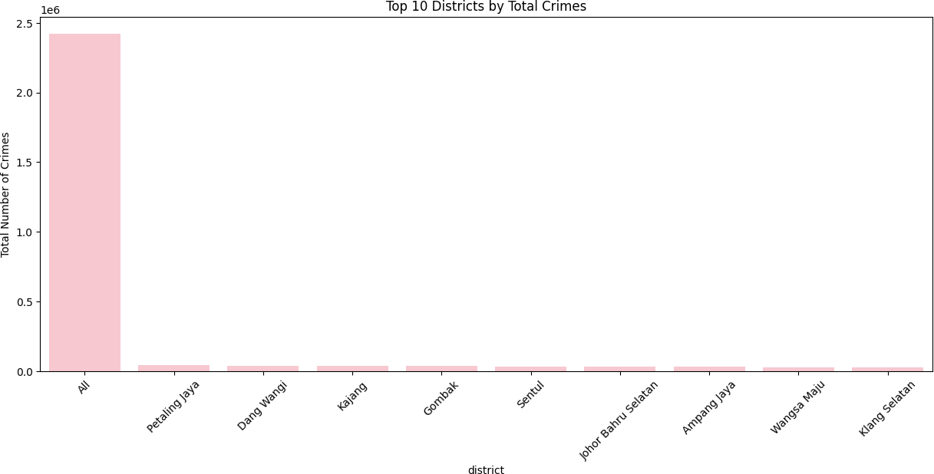

Figure 3: Top 10 Districts by Total Crimes
Certain districts consistently report higher crime numbers, likely due to population density, urbanization, or better reporting infrastructure. These districts may need more focus in predictive modeling.
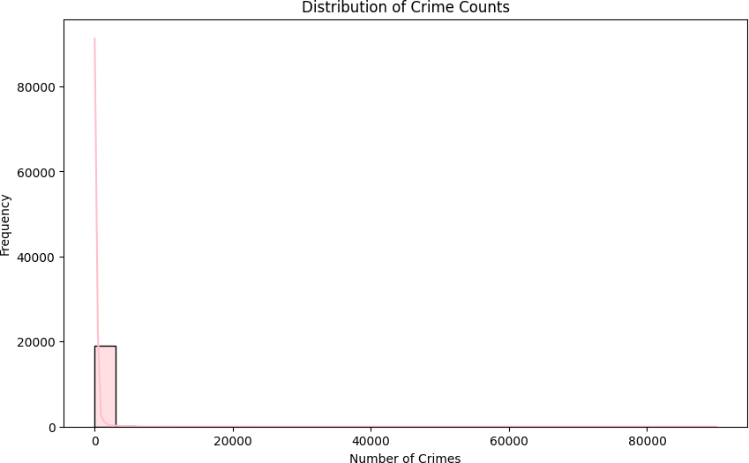

Figure 4: Distribution of Crime Counts
The distribution of crime counts is right-skewed, with most districts reporting lower crime numbers and a smaller number of districts exhibiting very high crime counts. This indicates the presence of outliers, which is common in real-world crime data and should be considered when evaluating regression performance.

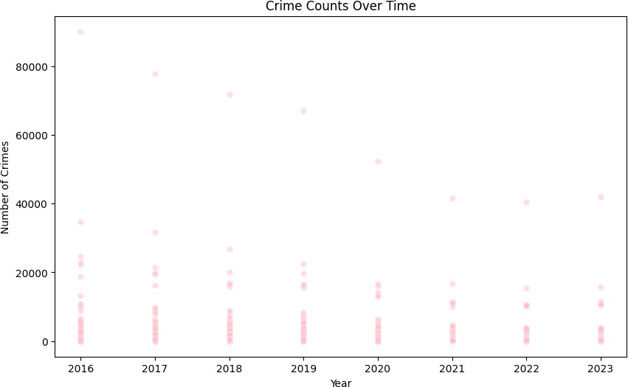

Figure 5: Crime Counts Over Time
The scatter plot shows how crime counts vary across years. While yearly trends exist, there is significant variability within each year, suggesting that temporal information alone is insuﬃcient and that location and crime-type features are also important predictors.

Model Building

In Task 1, a regression model of Neural Network was created to model the total number of crimes per year in each district depending on the temporal, geographical, and categorical characteristics.

Features and Target:
    - Features: year, stateencoded, districtencoded, categoryencoded, typeencoded.
    - Target: crimes

Data Splitting and Scaling:
The data set was divided into training and test set in a ratio of 80:20. To make the features have equal representation to the model, StandardScaler was used to standardize the training feature and the same transformation was performed on the test features.

Neural Network Architecture and Training

- The network is composed of three hidden layers containing 64, 32 and 16 neurons respectively.
- Activation: ReLU (Rectified Linear Unit) in every hidden layer.
- Loss function: Mean Squared Error (MSE) in order to minimize regression performance.
- Optimizer: Adam default learning rate.
- Training: The scaled training data were trained with maxiter=500 repetitions (maxiter=500).

Prediction and Evaluation:
The trained model was applied to make predictions on the number of crime in the test set. Regression measures were used to measure performance:

Metric | Value
Mean Squared Error (MSE) | 381,191.24
Root Mean Squared Error (RMSE) | 617.41
Mean Absolute Error (MAE) | 155.49
R-squared ®^2 | 0.43

Model Building (Classical ML Models)
For Task 2, two classical regression models were implemented to predict district-level crime incidence:
    - Linear Regression
    - Random Forest Regressor (100 trees, random_state = 42)

Features and Target:
      - Features: year, state_encoded, district_encoded, category_encoded, type_encoded
      - Target: crimes

Data Splitting:

The dataset was split into training and test sets with an 80:20 ratio (X_train: 15, 321 records, X_test: 3,831 records). Both models were trained using the same training set and evaluated on the held-out test set to ensure fair comparison.
Training:

      - The Linear Regression model was fitted directly to the training data.
      - The Random Forest Regressor was trained with 100 decision trees and default hyperparameters.

Predictions and Evaluation:
The models’ performance on the test set was evaluated using Mean Squared Error (MSE), Root Mean Squared Error (RMSE), Mean Absolute Error (MAE), and R-squared (R²).

Interpretation:

      - Random Forest Regressor works better than Linear Regression in all measures meaning that it can fit non-linear association in the data.
      - The two models have moderate predictive power as their R2 values imply that other variables not covered in the dataset can be used to predict the level of crime.

      - These findings oﬀer a point of reference to be compared to the Neural Network model.

Model Evaluation
The performance of the regression models was evaluated using the following metrics:

- Mean Absolute Error (MAE)

- Mean Squared Error (MSE)

- Root Mean Squared Error (RMSE)

- R-squared (R²)

Task 1: Neural Network (MLPRegressor).
The Neural Network model was trained in three hidden layers consisting of 64, 32 and 16 neurons, ReLU activation, and the Adam optimizer. The model was tested on the test set by the above metrics.

Model | MSE | RMSE | MAE | R-squared
MLP | 381,191.24 | 617.41 | 155.49 | 0.43

Interpretation:
The Neural Network represents the overall tendencies of the data and does this with relative precision. The fact that the R2 is 0.43 shows that it can only explain a certain amount of variability in crime counts, however the variation among districts and years is too big to perform well.

Task 2: Classical ML Models

Model | MSE | RMSE | MAE | R-squared
Linear Regression | 646,809.40 | 804.24 | 302.90 | 0.04
Random Forest | 53,397.65 | 231.08 | 40.90 | 0.92

The same training and test split was used to train and evaluate two classical regression models, i.e. Linear Regression and Random Forest Regressor (100 trees, random_state=42).
Interpretation:

- Random forest performed better than Neural Network and Linear Regression in all the parameters which shows that it is capable of capturing complicated
non-linear trends in the data.
- Linear Regression did not do well which means that simple linear relationships cannot be used to model crime counts.
- On the whole, non-linear models (Random Forest and MLP) are more adequate to predicting the incidence of crime at the district level in this dataset.

Optimization of Hyper-parameter.
The classical ML models (Task 2) were optimized to have better predictive performance by hyper-parameter optimization. Both Random Forest Regressor and Linear Regression were trained using gridSearchCV with 5 fold cross validation. R-squared (R 2 ) was used as a scoring measure to evaluate the models.

Random Forest Regressor:
A grid search was performed over the following parameter values:

Hyper-parameter | Values Tested
n_estimators | 50, 100, 20
max_depth | None, 10, 20, 30
min_samples_split | 2, 5, 10
min_samples_leaf | 1, 2, 4
max_features | ‘Auto’, ‘sqrt’

The optimal parameters identified were:

- Best Parameters: {‘max_depth’: 10, ‘max_features”: “sqrt”, “min_samples_leaf”: 1, “min_samples_split”: 2, “n_estimators”: 100}
- Best CV R² Score: 0.828

Linear Regression

The hyper-parameter grid included:

Hyper-parameter | Values Tested
fit_intercept | True, False
positive | True, False

The optimal parameters identified were:

- Best Parameters:{“fit_intercept”: True, “positive”: False}
- Best CV R² Score: 0.029

Interpretation:
Hyper-parameter optimization significantly improved Random Forest performance, while Linear Regression showed minimal improvement due to its linear assumptions. The optimized parameters were used to retrain both models for final evaluation.

Feature Selection
Feature selection was performed using feature importance scores from the optimized Random Forest model. Features with importance greater than 0.05 were selected for final modeling.
These features were used to retrain both the Random Forest and Linear Regression models. The final performance metrics are summarized in Table 5.

Model | Selected Features | MAE | RMSE | R² | CV R^2  Score
Linear Regression | state_encode d,type_encod ed,district_en coded,categor y_encoded, year | 302.90 | 804.24 | 0.04 | 0.029
Random Forest | state_encode d,type_encod ed,district_en coded,categor y_encoded, year | 40.90 | 231.08 | 0.92 | 0.828

Interpretation:

- The Random Forest model continues to outperform Linear Regression, confirming that non-linear models better capture patterns in district-level crime data.
- Feature selection helped eliminate negligible predictors while retaining all relevant information, simplifying the model without sacrificing accuracy.

Results and Conclusion

Key Findings
The models were evaluated on the test dataset using regression metrics (MSE, RMSE, MAE, and R²). Key observations include:
    - Random Forest Regressor achieved the highest predictive accuracy across all metrics, capturing non-linear patterns in crime data with an R² of 0.92.

    - The Neural Network (MLP) performed moderately well with an R² of 0.43, indicating it captured general trends but struggled with variability in crime counts.

    - Linear Regression performed poorly (R² = 0.04), highlighting that linear assumptions are insuﬃcient for modeling district-level crime incidence.

    - Temporal, categorical, and geographical features (year, state, district, crime category, and crime type) were significant predictors of crime counts.

Final Model
Based on the evaluation metrics, the Random Forest Regressor was selected as the final model, achieving:
    - MSE: 53,397.65

    - RMSE: 231.08

    - MAE: 40.90

    - R²: 0.92

This model eﬀectively captures complex patterns in the data and provides the most accurate predictions of district-level crime counts.

Challenges
During the project, several challenges were encountered:

    - High variability in crime counts across districts and years made modeling diﬃcult.

    - Skewed distribution of crime data required careful preprocessing and feature scaling.

    - Limited information on underlying factors aﬀecting crime (e.g., socioeconomic variables) constrained model performance.

    - Hyper-parameter tuning for large search grids was computationally intensive.

Future Work
Potential improvements for future studies include:

    - Incorporating additional features such as population density, socioeconomic indicators, or law enforcement presence.

    - Applying advanced regression models such as XGBoost, Gradient Boosting, or deep learning architectures.

    - Conducting feature engineering to better capture temporal trends and interactions between categorical variables.

    - Exploring ensemble methods that combine predictions from multiple models to improve accuracy and robustness.

Discussion

Model Performance
The performance of the models varied noticeably. The Random Forest Regressor clearly stood out, achieving the lowest errors and the highest R² (0.92). This indicates that it was able to capture the complex, non-linear relationships in crime counts across districts and years. The Neural Network (MLP) performed reasonably well, with an R² of 0.43, showing that it could grasp the general trends in the data, but it struggled to account for the large variability in crime counts. In contrast, Linear Regression performed poorly, with an R² of just 0.04, suggesting that simple linear assumptions are insuﬃcient for predicting district-level crime incidence in this dataset.

Impact of Hyperparameter Tuning and Feature Selection
Hyperparameter tuning had a noticeable eﬀect on model performance, particularly for the Random Forest. By carefully adjusting the number of trees, tree depth, and splitting criteria, the model’s predictive accuracy improved significantly. Feature selection and preprocessing, including the encoding of categorical variables and the inclusion of temporal and geographic features, helped ensure that the models focused on the most relevant information. Linear Regression, however, showed only modest improvement with tuning, highlighting that its linear structure could not adequately capture the patterns in the data.

Interpretation of Results
The models suggest that certain districts, crime categories, and specific years are associated with higher crime counts. Both the Neural Network and Random Forest models were able to identify these patterns, although the Random Forest was more precise. The distribution of crime counts is heavily skewed, with a small number of districts or categories contributing disproportionately to total crimes. This insight emphasizes the importance of non-linear modeling for datasets with high variability and skewed distributions.

Limitations
Several limitations aﬀected the study. The dataset only captures recorded crimes, leaving out unreported or undetected cases. Linear Regression’s assumptions limited its predictive power, and even the Neural Network was aﬀected by the inherent noise and skewness in the data.
Additionally, external socioeconomic factors, which may have a significant impact on crime trends, were not included in this analysis. These factors suggest that the models, while useful, do not capture the full complexity of crime dynamics.

Suggestions for Future Research
Future research could explore incorporating additional predictors, such as population density, income levels, or law enforcement resources, which may improve model accuracy. Applying more advanced ensemble methods or deep learning architectures could also enhance predictive performance. Feature engineering to capture temporal trends and interactions between categorical variables would likely benefit the models. Finally, testing this methodology on other regions or countries could help validate its generalizability and provide broader insights into crime prediction.

References
- Pandas Development Team. (2023). pandas: Python Data Analysis Library. Retrieved from https://pandas.pydata.org/
- NumPy Developers. (2023). NumPy: Fundamental package for scientific computing with Python. Retrieved from https://numpy.org/
- scikit-learn Developers. (2023). scikit-learn: Machine Learning in Python. Retrieved from https://scikit-learn.org/
- Seaborn Development Team. (2023). Seaborn: Statistical Data Visualization. Retrieved from https://seaborn.pydata.org/
- Matplotlib Development Team. (2023). Matplotlib: Python 2D plotting library. Retrieved from https://matplotlib.org/
- Kaggle Dataset. (2023). Malaysia District-level Crime Dataset. Retrieved from https://www.kaggle.com/datasets

