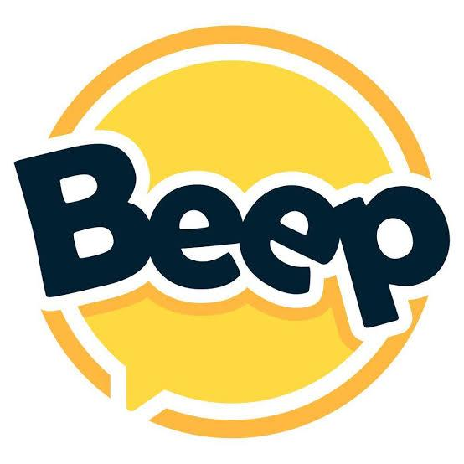 | Beep  India's Largest Student Community Platform | As Seen on Shark Tank India

Sponsorship Proposal for Your College
Get your college sponsored by Beep — when your students subscribe to Pro, Beep pays you.
1.2M+  Students | 1,700+  College Partners | 7,000+  Recruiters Pan India | Shark Tank  Featured & Funded

💰 How the Sponsorship Works  Get your students on Beep Pro and Beep sponsors your college — it's that simple.  Higher the participation, higher the sponsorship for your college. | 🎯 Internship Fair — Included  Beep plans & executes a full Internship Fair for your campus:  - 15–18 companies hiring freshers & interns  - Group Discussion rounds with expert feedback  - AI-powered mock interviews with real-time scoring  - Masterclasses & workshops by industry leaders  - Zero execution effort from your college
  Pro Plan Users | Sponsorship Amount
  100 Users | ₹10,000
  200 Users | ₹20,000
  300 Users | ₹30,000

What Your Students Get with Beep Pro
🏢 More Job Opportunities  Exclusive access to apply for a wider range of jobs & internships | ⭐ Priority Shortlisting  Higher preference in recruiter shortlisting based on your roadmap progress | 📄 ATS Resume Builder  Improve your ATS score and get your resume qualified by applicant tracking systems | 🎓 Micro-Courses & Programs  Access to curated learning programs to upskill at your own pace
📱 Short-Format Content  All informational short-form content unlocked — learn on the go | 🎥 Recorded Webinars  Full library of expert-led sessions and webinars, on demand | 🤝 Beep Community  Be part of a thriving network of students and recruiters across India | 🤖 AI Mock Interviews  Practice real interviews with an AI — get instant feedback and improve fast

Partner with Beep — Let's unlock opportunity for your students.
Reach out to us to get started | beep.social

