SmartLens-Indic: An Offline Raspberry Pi Wearable for Real-Time Devanagari Scene-Text Reading

Aadhya Sharma
MCA (AI & ML), Dept. of CSE
School of Engineering and Technology
K.R. Mangalam University
Gurugram, India
Pratyush Bharadwaj
MCA (AI & ML), Dept. of CSE
School of Engineering and Technology
K.R. Mangalam University
Gurugram, India
Ritu Devi
Project Supervisor, Dept. of CSE
School of Engineering and Technology
K.R. Mangalam University
Gurugram, India

Abstract—Reading text from signboards, notices, room signs and product labels is an important accessibility challenge for people with visual impairments. Conventional text-reading solutions may depend on smartphones, internet connectivity or remote processing. This paper presents SmartLens-Indic, an offline, Raspberry Pi-based wearable reading assistant designed to capture and read Devanagari scene text through spoken Hindi output. The system integrates button-triggered image acquisition, image preprocessing using OpenCV, text detection, Devanagari text recognition using a pretrained PP-OCRv5 mobile recognition model, confidence-based filtering and local neural text-to-speech synthesis. The architecture processes captured images locally, reducing dependence on network connectivity and avoiding the transmission of captured scenes to remote services. The evaluation methodology uses the Hindi subset of the IndicSTR12 dataset to assess recognition quality through character error rate, word error rate and exact-match accuracy. System-level evaluation considers end-to-end latency, memory consumption, power usage and processor temperature on the target Raspberry Pi. The study also defines a controlled optimisation procedure for comparing floating-point inference with ONNX-based quantised configurations while monitoring recognition accuracy. SmartLens-Indic provides an integrated design and evaluation framework for offline Devanagari text reading on resource-constrained hardware. [Add one or two sentences with the main measured results: CER/WER on IndicSTR12 Hindi and median end-to-end latency on the Raspberry Pi.]
Keywords—Devanagari OCR, scene text recognition, edge AI, Raspberry Pi, Hindi text-to-speech, model quantisation, assistive technology

Introduction
Text in the built environment, such as signboards, notices, room numbers and product labels, carries information that is essential for independent movement, yet it is designed for visual consumption. For visually impaired people this creates a daily barrier, and the barrier is sharper for Indic scripts. Devanagari is used for Hindi, Marathi, Nepali and Sanskrit and dominates public signage across much of northern India, but its structure (a connecting headline or shirorekha, vowel signs, conjunct consonants) makes recognition harder than for Latin text [1], [2].
Smartphone OCR applications and cloud services can read such text, but they typically require several touch interactions, a network connection or both. A cloud pipeline uploads a photograph of the user’s surroundings, waits for a remote OCR result and then waits again for remote speech synthesis, which adds latency, exposes private imagery and fails when connectivity is poor. Scene text also differs from scanned documents: fonts, illumination, perspective and clutter vary freely, and recognisers must handle cropped words rather than clean pages [3], [4].
Moving the whole pipeline to an edge device removes these dependencies but introduces a deployment problem: recognition networks must fit the memory, compute, power and thermal budget of a single-board computer. Quantisation and compact architectures are the standard tools for this [5], [6], but their accuracy cost on Devanagari scene text must be measured rather than assumed.
This paper presents SmartLens-Indic, a Raspberry Pi based assistant that reads Devanagari text aloud when the user presses one physical button. The principal contributions are:
- Integrated offline architecture: a Raspberry Pi pipeline combining button-triggered capture, text detection, Devanagari recognition and local speech synthesis, with no network access during operation.
- Language-specific reading pipeline: integration of a pretrained Devanagari recognition model with image preprocessing, confidence-based filtering, text ordering and Hindi speech output.
- Resource-aware evaluation methodology: a two-track framework separating recognition performance on Hindi scene-text images (CER, WER, exact match) from end-to-end system performance (latency, memory, power, temperature).
- Deployment optimisation strategy: a controlled procedure for comparing model export and quantisation configurations while checking their effect on recognition quality and computational cost.
The rest of the paper reviews related work (Section II), details the design (III), defines the evaluation (IV), reports and discusses the experimental results (V) and concludes (VI).

Related Work

Scene Text Recognition for Indic Scripts
Scene text reading is usually split into detection and recognition. Segmentation-based detectors such as CRAFT and differentiable binarisation (DB) localise text regions [7], [8]; recognisers combine a convolutional encoder, a sequence model and connectionist temporal classification (CTC) decoding [4], [9], or use a single visual transformer-style model [10]. For Indic scripts, Mathew et al. benchmarked Devanagari, Telugu and Malayalam recognition [1], and Gunna et al. showed that transfer learning helps across Indian languages [2]. IndicSTR12 provides more than 27,000 real word images over 12 Indian languages, with more than 1,000 per language, and benchmarks CRNN, STARNet and PARSeq [3].
Table I summarises the works that most directly shape this project.
- Selected prior work and its role here
Work | Contribution | Role in this paper
Mathew et al. [1] | Benchmark of scene text recognition for Devanagari, Telugu, Malayalam | Early Devanagari baseline
Gunna et al. [2] | Transfer learning across Indian-language scene text | Basis for optional fine-tuning
Lunia et al. [3] | IndicSTR12: 12 languages; CRNN, STARNet, PARSeq baselines | Test data for Track A
Du et al. [11] | Practical ultra-lightweight OCR system | Detector and recogniser family
Hansen [12] | Local neural TTS on ONNX Runtime | Offline speech output

Lightweight OCR and Edge Deployment
The PP-OCR family targets practical, ultra-lightweight OCR [11]. Its PP-OCRv5 generation includes script-specific mobile recognisers; the Devanagari model covers Hindi, Sanskrit and other Devanagari languages plus digits and has a published storage size of 7.5 MB [13]. Integer-only quantisation can reduce size and latency on CPUs with modest accuracy loss [5], and ONNX Runtime provides a portable CPU inference engine [14]. Published speeds, however, come from server hardware and do not transfer to a Raspberry Pi.

Offline Speech and Assistive Readers
Piper is a local neural text-to-speech system whose voices are VITS models [15] exported to ONNX and run on Raspberry Pi class hardware; Hindi (hi_IN) voices are available in its voice collection [12], [16]. Table II contrasts the architectures a reading aid can adopt.
- Reading-aid architectures (qualitative)
Aspect | Cloud OCR + TTS | On-device phone app | SmartLens-Indic
Internet needed | Yes | App dependent | No
Compute location | Remote server | Phone SoC | Raspberry Pi
Image leaves device | Yes | Usually no | No
Interaction | Touch screen | Touch screen | One physical button
Hands-free wear | No | Limited | Yes
Latency governed by | Network + server | Phone hardware | Pi + model size

System Design

Architecture and Hardware
Fig. 1 shows the architecture. A momentary push button on a GPIO pin triggers a single capture from a CSI camera module; the Raspberry Pi runs every later stage locally and drives a speaker or earphone. A USB power bank supplies power, which makes the unit wearable or handheld. Table III lists the configuration.
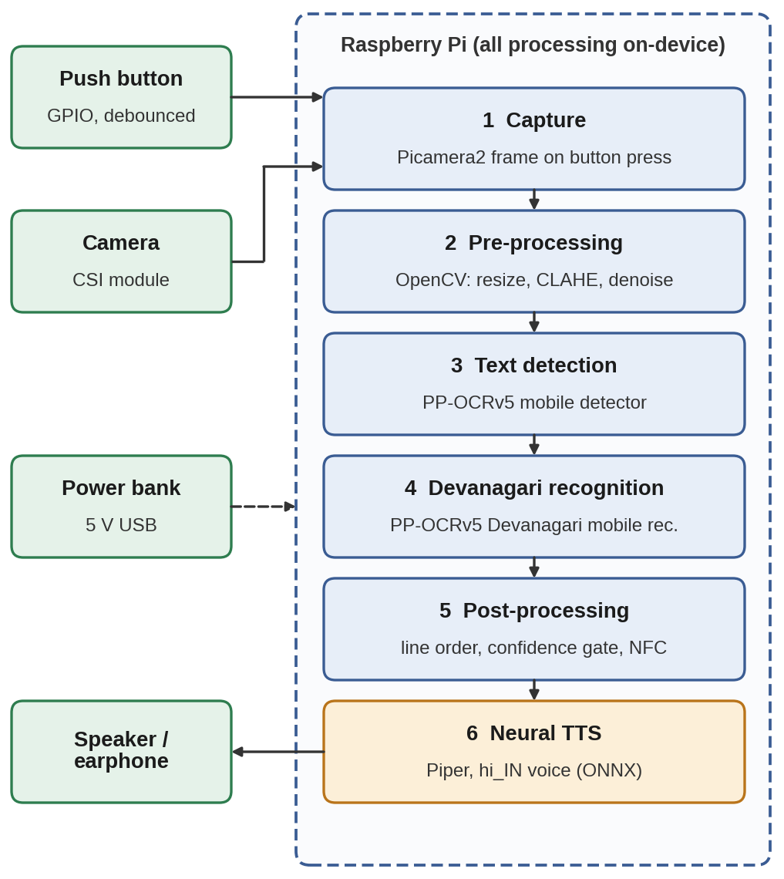
- Architecture of SmartLens-Indic. Peripherals (green) feed one on-device pipeline of six stages; no stage uses the network.
- Hardware and software configuration
Subsystem | Configuration | Role
Board | Raspberry Pi [model, RAM] | Host for all stages
Camera | [module, resolution], CSI | Scene capture
Trigger | GPIO push button, debounced | Starts one reading
OS, Python | [OS version, Python version] | Platform
Pre-processing | OpenCV [version] | Resize, CLAHE, denoise
Detector | PP-OCRv5 [detector model name] | Text regions
Recogniser | devanagari_PP-OCRv5_mobile_rec | Unicode text, score
Runtime | [PaddleOCR / ONNX Runtime versions] | CPU inference
TTS | Piper [version], voice [hi_IN voice name] | Speech waveform
Power | [power source, capacity] | Portable supply

Runtime Workflow
The workflow in Fig. 2 is event driven. Models are loaded once at start-up and stay resident, so a press pays only for capture and inference. Because nothing runs between presses, the design avoids continuous inference and keeps idle power and SoC temperature low. If no recognised line reaches the confidence threshold τ, the device speaks a short prompt asking the user to re-aim instead of reading unreliable text.
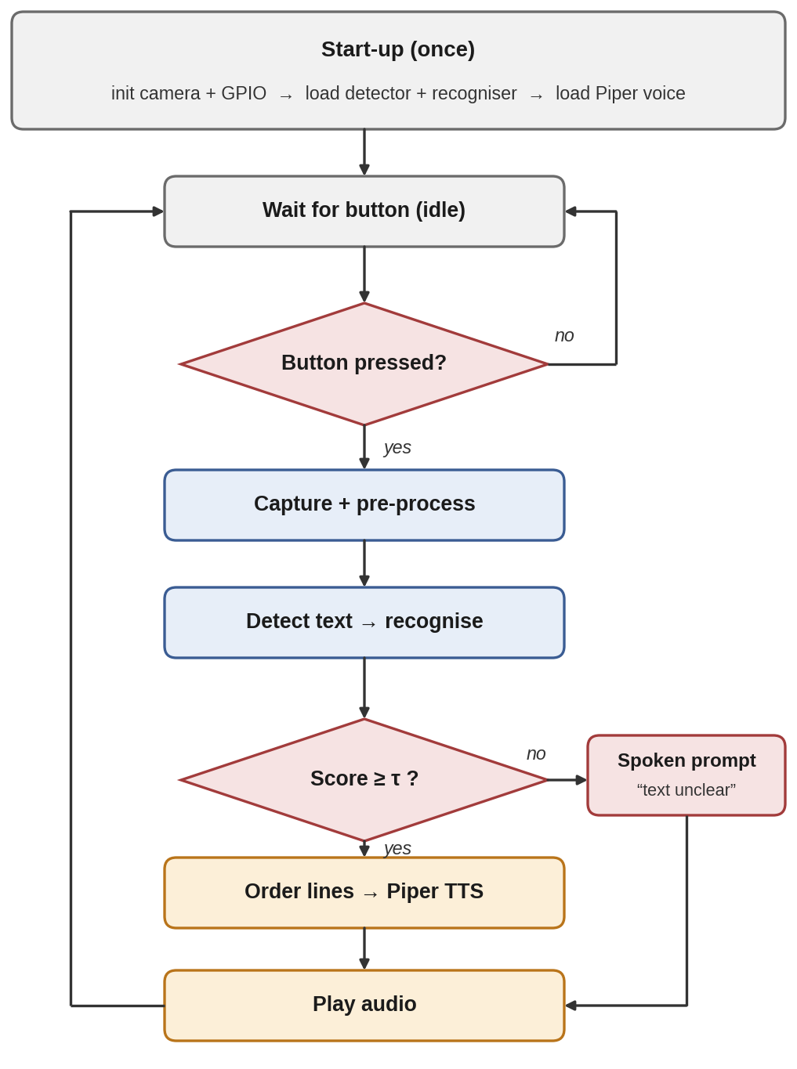
- Runtime workflow. Both outcomes of the confidence gate converge on the audio output, then the device returns to idle.

Pre-processing
The frame is resized so that its longest side is bounded (initially 960 px, a tunable value), converted to a normalised tensor and, when the scene is dim or low-contrast, enhanced with contrast-limited adaptive histogram equalisation on the luminance channel and light denoising using OpenCV. Optional perspective correction handles oblique views. Each operation is switchable so its effect can be isolated in ablations.

Detection and Devanagari Recognition
The detector localises text as polygons using the PP-OCR detector, a DB-style segmentation network [8], [11]. Each region is cropped, rectified and passed to the Devanagari recogniser, which returns a Unicode string and a confidence score by CTC decoding [9]. Because Devanagari characters combine into conjuncts and carry vowel signs, the recogniser outputs code-point sequences, and Section IV therefore computes error rates over Unicode code points after NFC normalisation.

Post-processing and Speech
Regions are grouped into lines by vertical overlap and read top to bottom, left to right. Fragments scoring below τ are dropped, whitespace is normalised and the text is sent to Piper, which phonemises with eSpeak NG and synthesises a waveform with a VITS acoustic model [15], [12]. To shorten the time to first sound, the first line is synthesised and played while later lines are queued.

Edge Optimisation
The optimisation path in Fig. 3 starts from the pretrained model (C0), exports it to ONNX in FP32 (C1) and then quantises to INT8 either dynamically (C2) or statically with a calibration set (C3). PaddleOCR can run its recognisers through ONNX Runtime [13]. A configuration is accepted only if its character error rate exceeds the FP32 value by at most ε on held-out data, where ε is set to [ε value]. Calibration images are drawn separately from the test images.
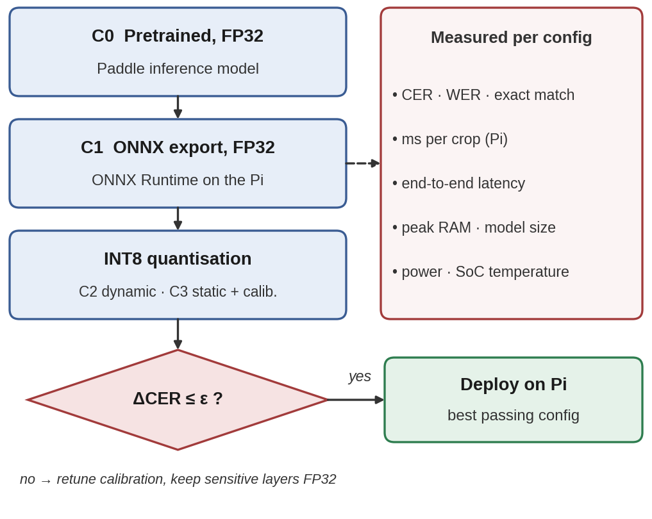
- Optimisation pipeline with an accuracy gate. A quantised model reaches the device only if it passes the CER test.

Software Implementation
The software is organised into modular components for image acquisition, preprocessing, text detection, text recognition, post-processing and speech synthesis (Fig. 4). The pipeline begins when the user presses the trigger button. The captured image is preprocessed and passed to the detector; detected regions are recognised individually, ordered by spatial position and filtered by confidence before the text reaches the Hindi speech engine. If no reliable text is obtained, an audio prompt asks the user to capture the scene again. Separating image processing from speech generation allows each component to be evaluated independently, and runtime measurements can be attached to each stage to locate bottlenecks. Algorithm 1 gives the control logic.
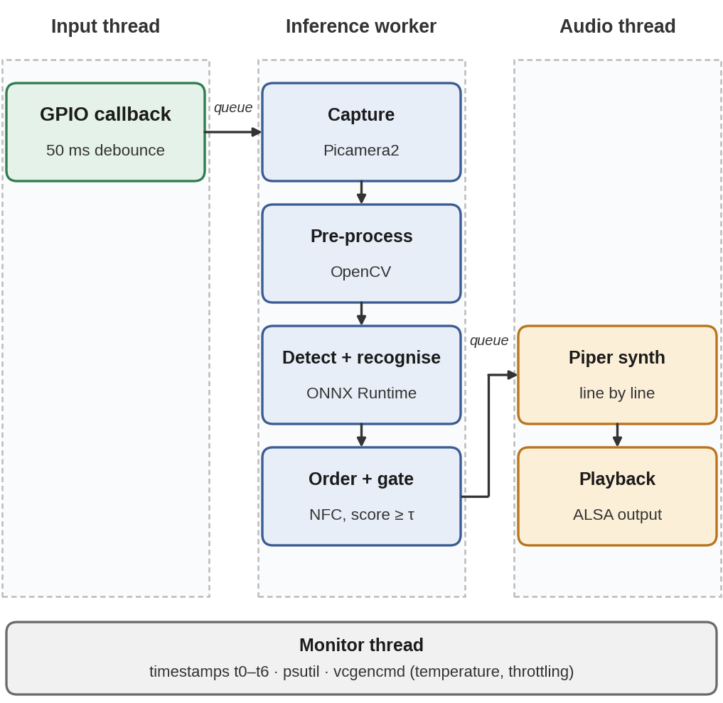
- Software structure of the design, separating input handling, inference and audio output.
Algorithm 1: Button-triggered reading
1 load detector D, recogniser R, voice V; init camera, button
2 loop
3 wait for debounced press; t₀ ← now
4 I ← preprocess(capture())
5 L ← [ ]; for each box b in reading_order(D(I)):
6 (s, c) ← R(crop(I, b)); if c ≥ τ: append s to L
7 if L is empty: play(prompt) else for s in L: play(V(NFC(s)))
8 log t₀ … t₆

Evaluation Methodology

Datasets
Track A evaluates the recogniser alone on the real Hindi word images of IndicSTR12 [3]. No fine-tuning is performed, so the whole subset acts as a held-out test set. Some of its Hindi images come from earlier Indic datasets [1], [2], and the training data of the pretrained model is not fully documented, so overlap cannot be excluded. Track B therefore evaluates the full pipeline on the prototype using [n] self-captured photographs of signboards, notices, labels and room numbers, annotated at line level and tagged by lighting, distance, viewing angle, font style and background.

Protocol
Fig. 5 summarises the protocol. All configurations see identical inputs, and every measurement is repeated until the spread is stable. CER is also reported per condition tag in Track B to expose failure modes.
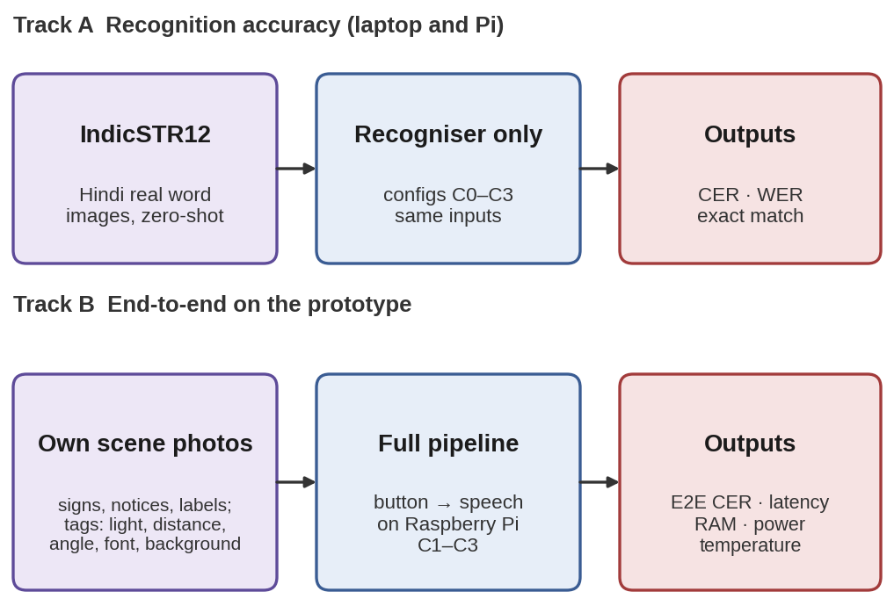
- Two-track evaluation protocol. Track A isolates the recogniser; Track B measures the whole device.

Test Bed and Instrumentation
Fig. 6 shows the test bed. Scenes are photographed from marked distances and angles so that conditions are repeatable. An inline USB power meter logs electrical power, the prototype logs timestamps, memory, CPU load and temperature to CSV files, and the analysis runs on a laptop so that it does not disturb the device under test. Ambient temperature, the CPU governor and the cooling setup are recorded for every run.
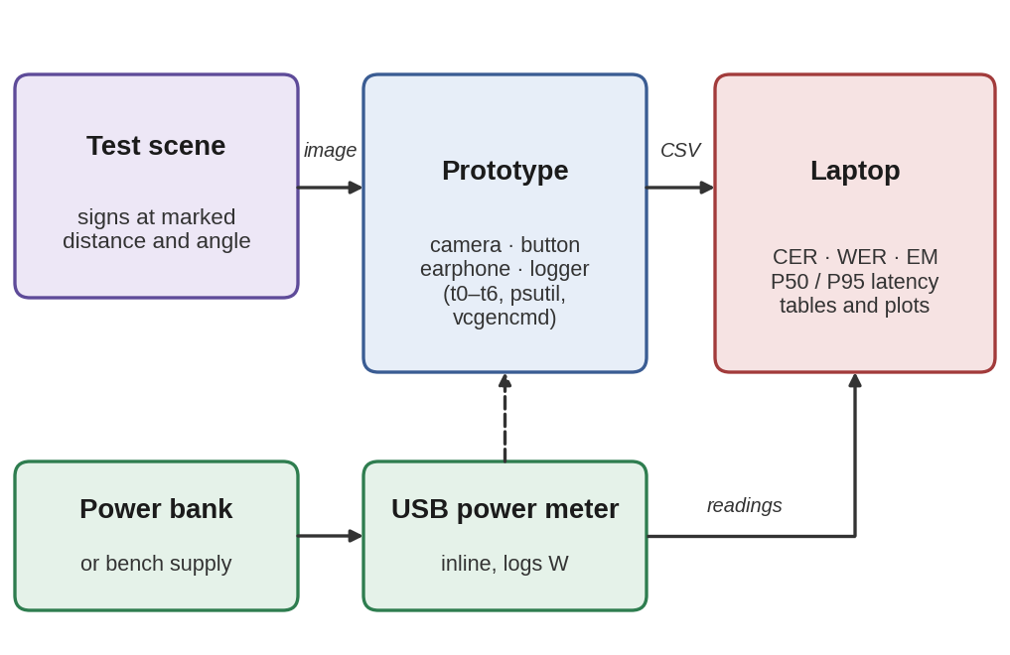
- Test bed. Dashed arrow: power path through the inline meter; solid arrows: data.

Metrics
Recognition quality is measured by character error rate (CER), word error rate (WER) and exact-match accuracy (EM):
CER = (S_{c} + D_{c} + I_{c}) / N_{c} (1)
WER = (S_{w} + D_{w} + I_{w}) / N_{w} (2)
EM = (1/M) Σ 1[ ŷ_{i} = y_{i} ] (3)
where S, D and I are substitutions, deletions and insertions from the Levenshtein alignment of prediction ŷ to reference y at character (c) or word (w) level, N is the reference length and M the number of samples. System cost is captured by the end-to-end latency
T_{e2e} = t₆ − t₀ = Σ_{k=1..6} Δt_{k} (4)
with the six timestamps of Fig. 7, reported as median and 95th percentile after discarded warm-up runs. Further metrics are model size on disk, peak resident memory and CPU load (psutil), average power from an inline USB meter, SoC temperature and throttling flags from vcgencmd [17], and battery runtime under a repeated reading cycle.
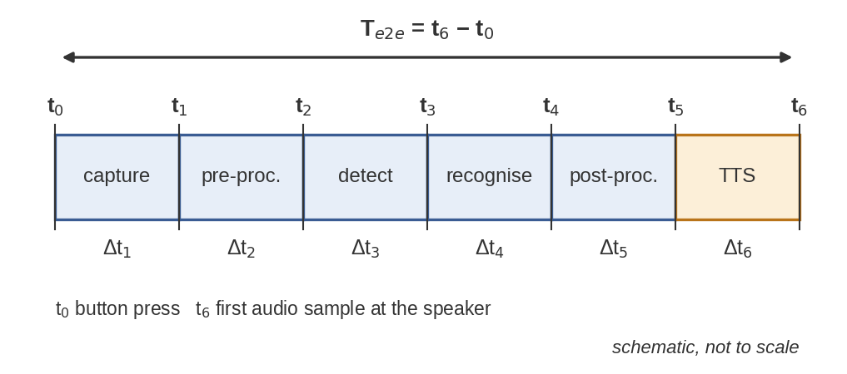
- Latency measurement points. Each Δt is logged with a monotonic clock; t₆ is the first audio sample.

Results and Discussion

Published Component Specifications
Table IV and Fig. 8 collect published figures for the selected components. They describe the components as documented by their authors and are not measurements of SmartLens-Indic. In particular, the 84.96% average recognition accuracy of the Devanagari model was reported by the PaddleOCR team on its own multilingual evaluation set [13]; it is not comparable with CER, WER or exact-match values on IndicSTR12 and must not be read as the accuracy of the proposed system. Speeds in the same documentation were obtained on server-class hardware and do not transfer to a Raspberry Pi.
- Published figures of selected components
Item | Published value | Source
Devanagari recogniser size | 7.5 MB | [13]
Recogniser avg. accuracy | 84.96% (PaddleOCR internal set) | [13]
Languages covered | Hindi, Sanskrit, other Devanagari, digits | [13]
IndicSTR12 real images | >27,000 words, >1,000 per language | [3]
Piper medium voice | about 60 MB (ONNX), hi_IN available | [16]

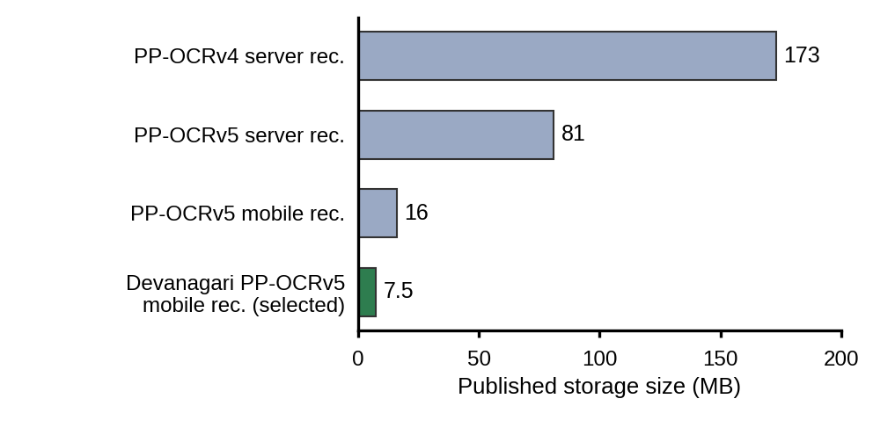
- Published storage size of PP-OCR recognition models [13]. The selected Devanagari model is the smallest.

Experimental Setup
Track A used [n] Hindi word images from IndicSTR12 [dataset variant and split]. Track B used [n] photographs captured with the prototype at [locations and conditions] and annotated at line level. All Raspberry Pi measurements were made on the configuration in Table III with [cooling setup] at an ambient temperature of [°C]. Configurations C0 and C1 were tested; C2 and C3 were tested only where INT8 conversion was supported [delete if not tested].

Recognition Accuracy
Table V reports recogniser-only results on the IndicSTR12 Hindi images. C0 achieved a CER of [x]%, a WER of [x]% and an exact-match accuracy of [x]%. C1 achieved [x]%, [x]% and [x]% respectively.
- Track A: IndicSTR12 Hindi results (recogniser only)
Config. | CER (%) | WER (%) | EM (%) | Size (MB)
C0 Paddle FP32 | [ ] | [ ] | [ ] | [ ]
C1 ONNX FP32 | [ ] | [ ] | [ ] | [ ]
C2 INT8 dynamic* | [ ] | [ ] | [ ] | [ ]
C3 INT8 static* | [ ] | [ ] | [ ] | [ ]

*Delete rows that were not tested.

Recognition Examples
Table VI lists representative correct and incorrect predictions drawn from the test set [state how examples were chosen].
- Recognition examples from IndicSTR12 Hindi
Image | Reference | Prediction | Error type
[id] | [ ] | [ ] | [ ]
[id] | [ ] | [ ] | [ ]
[id] | [ ] | [ ] | [ ]
[id] | [ ] | [ ] | [ ]

End-to-End Scene Evaluation
Table VII reports the full pipeline on [n] self-captured scene photographs. These results are separate from Track A because the images, annotation level and pipeline stages differ.
- Track B: end-to-end results on self-captured scenes
Metric | Value
Photographs / text lines | [ ] / [ ]
Line-level CER (%) | [ ]
Line-level WER (%) | [ ]
Exact-match lines (%) | [ ]
Readings rejected by confidence gate (%) | [ ]
Reading-order errors | [ ]

On-Device Performance
Table VIII gives the measurements on the Raspberry Pi. The median end-to-end latency from button press to first audio was [x] s (95th percentile [x] s) over [n] readings. Peak memory was [x] MB and the maximum SoC temperature was [x] °C.
- Raspberry Pi measurements
Metric | C1 | INT8*
Detector time (ms) | [ ] | [ ]
Recogniser time per crop (ms) | [ ] | [ ]
TTS time to first audio (ms) | [ ] | [ ]
End-to-end latency, median (s) | [ ] | [ ]
End-to-end latency, P95 (s) | [ ] | [ ]
Model size on disk (MB) | [ ] | [ ]
Peak RAM (MB) | [ ] | [ ]
Average power (W) | [ ] | [ ]
Max SoC temperature (°C) | [ ] | [ ]
Battery runtime (h)* | [ ] | [ ]

*Delete if not tested.

Accuracy–Efficiency Trade-off
Relative to C0, C1 changed CER by [x] percentage points and median latency by [x] s. [If INT8 was tested: C2/C3 changed CER by [x] points, reduced model size by [x]% and changed latency by [x]%, so the accuracy gate with tolerance ε was passed / not passed. If INT8 was not supported, state why.] Write the conclusion about the trade-off only from these numbers.

Error Analysis
Of [n] incorrect readings, [x]% involved vowel signs and [x]% conjuncts. Record only categories actually observed and delete the rest.
- Observed error categories
Category | Count | Share (%) | Example
Vowel signs | [ ] | [ ] | [ ]
Conjuncts | [ ] | [ ] | [ ]
Headline merging | [ ] | [ ] | [ ]
Low lighting | [ ] | [ ] | [ ]
Perspective | [ ] | [ ] | [ ]
Blur | [ ] | [ ] | [ ]
Reading order | [ ] | [ ] | [ ]

Limitations
The system covers Hindi and printed text only and uses a pretrained recogniser that is not tuned to Indian signage fonts. Mixed Devanagari and English signs need care because the Hindi voice may pronounce Latin words poorly. The scene test set is small compared with public benchmarks, and the system was not evaluated with visually impaired users, whose feedback on button feel, audio clarity and pacing would require ethical approval.

Conclusion and Future Work
SmartLens-Indic presents an offline, Raspberry Pi-based approach to reading Devanagari scene text through spoken Hindi output. The architecture integrates button-triggered capture, OpenCV preprocessing, text detection, Devanagari recognition, confidence-based filtering and local speech synthesis. Keeping the pipeline on the device reduces reliance on network connectivity and avoids sending captured scenes to remote services.
The study defines an evaluation approach that separates recognition accuracy from system-level performance. CER, WER and exact-match accuracy measure recognition quality, while latency, memory, power and temperature characterise deployment requirements. Both must be assessed when building assistive text readers for constrained hardware. Further work can address difficult signage, inference optimisation and usability assessment with intended users, and the architecture offers a foundation for studying offline Indic scene-text reading as an edge-AI assistive application. [Add one sentence summarising the main measured findings.]

Acknowledgment
The authors thank the Department of Computer Science and Engineering, School of Engineering and Technology, K.R. Mangalam University, for supporting this work.

References
- M. Mathew, M. Jain, and C. V. Jawahar, “Benchmarking scene text recognition in Devanagari, Telugu and Malayalam,” in Proc. 14th IAPR Int. Conf. Document Analysis and Recognition (ICDAR), vol. 7, 2017, pp. 42–46, doi: 10.1109/ICDAR.2017.364.
- S. Gunna, R. Saluja, and C. V. Jawahar, “Transfer learning for scene text recognition in Indian languages,” in ICDAR 2021 Workshops, ser. LNCS, vol. 12916. Springer, 2021, pp. 182–197.
- H. Lunia, A. Mondal, and C. V. Jawahar, “IndicSTR12: A dataset for Indic scene text recognition,” in Document Analysis and Recognition (ICDAR 2023). Springer, 2023, pp. 233–250, doi: 10.1007/978-3-031-41498-5_17.
- B. Shi, X. Bai, and C. Yao, “An end-to-end trainable neural network for image-based sequence recognition and its application to scene text recognition,” IEEE Trans. Pattern Anal. Mach. Intell., vol. 39, no. 11, pp. 2298–2304, 2017.
- B. Jacob et al., “Quantization and training of neural networks for efficient integer-arithmetic-only inference,” in Proc. IEEE/CVF CVPR, 2018, pp. 2704–2713.
- A. G. Howard et al., “MobileNets: Efficient convolutional neural networks for mobile vision applications,” arXiv:1704.04861, 2017.
- Y. Baek, B. Lee, D. Han, S. Yun, and H. Lee, “Character region awareness for text detection,” in Proc. IEEE/CVF CVPR, 2019, pp. 9365–9374.
- M. Liao, Z. Wan, C. Yao, K. Chen, and X. Bai, “Real-time scene text detection with differentiable binarization,” in Proc. AAAI, vol. 34, no. 7, 2020, pp. 11474–11481.
- A. Graves, S. Fernández, F. Gomez, and J. Schmidhuber, “Connectionist temporal classification: Labelling unsegmented sequence data with recurrent neural networks,” in Proc. ICML, 2006, pp. 369–376.
- Y. Du et al., “SVTR: Scene text recognition with a single visual model,” in Proc. IJCAI, 2022, pp. 884–890.
- Y. Du et al., “PP-OCR: A practical ultra lightweight OCR system,” arXiv:2009.09941, 2020.
- M. Hansen and Open Home Foundation, “Piper: A fast, local neural text to speech system.” [Online]. Available: https://github.com/OHF-Voice/piper1-gpl
- PaddleOCR Contributors, “Text recognition module: supported models,” PaddleOCR Documentation. [Online]. Available: https://www.paddleocr.ai/latest/en/version3.x/module_usage/text_recognition.html
- ONNX Runtime developers, “ONNX Runtime: cross-platform, high-performance ML inferencing.” [Online]. Available: https://onnxruntime.ai
- J. Kim, J. Kong, and J. Son, “Conditional variational autoencoder with adversarial learning for end-to-end text-to-speech,” in Proc. ICML, PMLR 139, 2021, pp. 5530–5540.
- rhasspy, “piper-voices,” Hugging Face model repository. [Online]. Available: https://huggingface.co/rhasspy/piper-voices
- Raspberry Pi Ltd, “Raspberry Pi documentation.” [Online]. Available: https://www.raspberrypi.com/documentation/

