e-Governance and Digital Services
DigiLocker and UPI

Introduction:
This report contains the presentation of our findings in a visual form which will help understand the insights clearly through compelling visuals.
The visualizations (charts/ graphs etc) will be related to the publicly available data related to DigiLocker and UPI.

DigiLocker :
DigiLocker is an initiative under the Government of India's Digital India programme. It provides citizens with a digital platform to access, store and share authentic digital documents issued by participating organisations.
The platform plays an important role in reducing dependence on physical documents.
This report presents a state-wise analysis of DigiLocker adoption using the supplied dataset. Power BI Desktop was used to prepare the data, calculate indicators and develop visualizations for comparing regional performance.
The analysis focuses on identifying regions with high registration numbers, regions with relatively low registration penetration and the relationship between issuer availability and registered users.
Dataset Overview:
The dataset contains state-wise and union-territory-wise information covering 36 geographical units.
The variables used in the analysis include:
Variable | Description
Sl. No. | Serial number of the record
State/UT | Name of the state or union territory
Registered Users | Number of DigiLocker registered users
No. of Issuers | Number of issuers recorded for the region
Population | Population figure associated with the region
Population.1 | Registration-to-population percentage
The Population.1 column represents the ratio of registered users to population, expressed as a percentage.
Calculation:
Registration Penetration (%) =
(Registered Users / Population) × 100
This indicator allows regional comparisons while accounting for differences in population size.

Data Preparation and Methodology:
The dataset was imported into Power BI Desktop through the Excel workbook connector.
The following preparation and analysis steps were undertaken:
- Checked the dataset for missing values and duplicate records.
- Examined the numerical columns to ensure appropriate data types.
- Used the registered-user and issuer fields for aggregation.
- Used the registration-to-population percentage to compare adoption levels.
- Applied Top N and Bottom N filters to identify leading and lower-penetration regions.
- Created a scatter chart to examine the relationship between issuer availability and registered users.
- Created calculated measures for summary indicators.
A distinct-count measure was also created to count the number of geographical units represented in the dataset.
The analysis covers 36 states and union territories.

Dashboard :
The following was created using Power BI application. The whole dashboard is available on github for further inspection.
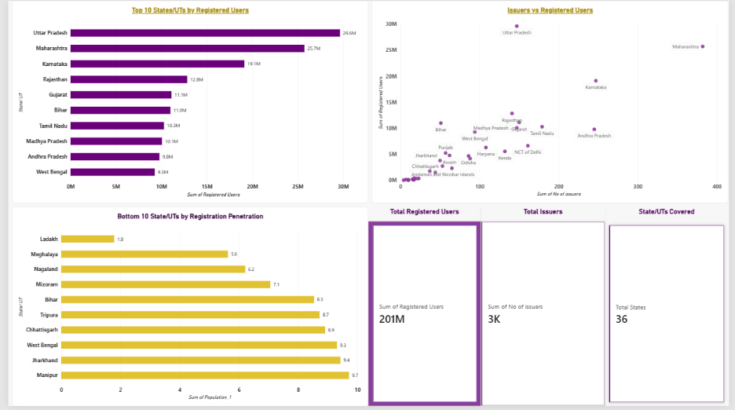

Detailed Analysis of Visualizations
Top 10 States/UTs by DigiLocker Registered Users
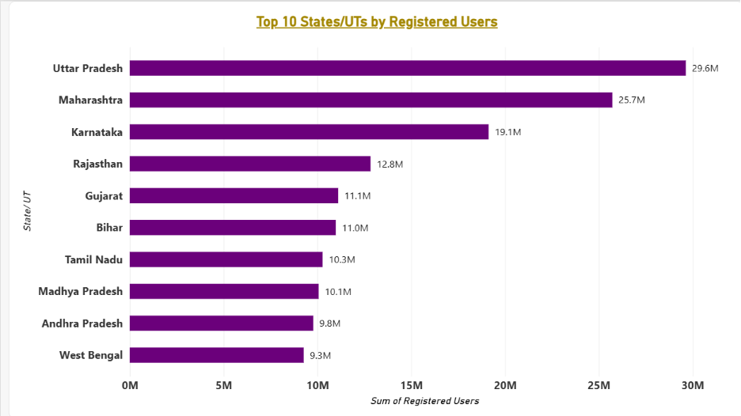
Visualization: Horizontal bar chart
Y-axis: State/UT
X-axis: Registered Users
This visualization identifies the ten states and union territories with the highest number of registered DigiLocker users.
The chart indicates that Uttar Pradesh has the highest registration count, followed by Maharashtra and Karnataka.
Insights gained:
- Uttar Pradesh leads the dataset in absolute registered-user numbers.
- Maharashtra and Karnataka also demonstrate substantial adoption.
- Several geographically large and highly populated states appear among the leading regions.
- High absolute registration numbers do not necessarily indicate high registration penetration.
- Bihar, for example, has approximately 10.98 million registered users but a registration penetration of only around 8.54%.
This distinction is important because populous states can have high registration counts even when a relatively small proportion of their population is registered.
Recommendations:
- Study successful onboarding and awareness practices in leading states.
- Identify effective service-delivery approaches that could be adapted in other regions.
- Continue expanding institutional participation and document availability.
- Evaluate regional adoption using both absolute registrations and population-based indicators.

Bottom 10 States/UTs by Registration Penetration
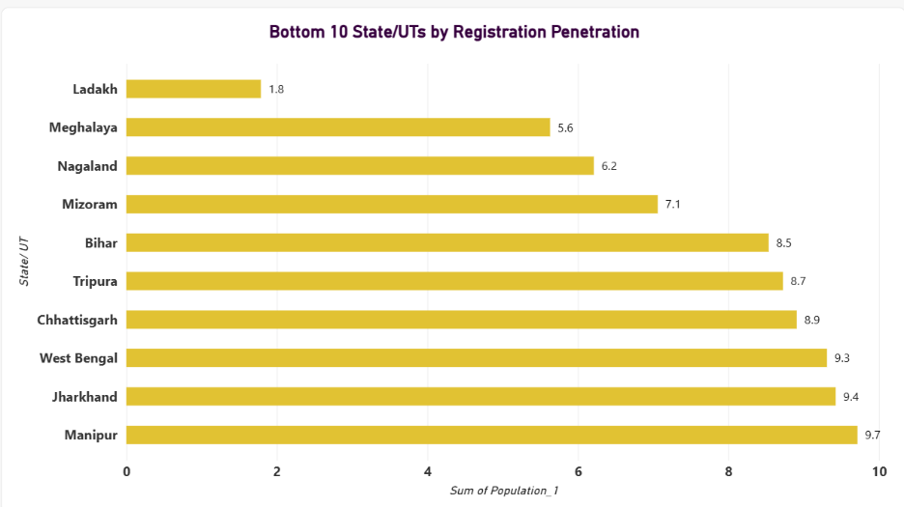
Visualization: Horizontal bar chart
Y-axis: State/UT
X-axis: Registration Penetration (%)
This visualization identifies the ten regions with the lowest registration-to-population percentages.
Unlike the previous chart, which focuses on absolute registered-user numbers, this visualization considers registration relative to population.
The chart highlights considerable variation in registration penetration across geographical regions.
Insights gained:
- Ladakh has the lowest registration penetration in the supplied dataset, at approximately 1.79%.
- Meghalaya, Nagaland and Mizoram also have relatively low registration penetration.
- Bihar and several other states appear among the lower-penetration regions despite having substantial absolute registration counts.
- The differences between regions suggest that population size alone does not explain the variation in adoption.
- Regional accessibility, digital awareness, internet availability, language accessibility and the perceived usefulness of services may be relevant factors to investigate.
These possible explanations require additional supporting data and should not be treated as proven causes based on this dataset alone.
Recommendations:
- Introduce targeted DigiLocker awareness campaigns in lower-penetration regions.
- Organise assisted digital onboarding through Common Service Centres and other appropriate public-service delivery points.
- Improve accessibility through regional-language support and user-friendly interfaces.
- Strengthen outreach in rural, remote and underserved communities.
- Investigate regional barriers through surveys and citizen feedback.
- Monitor changes in registration penetration over time to evaluate the effectiveness of adoption initiatives.

Relationship Between Issuer Availability and Registered Users
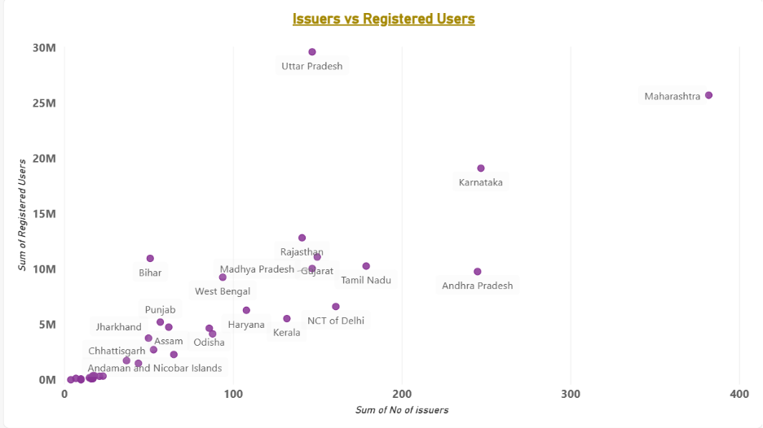
Visualization: Scatter chart
X-axis: Number of Issuers
Y-axis: Registered Users
Data points: Individual states and union territories
This visualization examines the relationship between the number of issuers recorded for a region and the number of registered DigiLocker users.
A scatter chart is useful because it allows multiple geographical units to be compared simultaneously.
Insights gained:
- Uttar Pradesh has the highest registered-user count despite having fewer recorded issuers than Maharashtra and Karnataka.
- Maharashtra has the highest issuer count among the leading examples and also has a high number of registered users.
- Some regions with comparatively fewer issuers have lower registered-user numbers, although this pattern is not universal.
- The scatter distribution suggests that issuer availability may be one factor associated with adoption, but it is not the only factor.
- Population size, awareness, institutional participation, accessibility and service relevance may also influence registrations.
Recommendations:
- Encourage more government departments, educational institutions and other eligible organisations to participate as issuers.
- Prioritise institutions whose digital documents are frequently required by citizens.
- Improve the availability of relevant documents across different regions.
- Investigate regions with relatively high issuer availability but lower registration levels.
- Study the relationship between issuer participation, document usage and user registrations using more detailed data.
- Evaluate the effectiveness of issuer expansion through changes in active usage and document downloads, not registrations alone.

DigiLocker Key Performance Indicators
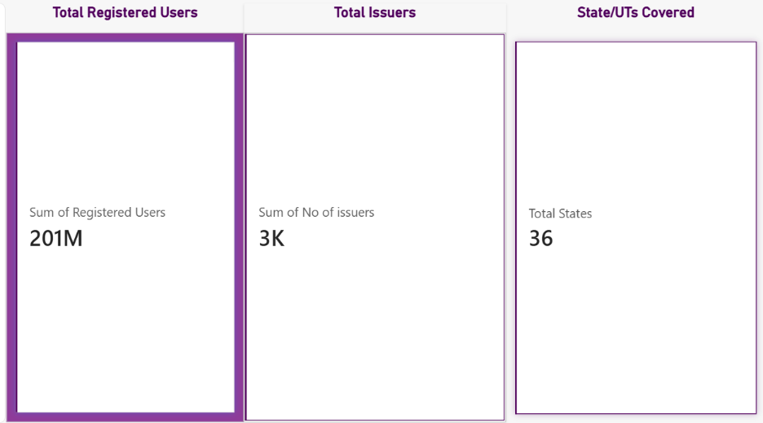
Visualization: Three Card visuals
The dashboard includes three summary cards to provide a quick overview of the dataset.
A. Total Registered Users
The card displays approximately 201 million registered users.
This figure is obtained by summing the state-wise registered-user counts in the supplied dataset.
It provides a convenient summary of the combined registrations represented across the 36 geographical records.
Insight:
The aggregate demonstrates the substantial scale of DigiLocker registrations represented in the dataset.
However, registered users should not automatically be interpreted as active users. The figure does not establish how frequently individuals access the platform or use its services.
B. Total Issuers
The card displays approximately 3K issuer records, representing the sum of the state-wise issuer counts.
This indicator provides a summary of the issuer entries recorded across the geographical units.
Insight:
The issuer records highlight the institutional dimension of DigiLocker. A strong issuer ecosystem is important because it supports the availability of digital documents.
However, the summed figure should not automatically be interpreted as the number of unique issuers nationally. The same organisation may potentially operate across multiple geographical units.
C. States/UTs Covered
The card displays 36 States/UTs.
This represents the number of distinct geographical units included in the dataset.
Insight:
The dataset covers all 36 state and union-territory records represented in the analysis, enabling a broad geographical comparison of registration patterns.
The card establishes the geographical scope of the dataset but does not independently prove that every region has achieved equal adoption or service accessibility.
Overall Dashboard Interpretation
The DigiLocker dashboard combines four analytical components to provide an overview of regional adoption and ecosystem development.
The first chart identifies regions with the highest absolute registered-user numbers. It demonstrates the scale of registrations in populous states such as Uttar Pradesh and Maharashtra.
The second chart examines registration penetration relative to population. It reveals that regions with substantial registration counts may still have relatively low penetration.
The third chart examines issuer availability in relation to registered users. It helps identify differences in regional issuer participation and adoption, while highlighting that issuer count alone cannot explain registration patterns.
Finally, the KPI cards summarise the overall scale represented by the dataset through registered-user counts, issuer records and geographical coverage.
Three major observations emerge from the combined analysis:
- Uneven regional adoption: DigiLocker registration levels vary substantially across states and union territories.
- Difference between scale and penetration: High absolute registration numbers do not necessarily indicate high population-based adoption.
- Importance of the issuer ecosystem: Institutional participation is relevant to the availability of digital documents, but adoption depends on several additional factors.
The dashboard therefore provides a foundation for identifying regional adoption gaps and developing more targeted digital-service strategies.

Limitations of the Analysis
The following limitations should be considered when interpreting the findings:
- The analysis is based on a single state-wise dataset rather than a time series of regional adoption.
- The reference date of the registered-user and issuer figures should be verified from the original data source.
- Population figures may be estimates and their reference year should be confirmed.
- Registration penetration represents registered users relative to population, not the proportion of eligible citizens who actively use DigiLocker.
- The summed issuer count may contain duplicate organisations operating across multiple regions.
- The dataset does not provide detailed information on active users, document downloads, service frequency or citizen satisfaction.
- The charts identify patterns and associations but do not establish the causes of regional adoption differences.

UPI:
The Unified Payments Interface (UPI) has become an important component of India's digital payment ecosystem. It enables users to transfer money between bank accounts through an interoperable, real-time payment infrastructure.
This report presents a data-driven analysis of UPI transaction trends using the supplied financial-year dataset. Power BI Desktop was used to transform the data, calculate relevant indicators and develop interactive visualizations.

Dataset Overview
The dataset contains financial-year-wise information on UPI transactions and reported incidents.
The principal variables used in the analysis are:
Variable | Description
Year | Financial year of the recorded data
Volume (in Millions) | Number of UPI transactions in millions
Volume (in Crores) | Transaction volume converted into crores
Value (in Crores) | Monetary value of transactions
No. of Incidents (in Lakhs) | Reported incidents in lakhs
Amount Involved (in Crores) | Monetary amount associated with reported incidents
The transaction volume and transaction value variables are used to study growth. The incident-related variables are used to examine reported incident trends.

Data Preparation and Methodology
The dataset was imported into Power BI Desktop using the Excel workbook connector.
The following preparation steps were undertaken:
- Relevant columns were selected for analysis.
- Numeric fields were checked to ensure that they could be used for aggregation.
- The incident column contained the text value "Null" for financial years where incident information was unavailable.
- A cleaned numeric incident column was created using Power Query, converting valid numerical entries into numeric values while preserving missing entries as null.
- Financial years were arranged in chronological order.
- Appropriate aggregations were selected for the visualizations.
A calculated measure was created to determine the reported incident rate per million transactions.
Formula:
Incident Rate per Million Transactions =
(Reported Incidents in Lakhs / Transaction Volume in Crores) × 10,000
The conversion factor accounts for the difference between lakhs, crores and millions.
Missing incident records were not replaced with zero because the absence of reported data does not establish that no incidents occurred.

Dashboard :
The following was created using Power BI application. The whole dashboard is available on github for further inspection.

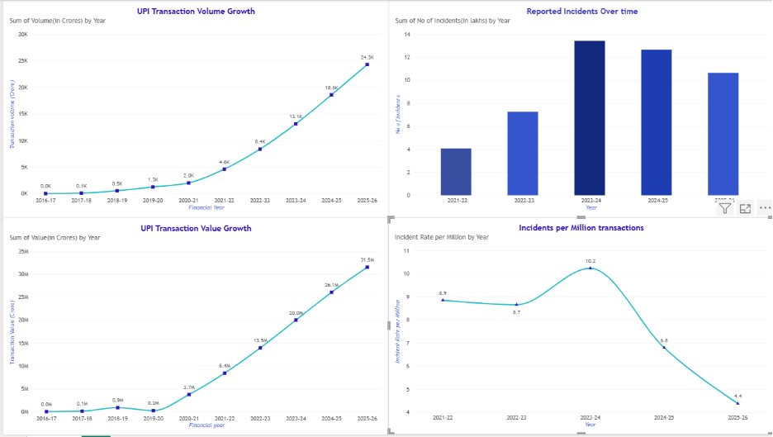
Detailed Analysis of Visualizations:
UPI Transaction Volume Growth-
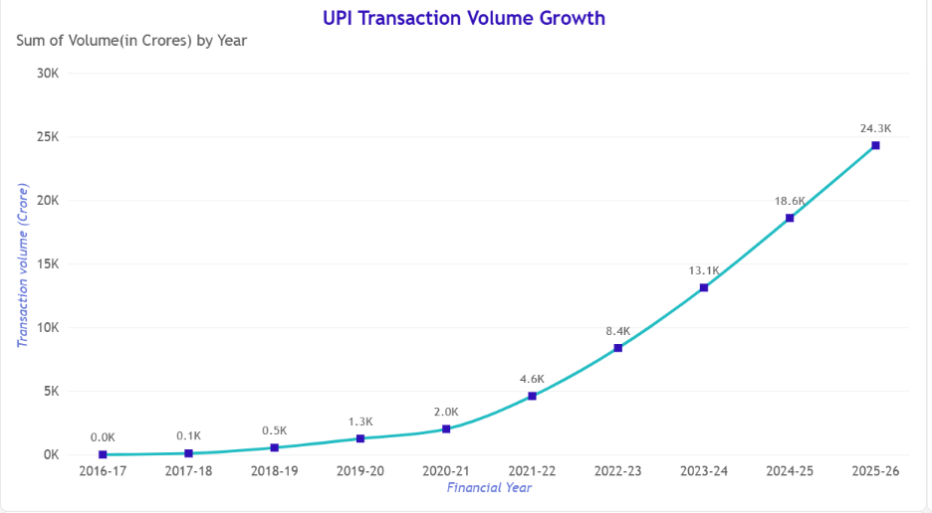
Visualization: Line chart
X-axis: Financial Year
Y-axis: Transaction Volume (Crores)
This visualization illustrates the expansion of UPI transaction volume from 2016–17 to 2025–26.
The dataset indicates an increase from approximately 1.786 crore transactions in 2016–17 to 24,288.767 crore transactions in 2025–26.
The line chart demonstrates a substantial and sustained upward trend. Growth becomes particularly pronounced from 2020–21 onwards, indicating the increasing scale of UPI usage.
Insights gained:
- UPI transaction volume has expanded significantly over the observed period.
- The increasing transaction volume indicates the growing role of digital payments in everyday financial activities.
- The acceleration in transaction volume suggests that UPI infrastructure must continue to support increasing transaction loads.
- The growing scale also increases the importance of system reliability, fraud monitoring, customer awareness and dispute-resolution mechanisms.
Recommendations:
- Continue strengthening payment infrastructure to support increasing transaction volumes.
- Improve real-time monitoring of unusual transaction patterns.
- Strengthen system availability and resilience during periods of high transaction demand.
- Expand public awareness regarding secure digital payment practices.

UPI Transaction Value Growth
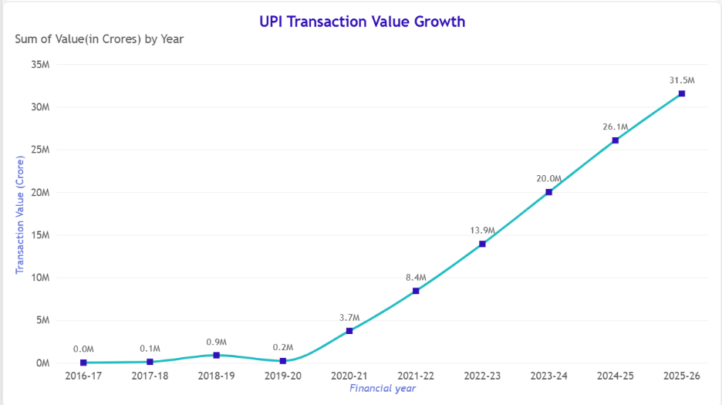
Visualization: Line chart
X-axis: Financial Year
Y-axis: Transaction Value (₹ Crores)
This chart examines the total monetary value of UPI transactions across the financial years.
The dataset records transaction value increasing from approximately ₹6,952.74 crore in 2016–17 to ₹31,541,509.82 crore in 2025–26.
The general pattern indicates substantial growth in the monetary scale of digital payments.
An unusual observation appears in 2019–20, when the recorded transaction value is lower than the previous financial year's value despite an increase in transaction volume.
This inconsistency deserves attention because transaction volume and transaction value generally provide complementary measures of payment activity.
Insights gained:
- UPI has expanded not only in the number of transactions but also in the monetary value processed.
- Increasing transaction value demonstrates the growing economic significance of the payment system.
- The 2019–20 observation represents a potential data-quality or reporting inconsistency that should be verified before drawing conclusions.
- Transaction volume and transaction value should be examined together because a higher number of transactions does not necessarily imply an equivalent increase in average transaction size.
Recommendations:
- Strengthen transaction monitoring and anomaly-detection mechanisms.
- Encourage regular verification of transaction reporting and data consistency.
- Improve transparency in payment-related reporting.
- Monitor both transaction volume and transaction value rather than relying on either indicator independently.

Reported UPI Incidents Over Time
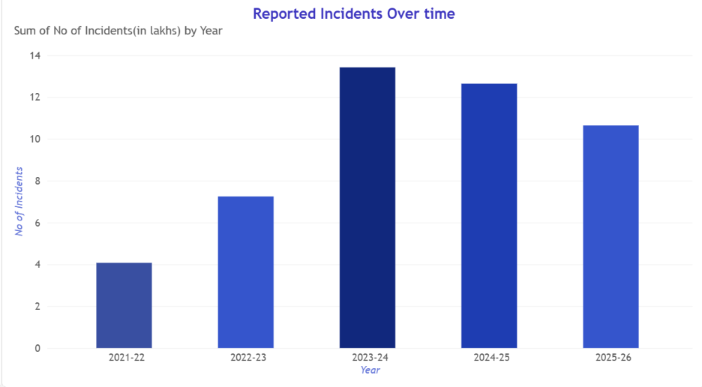
Visualization: Column chart
X-axis: Financial Year
Y-axis: Reported Incidents (Lakhs)
This visualization examines the number of reported incidents recorded in the dataset.
Incident information is available only from 2021–22 onwards.

Insights gained:
- Reported incidents increased substantially until 2023–24.
- The highest recorded number of incidents in the supplied data is 13.42 lakh in 2023–24.
- Reported incidents subsequently declined to 10.64 lakh in 2025–26.
- A decline in reported incidents should not automatically be interpreted as a decline in actual fraud or security risks. Changes in reporting practices, detection systems and classification may also influence the figures.

Recommendations:
- Strengthen fraud-reporting and incident-classification mechanisms.
- Promote awareness regarding phishing, impersonation, fraudulent payment requests and other digital payment risks.
- Improve coordination between banks, payment service providers and relevant authorities.
- Monitor incident trends regularly to identify emerging threats.
- Improve accessibility and responsiveness of complaint-resolution mechanisms.

Reported Incidents per Million UPI Transactions
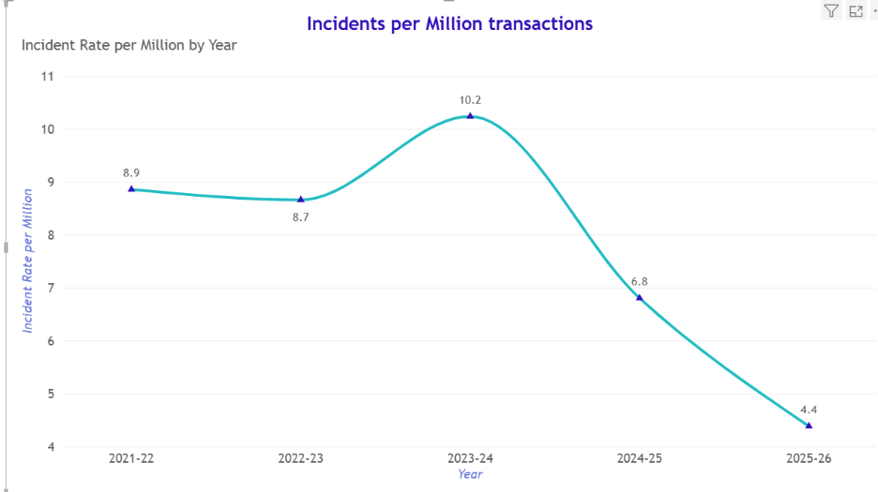
Visualization: Line chart
X-axis: Financial Year
Y-axis: Reported Incidents per Million Transactions
This visualization provides a relative measure of reported incidents by comparing them with the total transaction volume.
Unlike the previous chart, which displays the absolute number of reported incidents, this indicator accounts for the increasing scale of UPI transactions.

Insights gained:
- The reported incident rate was relatively stable between 2021–22 and 2022–23.
- It increased in 2023–24, indicating that reported incidents grew faster than transaction volume during that period.
- The rate declined in 2024–25 and 2025–26.
- By 2025–26, the calculated rate was substantially lower than its 2023–24 peak.
This visualization provides an important additional perspective. Although absolute incident counts increased in some years, the incident rate also depends on the total number of transactions processed.

Recommendations:
- Continue monitoring incident rates alongside absolute incident counts.
- Develop more detailed indicators covering incident categories, financial losses and resolution times.
- Investigate the factors associated with the increase in 2023–24.
- Evaluate whether security interventions and awareness campaigns correspond with subsequent changes in incident rates.
- Establish periodic reporting dashboards for monitoring payment-related incidents.

Overall Dashboard Interpretation:
The UPI dashboard combines four complementary visualizations to present an integrated view of digital payment growth and reported incident trends.
The first two charts establish the scale of UPI adoption by displaying transaction volume and monetary value. Together, they demonstrate the growing significance of UPI in India's digital payment ecosystem.
The third chart introduces the security dimension by examining the absolute number of reported incidents. The fourth chart adds context by measuring reported incidents relative to transaction volume.
The combined analysis produces three major observations:
- Significant growth: UPI transaction volume and monetary value have expanded considerably over the observed period.
- Need for continuous security monitoring: Reported incidents increased until 2023–24, demonstrating the importance of continuous fraud monitoring and public awareness.
- Improvement in the reported incident rate: The incident rate declined after 2023–24, although further verification and investigation are necessary to establish the reasons.
The dashboard therefore illustrates that digital payment growth and payment security must be considered together. Expansion of digital payment infrastructure should be accompanied by effective monitoring, consumer protection and institutional coordination.

Limitations of the Analysis:
The following limitations should be considered:
- Incident data is unavailable for the first five financial years in the supplied dataset.
- The dataset's metadata, reporting definitions and extraction date should be verified against the original official source.
- The 2019–20 transaction value requires source-level verification because it appears inconsistent with the surrounding trend.
- The 2025–26 reporting period should be confirmed as a complete financial year before final publication.
- The reported incident rate represents reported incidents relative to transaction volume, not the actual probability of fraud.
- The analysis identifies trends and associations but does not establish causal relationships.

