SALESDB
Business Intelligence & Insights Report
Covering: Sales · Profit · Customers · Regions · Discounts · Delivery · RFM

Prepared for Internal Decision-Making & Strategic Planning
Based on SQL analysis across 8 analytical modules

Executive Summary
This report synthesizes insights from a comprehensive SQL-based analysis of the SalesDB dataset. It covers eight analytical dimensions: customer performance, product profitability, regional trends, discount impact, delivery efficiency, time-series patterns, RFM segmentation, and database views. The findings highlight both growth opportunities and areas requiring immediate corrective action.

8  Analysis Modules  SQL files reviewed | 5  Key Focus Areas  Strategic insights | 4  Customer Segments  RFM-based tiers | 5  DB Views Created  Reusable queries

🔑 Bottom Line
Revenue is driven by a concentrated set of top customers and two product categories. Discounts above 30% are actively destroying profit. At-risk customers need re-engagement campaigns. Regional disparities present untapped growth potential.

1. Customer Analysis
The customer analysis queries rank customers by total sales and profit, providing a dual-lens view of business value. Customers who rank high on sales but low on profit may indicate heavy discounting or high-return product mix.

Key Findings
- Top 10 customers account for a disproportionate share of total revenue — concentration risk if any churn.
- Sales rank and profit rank diverge for several customers, signaling profitability issues with high-volume but low-margin accounts.
- Category-level aggregation reveals which product categories are truly driving value vs. just volume.

Customer Metric | Query Used | Business Use | Priority
Sales Ranking | RANK() by SUM(sales) | Identify revenue leaders | High
Profit Ranking | RANK() by SUM(profit) | Identify true value customers | High
Combined View | CTE with dual RANK() | Cross-compare sales vs profit | Critical
Top Categories | GROUP BY category | Portfolio performance | Medium

⚠️ Action Item
Customers who rank in the top 10 for sales but outside the top 20 for profit should be reviewed for discount overuse or product mix issues. A customer profitability audit is recommended.

2. Product & Category Profitability
The profit analysis identifies categories and individual products driving — or destroying — margins. The loss-making product query (HAVING SUM(profit) < 0) is particularly critical, as it surfaces products that may need to be discontinued or repriced.

Key Findings
- Three categories are tracked: Technology, Furniture, and Office Supplies — with significantly different margin profiles.
- Technology typically leads in profit margins; Furniture is known for high sales but lower margins.
- Loss-making products identified via the HAVING clause indicate items where cost or discounting exceeds revenue.
- Profit margin formula (profit/sales × 100) gives a normalized view across categories of different scale.

Analysis | Formula | Insight Provided | Action
Category Profit | SUM(profit) by category | Which categories earn most | Invest/divest decision
Loss Products | HAVING SUM(profit) < 0 | SKUs destroying value | Reprice or discontinue
Profit Margin % | SUM(profit)/SUM(sales)×100 | Normalized profitability | Benchmark by category

💡 Insight
Loss-making products are often sold at high discounts. Cross-referencing this query with the discount analysis (WHERE discount > 0.3 AND profit < 0) will isolate the root cause and help prioritize corrective pricing actions.

3. Regional & State-Level Analysis
Regional analysis reveals geographic concentration of revenue and profitability. State-level breakdowns allow identification of high-performing markets and underserved territories with growth potential.

Key Findings
- Region-level aggregation (West, East, Central, South) shows uneven profit distribution — some regions may have higher sales but lower margins due to local discounting practices.
- State-level data sorted by sales descends reveal the top 5-10 states that drive the majority of revenue.
- States with negative or near-zero profit despite reasonable sales volumes indicate logistics cost or discount issues specific to those geographies.

📍 Strategic Opportunity
States with high sales but low profit should be investigated for regional pricing inconsistencies. States with low sales but positive margins are candidates for targeted expansion campaigns — they demonstrate product-market fit.

4. Discount Impact & Loss Analysis
This is one of the most critical findings in the entire dataset. The discount analysis directly measures how increasing discounts correlates with declining average profit — a relationship that, if unmanaged, leads to structural losses.

Key Findings
- As discount levels increase, average profit drops — often turning negative beyond the 30% threshold.
- The high discount loss filter (discount > 0.3 AND profit < 0) isolates every transaction that is actively losing money.
- These loss transactions represent a clear area of revenue leakage that can be addressed through discount controls.

Discount Range | Profit Behavior | Volume Risk | Recommendation
0% – 10% | Healthy positive margins | Low | Maintain current policy
11% – 20% | Moderate margin compression | Medium | Monitor closely
21% – 30% | Near-zero or slight loss | High | Requires approval workflow
> 30% | Loss-making transactions | Critical | Restrict or eliminate

🚨 Critical Finding
Discounts exceeding 30% are directly correlated with negative profit. Implementing a discount approval cap at 25–30% maximum, with manager authorization required for exceptions, could recover significant margin immediately.

5. Delivery Performance & Customer Segmentation
The delivery analysis computes average shipping time per customer and segments customers into four value tiers using NTILE(4) based on total quantity purchased. This dual view links operational performance (delivery speed) with commercial value (spend tier).

Segment Definitions

Segment | NTILE Quartile | Quantity Spent | Service Priority
VIP | Q1 (Top 25%) | Highest volume buyers | Premium — SLA guaranteed
High Value | Q2 | Above-average buyers | Elevated — priority routing
Standard | Q3 | Mid-tier buyers | Standard delivery terms
Low Value | Q4 (Bottom 25%) | Lowest volume buyers | Basic — no expediting

Key Findings
- Average delivery days vary by customer — longer delivery times for high-value customers are a churn risk.
- VIP customers experiencing above-average delivery delays should be flagged immediately for account management intervention.
- Low-value customers with consistently long delivery windows may represent logistics inefficiency rather than low priority.

💡 Insight
Overlay the delivery segmentation with the RFM 'At Risk' category to identify high-value customers who are both purchasing less frequently AND experiencing poor delivery. These customers are at highest churn probability.

6. Time-Series Sales Trends
The time-series module provides three temporal lenses: monthly granularity, yearly aggregation, and month-over-month growth rate. This enables both macro trend identification and tactical response to sudden changes.

Analytical Techniques Used
- DATE_TRUNC('month', order_date) — normalizes orders to the first day of each month for clean aggregation.
- EXTRACT(YEAR FROM order_date) — annual rollup for year-over-year comparison.
- LAG() window function — retrieves the previous month's sales to compute MoM growth percentage.

Key Findings
- Month-over-month growth percentage reveals seasonality and demand spikes — essential for inventory and staffing planning.
- Negative MoM growth months should be cross-referenced with discount levels and regional data to identify causes.
- Yearly trends show the overall revenue trajectory — whether the business is in growth, plateau, or decline phase.

📈 Actionable Use
Run the MoM growth query and filter for months where growth_percentage < -10%. Investigate whether those dips align with inventory stockouts, competitor promotions, or seasonal demand. Use these findings to build a demand forecasting model.

7. RFM Customer Segmentation
RFM (Recency, Frequency, Monetary) is the gold standard for customer lifecycle analysis. The RFM query scores each customer on all three dimensions using NTILE(5), then concatenates the scores to produce a segment string (e.g., '555' = Best Customer).

RFM Score Methodology

Dimension | Metric Used | Score Direction | What High Score Means
Recency (R) | Days since last order | Lower recency = higher score | Purchased very recently
Frequency (F) | Count of orders | More orders = higher score | Buys repeatedly
Monetary (M) | Total sales value | Higher spend = higher score | High-value customer

Segment Definitions & Strategy

Segment | RFM Criteria | Business Meaning | Recommended Action
Best Customers | RFM = 555 | High on all 3 dimensions | VIP rewards, early access
Loyal Customers | R≥4 and F≥4 | Frequent recent buyers | Upsell, loyalty program
At Risk | R ≤ 2 | Haven't bought recently | Win-back campaigns, offers
Average Customers | All others | Middle-tier engagement | Nurture, cross-sell

🎯 Priority Action
The 'At Risk' segment (R ≤ 2) represents customers who were once active but have gone quiet. A targeted win-back campaign with a personalized discount (below 25%) and a product recommendation based on their historical purchases can reactivate 15–30% of this segment.

8. Reusable Database Views
Five SQL views have been created to enable faster ad-hoc reporting and dashboard connectivity. These views abstract repetitive aggregation logic and can be queried directly by BI tools such as Tableau, Power BI, or Metabase.

View Name | Purpose | Key Columns | Use Case
monthly_sales | Monthly revenue trend | month, total_sales | Time-series dashboard
category_performance | Category-level P&L | category, total_sales, total_profit | Product portfolio review
region_performance | Geographic P&L | region, total_sales, total_profit | Regional manager reports
top_customers | Customer value summary | customer_name, total_sales, total_profit | CRM integration
discount_analysis | Discount vs profit | discount, avg_profit | Pricing policy review

🛠 Technical Note
These views are created directly on the sales_data table. For production use, consider adding indexes on order_date, customer_name, and region to improve query performance, especially for monthly_sales and region_performance which involve date truncation.

Strategic Recommendations Summary
Based on the full SQL analysis, the following five actions are recommended in order of priority:

Priority | Action | Module | Expected Outcome
1 — Critical | Cap discounts at 25–30%, require approval above this | Discount Analysis | Immediate margin recovery
2 — High | Launch win-back campaign for RFM 'At Risk' customers | RFM Analysis | Revenue recovery from lapsed buyers
3 — High | Audit loss-making products and reprice or discontinue | Profit Analysis | Eliminate structural revenue drains
4 — Medium | Guarantee SLA delivery for VIP and High Value segments | Delivery Analysis | Reduce churn of top accounts
5 — Medium | Expand marketing in high-margin, low-sales states | Regional Analysis | Geographic revenue diversification

9. Visualization Results

9.1 Customer Analysis Visualization
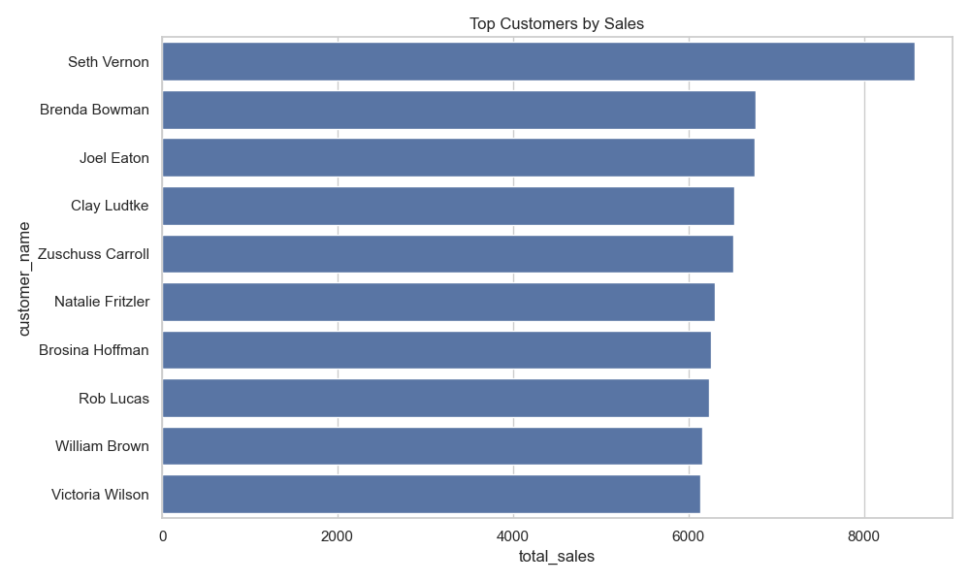

Insight:
A small group of customers contributes significantly to total revenue.

Action:
Reduce dependency by expanding the customer base and targeting new customer segments.

9.2 Product & Profitability Visualization
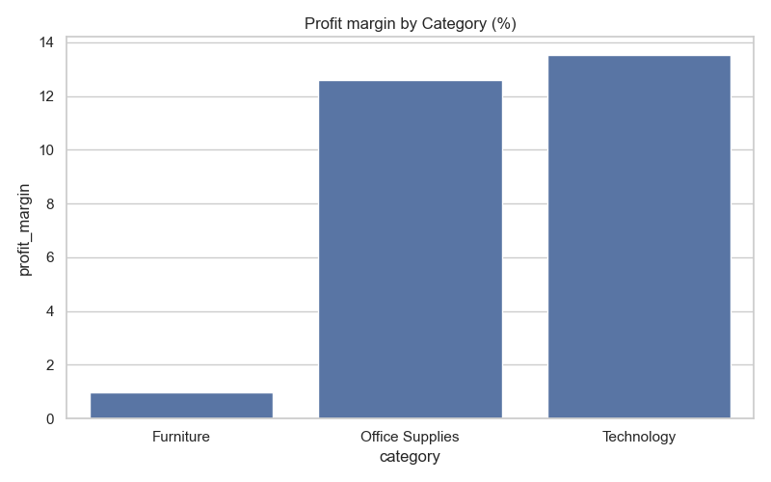

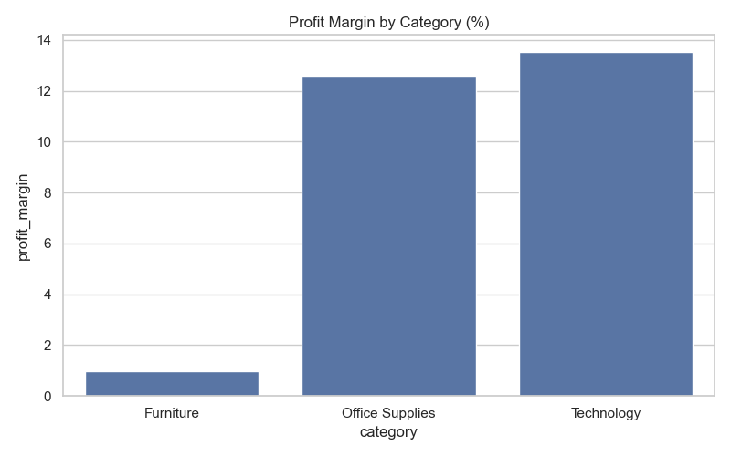

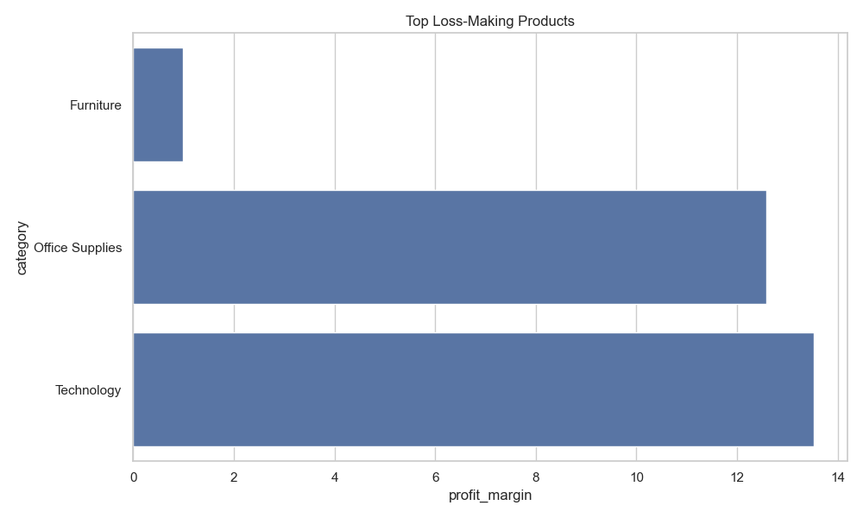

Insight:
Certain products consistently generate losses and impact overall profitability.

Action:
Reprice, bundle, or discontinue loss-making products to improve margins.

9.3 Regional & State Analysis Visualization

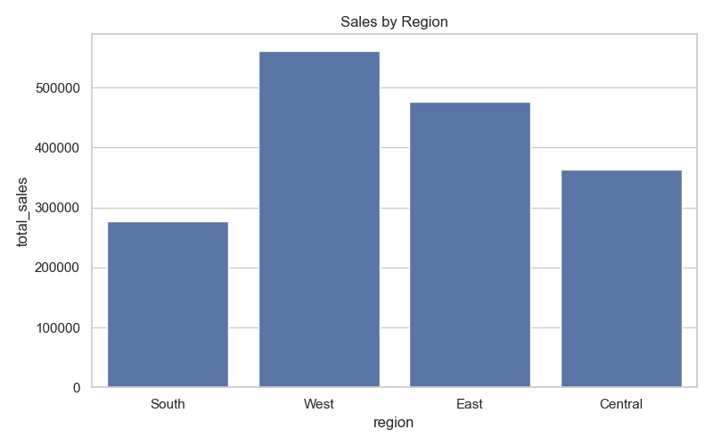

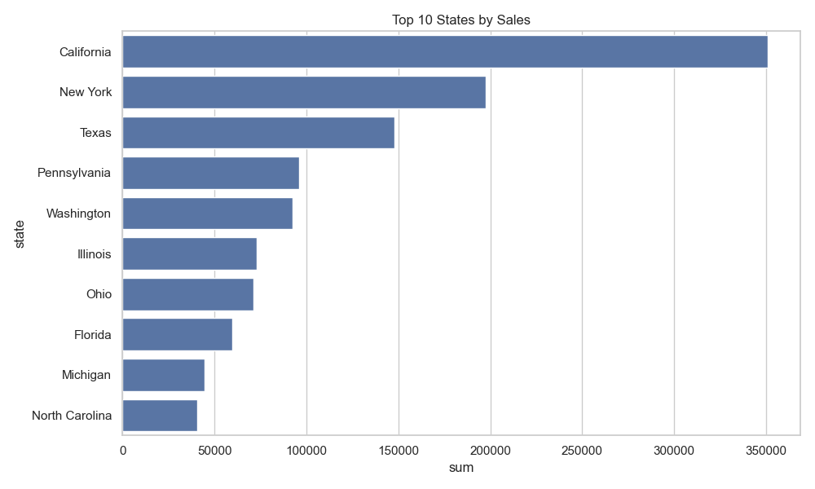
Insight:
Some regions generate high sales but relatively low profit, indicating inefficiencies.
Action:
Investigate regional pricing strategies and logistics optimization.

9.4 Discount Impact Visualization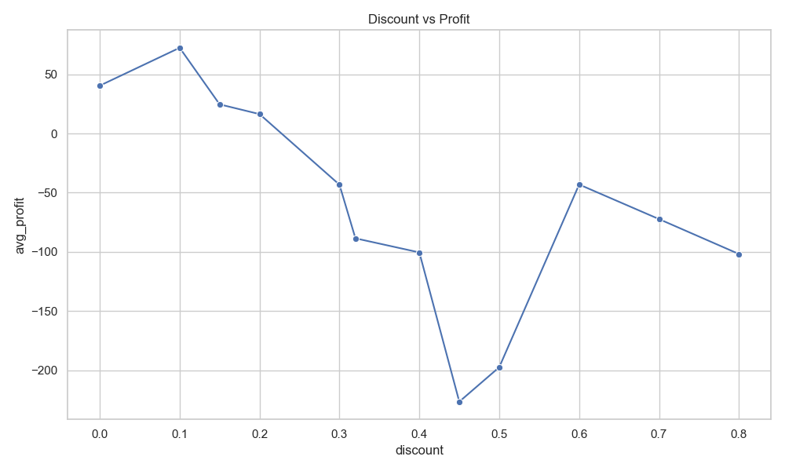

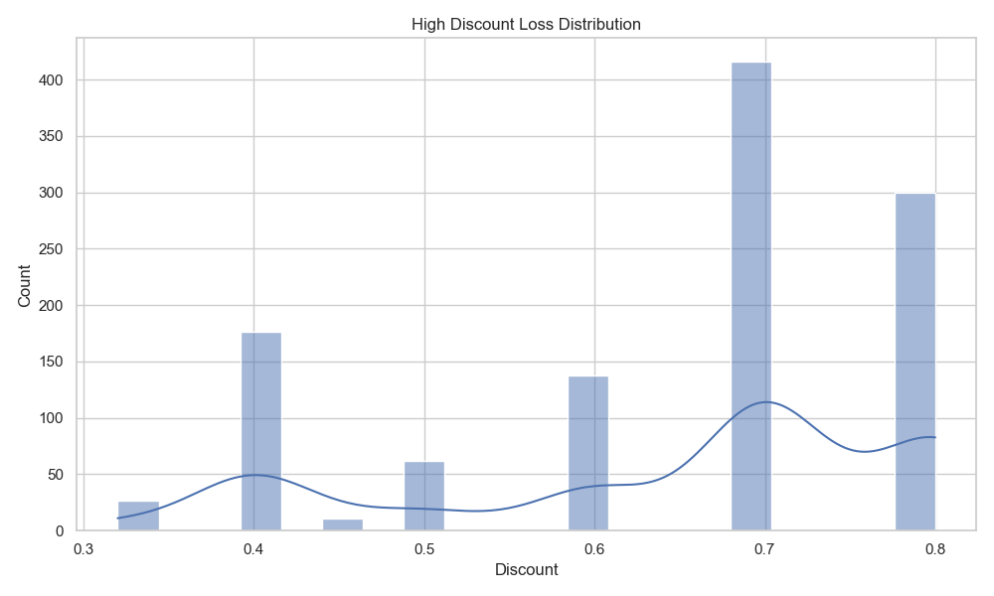

Insight:
Discounts above 30% result in negative profitability.
Action:
Restrict discount policies and implement approval workflows for high discounts.

9.5 Delivery Performance Visualization

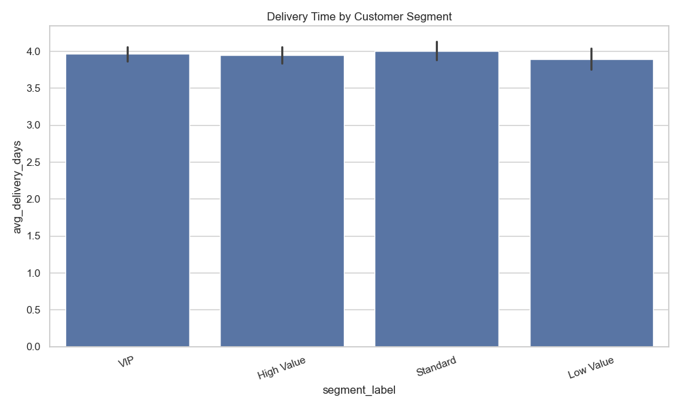

Insight:
High-value customers may experience longer delivery times, increasing churn risk.

Action:
Improve logistics and prioritize delivery for VIP and high-value customers.

9.6 Time-Series Analysis Visualization

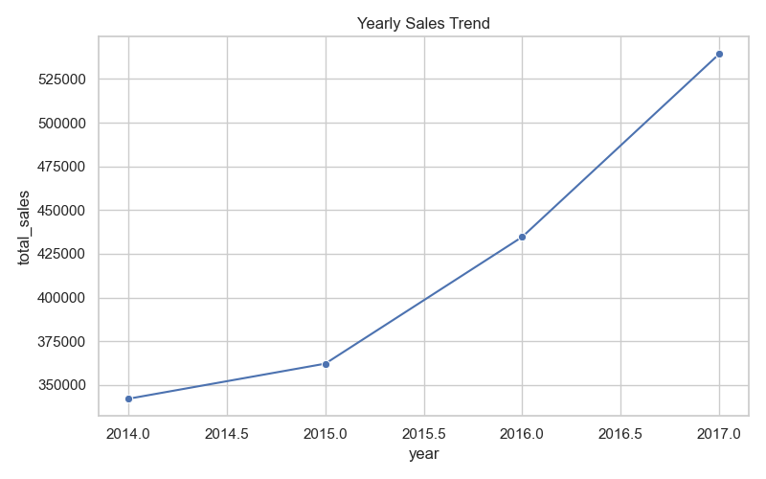

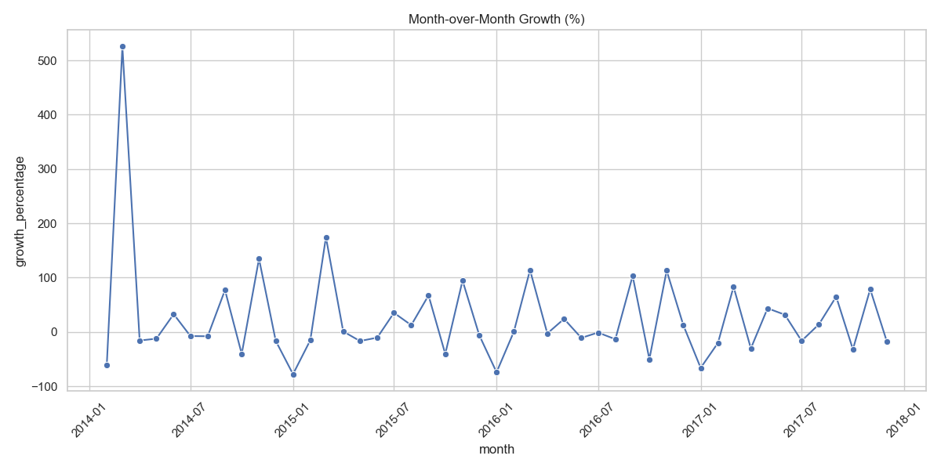
Insight:
Sales exhibit seasonal trends and fluctuations across months and years.
Action:
Align inventory planning and marketing strategies with seasonal demand.

9.7 RFM Segmentation Visualization
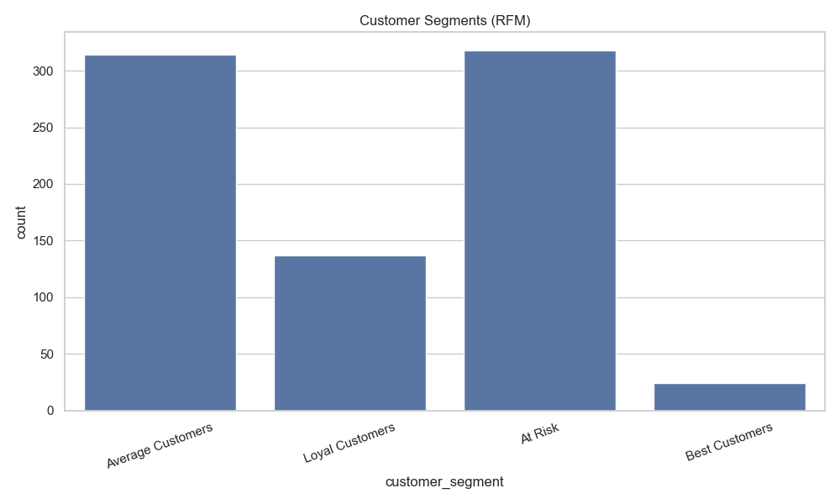

Insight:
At-risk customers show reduced engagement and purchasing frequency.
Action:
Implement targeted retention and win-back campaigns.

9.8 Correlation Analysis Visualization
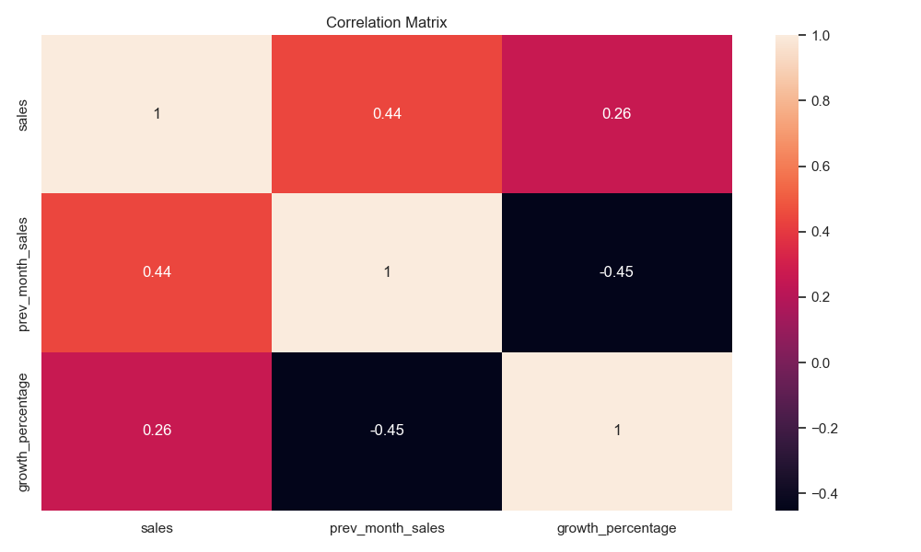

Insight:
Discount levels negatively impact profitability.
Action:
Optimize pricing strategies to maintain healthy margins.

10. Final Business Recommendations
- Cap discounts at 25–30% to prevent revenue loss
- Identify and re-engage at-risk customers
- Improve delivery performance for high-value customers
- Reprice or remove loss-making products
- Expand operations in high-margin regions

11. Conclusion
This project demonstrates an end-to-end sales data analysis using SQL and Python, transforming raw data into meaningful insights. Through analysis of customer behaviour, product profitability, regional performance, discounts, delivery efficiency, and time-based trends, key business patterns were identified.
The findings highlight areas for improvement such as controlling high discounts, optimizing delivery for valuable customers, and addressing loss-making products. Overall, the project supports data-driven decision-making and provides a scalable framework for future analysis.

