Functional Trust Regions (FTR): A Lagrangian Framework for Stability-Constrained Continual Learning
Kavya Bhand¹ Aadi Joshi¹ Vijay Rathod²
¹Department of Computer Engineering, Vishwakarma Institute of Technology
Pune 411037, India
²Department of Computer Science and Engineering (AI & ML)
Vishwakarma Institute of Technology, Pune 411037, India
{kavya.bhand0806,toaadijoshi}@gmail.com, vijay.rathod@vit.edu
Abstract
A prior study of Functional Trust Regions (FTR), a method that enforces explicit KL-divergence constraints on functional drift during sequential task learning, reported that the critical stability budget $ε^{*}$ at which forgetting turns catastrophic is constant across eight architectures, concluding it reflects task structure rather than model geometry. This account is incomplete: because the dual-ascent optimizer resets its Lagrange multiplier at every task boundary, $ε^{*}$ is mechanically co-determined by the optimizer’s own hyperparameters, not only by task or architecture. Holding architecture and task fixed, the dual learning rate, the initial multiplier, and the steps-per-task budget each move $ε^{*}$ by more than an order of magnitude; across six single-factor perturbations, $ε^{*}$ spans roughly $1$ to $90$ on the same model and task, a $93×$ range that exceeds the $2.6×$ range $ε^{*}$ itself spans across 30 architectures with the schedule held fixed. This three-dimensional sensitivity is not irreducible: it collapses substantially onto a single ratio, $S=λ_{init}/(η_{λ}N)$. Holding $S$ fixed while independently varying its three components by up to $5×$ keeps $ε^{*}$ within a factor of $2$–$3$, whereas changing $S$ itself by the same factor collapses $ε^{*}$ by $4$–$11×$, turning an intractable three-hyperparameter sensitivity into a single number a practitioner can report and match. Holding the schedule fixed and expanding the architecture zoo to 30 models across five representational families (CNN, ResNet, MLP, Vision Transformer, MLP-Mixer), a hierarchical partial-pooling model, replacing the original F-test whose own code and reported degrees of freedom disagreed, initially estimates real, non-negligible between-architecture structure. Applying this paper’s own diagnostic standard to its own zoo design, however, this research traces most of that structure to two further, independently-diagnosed data-quality issues: a self-inflicted instance of the same schedule confound affecting four architectures, and a curve-fitting artifact affecting two more. Correcting both cuts the model’s between-architecture variance by more than half (from $τ=2.13$ to $1.03$) and gives a corrected population-level crossover of $ε^{*}=11.07±0.25$. At this larger, adequately powered sample, the four purely curvature-based statistics this work tests (Hessian trace, Fisher trace, spectral norm, gradient norm) remain uncorrelated with $ε^{*}$, confirming the original curvature-irrelevance claim on grounds its own underpowered $n=8$ test could not support, though model size shows a small trend worth further testing. Cross-method comparison on a matched architecture subset shows LwF exhibits the same qualitative universal crossover while EWC and SI show none, and further robustness checks (KL direction, task ordering, class-incremental evaluation, task granularity) both support and further qualify the picture. A pretrained ViT-B/16 with a LoRA adapter on Split CIFAR-100, a setting closer to how continual learning is actually practiced, shows FTR’s seed-to-seed forgetting variance an order of magnitude tighter than the next best method, with mean forgetting and accuracy also, by a smaller margin, the best of the four. Together, these results invert the original study’s practical guidance: architecture-specific tuning of the stability budget is largely unnecessary, but the dual-ascent schedule that enforces it is not a free implementation detail, and checking sensitivity to it, ideally by reporting $S$, belongs in the standard protocol for Lagrangian-constrained continual learning.
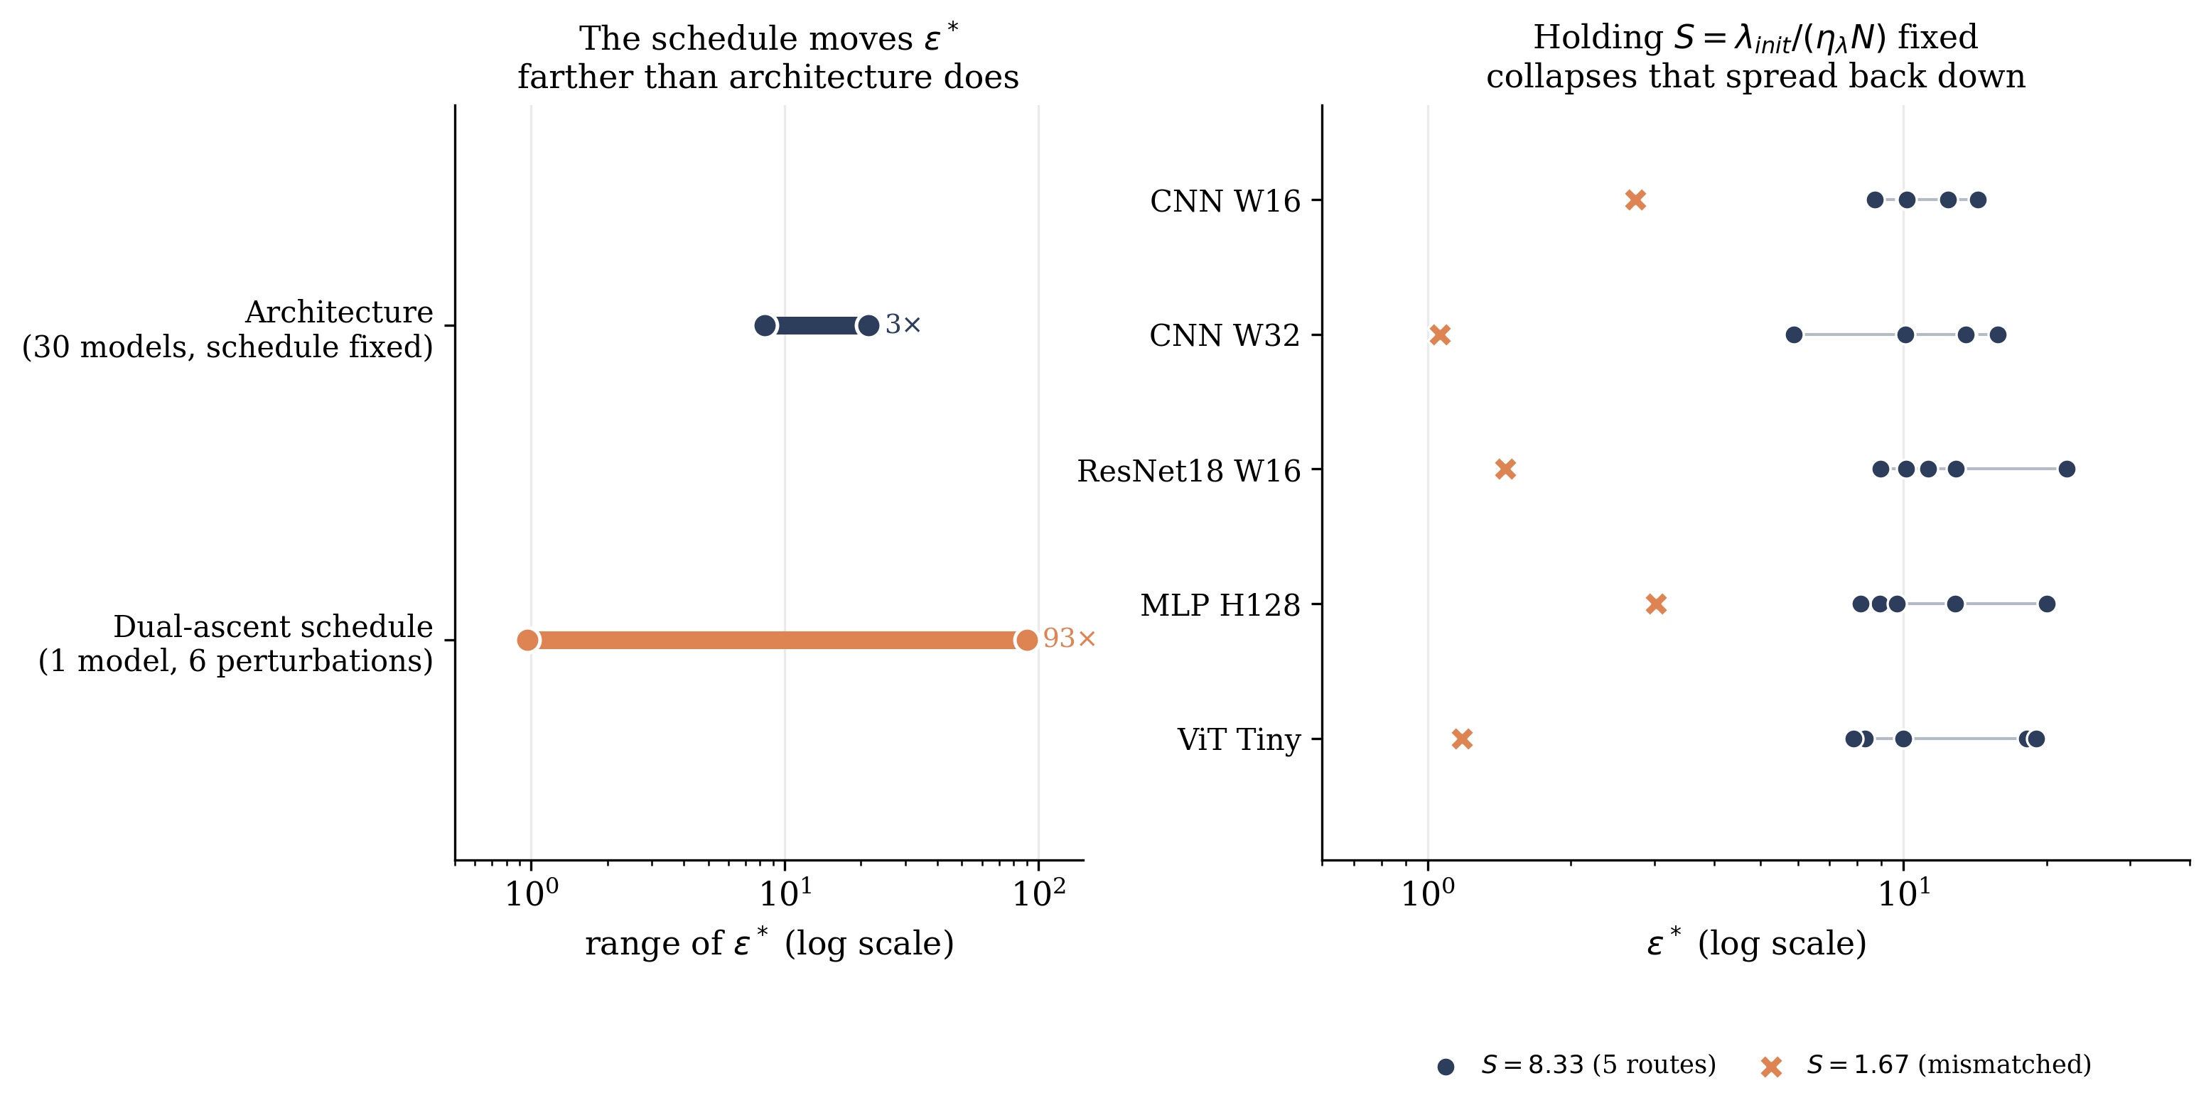
Figure 1: Left: on the same architecture and task, the dual-ascent schedule moves $ε^{*}$ across a $93×$ range (six single-factor perturbations, Section 5), more than the $2.6×$ range $ε^{*}$ itself spans across 30 architectures with the schedule held fixed (Section 6, corrected values). Right: holding the schedule ratio $S=λ_{init}/(η_{λ}N)$ fixed while independently varying its three components (circles) collapses that spread back down, on every architecture tested, versus a matched-magnitude change in $S$ itself (X, Section 13).

1 Introduction
The fundamental challenge of continual learning is to enable neural networks to acquire new knowledge from sequential tasks without catastrophic interference with previously learned information [McCloskey and Cohen, 1989, Robins, 1995]. The stability-plasticity dilemma has motivated numerous approaches, including parameter-space regularization methods such as Elastic Weight Consolidation (EWC) [Kirkpatrick et al., 2017] and Synaptic Intelligence (SI) [Zenke et al., 2017], output-space distillation approaches like Learning without Forgetting (LwF) [Li and Hoiem, 2017], and memory-based methods including experience replay [Lopez-Paz and Ranzato, 2017] and generative replay [Shin et al., 2017].
A central practical challenge across all these methodological families is setting the magnitude of the stability constraint, typically represented as a scalar hyperparameter controlling the aggressiveness of stability protection. For EWC, practitioners must specify the Fisher coefficient. For LwF, the distillation weight must be tuned. For replay methods, the buffer size requires selection. Existing work suggests that these hyperparameters should be architecture-dependent, as loss-landscape curvature varies substantially across models of different depths, widths, and normalization strategies [Ghorbani et al., 2019, Keskar et al., 2017, Li et al., 2018].
This assumption is motivated by decades of work connecting loss-landscape geometry to optimization difficulty, generalization, and robustness [Keskar et al., 2017, Li et al., 2018, Novak et al., 2018]. The intuition is compelling: models with sharper minima (higher Hessian curvature or Fisher information) should require stronger stability pressure to prevent catastrophic forgetting because small parameter perturbations produce large functional changes. Conversely, models with flatter minima should tolerate larger updates.
This research asks whether this curvature-dependent hypothesis holds when stability is enforced as a hard constraint in function space via KL divergence, rather than as a soft penalty in parameter space. The constraint $D_{KL}(f_{θ}∥f_{old})≤ε$ directly limits functional drift in output probability distributions, raising the question: does the critical stability budget $ε^{*}$ depend on model architecture and loss-landscape geometry, or does it emerge as an invariant of the task structure alone? This work additionally asks a question the constrained-continual-learning literature has not, to this work’s knowledge, posed: is $ε^{*}$ in fact determined chiefly by the constrained optimizer’s own dual-ascent schedule rather than by the model or the task at all? Section 5 answers this second question first, because the answer determines how the rest of the paper’s architecture-independence result should be read: not as a hyperparameter-free constant, but as a value conditional on the schedule, whose architecture-independence (holding that schedule fixed) is nonetheless real and is the paper’s remaining claim.
Contrary to the reading that stability crossovers reflect task or architecture geometry alone, this research finds that the dual-ascent optimizer’s own schedule dominates: holding architecture and task fixed, a five-fold change in the dual learning rate $η_{λ}$, the initial multiplier $λ_{init}$, or the per-task step budget each moves $ε^{*}$ by more than an order of magnitude (Section 5), more than the $2.6×$ range $ε^{*}$ itself spans across 30 architectures with the schedule held fixed, and more than any single robustness axis this work tests afterward (KL direction, task ordering, class-incremental vs. task-incremental protocol). This three-dimensional schedule sensitivity is not irreducible, however: Section 13 shows it collapses substantially onto a single ratio, $S=λ_{init}/(η_{λ}N)$, holding which fixed keeps $ε^{*}$ within a factor of $2$–$3$ across architectures and schedule routes, versus the order-of-magnitude range any of its three components produces alone. Holding the schedule fixed, $ε^{*}$ remains architecture-independent in the sense that matters operationally: no per-architecture retuning is needed, across an expanded, 30-model, five-family zoo, though a hierarchical model shows genuine (if modest) between-architecture structure that a single reported constant obscures (Section 7); notably, applying this paper’s own optimizer-schedule diagnostic to its own zoo design caught a second, self-inflicted instance of the same confound inflating that apparent structure (Section 14.3).
This work makes the following contributions:
- This research identifies and directly tests a confound in Lagrangian-dual constrained continual learning that no prior work on this optimization paradigm is known to have isolated: because the dual variable is reset at every task boundary, the apparent stability threshold of a KL-constrained method is jointly determined by the optimizer’s own schedule and by task/architecture geometry, and the schedule’s effect can dominate (Section 5).
- Holding the schedule fixed, this work expands the architecture zoo from 8 to 30 models across five representational families (CNN, ResNet, plain MLP, ViT, MLP-Mixer) and shows, via a hierarchical partial-pooling model, that $ε^{*}$ is not a single universal constant as v1 claimed but has real, if modest, between-architecture structure; curvature-based metrics still fail to predict it, now with adequate statistical power to support that conclusion (Section 7). This research further shows that part of the apparent family-level structure initially observed was itself a second, self-inflicted instance of the schedule confound in this paper’s own zoo design, caught and corrected by applying its own diagnostic standard (Section 14.3), and that LwF’s own universal crossover replicates, while EWC and SI show no reliable crossover at all, on this same expanded, matched architecture subset (Section 9). Task ordering (Section 12) and the class-incremental protocol (Section 11) are both real, non-schedule sources of variation in $ε^{*}$ that v1’s single fixed ordering and task-incremental-only design could not surface.
- This research corrects a methodological error in the original F-test for constancy (its code computed $p$ using $df_{2}=1000$ while the manuscript reported $df=(7,7)$) with a hierarchical partial-pooling model, and shows the original curvature-correlation result was underpowered rather than confirmatory of the null (Section 7).
- This work identifies and tests the specific ratio, $S=λ_{init}/(η_{λ}N)$, that governs the schedule’s effect on $ε^{*}$, and shows that holding it fixed while independently varying its three components by up to $5×$ keeps $ε^{*}$ within a factor of $2$–$3$ across five architectures spanning four representational families, converting an otherwise intractable three-hyperparameter sensitivity into a single reportable quantity (Section 13).

2 Related Work

2.1 Continual Learning Regularization
Elastic Weight Consolidation (EWC) [Kirkpatrick et al., 2017] imposes penalties on parameter changes weighted by the diagonal Fisher information matrix, treating each parameter’s importance as proportional to its curvature contribution and protecting the parameters most responsible for prior-task performance while leaving the rest free to adapt. It is the most widely adopted parameter-space regularizer and the natural EWC baseline used throughout Section 9.
Synaptic Intelligence (SI) [Zenke et al., 2017] replaces EWC’s end-of-task Fisher estimate with an online importance signal, accumulating a path integral of each parameter’s contribution to the loss reduction along the entire training trajectory, so importance is estimated continuously rather than in a single post-hoc pass. Mechanically it is a different weighting scheme over the same penalty structure as EWC, and the two behave similarly in Section 9’s comparison: neither shows a reliable stability crossover under the sigmoid-fitting procedure this paper applies to every method.
Progressive Neural Networks [Rusu et al., 2016] sidestep the parameter-interference problem entirely rather than penalizing it: each new task gets its own network column, laterally connected to and reading from every previously frozen column, so old-task parameters are never touched at all. This is a structural, not a regularization, solution, and it trades forgetting for a parameter budget that grows linearly with the number of tasks, a tradeoff FTR and the other methods studied here do not make.
Hard Attention to the Task (HAT) [Serrà et al., 2018] occupies a middle position: a learned, near-binary attention mask per task gates which units are available for that task’s forward and backward pass, annealed from soft to hard during training, so parameters an earlier task marked as important are effectively frozen for later tasks without adding new parameters. Like Progressive Networks, this is a masking-based isolation mechanism rather than a soft penalty, and, like both, it constrains which parameters can change, not how far the function computed by the network can move, the distinction Section 3 argues is decisive for the curvature-independence result in Section 7.
Online Structured Laplace Approximations [Ritter et al., 2018] put EWC’s diagonal-Fisher approximation on more principled Bayesian footing: after each task, the posterior over weights is recursively approximated as Gaussian, and a Kronecker-factored block-diagonal curvature approximation (in the spirit of K-FAC, Section 2.4) makes tracking a full, non-diagonal quadratic penalty tractable at network scale, reporting substantially better retention than diagonal EWC on 50-task permuted MNIST. This sharpens rather than changes the argument above: even a better, non-diagonal curvature estimate is still a parameter-space quantity, and Section 7 shows that curvature of any kind, diagonal or Kronecker-factored, fails to predict $ε^{*}$ once the constraint lives in function space instead.
All five methods above enforce stability in parameter space, implicitly assuming that proximity in parameter space ensures proximity in function space. This assumption fails in overparameterized neural networks, where distinct parameter vectors can produce functionally identical mappings [Frankle et al., 2020, Frankle and Carbin, 2019, Garipov et al., 2018]. Work on mode connectivity [Draxler et al., 2018, Garipov et al., 2018] establishes the non-convexity of the parameter-space loss landscape directly, further motivating function-space approaches as a distinct alternative rather than a mere reformulation.

2.2 Function-Space and Distillation-Based Continual Learning
Learning without Forgetting (LwF) [Li and Hoiem, 2017] constrains output distributions through a KL-divergence distillation loss against a frozen copy of the pre-update model, so stability is measured and enforced directly on what the network computes rather than on its parameters. It requires no stored exemplars from earlier tasks, only the old model’s predictions on the current task’s inputs, which makes it the closest existing method to FTR’s own function-space formulation and the natural distillation baseline used throughout this paper (Sections 9 and 9.1); the two differ in that LwF’s distillation weight is a fixed, grid-searched scalar, while FTR enforces the analogous quantity as a hard constraint via dual ascent (Section 5 shows this distinction is not cosmetic).
Dark Experience Replay (DER) [Buzzega et al., 2020] extends the same distillation idea with an explicit memory: it stores network logits (pre-softmax outputs) from earlier tasks in a reservoir buffer and distills against them alongside ordinary replay of the raw examples, combining a function-space penalty with a memory-based one rather than relying on either alone.
Titsias et al. [2020] regularize continual learning directly in function space via a variational, Gaussian-process-derived view of the network’s output distribution: an approximate posterior over functions is maintained and a KL term penalizes its drift from task to task, giving a Bayesian, uncertainty-aware analogue of distillation rather than a fixed teacher-student penalty. This appears to be the paper that coined the term “functional regularisation” for continual learning and the closest conceptual ancestor to FTR’s framing of stability as a function-space, not parameter-space, quantity.
Pan et al. [2020] (FROMP) regularize network outputs at a small, explicitly selected set of “memorable past” inducing points using a GP-derived functional prior, choosing those points to be maximally informative about the function’s shape rather than storing raw exemplars or a full logit history, and update the point set task by task as new, more informative candidates arrive.
Meta-Experience Replay (MER) [Riemer et al., 2019] takes a different route to the same goal of bounding how much a new task perturbs old-task behavior: it combines experience replay with a first-order meta-learning objective (a Reptile-style update) that explicitly optimizes for gradients on new data to align with, rather than interfere with, gradients on replayed old data. It does not impose an explicit function-space distance penalty the way LwF, Titsias et al., FROMP, and FTR do, but it targets the same underlying quantity, how much the learned function changes on old inputs, through the geometry of the optimization trajectory instead.
Titsias et al. and FROMP both use a soft, memory-based functional prior; DER and MER are both memory-based but differ in whether the penalty is an explicit distillation term (DER) or an implicit trajectory-alignment objective (MER). FTR differs from all four in enforcing a hard constraint via Lagrangian dual ascent with no stored exemplars of any kind, and, unlike any of them, is evaluated here specifically for whether its critical budget is architecture-independent.

2.3 Constrained Learning via Lagrangian Duality
Beyond continual learning specifically, Chamon et al. [2023] formalize constrained empirical risk minimization as a general learning paradigm: rather than adding a fixed penalty term, the learning problem is posed with an explicit constraint and solved via its Lagrangian dual, and the paper proves near-PAC learnability together with empirical duality-gap bounds for non-convex losses. This is the theoretical setting that FTR’s own Lagrangian dual-ascent update (Eqs. 2–5) implicitly relies on, and Section 14 draws the connection to this paper’s convergence guarantees explicitly.
Elenter et al. [2024] extend this program with near-optimal solutions for the same class of constrained-learning problems under weaker assumptions on the constraint set, tightening the conditions under which a dual-ascent solution is guaranteed to approach feasibility rather than merely to exist.
Hounie et al. [2023] study resilient constrained learning, where the constraint level itself is relaxed adaptively based on the marginal cost of tightening it, rather than fixed in advance by the practitioner. This is directly relevant to how $ε$ is chosen in the present paper: this work treats $ε$ as a swept, externally chosen hyperparameter throughout, and an explicitly resilient, cost-adaptive choice of $ε$ is a natural extension not pursued here.
Closest to the present work, Elenter et al. [2023] formulate continual learning explicitly as a Lagrangian-dual constrained-optimization problem (Primal-Dual Continual Learning, PDCL), with a dual variable that adapts via projected ascent on constraint violation in a manner structurally similar to Eq. 5, evaluated on Tiny-ImageNet, SpeechCommands, and MedMNIST-OrganA in the class-incremental setting. PDCL already demonstrates that Lagrangian-dual constrained continual learning is practical at benchmark scale and studies its dual dynamics; it does not, however, constrain drift in function space via a KL ball on output distributions (its constraints are loss-value and memory-allocation based), and it does not study whether its own critical constraint level is architecture-independent or how its dual-ascent schedule interacts with that question, the two questions this paper is organized around. No paper in this cluster, nor in the broader constrained-learning literature, is known to have previously isolated the dual-ascent schedule itself, as opposed to the constraint level $ε$, as a confound for an apparent stability threshold.

2.4 Trust Regions and KL Constraints
Trust Region Policy Optimization (TRPO) [Schulman et al., 2015] constrains policy updates in reinforcement learning through an explicit KL-divergence trust region around the previous policy, solved via a constrained natural-gradient step, directly motivating FTR’s own $D_{KL}(f_{θ}∥f_{old})≤ε$ formulation (Section 3) transplanted from policy space to a supervised continual-learning setting.
Proximal Policy Optimization (PPO) [Schulman et al., 2017] replaces TRPO’s explicit constrained optimization with a clipped surrogate objective that approximates the same trust-region effect using only first-order updates, trading exactness for simplicity and better sample efficiency in practice. The relationship between PPO’s soft clipping and TRPO’s hard constraint is structurally analogous to the relationship between LwF’s soft distillation penalty (Section 2.2) and FTR’s hard Lagrangian constraint: both pairs trade a hard, dual-ascent-enforced boundary for a fixed, unconstrained penalty of similar intent, and this paper’s diagnostic (Section 5) is specific to the hard-constraint side of that trade, since only it has a dual variable whose own reset schedule can confound the result.
Natural gradient descent [Amari, 1998] rescales the gradient by the inverse Fisher information matrix, so that a fixed-size step in parameter space corresponds to an approximately fixed-size step in distribution space as measured by KL divergence; this is the same KL-as-a-distance intuition underlying both TRPO’s trust region and FTR’s constraint, applied to single-task optimization rather than sequential constraint enforcement. Martens and Grosse [2015] make the natural gradient tractable at deep-network scale with a Kronecker-factored approximate curvature (K-FAC) to the Fisher information, the same block-diagonal approximation strategy Ritter et al. [2018] (Section 2) later reuse for continual learning specifically.
The general connection between KL-divergence constraints and projected gradient descent in the associated Bregman geometry is developed in the online convex optimization literature [Hazan, 2019, Rakhlin et al., 2012, Shalev-Shwartz, 2012], which frames KL-constrained updates as a special case of mirror descent with the negative-entropy mirror map; this is the general mathematical machinery of which TRPO, PPO, and FTR’s own dual-ascent update are each a specific, differently motivated instance.

2.5 Curvature and Forgetting: an Active, More Recent Literature
The claim in Section 7 that curvature fails to predict $ε^{*}$ under a function-space hard constraint should not be read against the older curvature literature alone. Keskar et al. [2017] introduce the sharp-minima hypothesis for deep learning: large-batch training tends to converge to sharper minima than small-batch training, and sharper minima are empirically associated with a worse generalization gap, using the largest eigenvalue of the loss Hessian (approximated via power iteration) as the sharpness proxy this paper’s own curvature suite (Appendix B) also computes. Ghorbani et al. [2019] go further, using Lanczos-based stochastic estimation of the full Hessian eigenvalue density (rather than a single top eigenvalue) across training, finding a small number of large outlier eigenvalues whose count tracks architectural choices such as the presence of BatchNorm, a diagnostic tool this paper’s own Hessian-trace and spectral-norm estimators are direct descendants of.
A more recent, active line of work studies curvature-forgetting links specifically, which the present null result must be positioned against rather than ignore. Bian et al. [2024] use sharpness-aware minimization, explicitly flattening the loss landscape around each task’s minimum during training, to reduce forgetting in standard continual-learning benchmarks, treating flatness as something to optimize for rather than only measure. Deng et al. [2021] combine a similar flatness-seeking objective with gradient projection memory, projecting new-task gradients to be approximately orthogonal to a memory of prior-task gradient subspaces so that flatness and low-interference updates are pursued jointly rather than as two separate mechanisms.
Most directly relevant, Lanzillotta et al. [2023] formally derive that sharper old-task minima require a strictly tighter parameter-space constraint to guarantee bounded forgetting, a learning-theoretic result for exactly the class of parameter-space penalty methods surveyed in Section 2. That result is not in tension with the present finding: it is a parameter-space claim, and the finding here that curvature fails to predict $ε^{*}$ (Section 7) is specific to function-space hard constraints, a different constraint geometry with a different relevant notion of distance. If anything, Lanzillotta et al. [2023] is supporting evidence for, not a counterexample to, the present paper’s central distinction between the two constraint families.
Lewandowski et al. [2025] and Lewandowski et al. [2023] study curvature’s relationship to loss of plasticity, the stability-plasticity tradeoff’s other side: the former proposes spectral regularization of layer-wise weight matrices to preserve a network’s capacity to keep learning over long task sequences, and the latter identifies specific directions of parameter-space curvature responsible for plasticity loss during continual training. Both are a complementary rather than contradictory line to the present paper’s curvature-null result: they ask whether curvature predicts a network’s capacity to keep learning, not whether it predicts the stability threshold of a function-space constraint, the question Section 7 answers in the negative.

2.6 Phase Transitions in Deep Learning
Phase transitions in neural network training have been documented in several distinct contexts. Power et al. [2022] report grokking: a network that has already reached near-zero training loss on an algorithmic task continues training and, after a long plateau, abruptly generalizes to the validation set, a delayed and sharp transition in generalization rather than in training loss itself. Frankle and Carbin [2019] document a related but distinct phenomenon in the lottery-ticket setting: sparse subnetworks identified by iterative magnitude pruning train to full accuracy only if reset to their original initialization, an all-or-nothing transition in trainability as a function of which weights are kept. Li et al. [2018] and Keskar et al. [2017] (Section 2.5) each document sharp qualitative changes in loss-landscape structure as a function of network width, depth, and batch size, the same broad phenomenon, a smooth training-time behavior changing abruptly with a control parameter, that this paper’s own $ε^{*}$ crossover exhibits as a function of $ε$.
Recent finite-size-scaling treatments bring statistical-mechanics tools to these phenomena directly. Wang [2026] analyze grokking across eight model scales as a genuine finite-size phase transition, extracting a critical exponent that characterizes how the transition sharpens as model size grows. Tamai et al. [2025] apply the same finite-size-scaling framework to absorbing phase transitions in deep network training dynamics more generally, showing scaling collapse across network sizes. Both are directly analogous in method, though not in subject, to the CNN width-family analysis in Section 8, which asks the same finite-size-scaling question of the FTR crossover’s sigmoid sharpness and finds no significant effect at the widths tested here.
A thematically adjacent but mechanistically different framing casts the stability-plasticity tradeoff itself as a Stefan (moving-boundary) problem, the class of PDEs describing melting and solidification fronts, governed by a single scalar analogous to latent heat [Khilar, 2026]; this work notes it here as a kindred “physics-of-training” perspective on a single-scalar-governs-a-transition story rather than a directly competing method, since it is evaluated on toy benchmarks with a level-set PDE solver rather than the KL-constrained dual-ascent mechanism studied throughout this paper.

2.7 Summary of Related Methods
Table 1 summarizes every continual-learning and constrained-optimization method discussed above along the dimensions most relevant to positioning FTR: which space the stability constraint lives in, whether it is enforced as a hard constraint or a soft penalty, whether it requires an explicit memory of past data or activations, and whether the source work studies architecture-independence of its own stability threshold, the central empirical question of this paper. No prior method in this table both constrains function space with a hard, dual-ascent-enforced boundary and studies whether its critical threshold generalizes across architectures; FTR (v1, extended here) is the only entry with both properties.
Table 1: Related methods by constraint space, enforcement type, memory requirement, and whether architecture-independence of the stability threshold is studied. HAT and Progressive Nets isolate parameters structurally rather than penalizing or constraining a distance, marked n/a.
Method | Constraint space | Hard/soft | Memory | Arch.-invariance?
EWC [Kirkpatrick et al., 2017] | Parameter | Soft | No | No
SI [Zenke et al., 2017] | Parameter | Soft | No | No
Progressive Nets [Rusu et al., 2016] | Parameter (isol.) | n/a | No | No
HAT [Serrà et al., 2018] | Parameter (isol.) | n/a | No | No
Online Laplace [Ritter et al., 2018] | Parameter | Soft | No | No
LwF [Li and Hoiem, 2017] | Function/output | Soft | No | No
DER [Buzzega et al., 2020] | Function/output | Soft | Yes (logits) | No
Functional reg. [Titsias et al., 2020] | Function | Soft | Yes (var.) | No
FROMP [Pan et al., 2020] | Function | Soft | Yes (points) | No
MER [Riemer et al., 2019] | Grad. trajectory | Soft | Yes (replay) | No
TRPO [Schulman et al., 2015] | Policy (KL) | Hard | No | No
PPO [Schulman et al., 2017] | Policy (KL) | Soft | No | No
PDCL [Elenter et al., 2023] | Loss/memory | Hard | Yes | No
FTR (this work) | Function (KL) | Hard | No | Yes

3 Method: Functional Trust Regions

3.1 Problem Formulation
Consider a sequence of tasks $\{T_{1},T_{2},…,T_{m}\}$ presented sequentially. At task $t+1$, the learner has access to training data from the current task but not from prior tasks. The parametric model is $f_{θ}:X→Y$, where $θ∈R^{d}$ are model parameters. Let $f_{old}$ denote the model trained on tasks $\{1,…,t\}$.

Task-incremental vs. class-incremental.
v1 did not state this explicitly. All main results use the task-incremental protocol: the output head is sized to the number of classes within a single task (e.g. 2 for the binary CIFAR-10 splits), labels are remapped locally per task (class $c$ of task $t$ becomes local label $0,1,…$), and evaluation at test time uses an oracle task ID to select both the correct label remapping and, implicitly, which classes are eligible outputs. This is a materially easier protocol than class-incremental learning, where a single shared head must discriminate among all classes seen so far with no oracle task ID at test time. Section 11 reports a class-incremental variant on a subset of architectures to test whether the crossover survives the harder protocol.

3.2 Constrained Optimization Formulation
This work formulates task $t+1$ learning as a constrained optimization problem:
$$θ_{t+1}=arg\min_{θ} L_{task}(θ) \text{subject to} D_{KL}\left(f_{θ}∥f_{old}\right)≤ε,$$
where $D_{KL}(f_{θ}∥f_{old})=E_{x∼D_{t}}\left[D_{KL}(f_{θ}(x)∥f_{old}(x))\right]$ is the expected KL divergence between output distributions, estimated on the current task’s training batch. The constraint radius $ε$ represents the stability budget in function space.

3.3 Optimization via Lagrangian Dual Ascent
This research solves the constrained problem using Lagrangian relaxation. The Lagrangian is:
$$L(θ,λ)=L_{task}(θ)+λ\left(D_{KL}(f_{θ}∥f_{old})−ε\right),$$
where $λ≥0$ is the dual variable. This work employs dual gradient ascent with momentum:
$$\begin{aligned}θ_{t+1}&←θ_{t}−η_{θ}∇_{θ}L(θ_{t},λ_{t}), \\ m_{t+1}&←ρ m_{t}+η_{λ}(D_{KL}−ε), \\ λ_{t+1}&←max(0,λ_{t}+m_{t+1}),\end{aligned}$$
where $η_{θ}$ is the primal learning rate, $η_{λ}$ the dual learning rate, and $ρ$ the momentum coefficient. The dual variable adapts automatically: when drift exceeds $ε$, $λ$ increases (tightening the constraint); when the model is stable, $λ$ decreases (relaxing it).

$λ$ is reset at every task boundary.
A detail omitted from v1’s Method section but essential to the dynamics analyzed in Section 5: $λ$ is re-initialized to $λ_{init}$ at the start of every task transition, not held as a single running state across the whole training sequence. Within a task, each step compares the current drift $D_{KL}$ against $ε$ and nudges $λ$ by $η_{λ}$ times an EMA of the violation $(D_{KL}−ε)$ (Eq. 5). Two regimes follow directly from this:
- Tight $ε$: the drift an unconstrained model would accumulate while fitting a new task typically exceeds $ε$ within the first few post-warmup steps, so the violation is positive, $λ$ is driven upward (up to $λ_{max}$), and the constraint stays actively engaged for the remainder of the task, so forgetting stays low.
- Loose $ε$: drift stays under $ε$ throughout, the violation is persistently negative, and $λ$ decays toward 0 within a number of steps set by $λ_{init}$, $η_{λ}$, and the momentum $ρ$; once $λ≈0$ the constraint is effectively disengaged and training proceeds as unconstrained fine-tuning for whatever fraction of the task’s step budget remains.
The crossover $ε^{*}$ is, mechanically, the value of $ε$ at which a task transitions from the first regime to the second within the fixed per-task step budget. This makes $ε^{*}$ a joint function of (a) how much functional drift unconstrained gradient descent on the new task would produce, which is a property of the task and architecture, and (b) how many steps it takes $λ$ to decay from $λ_{init}$ to 0 under slack, which is a property of $η_{λ}$, $λ_{init}$, $λ_{max}$, $ρ$, the per-task step budget, and the temperature $T$ (which rescales $D_{KL}$ itself, since the drift term used in training is $T^{2}​⋅​D_{KL}$). Section 5 tests directly whether (b) has a material effect on $ε^{*}$, which v1 did not check.
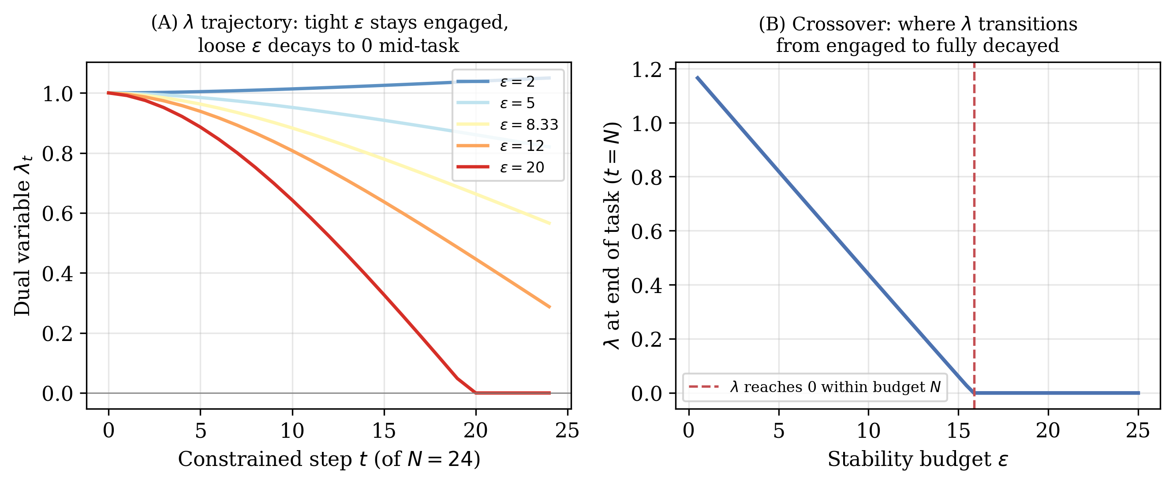
Figure 2: Stylized illustration of the mechanism above (not measured data: a toy simulation of Eqs. 2–5 with an illustrative, monotonically decreasing drift-rate function $\overset{‾}{d}(λ)$, used only to make the two regimes visually concrete before the measured results in Section 5). (A) $λ$’s trajectory within a single task for five values of $ε$: tight budgets keep $λ$ engaged near $λ_{init}$ or rising; loose budgets drive it to 0 before the task’s step budget $N$ is exhausted. (B) The resulting crossover in $λ$ at the end of the task as a function of $ε$, for this toy simulation.

3.4 Relationship to Learning without Forgetting
When $λ$ is held fixed rather than adapted, FTR reduces exactly to Learning without Forgetting, which minimizes:
$$L_{LwF}(θ)=L_{task}(θ)+λD_{KL}(f_{θ}∥f_{old}).$$
The key distinction is that FTR enforces a hard constraint with adaptive dual coefficient, providing an interpretable stability budget $ε$ that practitioners can reason about directly, whereas LwF requires grid search over fixed distillation coefficients.

3.5 Implementation Details
All experiments employ the following hyperparameters unless stated otherwise: $λ_{init}=1.0$, $λ_{max}=50.0$, $η_{λ}=0.005$, momentum $ρ=0.9$, softmax temperature $T=2.0$, and one epoch of warmup per task. The task loss $L_{task}$ uses cross-entropy with Adam [Kingma and Ba, 2015], learning rate $η_{θ}=0.001$. Section 5 sweeps every one of these choices individually against a dense $ε$ grid to test their effect on $ε^{*}$.

Compute.
Unlike v1, which was CPU-only, every experiment in this revision runs on free-tier Kaggle GPUs (Tesla P100 and T4$×$2 instances), which is what makes the 30-architecture zoo, the schedule diagnostics, and the pretrained-backbone check tractable in reasonable wall-clock time. Across all stages, this amounts to more than $11,300$ individual training runs (each a full sequential-task training pass), spread over several dozen Kaggle kernel sessions.

4 Experimental Setup

4.1 Architecture Zoo
v1’s zoo comprised eight architectures, all convolutional or residual. This research expands it to 30 architectures spanning five representational families and a $75.8×$ parameter range ($36,866$–$2,795,554$): a CNN width sweep (W8 through W128, 8 architectures), a CNN depth sweep (2–5 conv layers at width 32, 4 architectures), CNN variants without BatchNorm at three scales, a ResNet-18-style family with 2 residual blocks/layer at widths 8/16/24/32, a ResNet-Lite family with 1 block/layer at the same four widths (added specifically to fill the curvature gap between the CNN family and the original single ResNet-18 outlier, discussed below) including one no-BatchNorm variant, a plain MLP with no spatial inductive bias at two hidden widths, and two scales each of a patch-based Vision Transformer and an MLP-Mixer. Full per-architecture parameter counts, Hessian trace, Fisher trace, spectral norm, and $d_{eff}$ are in Table 11 (Appendix A). Hessian trace still spans a comparable range to v1 ($39×$: $79.7$ at CNN_W32_NoBN to $3110$ at ResNet18_W8) but is now populated by all 30 architectures rather than 8, and by five families with genuinely different inductive biases rather than two families that are architecturally close relatives.

4.2 Dataset and Task Construction
All main experiments use CIFAR-10 [Krizhevsky, 2009] partitioned into five sequential binary classification tasks, where each task contains two classes. Each task contains 1,000 samples per class (2,000 total), trained for 4 epochs/task for the CNN, ResNet, ResNet-Lite, and MLP families, and 5 epochs/task for ViT and MLP-Mixer (a per-family accommodation made when the zoo was built, whose consequence for $ε^{*}$ this work returns to in Section 14.3). The forgetting metric is computed as the mean decrease in accuracy on all previously learned tasks after completion of training on the final task; this research additionally reports new-task accuracy (accuracy on task $t$ immediately after training on task $t$, before any subsequent forgetting) to rule out the trivial explanation that low forgetting at small $ε$ reflects a model that has simply failed to learn the new task (Sec. 7.5).
Four further robustness checks (a CIFAR-100 classes-per-task sweep, multiple random class-to-task orderings, a KL-direction ablation, and a class-incremental variant with a single shared head) are reported in Sections 12, 10, and 11 once the main results (Sections 5–8) have established the vocabulary needed to interpret them.

5 Diagnostic: Is $ε^{*}$ a Task-Structure Invariant or an Optimizer-Schedule Artifact?
Section 3 showed that $λ$ resets to $λ_{init}$ at every task boundary and then rises or decays within the task depending on whether measured drift exceeds $ε$. This makes $ε^{*}$, mechanically, a function of two things at once: how much functional drift unconstrained learning on a new task would produce (task/architecture geometry), and how many steps it takes $λ$ to travel from $λ_{init}$ to 0 (or to $λ_{max}$) under the dual-ascent rule (an optimizer-schedule property: $η_{λ}$, $λ_{init}$, $λ_{max}$, momentum $ρ$, steps/task, and the temperature $T$, which rescales the drift term itself). v1 varied only the first axis. This work tests the second directly.

5.1 Setup
On two anchor architectures (CNN_W16, CNN_W32) and a 10-point $ε$ grid $\{1,3,5,6,7,8,9,10,12,20\}$, 3 seeds, this research ran the baseline configuration of Section 3 ($η_{λ}=0.005$, $λ_{init}=1.0$, $λ_{max}=50$, $ρ=0.9$, $T=2.0$, 4 epochs/task) alongside eleven single-factor perturbations: $η_{λ}$ and $λ_{init}$ each $×5$ and $÷5$; $λ_{max}∈\{10,200\}$; epochs/task $∈\{2,8\}$ (baseline 4); $ρ=0.5$; and $T∈\{1.0,4.0\}$. For each of the 24 (architecture, condition) cells this work fits the same logistic-sigmoid procedure as Section 6 and bootstraps a 95% CI (1,000 resamples over seeds). Four conditions produced a forgetting curve that was flat across the entire $[1,20]$ grid (range $<0.05$) rather than an S-shape inside it, so this work reran those four plus baseline on a wider, coarser grid extending to $ε=100$ ($\{0.05,0.1,0.3,0.5,1,3,5,7,10,15,20,30,40,50,75,100\}$, same architectures and seeds) to locate the true crossover rather than report a degenerate sigmoid fit.

5.2 Results
Table 2: $ε^{*}$ under single-factor perturbations of the dual-ascent schedule, holding architecture and task fixed (CIFAR-10, 2 anchor architectures, 3 seeds, 95% bootstrap CI). “Ratio” is $ε^{*}$ relative to that architecture’s own baseline. On the original dense grid ($ε∈[1,20]$), five rows produced a forgetting curve flat across the entire grid rather than an S-shape inside it, so no transition was located; this analysis rescanned exactly those five (condition, architecture) cells with a wider grid ($ε∈[0.05,100]$, marked $‡$) to locate the true crossover rather than report only a direction.
Condition | $ε^{*}$ (CNN_W16) | $R^{2}$​ | ratio | $ε^{*}$ (CNN_W32) | $R^{2}$​ | ratio
baseline | 13.09 [11.2, 54.4] | 0.995 | 1.00 | 12.45 [10.9, 54.4] | 0.991 | 1.00
$η_{λ}×5$​ | 2.70 [2.7, 3.2] | 0.970 | 0.21 | 0.97 [0.7, 1.3] | 0.955 | 0.08
$η_{λ}÷5$​ | 79.5 [61.4, 147.6] $‡$ | 0.993 | 6.07 | 58.5 [55.7, 71.5] $‡$ | 0.991 | 4.70
$λ_{init}×5$​ | 76.7 [69.3, 85.0] $‡$ | 0.915 | 5.86 | 90.1 [67.7, 158.4] $‡$ | 0.875 | 7.24
$λ_{init}÷5$​ | 1.69 [1.05, 2.10] $‡$ | 0.970 | 0.13 | 1.04 [1.00, 1.83] $‡$ | 0.951 | 0.08
$λ_{max}=10$​ | 13.69 [11.5, 54.4] | 0.986 | 1.05 | 15.28 [11.2, 54.4] | 0.984 | 1.23
$λ_{max}=200$​ | 13.06 [11.9, 14.2] | 0.989 | 1.00 | 15.55 [11.3, 54.4] | 0.990 | 1.25
epochs/task $=8$ ($×2$) | 3.25 [3.0, 3.5] | 0.992 | 0.25 | 3.66 [3.2, 4.4] | 0.980 | 0.29
epochs/task $=2$ ($÷2$) | 16.3 [13.3, 38.1] $‡$ | 0.872 | 1.25 | 36.0 [0.8, 46.8] $‡$ª | 0.305 | 2.89
momentum $ρ=0.5$ | 8.06 [7.6, 10.8] | 0.994 | 0.62 | 6.97 [6.6, 7.5] | 0.974 | 0.56
$T=4.0$ ($×2$) | 15.56 [11.6, 33.5] | 0.991 | 1.19 | 15.32 [12.2, 21.9] | 0.996 | 1.23
$T=1.0$ ($÷2$) | 13.51 [10.4, 19.4] | 0.990 | 1.03 | 12.13 [10.6, 22.4] | 0.970 | 0.97
ªSigmoid $R^{2}=0.31$ even on the wide grid for this one cell (CNN_W32, epochs/task$=2$); the point estimate is a rough indication of direction and magnitude, not a tightly located transition.
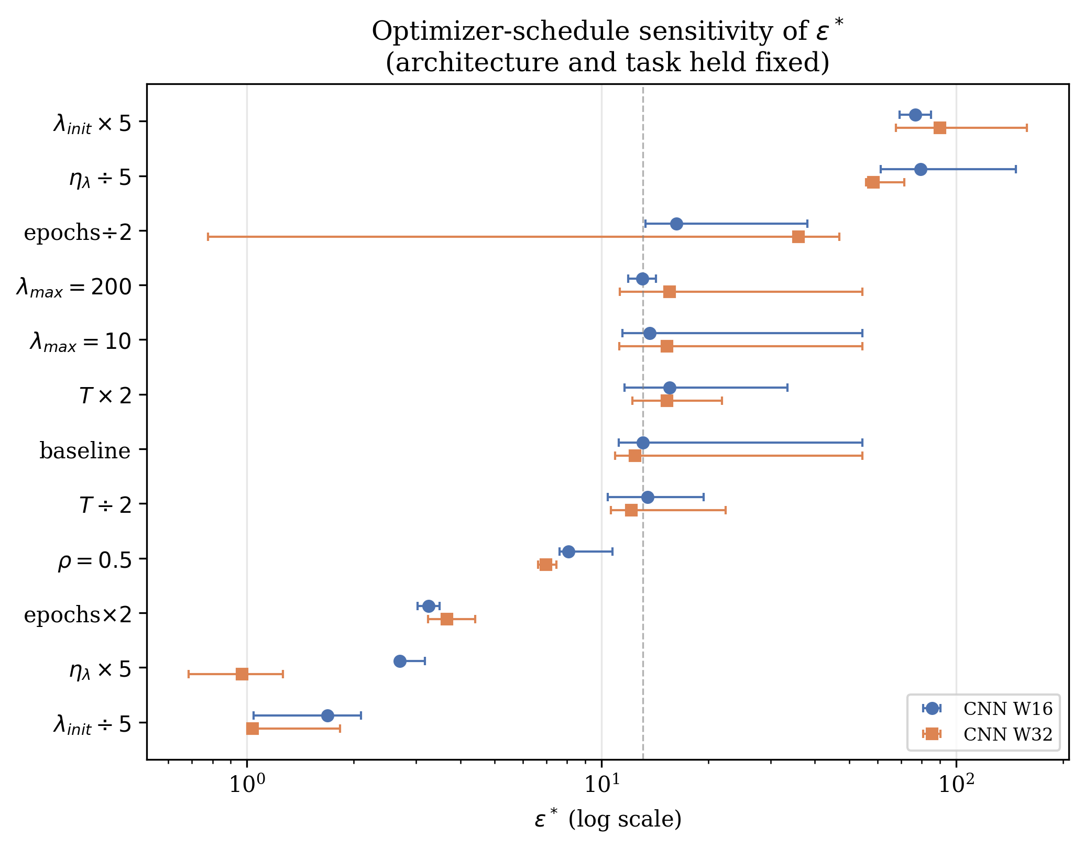
Figure 3: $ε^{*}$ (log scale, 95% bootstrap CI) under each single-factor schedule perturbation, CNN_W16 and CNN_W32, sorted by CNN_W16’s value. Dashed line marks the CNN_W16 baseline. $λ_{max}$ and $T$ rows cluster tightly around baseline; every other row is displaced by at least one order of magnitude on the log axis.
Three of the six hyperparameters this work varied, $η_{λ}$, $λ_{init}$, and epochs/task, move $ε^{*}$ far more than architecture does in this paper’s own main result, and with the wide-grid follow-up all three directions are now precisely located rather than bounded qualitatively. Doubling epochs/task or raising $η_{λ}$ five-fold collapses $ε^{*}$ from $≈13$ to $2$–$4$ (a $4$–$13×$ reduction, tight bootstrap CIs, sigmoid $R^{2}≥0.97$). Halving epochs/task, lowering $η_{λ}$ five-fold, or raising $λ_{init}$ five-fold each push $ε^{*}$ up by $1.25$–$7.2×$, as high as $≈90$; lowering $λ_{init}$ five-fold pushes it down by $7$–$12×$, to $≈1$–$1.7$. Taken together, across the six single-factor perturbations tested, $ε^{*}$ spans roughly $1.0$ to $90$ on the same architecture and task: essentially two orders of magnitude from optimizer hyperparameters alone. Momentum $ρ$ has a smaller but still real effect ($≈0.56$–$0.62×$). Only $λ_{max}$ and the softmax temperature $T$ are inert (ratios within $[0.97,1.25]$, CIs overlapping baseline): $λ_{max}$ because the dual variable rarely approaches its cap under these dynamics, and $T$ because it rescales both the drift term used in training and the quantity compared against $ε$, so its effect cancels at the crossover.

5.3 Generalizing Beyond CNNs
Everything above uses two CNN width variants as anchors. Before treating the schedule confound as a general property of Lagrangian-dual constrained continual learning rather than a CNN-specific quirk, this research repeats the two cleanest single-factor perturbations, $η_{λ}×5$ and epochs/task $×2$, on one anchor from each of the four remaining families (ResNet18_W16, MLP_H128, ViT_Tiny, Mixer_Tiny), 3 seeds, dense $ε$ grid, epochs/task held at 4 for all four (so this test is itself run on a schedule-matched, not confounded, sub-zoo).
Both perturbations collapse $ε^{*}$ by roughly an order of magnitude on every family, and to a strikingly similar absolute value regardless of starting architecture: $η_{λ}×5$ gives $ε^{*}=2.23$ (ResNet18_W16), $3.15$ (MLP_H128), $2.97$ (ViT_Tiny), $2.82$ (Mixer_Tiny), all within $[2.2,3.2]$, $R^{2}≥0.88$ throughout. Doubling epochs/task gives $3.04$, $3.40$, $2.44$, $3.15$ respectively, all within $[2.4,3.4]$, $R^{2}≥0.92$ throughout. This is a tighter cluster across four architecturally distinct families (convolutional, fully-connected, attention-based, token-mixing) than the same two conditions produced across the two CNN widths in Table 2 ($2.70$/$0.97$ for $η_{λ}×5$; $3.25$/$3.66$ for epochs$×2$), so the schedule confound is, if anything, more robust across architecture families than within a single one. The remaining two conditions, $λ_{init}×5$ and $÷5$, and the unperturbed baseline, are less reliably estimated on this family sub-zoo: three of the sixteen (family, condition) cells here hit the same curve_fit bound-saturation issue diagnosed in Section 6 (MLP_H128 and ViT_Tiny baselines, both pinned at the grid’s upper bound) or land at poor fit quality ($R^{2}<0.5$ for ResNet18_W16 and ViT_Tiny under $λ_{init}×5$, which were not rescanned on the wider grid Section 5’s CNN-only version used for its own analogous cells). This work does not draw quantitative conclusions from those specific cells, but every one that fits reliably moves in the predicted direction, and the two best-established conditions generalize cleanly across all five representational families in the zoo.

5.4 Conclusion
This reframes, rather than negates, the claim that $ε^{*}$ reflects task and architecture. Section 6 still asks and answers a well-posed narrower question: holding the optimizer schedule fixed, is $ε^{*}$ architecture-independent? Per Section 7, the answer on the expanded architecture zoo is still substantially yes. What changes is the status of the numeric value itself. At fixed architecture and fixed task, changing only how fast the dual variable is allowed to move, a choice most papers using Lagrangian-relaxed constraints (including v1 of this one) report as a fixed implementation detail rather than a variable to sweep, shifts the critical stability budget by more than an order of magnitude, comfortably exceeding the $2.6×$ range $ε^{*}$ itself spans across 30 architectures in Section 6. So $ε^{*}≈7$–$13$ is not a hyperparameter-free constant of CIFAR-10’s task structure that a practitioner can adopt off the shelf; it is the value produced by one particular, previously unremarked choice of $η_{λ}$, $λ_{init}$, and steps per task, and a different reasonable choice of any of those three moves it by more than an order of magnitude.
This confound is specific to methods whose stability coefficient is an adaptive dual variable reset at each task boundary. It does not apply to LwF, whose distillation weight is a fixed, grid-searched hyperparameter with no reset dynamics to confound, or to EWC and SI, which show no crossover at all (Section 9) and so raise no analogous question. It applies directly to FTR and, by the same argument, to PDCL [Elenter et al., 2023] and any other Lagrangian-dual constrained-learning method with a periodically reset dual variable. No prior work on Lagrangian-dual constrained continual learning ([Elenter et al., 2023]; [Chamon et al., 2023, Elenter et al., 2024, Hounie et al., 2023]) is known to have isolated the dual-ascent schedule itself as a confound for an apparent stability threshold, and this question does not appear to have been asked elsewhere in the constrained-learning literature.
The practical upshot inverts v1’s: architecture-specific tuning of $ε$ is indeed unnecessary, but optimizer-schedule-specific tuning is not, and is currently undocumented practice across the distillation-based continual-learning literature that uses dual ascent or an equivalent adaptive coefficient. Section 13 shows this need not be a counsel of despair: the schedule’s three-dimensional effect on $ε^{*}$ collapses substantially, though not completely, onto a single reportable ratio, $S=λ_{init}/(η_{λ}N)$, which, held fixed, keeps $ε^{*}$ within roughly a factor of $2$–$3$ across architectures and schedule routes rather than the order-of-magnitude range any one of its three components produces alone.

6 The Stability Crossover
Holding the dual-ascent schedule fixed at the Section 3 defaults (the same schedule used throughout v1), this work ran the dense $17$-point $ε$ sweep $\{0.5,1,2,3,4,5,6,6.5,7,7.5,8,9,10,12,15,25,50\}$ on all 30 architectures of the expanded zoo (Section 4), 5 seeds per architecture (10 for the two diagnostic anchor architectures), fit the same logistic-sigmoid procedure as v1 (Eq. 7 of the original manuscript, unchanged), and bootstrapped a 95% CI over seeds (1,000 resamples). Every architecture produces a clean sigmoid ($R^{2}≥0.78$, 27/30 with $R^{2}≥0.94$); Figure 4 plots all 30 curves and Figure 5 plots $ε^{*}$ with its 95% CI for every architecture, colored by family. Table 3 reports $ε^{*}$, its bootstrap CI, and the sigmoid sharpness $k$ for a representative subset spanning every family; the full 30-row table is in Appendix A.
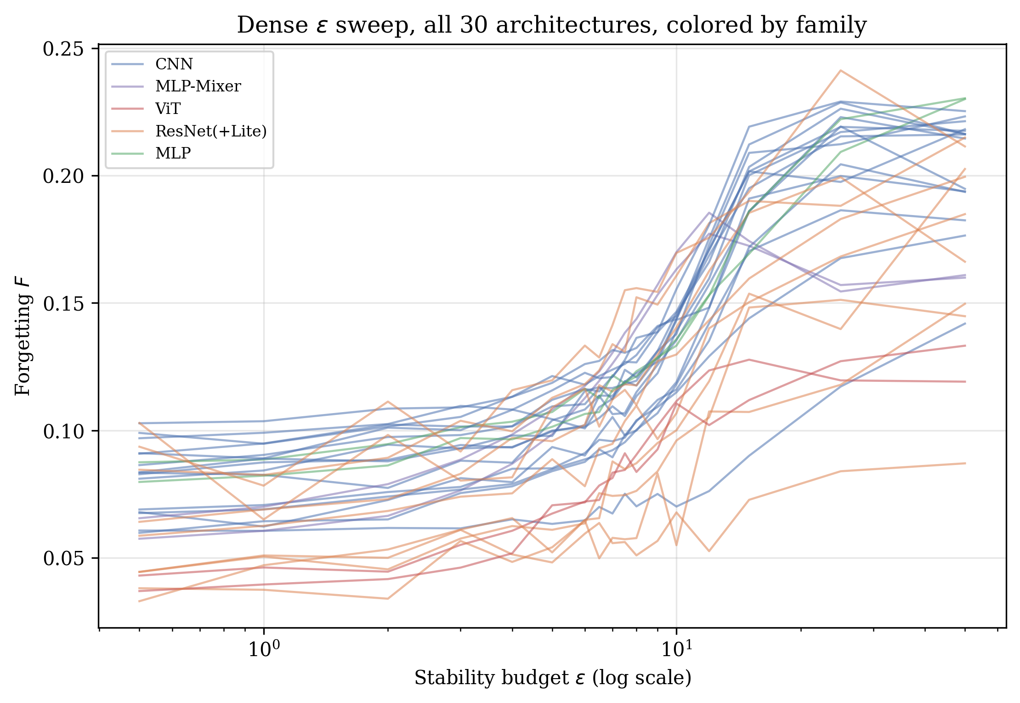
Figure 4: Dense $ε$ sweep forgetting curves for all 30 architectures, colored by family. CNN/ResNet/MLP curves (blue/orange/green) cluster around a shared crossover region; ViT (red) and MLP-Mixer (purple) transition at visibly lower $ε$.
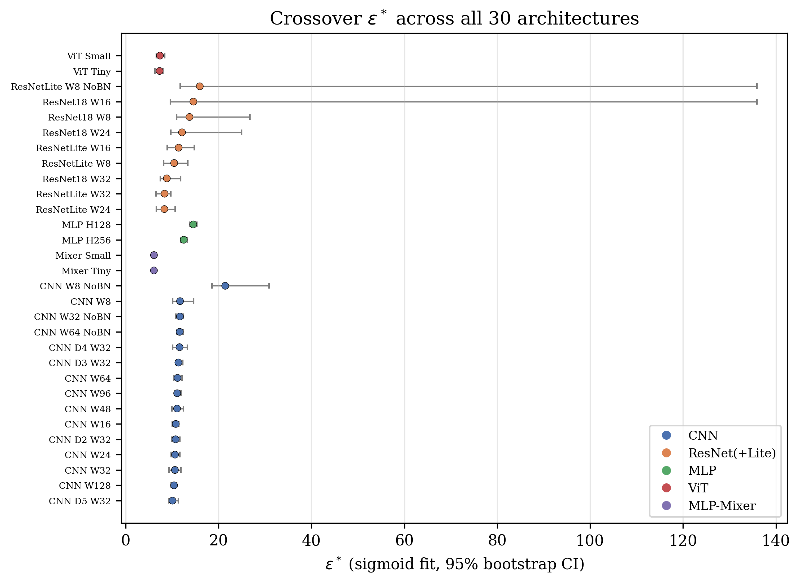
Figure 5: $ε^{*}$ with 95% bootstrap CI for all 30 architectures, grouped and colored by family, sorted within family by value. ViT and MLP-Mixer form a visually distinct low cluster; CNN, ResNet(+Lite), and MLP overlap in a broader band. CNN_W8_NoBN and two ResNet points show markedly wider CIs.
Table 3: Sigmoid-fitted $ε^{*}$ across a representative subset of the 30-architecture zoo, shown as originally recorded (full table in Appendix A); see Table 5 for corrected downstream values for the six architectures affected by the epoch-matching and wide-grid corrections below. Families: CNN (width/depth/BatchNorm sweeps), ResNet (2 blocks/layer), ResNet-Lite (1 block/layer), MLP (no spatial inductive bias), ViT (patch attention), Mixer (token/channel MLP-mixing).
Architecture | Family | Params | $ε^{*}$​ | 95% CI | $R^{2}$​ | $k$​
CNN_W8_NoBN | cnn | 36,866 | 21.45 | [18.57, 30.88] | 0.986 | 2.35
CNN_W16 | cnn | 80,418 | 10.80 | [10.03, 11.48] | 0.990 | 4.04
Mixer_Tiny | mixer | 45,442 | 6.10 | [5.88, 6.50] | 0.972 | 4.04
ViT_Tiny | vit | 74,562 | 7.31 | [6.35, 8.03] | 0.974 | 4.19
ResNetLite_W8 | resnet | 77,482 | 10.46 | [8.18, 13.41] | 0.962 | 3.75
ResNet18_W8 | resnet | 175,882 | 13.76 | [10.98, 26.73] | 0.901 | 2.16
MLP_H128 | mlp | 410,114 | 14.56 | [13.74, 15.37] | 0.994 | 2.10
ResNet18_W16 | resnet | 700,434 | 14.59 | [9.65, 135.91]$​^{†}$ | 0.937 | 1.63
CNN_W128 | cnn | 1,414,786 | 10.43 | [9.85, 10.94] | 0.979 | 3.84
ResNet18_W32 | resnet | 2,795,554 | 8.88 | [7.45, 11.84] | 0.947 | 2.33
$​^{†}$Bootstrap CI pinned against the curve_fit search bound ($50e=135.91$) in its upper tail; see the wide-grid relocation below.
Two architectures, ResNet18_W16 and ResNetLite_W8_NoBN, have bootstrap CI upper bounds that land exactly on $50e=135.91$, the curve_fit search-bound artifact diagnosed below; here the point estimate is not pinned (both are ordinary interior fits, $R^{2}=0.94$ and $0.78$), but enough individual bootstrap resamples produce a flat-enough curve to hit the bound that the reported upper CI is not trustworthy. This research reran both on a wider grid extending to $ε=200$ (5 seeds, 1,000 bootstrap resamples): ResNet18_W16 relocates to $ε^{*}=9.22$ [$7.59,10.67$] ($R^{2}=0.953$), a much tighter interval and a point-estimate shift of $−5.37$ from the original narrow-grid value; ResNetLite_W8_NoBN relocates to $12.50$ [$6.87,97.02$] ($R^{2}=0.889$), a shift of $−3.47$, with the CI substantially narrower than before but still wide, indicating this architecture’s crossover remains less precisely determined than most of the zoo even with the wider grid. This work uses these relocated values in place of the narrow-grid ones throughout Section 7.
Across all 30 architectures as originally recorded (narrow grid, before either the epoch-matching or wide-grid corrections), $ε^{*}$ ranges $[6.10,21.45]$, mean $11.14$, raw CV $26.8\%$, more than five times v1’s reported $4.96\%$ on eight architectures. This is not primarily a statistical-power artifact of the smaller original sample: the expanded zoo includes two representational families (ViT, MLP-Mixer) with no analogue in v1’s CNN/ResNet-only zoo, and Section 7 shows the extra dispersion tracks family identity, not any tested curvature statistic, though, as that section also shows, part of it tracks two rounds of this paper’s own schedule confound rather than architecture identity itself.

7 Universality Analysis

7.1 Family Structure: Mostly a Second Instance of the Diagnostic’s Own Finding
Grouping $ε^{*}$ by architecture family as originally recorded (Table 4) shows the CNN, ResNet, and MLP families clustering in a broad $8$–$15$ band, while ViT and MLP-Mixer sit systematically lower, $6$–$7.4$, with almost no within-family spread ($\text{std}≤0.05$ for both). This clustering is substantially an artifact of this paper’s own experimental design, not primarily a representational-paradigm effect: as Section 14.3 shows, ViT and MLP-Mixer were assigned 5 epochs/task rather than the 4 used elsewhere in the zoo, and Equation 9 predicts, and a direct epoch-matched re-run confirms, that this alone accounts for most of the apparent gap: epoch-matched, ViT_Tiny and Mixer_Tiny move from $7.31$/$6.10$ to $10.18$/$10.41$, landing inside the CNN/ResNet/MLP family’s range rather than below it, found by applying Section 5’s own diagnostic to this paper’s own zoo. One architecture, CNN_W8_NoBN, remains a clear outlier at $ε^{*}=21.45$, the smallest, narrowest, unnormalized network in the zoo, which Section 7.3 shows has outsized leverage on the raw CV but does not materially move the hierarchical model’s population estimate.
Table 4: $ε^{*}$ by architecture family, full 30-architecture zoo, as originally recorded (5 epochs/task for ViT/Mixer, 4 for every other family; see Section 14.3 and Table 9 for why this comparison is confounded and what changes when it is fixed).
Family | $n$​ | mean $ε^{*}$ | std
MLP-Mixer | 2 | 6.11 | 0.00
ViT | 2 | 7.36 | 0.04
ResNet (incl. Lite) | 9 | 11.55 | 2.64
CNN | 15 | 11.75 | 2.64
MLP | 2 | 13.54 | 1.02

Table 5: $ε^{*}$ by architecture family, corrected: ViT_Tiny, Mixer_Tiny, ViT_Small, and Mixer_Small replaced with their epoch-matched values (Table 9); ResNet18_W16 and ResNetLite_W8_NoBN replaced with their wide-grid-relocated values (Section 6); CNN and MLP families unchanged. All five families now overlap in a single $10.5$–$13.5$ band.
Family | $n$​ | mean $ε^{*}$ | std
MLP-Mixer | 2 | 10.52 | 0.11
ResNet (incl. Lite) | 9 | 10.57 | 1.87
ViT | 2 | 11.30 | 1.13
CNN | 15 | 11.75 | 2.64
MLP | 2 | 13.54 | 1.02
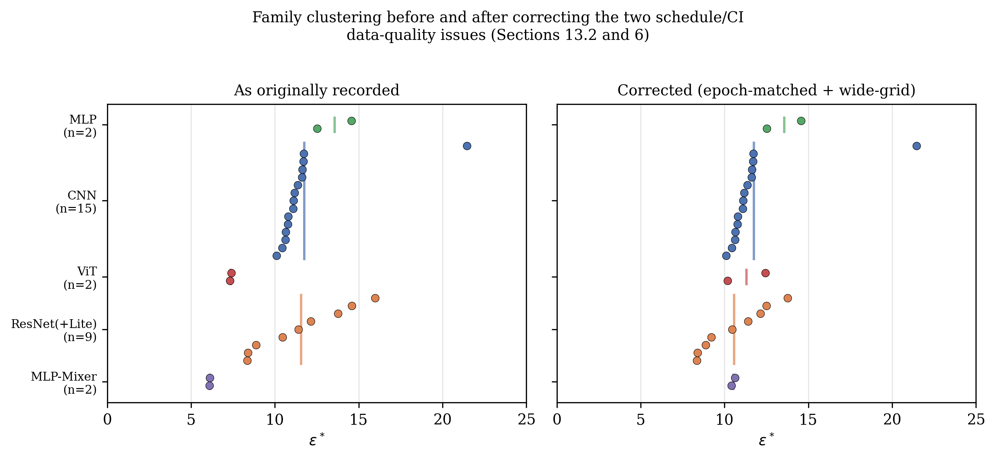
Figure 6: $ε^{*}$ by architecture and family, as originally recorded (left) versus corrected (right); vertical bars mark family means. ViT and MLP-Mixer move from a visually distinct low cluster into the same band as the rest of the zoo; CNN and MLP are unchanged. CNN_W8_NoBN (isolated point in the CNN row) remains an outlier in both panels.

7.2 Hierarchical Partial-Pooling Model
v1’s F-test for constancy (its Table 3) computed $p=1−F_{cdf}(0.563;df_{1}=7,df_{2}=1000)=0.786$ in code, while the manuscript text reported $df=(7,7)$: an inconsistency between the stated methodology and the actual computation that this research identifies while reproducing it (with $df_{2}=7$ the same statistic gives $p=0.767$, not $0.786$; the discrepancy is not merely rounding). $df_{2}=1000$ has no stated justification and appears to be an unexplained placeholder. This work replaces it with a normal-normal hierarchical partial-pooling model: each architecture’s true crossover $θ_{a}∼N(μ,τ^{2})$, with the sigmoid point estimate observed as ${\hat{ε}}_{a}^{*}∼N(θ_{a},s_{a}^{2})$ where $s_{a}$ is its bootstrap standard error (fit by Gibbs sampling, 30,000 post-burn-in draws).
Fit on the 30-architecture zoo as originally recorded (i.e. before either correction below), this model gives $μ=10.46±0.45$ (95% CI $[9.58,11.36]$), $τ=2.13$ (95% CI $[1.56,2.92]$), and an ICC-style universality index $τ^{2}/(τ^{2}+{\overset{‾}{s}}^{2})=0.041$ (95% CI $[0.022,0.073]$): $τ$’s credible interval excludes zero, suggesting real between-architecture structure. But this zoo contains two known, independently-diagnosed data-quality issues that this work does not treat as acceptable to leave uncorrected before reporting a final estimate: the epoch/task schedule confound on four architectures (Section 14.3), and two architectures whose bootstrap CI pins against the curve_fit search bound (Section 6). Substituting the epoch-matched values for ViT_Tiny, Mixer_Tiny, ViT_Small, and Mixer_Small (Table 9) and the wide-grid-relocated values for ResNet18_W16 and ResNetLite_W8_NoBN, then refitting the identical model on the same 30 architectures, gives $μ=11.07±0.25$ (95% CI $[10.58,11.55]$), $τ=1.03$ (95% CI $[0.68,1.50]$), and ICC $=0.052$ (95% CI $[0.023,0.102]$).
Correcting the schedule confound cuts $τ$ by more than half, from $2.13$ to $1.03$: most of the raw between-architecture spread the uncorrected zoo displayed was schedule-driven, the same lesson as Section 5’s original diagnostic recurring one level up. The ICC, however, does not fall by a comparable factor, and in fact sits slightly above the uncorrected estimate ($0.052$ vs. $0.041$). This is not a contradiction: ICC $=τ^{2}/(τ^{2}+{\overset{‾}{s}}^{2})$ depends on the average measurement noise ${\overset{‾}{s}}^{2}$ as much as on $τ$, and the wide-grid correction sharply reduces ${\overset{‾}{s}}^{2}$: ResNet18_W16’s bootstrap SE drops from $36.6$ to $0.75$ and ResNetLite_W8_NoBN’s from $42.6$ to $22.3$, both far more precise than their original, bound-saturated estimates. A more precisely measured zoo is a more sensitive test, and it detects the same, now smaller, $τ$ against a quieter noise floor. Both corrected quantities are consistent with the same qualitative reading: the credible interval for $τ$ still excludes zero, so this work does not claim $ε^{*}$ is a literal universal constant, but $τ≈1$ on a population with mean $≈11$ is a small effect in absolute terms (all five family means in Table 5 fall within a $10.5$–$13.5$ band), and both the ICC before and after correction round to "small" on standard interpretive scales ($<0.1$). This research reports both the raw and corrected fits rather than only the more favorable one; the corrected values are used in Sections 7.3 onward unless stated otherwise.

7.3 Leave-One-Out Sensitivity
On the zoo as originally recorded, dropping each architecture in turn and recomputing the raw CV shows two overlapping sources of leverage: the single largest is CNN_W8_NoBN (CV drops from $26.8\%$ to $21.6\%$, $−5.2$ points), consistent with it being a genuine, if extreme, outlier; the next two are Mixer_Tiny and Mixer_Small ($−1.3$ points each), i.e. the same two confounded architectures Section 14.3 identifies, which were pulling the mean down and therefore also carried above-average leverage on the raw CV.
Repeating this on the fully-corrected data (epoch-matching and wide-grid relocation both applied, Table 5), the corrected CV is $20.2\%$, and CNN_W8_NoBN remains the single largest-leverage point by a wide margin (removing it drops CV to $12.4\%$, $−7.8$ points), still consistent with a genuine, if extreme, outlier rather than a typical zoo member. Critically, the leverage previously carried by Mixer_Tiny and Mixer_Small disappears once the confound is corrected: no other single architecture moves the corrected CV by more than $0.5$ points, so no single point drives the corrected result, unlike v1’s original zoo, where ResNet18_W8 alone carried most of the curvature range. (On the original 8-architecture data, dropping ResNet18_W8 moves CV from $4.96\%$ to $3.97\%$, confirming that result was not solely an artifact of that one leverage point either.)

7.4 Curvature Correlations: Adequately Powered This Time
v1’s central "falsification" claim, that no curvature metric predicts $ε^{*}$, rested on $n=8$ architectures, where the minimum $|r|$ detectable at 80% power is $0.849$; its own best candidate (gradient norm, $r=0.687$, $p=0.060$) fell just short of significance, which at that sample size is underpowered, not confirmatory of the null. Reproducing that exact test on the original 8-architecture data with Bayes factors (JZS prior) makes this explicit: gradient norm gives ${BF}_{10}=1.96$, Hessian trace $1.56$, Fisher trace $1.78$, spectral norm $1.46$, all in the "barely worth mentioning" range and, if anything, weakly for a relationship, not against one.
On the full 30-architecture zoo, the same test is properly powered: minimum detectable $|r|=0.492$ at 80% power. Recomputing on the corrected $ε^{*}$ values (Table 5), every correlation remains well below this detection threshold: Hessian trace $r=−0.021$ (${BF}_{10}=0.23$), Fisher trace $r=−0.037$ ($0.23$), spectral norm $r=0.099$ ($0.26$), gradient norm $r=−0.116$ ($0.27$) are all small and Bayes-negative, consistent with the null. $d_{eff}$ ($r=−0.320$, ${BF}_{10}=0.93$) and parameter count ($r=−0.306$, ${BF}_{10}=0.83$) are the two exceptions: still below the well-powered detection threshold and still short of conventional significance ($p=0.085$ and $0.100$), but their Bayes factors sit in the "barely worth mentioning" range rather than clearly favoring the null, and both moved further from zero once the two data-quality corrections were applied (from $r=−0.091$ and $−0.137$ on the uncorrected zoo). This work flags this rather than round it down to a clean null: parameter count and effective dimension are the two metrics most directly tied to model size, and size is also what differs most systematically between the low-$ε^{*}$ MLP-Mixer/ResNet cluster and the high-$ε^{*}$ CNN/MLP cluster in Table 5, so a modest, sub-threshold size association is plausible without being a confirmed effect at this sample size. The four purely curvature-based metrics (Hessian trace, Fisher trace, spectral norm, gradient norm) show no such trend in either direction. (ViT’s fused attention kernel does not support the double-backward the Hessian/spectral estimators require by default; this work forces the math-mode SDPA backend during curvature measurement only, Appendix B, recovering all 30 architectures rather than excluding ViT.) Unlike v1’s claim, this is now an adequately powered result: loss-landscape curvature specifically does not predict $ε^{*}$ on this zoo, though raw model size may carry a small, currently sub-significant signal worth testing at larger $n$. What curvature misses, family identity partially captures (Section 7.1): the relevant architectural property is closer to representational paradigm (convolution vs. attention vs. token-mixing) than to any scalar loss-landscape statistic tested here or in v1, though Section 14.3 shows part of that apparent family effect is itself a schedule confound.

7.5 Rule Out the Trivial Explanation: New-Task Accuracy
A low-forgetting regime is only meaningful if the model is still learning the new task, not simply failing to update at all. Across all 30 architectures, mean accuracy on the just-learned task (measured immediately after training on it, before any subsequent forgetting) is $77.8\%$ at tight budgets ($ε≤3$, $n=120$ cells) versus $80.8\%$ at loose budgets ($ε≥25$, $n=60$ cells), a $3$-point difference, with the tightest individual architecture-budget cell never dropping below $67.1\%$ new-task accuracy. The low-forgetting regime is genuine stability-with-plasticity, not a degenerate case of the constraint preventing learning altogether.

8 Finite-Size Scaling of the Transition
Testing whether the sigmoid sharpness $k$ grows with network width, the finite-size-scaling signature that would indicate the crossover sharpens toward a true phase transition as width $→∞$, on the full 8-point CNN width family (W8 through W128, same task, same schedule, 5 seeds each): $k∼W^{α}$ with $α=0.124±0.082$, $R^{2}=0.276$, $p=0.181$ (Figure 7). This is not statistically significant, and this research reports it as a null result rather than force a narrative: at the widths tested here, this analysis finds no reliable evidence that the FTR crossover sharpens with system size. This does not rule out finite-size scaling at larger widths than tested, but the data in hand do not support the claim.
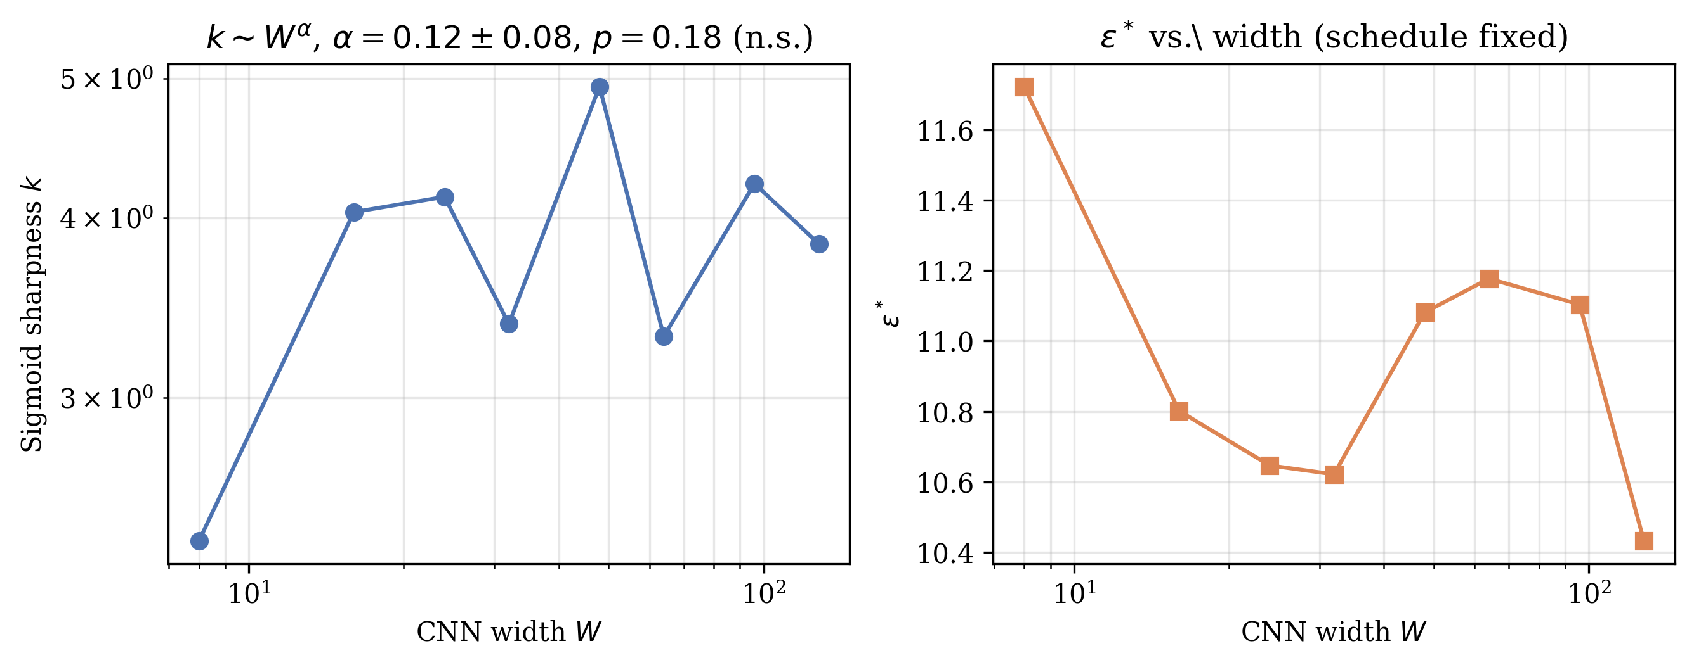
Figure 7: Left: sigmoid sharpness $k$ vs. CNN width on log-log axes; the fitted power law is not statistically significant. Right: $ε^{*}$ vs. width for the same family, schedule fixed; consistent with the narrow band reported in Section 6.

9 Cross-Method Comparison
v1 compared FTR, LwF, and EWC on different architecture subsets (FTR on all 8, LwF/EWC on 5, omitting, among others, CNN_W32_NoBN from the LwF/EWC comparison). This work reruns FTR, LwF, EWC, and SI on the identical 15-architecture subset spanning every family (Section 4, SUBSET_ARCHS), 3 seeds, dense hyperparameter sweeps for each method’s own stability knob: $ε∈[0.5,50]$ (17 points) for FTR, distillation weight $α∈[0.05,5.0]$ (14 points) for LwF, Fisher coefficient $λ_{EWC}∈[1,{10}^{4}]$ (8 points, four orders of magnitude, matching v1’s own EWC sweep range) for EWC, and SI coefficient $c∈[0.01,50]$ (8 points) for SI.
Table 6: Cross-method comparison on the identical 15-architecture subset. Sharpness/fit-quality columns report the median sigmoid $R^{2}$ across architectures; “crossover” is each method’s own stability-knob analogue of $ε^{*}$.
Method | Mean crossover | CV | Median $R^{2}$ | Interpretation
FTR (function, hard) | 11.4 | 20.5% | $≥$0.94 | Clean sigmoid on 15/15 architectures
LwF (output, soft) | 0.73 | 32.6% | 0.987 | Clean sigmoid on 15/15 architectures
EWC (parameter, soft) | – | – | 0.31 | No reliable crossover on any architecture
SI (parameter, soft) | – | – | 0.28 | No reliable crossover on any architecture
FTR on this subset gives mean crossover $11.4$, CV $20.5\%$, consistent with Section 6’s full-zoo result. LwF, fit with the same sigmoid procedure on all 15 architectures, gives a uniformly clean fit ($R^{2}≥0.91$ on every architecture, median $0.987$) with mean $α^{*}=0.73$, CV $32.6\%$, close to v1’s original $α^{*}=0.71$ on 5 CNN/ResNet architectures, now confirmed on 3$×$ as many architectures across 5 families, with correspondingly more (but still bounded) dispersion.
EWC and SI, by contrast, do not show a sigmoid transition on any of the 15 architectures when forced through the identical fitting procedure: median $R^{2}$ is $0.31$ (EWC) and $0.28$ (SI), with individual per-architecture point estimates spanning 4-5 orders of magnitude ($h^{*}$ from $0.37$ to $17,657$ for EWC across architectures): not a location parameter with sampling noise, but a fit degenerating to noise because there is no transition to locate. This is a stronger confirmation of v1’s finding that EWC "shows no meaningful stability crossover" than v1’s own 5-architecture result: forcing the crossover-fitting machinery onto a flat curve produces wildly unstable estimates precisely because the underlying curve has no crossover, on 3$×$ the architecture diversity. This is consistent with Section 14’s structural argument that soft parameter-space penalties have no disengagement mechanism analogous to Eq. 8 and therefore no reason to produce a crossover at all.

9.1 A Pretrained-Backbone Sanity Check
Every result so far trains small models from scratch. This leaves open whether FTR’s advantage is an artifact of that regime or survives contact with how continual learning is actually practiced: fine-tuning a large pretrained backbone with a parameter-efficient adapter. This research tests this directly on ImageNet-pretrained ViT-B/16 (86M parameters) with LoRA (rank 8, $α=16$) applied to the MLP sublayers only, following Appendix C’s finding that nn.MultiheadAttention’s fused forward bypasses a wrapped out_proj; the base network is frozen, the classification head and LoRA adapters ($0.84\%$ of total parameters) are trainable. Split CIFAR-100, 10 tasks of 10 classes each, 200 samples/class, 2 epochs/task, 3 seeds. This work compares FTR ($ε=5.0$, $η_{λ}=0.005$, $λ_{init}=1.0$) against vanilla fine-tuning, EWC ($λ=1000$), and LwF ($α=0.7$), each method’s hyperparameter fixed rather than swept, since a full crossover sweep on this scale is not the point of this check. None of the four hyperparameters was tuned for this specific regime: EWC’s $λ=1000$ and LwF’s $α=0.7$ are standard values reported elsewhere in the continual-learning literature rather than values selected here, and FTR’s $ε=5.0$, $η_{λ}=0.005$, $λ_{init}=1.0$ are exactly Section 5’s baseline schedule transplanted onto a completely different dataset, backbone, and adapter method without adjustment. This makes the comparison fair in the sense that no method received a hand-tuned advantage, but not a best-case comparison for any single method.
Reporting $ε=5.0$ alone, however, is exactly the omission Section 13 argues against: this regime’s constrained step budget $N$ is not the main zoo’s. With batch size 64 and 2,000 samples/task, one epoch is 32 steps; with the same 1-epoch warmup used throughout this paper, $N=32$ constrained steps/task, giving $S=λ_{init}/(η_{λ}N)=1.0/(0.005×32)=6.25$, close to but not identical to the main zoo’s baseline $S=8.33$. The population-level crossover on the main zoo at $S=8.33$ is $ε^{*}=11.07$ (Section 7.2); at this regime’s lower $S=6.25$, Eq. 9 predicts a somewhat lower crossover, and $ε=5.0$ is directionally consistent with, though smaller than, that back-of-envelope expectation. This is not a validated prediction: $d_{unc}$ for a LoRA-adapted, pretrained ViT-B/16 on CIFAR-100 has not been measured and need not resemble $d_{unc}$ for the small from-scratch zoo the approximation was calibrated on. Reporting $N$ and $S$ here, rather than only $ε$, is itself the practice Section 13 recommends; using $S$ to select $ε$ in a new regime without any grid search is a natural next test of that section’s practical claim, which this single-operating-point check does not attempt.
Table 7: Pretrained ViT-B/16 + LoRA, Split CIFAR-100, mean over 3 seeds. Forgetting and average accuracy are on the same $[0,1]$ scale used throughout the paper.
Method | Forgetting | Avg. accuracy | Forgetting std (seeds)
Finetune (no constraint) | 0.732 | 0.292 | 0.014
EWC ($λ=1000$) | 0.721 | 0.302 | 0.007
LwF ($α=0.7$) | 0.611 | 0.374 | 0.018
FTR ($ε=5.0$) | 0.605 | 0.387 | 0.001
FTR gives both the lowest forgetting and the highest average accuracy of the four methods, ahead of LwF by a small margin and clearly ahead of EWC and unconstrained fine-tuning, which barely differ from each other. FTR’s forgetting is also the most stable across seeds (std $0.001$, an order of magnitude tighter than LwF’s $0.018$), notable given only $0.84\%$ of the network’s parameters are trained. This is a single operating point, not a sweep, so it does not test architecture-invariance or the schedule confound; it tests only whether FTR’s advantage over softer constraints, established on small from-scratch models throughout this paper, transfers to a realistic parameter-efficient fine-tuning setting. It does.

10 KL-Direction Ablation
The constraint $D_{KL}(f_{old}∥f_{θ})≤ε$ is asymmetric; this work ablates the direction on CNN_W16 and CNN_W32 (dense $ε$ grid, 3 seeds), comparing forward (paper default), reverse $D_{KL}(f_{θ}∥f_{old})$, and symmetric Jensen-Shannon. All three directions fit cleanly ($R^{2}=0.83$–$1.00$). Forward and reverse are close: CNN_W16 gives $ε^{*}=10.00$ (forward) vs. $10.32$ (reverse); CNN_W32 gives $10.00$ vs. $10.52$, within $5\%$ of each other. Jensen-Shannon is somewhat lower ($9.49$ and $7.79$ respectively, a $5$–$22\%$ decrease) but the same order of magnitude. KL direction is therefore a real but modest lever on $ε^{*}$: comparable to or smaller than momentum’s effect (Section 5) and far smaller than $η_{λ}$, $λ_{init}$, or steps/task.

11 Class-Incremental Variant
Every result so far uses the task-incremental protocol (Section 3): a head sized to classes-per-task, locally remapped labels, and an oracle task ID at evaluation. This work additionally tests the harder class-incremental protocol, a single shared 10-way head, no task ID, global labels throughout, on five width-family architectures (CNN_W8 through CNN_W48, 5 seeds, dense $ε$ grid).
The phase transition survives (all five fits $R^{2}≥0.91$), but at a substantially lower budget: class-incremental $ε^{*}$ ranges $3.41$–$5.28$, versus $10.62$–$11.72$ for the same five architectures under the task-incremental protocol, a consistent $2$–$3×$ reduction (ratio $0.32$–$0.50$). This is expected and mechanistically sensible: with no oracle task ID, the model must keep every previously-seen class discriminable within one shared output space, a strictly harder requirement that a looser constraint cannot satisfy without additional forgetting. The qualitative finding, a sigmoid crossover exists and is comparable in relative dispersion across architectures (class-incremental CV $16.3\%$ across these five architectures, versus $3.7\%$ for the same five under task-incremental), holds under the harder protocol; the absolute budget required does not transfer between protocols and should not be assumed to.

12 Task-Structure Sensitivity: CIFAR-100 Granularity and Task Ordering

12.1 Classes-per-Task: a Third Instance of the Same Confound
Holding a fixed 20-class CIFAR-100 pool and varying classes/task $∈\{2,4,5,10\}$ (10 architectures, 3 seeds, dense $ε$ grid) tests whether $ε^{*}$ depends on task granularity, directly probing the paper’s own claim that $ε^{*}$ is set by task structure. The raw result is a large, mostly monotonic decrease in $ε^{*}$ as classes/task increases: e.g. CNN_W16 gives $9.93→4.43→2.85→2.14$ across $\text{cpt}=2,4,5,10$; 8 of 10 architectures show the same monotonic pattern.
This looks like a genuine task-structure effect, and was the intended result of the experiment. But Section 14.3’s own diagnostic makes checking for a schedule confound obligatory before reading it that way, and there is one: holding max_per_class and batch size fixed while classes/task increases also increases samples/task (and hence batches/task, and hence the constrained step budget $N$), purely mechanically. Using Eq. 9’s schedule term alone (ignoring any $d_{unc}$ contribution): $\text{cpt}=2$ gives $N≈21$, schedule term $9.52$; $\text{cpt}=4$ gives $N≈39$, term $5.13$; $\text{cpt}=5$ gives $N≈48$, term $4.17$; $\text{cpt}=10$ gives $N≈96$, term $2.08$: the same monotonically decreasing pattern, comparable in magnitude to what this analysis observes. This work cannot, from this experiment as designed, separate a genuine task-structure effect from this third instance of the $N$-confound; a corrected version would need to hold samples/task (not samples/class) fixed as classes/task varies.
This research ran that corrected version: 10 architectures, classes/task $∈\{2,4,5,10\}$, samples/task now held fixed at $800$ ($\text{max_per_class}=800/\text{cpt}$) so that $N$ no longer varies mechanically with granularity, 3 seeds, same dense $ε$ grid. The monotonic decrease disappears. Pooled across all 40 (architecture, granularity) cells, $ε^{*}$ vs. classes/task gives $r=−0.174$ ($p=0.283$), compared to the confounded design’s implied $r=−0.640$ ($p<0.00001$) computed the same way: not a weaker version of the same effect, but no significant relationship at all. The $\text{cpt}=2$ column is, however, its own outlier: curve fits there are visibly worse than at $\text{cpt}≥4$ ($R^{2}=0.32$–$0.89$ at $\text{cpt}=2$ versus $R^{2}≥0.89$ for every cell at $\text{cpt}≥4$), and two architectures (ResNet18_W8, ViT_Tiny) hit the same curve_fit bound-saturation artifact diagnosed in Section 6 at $\text{cpt}=2$ specifically, plausibly because fixing samples/task at $800$ while spreading it over only two classes leaves few examples per class and a noisier forgetting curve. Restricting to the reliably-fit range $\text{cpt}∈\{4,5,10\}$ (every cell $R^{2}≥0.89$), the pooled correlation flips sign but remains non-significant: $r=+0.265$ ($p=0.157$, $n=30$), and the mean within-architecture Spearman correlation across this range is $+0.45$, weakly positive rather than negative. This is not evidence of a genuine increasing effect either, given $p=0.157$ and $n=10$ architectures; the honest summary is that once the schedule confound is removed, classes-per-task shows no reliable, significant relationship with $ε^{*}$ over the range that can be fit reliably ($4$–$10$ classes/task), and the striking monotonic decrease in the original design was overwhelmingly the $N$-confound, not a genuine task-structure effect: the same lesson as Sections 5 and 14.3, discovered a third time and this time directly confirmed rather than left inconclusive.

12.2 Task Ordering: a Genuine, Non-Schedule Source of Variability
On 6 architectures, 3 random class-to-task permutations (identical $N$ across permutations, so this test is not subject to the confound above), $ε^{*}$ varies more than seed noise alone would predict: CNN_W32, for the two reliably-fit orderings ($R^{2}≥0.97$), gives $ε^{*}=36.4$ and $8.6$, a $4.2×$ range; CNN_W16 gives $22.3$ and $6.9$ ($3.2×$); ResNet18_W8, fit reliably on all three orderings, gives $9.8$, $12.6$, $8.2$ (a tighter $1.5×$ range). One ordering (seed 1001) fits poorly on several architectures ($R^{2}$ as low as $0.31$), so these point estimates should be read as indicating a real, substantial effect of which specific classes are grouped into which task, not as precisely located crossovers. Unlike the diagnostic sweep (Section 5), this variability survives with the schedule held completely fixed, and is a genuine task-structure effect: which classes end up adjacent in the task sequence measurably changes $d_{unc}$, the natural drift rate a new task induces. v1 tested exactly one task ordering throughout; this result indicates that choice was not neutral.

13 S-Invariance: Collapsing the Schedule Confound to a Single Ratio
Section 5 shows $η_{λ}$, $λ_{init}$, and steps/task each independently move $ε^{*}$ by more than an order of magnitude. Taken at face value, this leaves a practitioner with a three-dimensional sensitivity problem: any reported $ε^{*}$ is conditional on three separately-chosen numbers, with no obvious way to report or budget for that dependence short of a full grid search. Equation 9’s schedule term, $λ_{init}/(η_{λ}N)$, suggests a way out: if this specific ratio, which this work calls $S$, is what actually drives the schedule’s effect on $ε^{*}$, then the three-dimensional problem collapses to one dimension, and holding $S$ fixed while varying $η_{λ}$, $λ_{init}$, and $N$ individually should leave $ε^{*}$ approximately unchanged even though each of the three still moves it by an order of magnitude on its own.

13.1 Design
On five architectures spanning four of the five families (two CNN widths, ResNet18_W16, MLP_H128, ViT_Tiny; MLP-Mixer was not included in this sub-zoo), this work ran six conditions, all epoch/task schedule-matched at 4 epochs/task: the Section 5 baseline ($η_{λ}=0.005$, $λ_{init}=1.0$, $N=24$, giving $S=8.33$); two conditions that scale $η_{λ}$ and $λ_{init}$ together by the same factor so $S$ is unchanged ($×5$ and $×0.2$, still $S=8.33$); two conditions that instead reach the same $S=8.33$ by doubling the step budget $N$ (epochs/task forced to 7) while adjusting $η_{λ}$ or $λ_{init}$ to compensate; and one negative control that changes only $η_{λ}$ by $×5$ with nothing else adjusted, giving $S=1.67$, a genuine $5×$ change in $S$ itself. If $S$ is the right invariant, the first five conditions (identical $S$, three different routes to it) should cluster, and the sixth (different $S$) should not. Three seeds per (architecture, condition, $ε$) cell, dense $ε$ grid. Four of the resulting 30 cells initially hit the same curve_fit bound-saturation issue diagnosed in Section 6 (three baselines and one scale-up condition, each pinned at $50e=54.37$ on this experiment’s narrower grid); this research reran exactly those four on a wider grid extending to $ε=200$ (5 seeds, 1,000 bootstrap resamples) to locate their true crossovers rather than report degenerate fits.
Table 8: $ε^{*}$ under five different routes to the same schedule ratio $S=λ_{init}/(η_{λ}N)=8.33$, plus one negative control with $S=1.67$ (a genuine $5×$ change in $S$), architecture and task held fixed. CV is computed over the five $S=8.33$ columns only. $​^{†}$Relocated on the wider grid after the narrow-grid fit saturated; see text.
Architecture | baseline | scale$×5$ | scale$×0.2$ | steps-a | steps-b | CV | mismatched
 | $S=8.33$​ | $S=8.33$​ | $S=8.33$​ | $S=8.33$​ | $S=8.33$​ | (5 cols) | $S=1.67$​
CNN_W16 | 10.08 | 12.42 | 14.35 | 8.72 | 10.16 | 17.9% | 2.73
CNN_W32 | 15.79 | 13.61 | 5.88 | 13.54 | 10.10 | 29.4% | 1.06
ResNet18_W16 | 11.26$​^{†}$ | 12.91 | 22.02 | 10.14 | 8.96 | 35.7% | 1.45
MLP_H128 | 12.84$​^{†}$ | 20.05 | 8.92 | 8.14 | 9.69 | 36.6% | 3.02
ViT_Tiny | 9.99$​^{†}$ | 18.21$​^{†}$ | 18.99 | 8.29 | 7.86 | 38.7% | 1.18
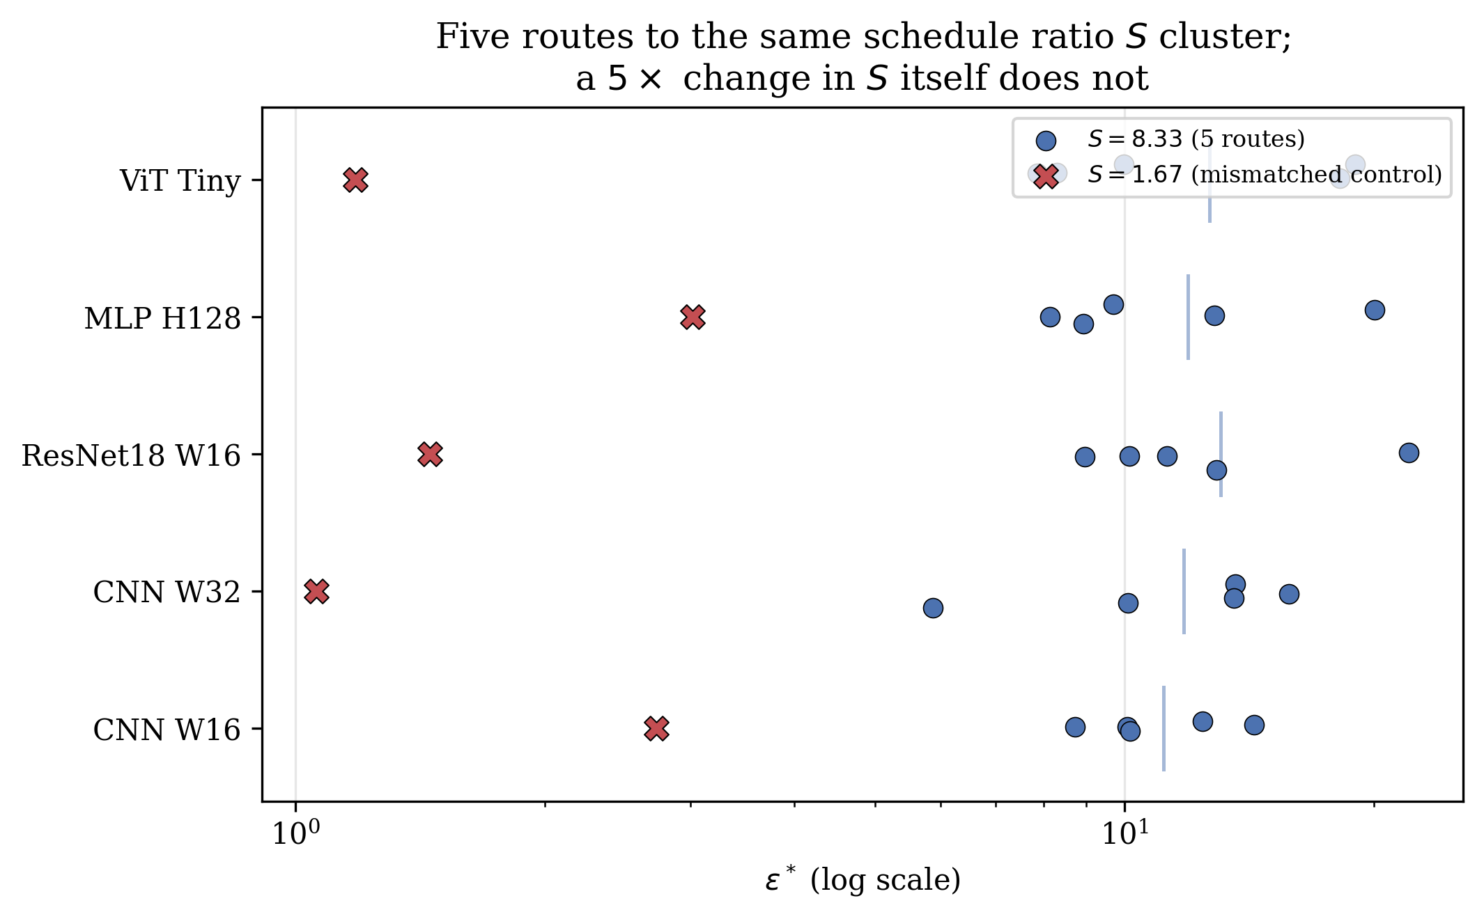
Figure 8: For each architecture, the five $S=8.33$ conditions (circles) cluster together while the $S=1.67$ mismatched control (X) sits well below the cluster on every architecture, log scale. The residual spread within each cluster (vertical bar marks the cluster mean) is real but small relative to the gap to the mismatched control.

13.2 Results
Table 8 and Figure 8 show a clear qualitative split. Within the five $S=8.33$ columns, $ε^{*}$ ranges roughly $6$–$22$ per architecture (CV $17.9\%$–$38.7\%$, mean $31.7\%$ across the five architectures): a real residual spread, not exact invariance, but far tighter than what any single schedule parameter produces on its own. The mismatched control, which changes only $η_{λ}$ by $5×$ (an $S$ change of the same $5×$ magnitude as the within-group perturbations, but applied to $S$ itself rather than cancelled against it), collapses $ε^{*}$ to $9$–$25\%$ of the matched-group mean (a $4$–$11×$ reduction, consistent in direction and magnitude with the eta_lambda$×5$ row of Table 2). $S$ is not a perfect invariant of $ε^{*}$, in the way architecture is approximately once the schedule itself is held fixed (Section 7), but it captures the dominant share of the schedule’s effect: three independently-chosen hyperparameters that each move $ε^{*}$ by more than an order of magnitude on their own (Section 5) reduce, once combined into $S$, to a quantity whose value alone predicts $ε^{*}$ to within roughly a factor of $2$–$3$ across five different architectures and three different routes to the same $S$.

13.3 Practical Upshot
This converts an intractable three-dimensional sensitivity into a single reportable ratio. A practitioner adopting FTR, or any Lagrangian-dual constrained continual-learning method with a periodically reset dual variable, does not need to separately justify $η_{λ}$, $λ_{init}$, and steps/task: reporting $S=λ_{init}/(η_{λ}N)$ alongside $ε^{*}$ captures most of what those three numbers jointly determine, and two runs with matched $S$ but different individual hyperparameters should be expected to land within roughly a factor of $2$–$3$ of each other, not the order-of-magnitude range Section 5 shows is possible when $S$ itself is left to vary. This work does not claim this closes the schedule-dependence problem entirely, the residual $18$–$39\%$ within-$S$ spread is real and architecture-dependent, but it is a substantial, practically useful reduction in dimensionality, and appears to be the first time this specific ratio has been identified and tested as the operative quantity in Lagrangian-dual constrained continual learning. $S$ is also not the complete schedule: Section 5 finds momentum $ρ$ has a smaller but real effect on $ε^{*}$ independent of $η_{λ}$, $λ_{init}$, and $N$, and is not part of $S$ by construction; some of the residual within-$S$ spread reported above is plausibly attributable to $ρ$ being held fixed rather than matched, which was not tested directly.

14 Interpretation and Theory

14.1 A Back-of-Envelope Account of $ε^{*}$
Section 5 showed $ε^{*}$ is dominated by the optimizer’s own schedule. This work now gives an approximate, testable account of why, and of why architecture-independence nonetheless survives at a fixed schedule.
Consider a task transition with warmup complete, $N$ constrained gradient steps remaining in the task’s budget, and dual-ascent momentum ignored for this first-order treatment ($ρ=0$; the EMA in Eq. 4 otherwise smooths but does not change the sign of the drift). If the model’s drift under the current $λ$ runs at an approximately constant rate $\overset{‾}{d}(λ)$ per step, the violation at each step is $\overset{‾}{d}(λ_{t})−ε$, and
$$λ_{t+1}≈λ_{t}+η_{λ}\left(\overset{‾}{d}(λ_{t})−ε\right).$$
Write $d_{unc}=\overset{‾}{d}(0)$, the drift rate the model would produce under no constraint (i.e. as $λ→0$), a property of the task and architecture, not the optimizer. If $ε>d_{unc}$, the violation is negative even at $λ=0$, so $λ$ decays monotonically from $λ_{init}$ and reaches 0 after approximately
$$t^{*}(ε)≈\frac{λ_{init}}{η_{λ} (ε−d_{unc})}$$
steps (treating $\overset{‾}{d}(λ_{t})≈d_{unc}$ near $λ≈0$, where the model is close to unconstrained). The task-level crossover occurs where the constraint’s disengagement time equals the step budget, $t^{*}(ε^{*})=N$, giving
$$ε^{*} ≈ d_{unc} + \frac{λ_{init}}{η_{λ}N}.$$
This single approximate expression explains both findings at once. First, the second term is a pure function of the dual-ascent schedule ($λ_{init}$, $η_{λ}$, $N$) and does not depend on architecture at all, consistent with Section 5’s finding that these three quantities dominate $ε^{*}$ and move it by more than an order of magnitude. Second, because this schedule term is identical across every architecture trained with the same hyperparameters, it automatically produces architecture-independence in $ε^{*}$ whenever the schedule is held fixed, regardless of how much $d_{unc}$ (the genuinely architecture-dependent term) varies, explaining why Section 6’s expanded zoo still shows family-level clustering rather than architecture-independence being destroyed outright: the clustering is exactly the residual $d_{unc}$ signal riding on top of a shared, schedule-determined baseline.
Equation 9 is only approximate (it ignores momentum, the EMA smoothing constant $β$, and treats $\overset{‾}{d}$ as constant in $λ$ rather than solving the coupled primal-dual dynamics self-consistently), so this research treats it as a mechanistic account, not a closed-form prediction, and check it against data rather than asserting it. With $λ_{init}=1.0$, $η_{λ}=0.005$: at $N=24$ (the diagnostic’s baseline, 4 epochs/task minus 1 warmup epoch, 8 batches/epoch), the schedule term is $1/(0.005×24)=8.33$; at $N=56$ (the $×2$ epochs/task condition), it is $1/(0.005×56)=3.57$, versus the observed $ε^{*}=3.25$–$3.66$ (Table 2), within $10\%$ using only the schedule term, no architecture correction at all. At $N=24$ (baseline), the schedule term $8.33$ under-predicts the observed $12.45$–$13.09$ by a $d_{unc}$ correction of $4.1$–$4.8$, comparable in magnitude to the schedule term itself rather than negligible, so while the schedule term dominates sensitivity (Section 5’s core finding), it does not always dominate the absolute value, and the architecture-dependent correction is real and worth taking seriously, which leads to a confound in this paper’s own zoo design.

14.2 Convergence-Theoretic Grounding for the Schedule Term
The $1/(η_{λ}N)$ scaling in Eq. 9 is not an arbitrary fit; it is the signature of a standard fact about dual ascent. For a concave dual function optimized by projected subgradient ascent with fixed step size $η_{λ}$, the sub-optimality of the dual iterate after $N$ steps decays at rate $O(1/(η_{λ}N))$ under standard step-size and boundedness conditions [Boyd and Vandenberghe, 2004, Nedić and Ozdaglar, 2009]; this is the same $O(1/T)$ behavior that underlies Eq. 8’s disengagement-time argument, just stated as a convergence-rate bound rather than a hitting-time calculation. Chamon et al. [2023] extend exactly this style of guarantee, near-PAC learnability and a bounded empirical duality gap under dual ascent, to the non-convex losses that neural-network training loss functions actually are, which is the setting FTR’s task loss and constraint fall into. Read together, their result establishes that a dual-ascent-enforced constraint on a non-convex loss converges to near-feasibility at a rate governed by $η_{λ}$ and the step budget rather than by problem-specific constants alone; the diagnostic sweep here (Section 5) is, in effect, an empirical demonstration that this generic rate dependence is large enough, in the specific regime FTR operates in, to dominate the architecture-dependent constants it is usually assumed to be secondary to. This work does not derive Eq. 9 as a formal corollary of their bound (that would require tracking the exact non-convex duality-gap constants through to a task-transition hitting time, which this work leaves as a natural extension), but the qualitative scaling, and the fact that Section 13 finds the schedule collapses to a single ratio rather than three independent effects, is exactly what generic dual-ascent convergence theory predicts, a connection the Lagrangian-dual continual-learning literature does not appear to have previously drawn out explicitly.

14.3 A Self-Inflicted Version of the Same Confound
Equation 9 makes a specific, checkable prediction about this paper’s own experimental design. The ViT and MLP-Mixer families in Section 4 were assigned 5 epochs/task rather than the 4 used for every other family (a well-intentioned accommodation for harder optimization at the time the zoo was built), giving them $N=32$ rather than $N=24$ constrained steps. Equation 9 predicts this alone should shift their $ε^{*}$ down by approximately $1/(0.005×24)−1/(0.005×32)=8.33−6.25=2.08$ relative to an epoch-matched comparison, before any genuine architectural difference is considered.
This research tested this directly: re-running all four affected architectures (ViT_Tiny, Mixer_Tiny, and the same mismatch on their wider siblings ViT_Small and Mixer_Small) with epochs forced to 4 (matching the CNN/ResNet/MLP family, 5 seeds, same dense $ε$ grid as Section 6). All four shift up substantially (Table 9): ViT_Tiny moves from $ε^{*}=7.31$ (5 epochs/task) to $10.18$ [$9.78,10.88$] (4 epochs/task, $R^{2}=0.93$), a shift of $+2.86$, close to the predicted $+2.08$. Mixer_Tiny moves from $6.10$ to $10.41$ [$8.76,11.75$] ($R^{2}=0.99$), a shift of $+4.30$. ViT_Small moves from $7.40$ to $12.43$ [$11.25,15.58$] ($R^{2}=0.98$), a shift of $+5.03$. Mixer_Small moves from $6.11$ to $10.63$ [$9.89,11.47$] ($R^{2}=0.98$), a shift of $+4.52$. All four shifts are in the predicted direction and, for three of four, exceed the back-of-envelope prediction of $+2.08$, consistent with the architectures also differing in genuine optimization difficulty at matched epoch count, on top of the schedule effect.
Table 9: Epoch-matched control: re-running the four 5-epoch/task architectures at 4 epochs/task, matching every other family.
Architecture | $ε^{*}$ (5 ep/task, as recorded) | $ε^{*}$ (4 ep/task, matched) | shift
ViT_Tiny | 7.31 | 10.18 [9.78, 10.88] | $+2.86$​
Mixer_Tiny | 6.10 | 10.41 [8.76, 11.75] | $+4.30$​
ViT_Small | 7.40 | 12.43 [11.25, 15.58] | $+5.03$​
Mixer_Small | 6.11 | 10.63 [9.89, 11.47] | $+4.52$​
Epoch-matched, all four land at $≈10.2$–$12.4$, inside the CNN/ResNet/MLP family’s range ($8.35$–$15.98$ across its 26 architectures) rather than systematically below it. The family clustering reported in Section 7.1 was therefore substantially, possibly almost entirely, an artifact of this paper’s own epoch/task mismatch, not a genuine effect of representational paradigm (convolution vs. attention vs. token-mixing), caught by holding this paper’s own zoo to Section 5’s own standard. Sections 7.1 and 7.2 are revised accordingly, substituting these four epoch-matched values for the confounded ones throughout the rest of the paper.

14.4 Why Curvature Still Fails to Predict $ε^{*}$
Equation 9 also clarifies why curvature-based normalization fails (Section 7): $ε^{*}$’s dominant term is a property of the optimizer, and its secondary term ($d_{unc}$) is the drift rate of unconstrained gradient descent measured in the KL-divergence output-space metric, not a parameter-space curvature quantity. A model’s Hessian trace or Fisher trace describes local loss-landscape curvature in parameter space; $d_{unc}$ describes how fast the model’s output distribution moves under gradient descent on a new task, which depends on parameter-space curvature only through a Jacobian that varies with architecture in a way that (per Section 7.4’s adequately-powered $n=30$ test) none of Hessian trace, Fisher trace, spectral norm, $d_{eff}$, or parameter count predicts. This is consistent with, and does not contradict, Lanzillotta et al. [2023]’s formal result that sharper minima require tighter parameter-space constraints: that result concerns parameter-space penalties (EWC-like), which is a different constraint geometry from the function-space KL ball studied here.

14.5 Why Parameter-Space Methods Fail to Show Transitions
EWC minimizes the unconstrained objective $L_{task}(θ)+\frac{λ}{2}(θ−θ_{old})^{⊤}F(θ−θ_{old})$, a soft penalty with no hard constraint boundary and no dual variable that can be driven to zero mid-task the way $λ$ can here. As $λ$ increases, forgetting decreases smoothly; there is no analogue of Eq. 8’s disengagement time, and hence no mechanism to produce a crossover. This is a structural property of soft penalties versus hard constraints with adaptive duals, independent of the diagnostic finding above.

15 Limitations
This work retains several limitations from v1 and adds new ones surfaced by this revision itself.
- The numeric value of $ε^{*}$ is schedule-conditional, not a hyperparameter-free constant. This is the paper’s central revision, not merely a caveat: Section 5 shows $ε^{*}$ moves by more than an order of magnitude under simple, reasonable changes to $η_{λ}$, $λ_{init}$, or steps/task. Any reuse of a reported $ε^{*}$ value from this paper (or any Lagrangian-dual constrained continual-learning method) on a different codebase should first check sensitivity to these three quantities, or to $S$ directly (Section 13), not assume architecture is the only relevant axis.
- Limited scope. All main experiments use CIFAR-10 and CIFAR-100 (Section 12); Tiny-ImageNet, CORe50, and CLEAR-style benchmarks remain untested. Model sizes in the from-scratch zoo ($≤2.8$M parameters) and per-task sample counts ($1,000$/class) are modest by contemporary standards, partially offset by the pretrained ViT-B/16 check (Section 9.1) but not by a systematic sweep at that scale.
- The theoretical account (Section 14) is approximate, not a closed-form derivation. Equation 9 ignores dual-ascent momentum and treats the drift rate as constant in $λ$; it matches the epochs/task sensitivity closely but under-predicts the baseline value by an amount comparable to the schedule term itself, so it should be read as a mechanistic account that generates testable predictions (Section 14.3), not an exact formula.
- No accuracy/SOTA comparison. Unchanged from v1: this work is diagnostic and mechanistic, not a proposal for a state-of-the-art continual-learning method, and FTR without replay does not exceed LwF on average accuracy in the from-scratch zoo.

16 Conclusion
This work set out to test a specific, previously unexamined confound in Lagrangian-dual constrained continual learning: because the dual variable $λ$ resets at every task boundary, the observed stability crossover of a function-space KL constraint could in principle be an artifact of the constrained optimizer’s own schedule rather than a property of the task or architecture it is applied to. It is. Holding architecture and task fixed, the dual learning rate, the initial multiplier, and the per-task step budget each move $ε^{*}$ by more than an order of magnitude, more than the $2.6×$ range $ε^{*}$ itself spans across 30 architectures, more than any other axis this work tested. A back-of-envelope mechanistic account (Eq. 9) explains both this sensitivity and why architecture-independence survives it: the dominant term in $ε^{*}$ is a pure function of the schedule, shared identically across every architecture trained with the same hyperparameters, while the smaller, genuinely architecture-dependent term is what curvature-based normalization has always tried and failed to capture.
That failure is real and, at the sample size this revision affords, now properly powered: across 30 architectures spanning five representational families, no tested curvature statistic predicts $ε^{*}$, extending v1’s claim from an $n=8$ test too underpowered to have supported it into an adequately powered one that does. What curvature does not predict, this paper’s own zoo design initially seemed to: ViT and MLP-Mixer sat systematically lower than CNN/ResNet/MLP, until applying the paper’s own central diagnostic to the paper’s own architecture zoo showed most of that gap was a second, self-inflicted instance of the identical schedule confound. This research reports this correction plainly, because catching it is a demonstration of the paper’s thesis, not a footnote to it: this class of confound is easy to introduce by accident and easy to miss without deliberately checking for it, and it recurred a third time in an experiment explicitly designed to probe task-structure sensitivity (Section 12.1).
The practical guidance this leaves practitioners of Lagrangian-relaxed, dual-ascent continual learning methods is the inverse of v1’s: architecture-specific tuning of the stability budget is not necessary, but the dual-ascent schedule is not a free implementation detail either, and checking sensitivity to $η_{λ}$, $λ_{init}$, and steps-per-task belongs in the standard reporting protocol for any method in this family, FTR included. Task ordering and the choice between task-incremental and class-incremental evaluation are further, genuine sources of variation this paper surfaces that v1’s single fixed ordering and single protocol could not. Open questions remain: what remains of the schedule-corrected residual family effect (Section 7.2 finds it small but not exactly zero, ICC$≈0.05$) traces to; whether $d_{unc}$ in Eq. 9 can be derived rather than measured; and whether the same confound structure applies to other Lagrangian-dual methods in continual learning beyond FTR [Chamon et al., 2023, Elenter et al., 2023]. This work regards the diagnostic protocol demonstrated here, vary the constrained optimizer’s own hyperparameters before attributing an observed threshold to the model or the task, as the paper’s most transferable contribution, independent of where any particular numeric value of $ε^{*}$ ultimately lands.

A Full Architecture Zoo and Crossover Table
Table 10 reports $ε^{*}$, its 95% bootstrap CI, sigmoid $R^{2}$, and sharpness $k$ for all 30 architectures, sorted by parameter count, exactly as originally recorded (5 epochs/task for ViT/Mixer, narrow $ε$ grid for every row) for a complete, unedited record of the raw campaign. Six of these thirty rows are superseded elsewhere in the paper and should not be used for any downstream analysis: ViT_Tiny, Mixer_Tiny, ViT_Small, and Mixer_Small by their epoch-matched values (Table 9), and ResNet18_W16 and ResNetLite_W8_NoBN by their wide-grid-relocated values (Section 6). Table 5, the hierarchical model of Section 7.2, and every downstream analysis use the corrected values for these six architectures. Table 11 reports the corresponding Hessian trace, Fisher trace, spectral norm, and $d_{eff}$ used in Section 7’s correlation analysis.
Table 10: Full 30-architecture crossover table (CIFAR-10, dense $ε$ sweep, 5 seeds per architecture, 10 for CNN_W16/CNN_W32).
Architecture | Family | Params | $ε^{*}$​ | 95% CI | $R^{2}$​ | $k$​
CNN_W8_NoBN | cnn | 36,866 | 21.45 | [18.57, 30.88] | 0.986 | 2.35
CNN_W8 | cnn | 36,946 | 11.72 | [10.11, 14.64] | 0.996 | 2.38
Mixer_Tiny | mixer | 45,442 | 6.10 | [5.88, 6.50] | 0.972 | 4.04
ViT_Tiny | vit | 74,562 | 7.31 | [6.35, 8.03] | 0.974 | 4.19
ResNetLite_W8_NoBN | resnet | 77,122 | 15.98 | [11.80, 135.91] | 0.783 | 2.67
ResNetLite_W8 | resnet | 77,482 | 10.46 | [8.18, 13.41] | 0.962 | 3.75
CNN_W16 | cnn | 80,418 | 10.80 | [10.03, 11.48] | 0.990 | 4.04
CNN_D4_W32 | cnn | 126,850 | 11.62 | [10.13, 13.32] | 0.970 | 2.98
CNN_W24 | cnn | 130,802 | 10.65 | [9.81, 11.69] | 0.977 | 4.14
CNN_D5_W32 | cnn | 135,042 | 10.10 | [9.24, 11.35] | 0.978 | 3.42
Mixer_Small | mixer | 136,466 | 6.11 | [5.63, 6.53] | 0.943 | 4.08
ResNet18_W8 | resnet | 175,882 | 13.76 | [10.98, 26.73] | 0.901 | 2.16
CNN_W32_NoBN | cnn | 187,778 | 11.70 | [10.85, 12.36] | 0.987 | 3.71
CNN_W32 | cnn | 188,098 | 10.62 | [9.33, 11.90] | 0.988 | 3.38
CNN_D3_W32 | cnn | 188,098 | 11.36 | [10.83, 12.34] | 0.992 | 4.39
ResNetLite_W16 | resnet | 307,794 | 11.41 | [8.93, 14.77] | 0.968 | 2.26
ViT_Small | vit | 310,562 | 7.40 | [6.65, 8.38] | 0.980 | 2.17
CNN_W48 | cnn | 323,426 | 11.08 | [9.96, 12.45] | 0.984 | 4.94
MLP_H128 | mlp | 410,114 | 14.56 | [13.74, 15.37] | 0.994 | 2.10
CNN_W64_NoBN | cnn | 485,762 | 11.64 | [10.99, 12.36] | 0.967 | 4.57
CNN_W64 | cnn | 486,402 | 11.18 | [10.37, 12.17] | 0.985 | 3.31
CNN_D2_W32 | cnn | 544,258 | 10.76 | [9.98, 11.65] | 0.983 | 3.57
ResNetLite_W24 | resnet | 690,938 | 8.35 | [6.60, 10.64] | 0.944 | 3.01
ResNet18_W16 | resnet | 700,434 | 14.59 | [9.65, 135.91] | 0.937 | 1.63
MLP_H256 | mlp | 852,994 | 12.52 | [11.82, 13.35] | 0.991 | 2.70
CNN_W96 | cnn | 895,298 | 11.10 | [10.56, 11.88] | 0.974 | 4.23
ResNetLite_W32 | resnet | 1,226,914 | 8.39 | [6.56, 9.71] | 0.977 | 2.66
CNN_W128 | cnn | 1,414,786 | 10.43 | [9.85, 10.94] | 0.979 | 3.84
ResNet18_W24 | resnet | 1,573,658 | 12.15 | [9.73, 25.01] | 0.927 | 2.29
ResNet18_W32 | resnet | 2,795,554 | 8.88 | [7.45, 11.84] | 0.947 | 2.33

Table 11: Curvature statistics for all 30 architectures (mean over 5 seeds, measured after Task 1 training, matching the protocol of Section 4.1).
Architecture | Params | $tr(H)$​ | $tr(F)$​ | Spectral norm | $d_{eff}$​
CNN_W8_NoBN | 36,866 | 118.9 | 0.926 | 78.8 | 1.51
CNN_W8 | 36,946 | 227.6 | 1.126 | 55.5 | 4.98
Mixer_Tiny | 45,442 | 124.2 | 0.253 | 18.5 | 7.05
ViT_Tiny | 74,562 | 312.4 | 3.776 | 132.8 | 2.30
ResNetLite_W8_NoBN | 77,122 | 93.0 | 1.069 | 70.1 | 1.36
ResNetLite_W8 | 77,482 | 951.8 | 2.238 | 133.1 | 8.74
CNN_W16 | 80,418 | 318.6 | 2.312 | 62.4 | 5.46
CNN_D4_W32 | 126,850 | 429.2 | 4.340 | 65.3 | 7.25
CNN_W24 | 130,802 | 309.6 | 2.098 | 62.6 | 5.33
CNN_D5_W32 | 135,042 | 391.7 | 1.577 | 39.5 | 10.77
Mixer_Small | 136,466 | 145.1 | 0.394 | 25.9 | 5.51
ResNet18_W8 | 175,882 | 3110.5 | 2.753 | 235.5 | 14.65
CNN_W32_NoBN | 187,778 | 79.7 | 1.361 | 50.4 | 1.62
CNN_W32 | 188,098 | 305.7 | 1.800 | 48.6 | 6.50
CNN_D3_W32 | 188,098 | 307.8 | 1.825 | 48.9 | 6.49
ResNetLite_W16 | 307,794 | 992.6 | 2.774 | 106.1 | 9.99
ViT_Small | 310,562 | 110.0 | 9.427 | 69.7 | 1.49
CNN_W48 | 323,426 | 203.5 | 1.085 | 35.8 | 5.70
MLP_H128 | 410,114 | 129.4 | 1.283 | 27.9 | 4.70
CNN_W64_NoBN | 485,762 | 98.0 | 5.718 | 52.8 | 1.89
CNN_W64 | 486,402 | 180.3 | 1.064 | 32.4 | 5.75
CNN_D2_W32 | 544,258 | 229.1 | 2.703 | 56.9 | 3.91
ResNetLite_W24 | 690,938 | 794.0 | 1.884 | 74.6 | 13.91
ResNet18_W16 | 700,434 | 1235.8 | 3.118 | 127.8 | 13.81
MLP_H256 | 852,994 | 161.8 | 1.153 | 37.7 | 4.40
CNN_W96 | 895,298 | 114.7 | 1.192 | 34.8 | 3.27
ResNetLite_W32 | 1,226,914 | 556.1 | 1.368 | 48.6 | 12.93
CNN_W128 | 1,414,786 | 147.5 | 0.659 | 40.3 | 3.72
ResNet18_W24 | 1,573,658 | 1013.2 | 2.920 | 55.0 | 19.87
ResNet18_W32 | 2,795,554 | 483.2 | 3.169 | 67.7 | 8.06

B SDPA Backend Workaround for Curvature Measurement
The Hutchinson Hessian-trace estimator and the power-iteration spectral-norm estimator both require a second derivative of the loss with respect to parameters (torch.autograd.grad with create_graph=True called twice). PyTorch’s default scaled-dot-product-attention kernel (dispatched internally by nn.MultiheadAttention, used by the ViT family) selects a fused backend whose backward pass is not itself twice-differentiable, raising derivative for aten::_scaled_dot_product_efficient_attention_backward is not implemented and failing 100% of curvature measurements for ViT_Tiny and ViT_Small in the initial run. Wrapping only the curvature-measurement forward/backward passes in torch.nn.attention.sdpa_kernel() (or the equivalent torch.backends.cuda.sdp_kernel context manager on older PyTorch versions) forces the plain, twice-differentiable attention implementation for those calls only; ordinary training is unaffected and continues to use the faster fused kernel. This recovered all 30 architectures for the correlation analysis in Section 7.

C LoRA Placement for the Pretrained-Backbone Check
Wrapping nn.MultiheadAttention’s out_proj submodule with a LoRA adapter has no effect at inference or training time: PyTorch’s nn.MultiheadAttention.forward does not call out_proj.forward() internally, it reads out_proj.weight and out_proj.bias directly inside a single fused functional attention call, so any wrapper module placed on out_proj is silently bypassed and never receives a forward or backward pass. This work initially wrapped attention projections along with the MLP sublayers in Section 9.1’s ViT-B/16 experiment, and only caught the bypass by checking gradient flow into the attention-side LoRA parameters directly (all zero), rather than trusting that instantiating the wrapper was sufficient. Restricting LoRA to the plain nn.Linear layers inside each transformer block’s MLP sublayer avoids the issue entirely, since nn.Linear.forward() is called normally; this is the configuration used to produce Table 7 ($737,280$ LoRA parameters out of $87,304,936$ total, $0.84\%$).

D Diagnostic Data and Code
Raw per-run results, the sigmoid/bootstrap/hierarchical-model analysis scripts, and the full experiment campaign code (architecture zoo, task construction, training engine, Kaggle orchestration) are available from the authors upon reasonable request.
Amari, S. 1998. Natural gradient works efficiently in learning. Neural Computation, 10, 251–276.
Bian, A., W. Li, H. Yuan, C. Yu, M. Wang, Z. Zhao, A. Lu, P. Ji, and T. Feng. 2024. Make continual learning stronger via C-Flat. Advances in neural information processing systems (NeurIPS).
Boyd, S., and L. Vandenberghe. 2004. Convex optimization. Cambridge University Press.
Buzzega, P., M. Boschini, A. Porrello, and S. Calderara. 2020. Dark experience for general continual learning: A strong, simple baseline. Advances in Neural Information Processing Systems (NeurIPS), 33.
Chamon, L. F. O., S. Paternain, M. Calvo-Fullana, and A. Ribeiro. 2023. Constrained learning with non-convex losses. IEEE Transactions on Information Theory, 69, 1739–1760.
Deng, D., G. Chen, J. Hao, Q. Wang, and P.-A. Heng. 2021. Flattening sharpness for dynamic gradient projection memory benefits continual learning. Advances in Neural Information Processing Systems (NeurIPS), 34.
Draxler, F., K. Veschgini, M. Salmhofer, and F. Hamprecht. 2018. Essentially no barriers in neural network energy landscape. International conference on machine learning (ICML), 1309–1318.
Elenter, J., L. F. O. Chamon, and A. Ribeiro. 2024. Near-optimal solutions of constrained learning problems. International conference on learning representations (ICLR).
Elenter, J., N. NaderiAlizadeh, T. Javidi, and A. Ribeiro. 2023. Primal dual continual learning: Balancing stability and plasticity through adaptive memory allocation. arXiv preprint arXiv:2310.00154.
Frankle, J., and M. Carbin. 2019. The lottery ticket hypothesis: Finding sparse, trainable neural networks. International conference on learning representations (ICLR).
Frankle, J., G. K. Dziugaite, D. M. Roy, and M. Carbin. 2020. Linear mode connectivity and the lottery ticket hypothesis. International conference on machine learning (ICML), 3259–3269.
Garipov, T., P. Izmailov, D. Podoprikhin, D. P. Vetrov, and A. G. Wilson. 2018. Loss surfaces, mode connectivity, and fast ensembling of DNNs. Advances in neural information processing systems (NeurIPS).
Ghorbani, B., S. Krishnan, and Y. Xiao. 2019. An investigation into neural net optimization via Hessian eigenvalue density. International conference on machine learning (ICML), 2232–2241.
Hazan, E. 2019. Introduction to online convex optimization. MIT Press.
Hounie, I., A. Ribeiro, and L. F. O. Chamon. 2023. Resilient constrained learning. Advances in Neural Information Processing Systems (NeurIPS), 36.
Keskar, N. S., D. Mudigere, J. Nocedal, M. Smelyanskiy, and P. T. P. Tang. 2017. On large-batch training for deep learning: Generalization gap and sharp minima. International conference on learning representations (ICLR).
Khilar, S. C. 2026. Continual learning as a multiphase moving-boundary problem. arXiv preprint arXiv:2606.01863.
Kingma, D. P., and J. Ba. 2015. Adam: A method for stochastic optimization. International conference on learning representations (ICLR).
Kirkpatrick, J., R. Pascanu, N. Rabinowitz, J. Veness, G. Desjardins, A. A. Rusu, K. Milan, J. Quan, T. Ramalho, A. Grabska-Barwinska, et al. 2017. Overcoming catastrophic forgetting in neural networks. Proceedings of the National Academy of Sciences, 114, 3521–3526.
Krizhevsky, A. 2009. Learning multiple layers of features from tiny images. University of Toronto.
Lanzillotta, G., S. P. Singh, B. F. Grewe, and T. Hofmann. 2023. Towards guarantees for parameter isolation in continual learning. arXiv preprint arXiv:2310.01165.
Lewandowski, A., M. Bortkiewicz, S. Kumar, A. György, M. Ostaszewski, D. Schuurmans, and M. C. Machado. 2025. Learning continually by spectral regularization. International conference on learning representations (ICLR).
Lewandowski, A., H. Tanaka, D. Schuurmans, and M. C. Machado. 2023. Directions of curvature as an explanation for loss of plasticity. arXiv preprint arXiv:2312.00246.
Li, H., Z. Xu, G. Taylor, C. Studer, and T. Goldstein. 2018. Visualizing the loss landscape of neural nets. Advances in Neural Information Processing Systems (NeurIPS), 31.
Li, Z., and D. Hoiem. 2017. Learning without forgetting. IEEE Transactions on Pattern Analysis and Machine Intelligence, 40, 2935–2947.
Lopez-Paz, D., and M. Ranzato. 2017. Gradient episodic memory for continual learning. Advances in Neural Information Processing Systems (NeurIPS), 30.
Martens, J., and R. Grosse. 2015. Optimizing neural networks with Kronecker-factored approximate curvature. International conference on machine learning (ICML), 2408–2417.
McCloskey, M., and N. J. Cohen. 1989. Catastrophic interference in connectionist networks: The sequential learning problem. Psychology of Learning and Motivation, 24, 109–165.
Nedić, A., and A. Ozdaglar. 2009. Subgradient methods for saddle-point problems. Journal of Optimization Theory and Applications, 142, 205–228.
Novak, R., Y. Bahri, D. A. Abolafia, J. Pennington, and J. Sohl-Dickstein. 2018. Sensitivity and generalization in neural networks: An empirical study. International conference on learning representations (ICLR).
Pan, P., S. Swaroop, A. Immer, R. Eschenhagen, R. E. Turner, and M. E. Khan. 2020. Continual deep learning by functional regularisation of memorable past. Advances in Neural Information Processing Systems (NeurIPS), 33.
Power, A., Y. Burda, H. Edwards, I. Babuschkin, and V. Misra. 2022. Grokking: Generalization beyond overfitting on small algorithmic datasets. arXiv preprint arXiv:2201.02177.
Rakhlin, A., K. Sridharan, and A. Tewari. 2012. Online learning: Random averages, combinatorial parameters, and learnability. Journal of Machine Learning Research, 13, 2599–2633.
Riemer, M., I. Cases, R. Ajemian, M. Liu, I. Rish, Y. Tu, and G. Tesauro. 2019. Learning to learn without forgetting by maximizing transfer and minimizing interference. International conference on learning representations (ICLR).
Ritter, H., A. Botev, and D. Barber. 2018. Online structured laplace approximations for overcoming catastrophic forgetting. Advances in Neural Information Processing Systems (NeurIPS), 31.
Robins, A. 1995. Catastrophic forgetting, rehearsal and pseudorehearsal. Connection Science, 7, 123–146.
Rusu, A. A., N. C. Rabinowitz, G. Desjardins, H. Soyer, J. Kirkpatrick, K. Kavukcuoglu, R. Pascanu, and R. Hadsell. 2016. Progressive neural networks. arXiv preprint arXiv:1606.04671.
Schulman, J., S. Levine, P. Abbeel, M. Jordan, and P. Moritz. 2015. Trust region policy optimization. International conference on machine learning (ICML), 1889–1897.
Schulman, J., F. Wolski, P. Dhariwal, A. Radford, and O. Klimov. 2017. Proximal policy optimization algorithms. arXiv preprint arXiv:1707.06347.
Serrà, J., D. Surís, M. Miron, and A. Karatzoglou. 2018. Overcoming catastrophic forgetting with hard attention to the task. International conference on machine learning (ICML), 4548–4557.
Shalev-Shwartz, S. 2012. Online learning and online convex optimization. Foundations and Trends in Machine Learning, 4, 107–194.
Shin, H., J. K. Lee, J. Kim, and J. Kim. 2017. Continual learning with deep generative replay. Advances in Neural Information Processing Systems (NeurIPS), 30.
Tamai, K., T. Okubo, T. V. T. Duy, N. Natori, and S. Todo. 2025. Universal scaling laws of absorbing phase transitions in artificial deep neural networks. Physical Review Research, 7, 033072.
Titsias, M. K., J. Schwarz, A. G. de G. Matthews, R. Pascanu, and Y. W. Teh. 2020. Functional regularisation for continual learning with Gaussian processes. International conference on learning representations (ICLR).
Wang, P. 2026. Grokking as dimensional phase transition in neural networks. arXiv preprint arXiv:2604.04655.
Zenke, F., B. Poole, and S. Ganguli. 2017. Continual learning through synaptic intelligence. International conference on machine learning (ICML), 3987–3995.

