Assignment 1
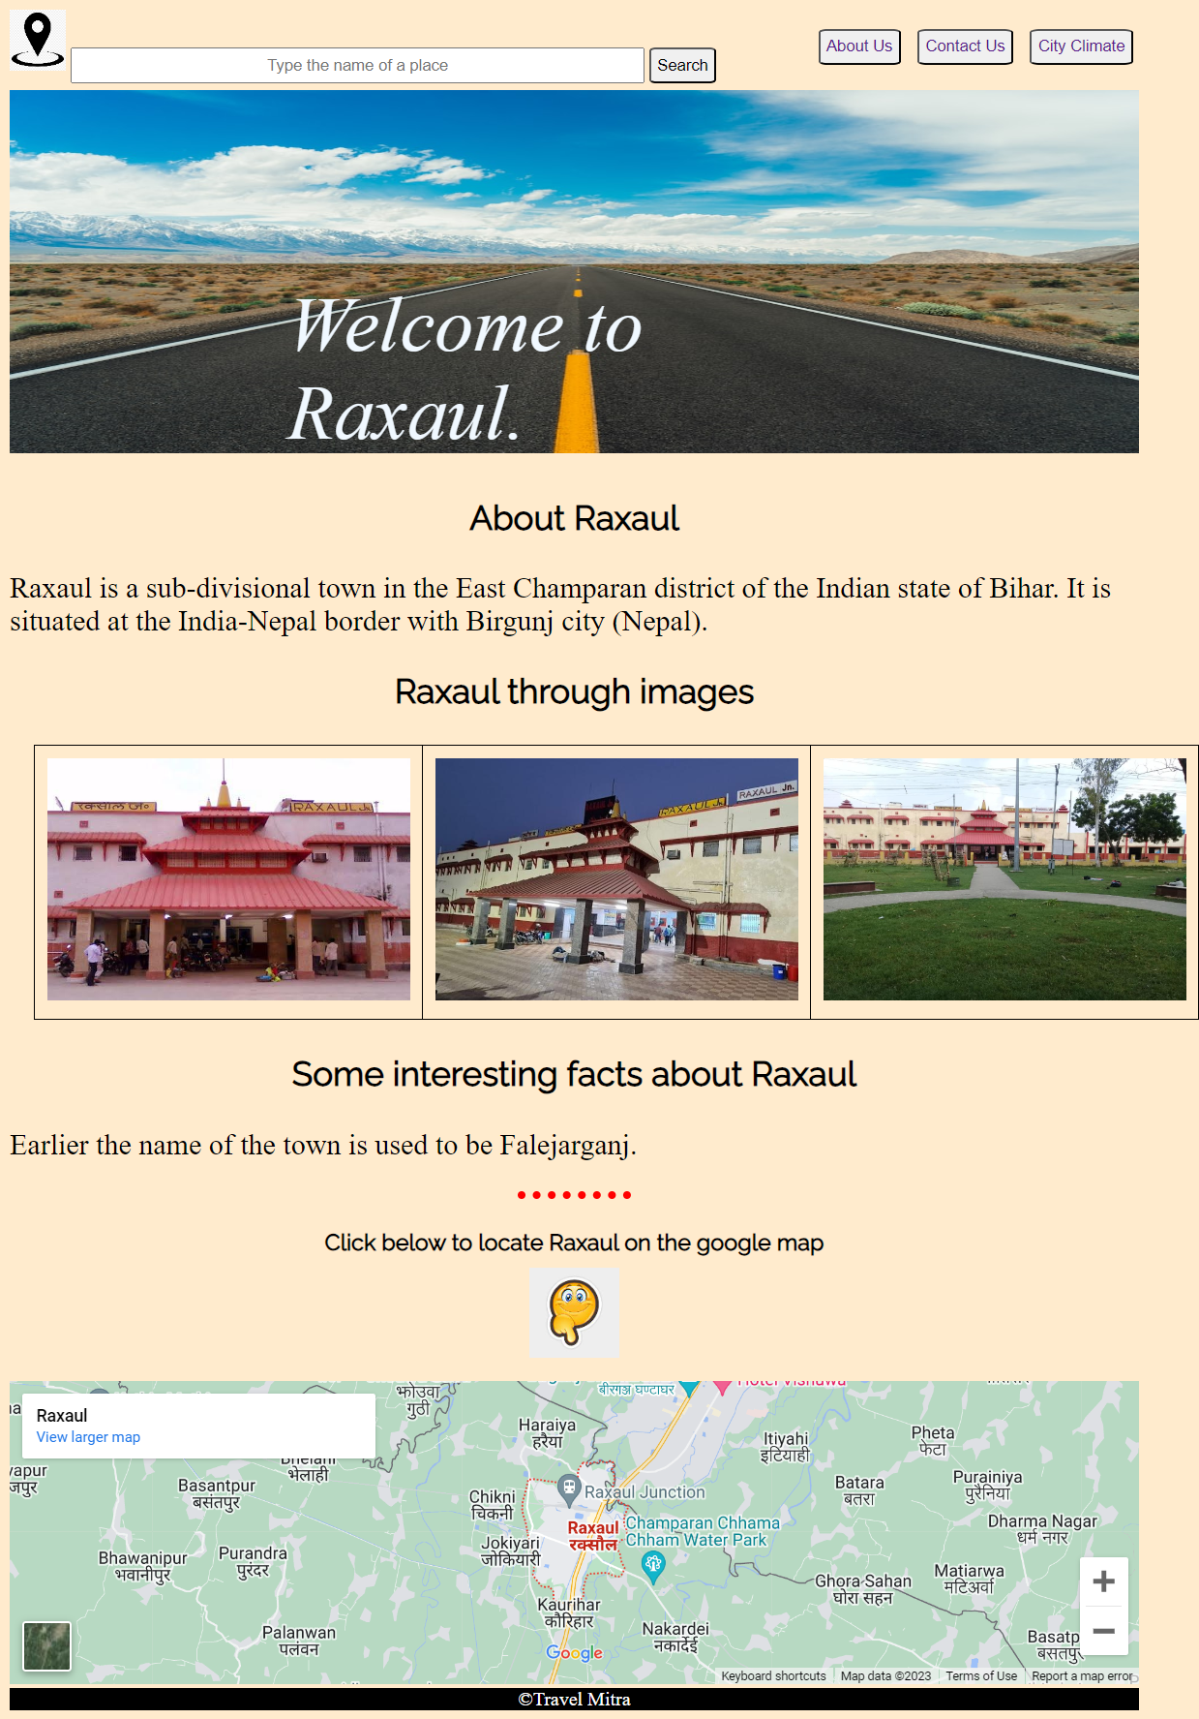
The project contains a webpage for a travel company describing details about my city. It contains links for 3 more pages, which are contactUs.html, aboutUs.html and cityClimate.html. Further the home page contains a search box, title image along with image title. In the next section city description is given, which includes some details about the city, some images of the city and an inline frame showing google map location of the city. At last there is a footer containing copyright of the company.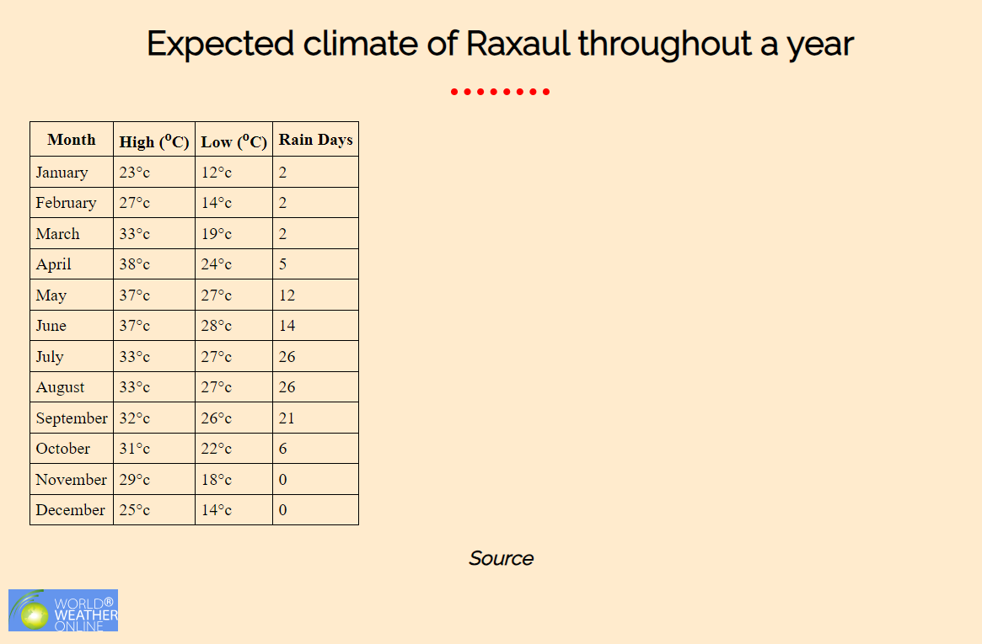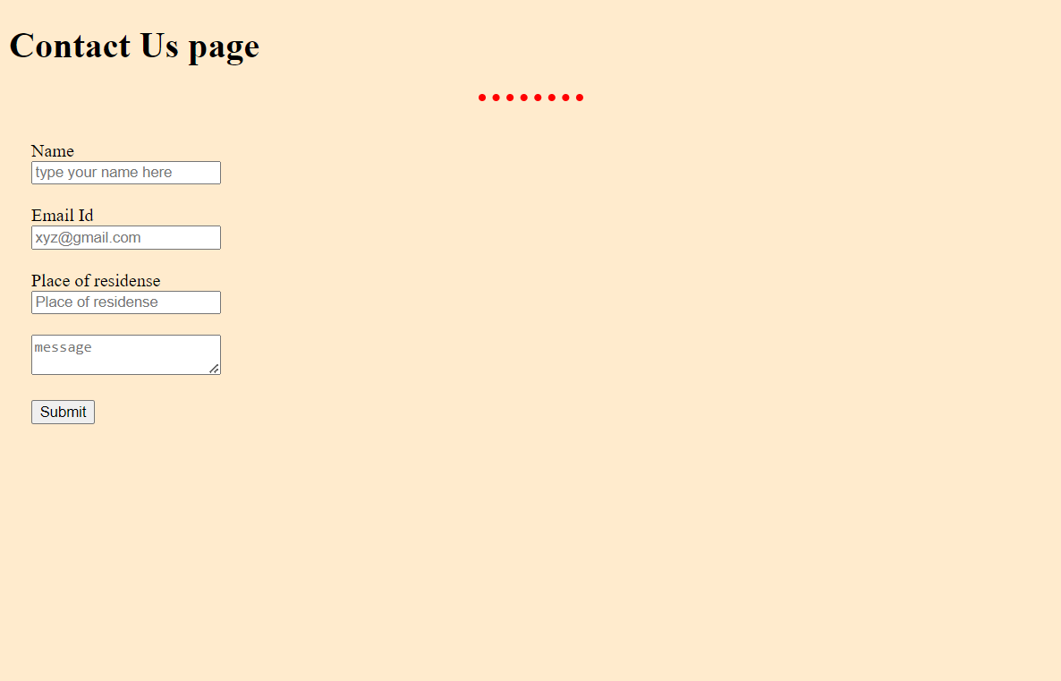 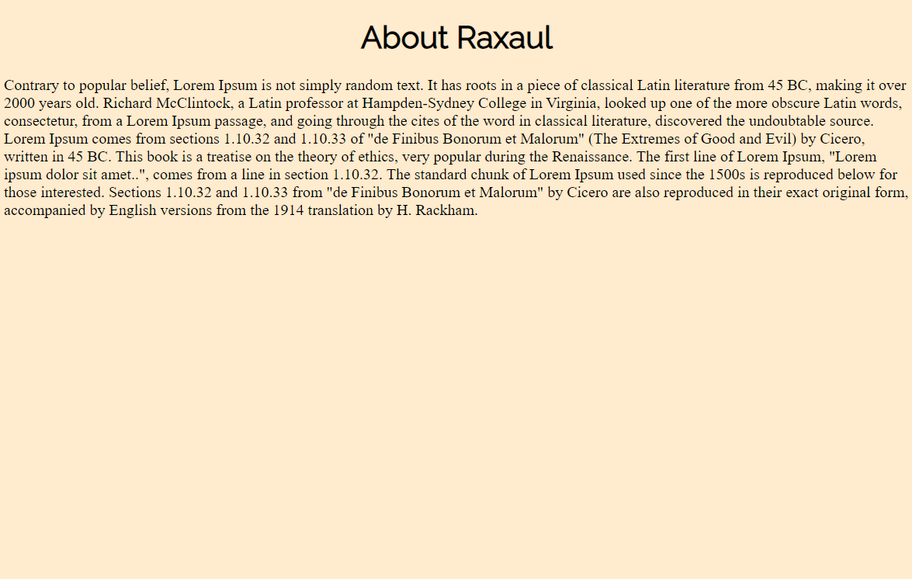
About page contains a heading a dummy para.
Contact us page contains a submit form contining text inputs, email input, a text area and a submit button.
City climage page contains a headinga a table showing expected climate of the city thoroughout a year. Sourse of the data is also included via its hyperlink.
Technology used: HTML and CSS (added externaly inside the <head> tag.
Tools used: Google fonts using its CDN, google map iframe. <div> tags and CSS selectors have been used to separate different sections of the webpage and desigen them individually.
Thank you !!

