Now in this project I added helmet detection from videos also and this video helmet detection will give 90% correct detection rate and 10% may be wrong detected as some people may have bald head or due to video quality. To run code double click on ‘run.bat’ file to get below screen and first 3 button execution same as old screen shots with images and fourth button is for video helmet detection

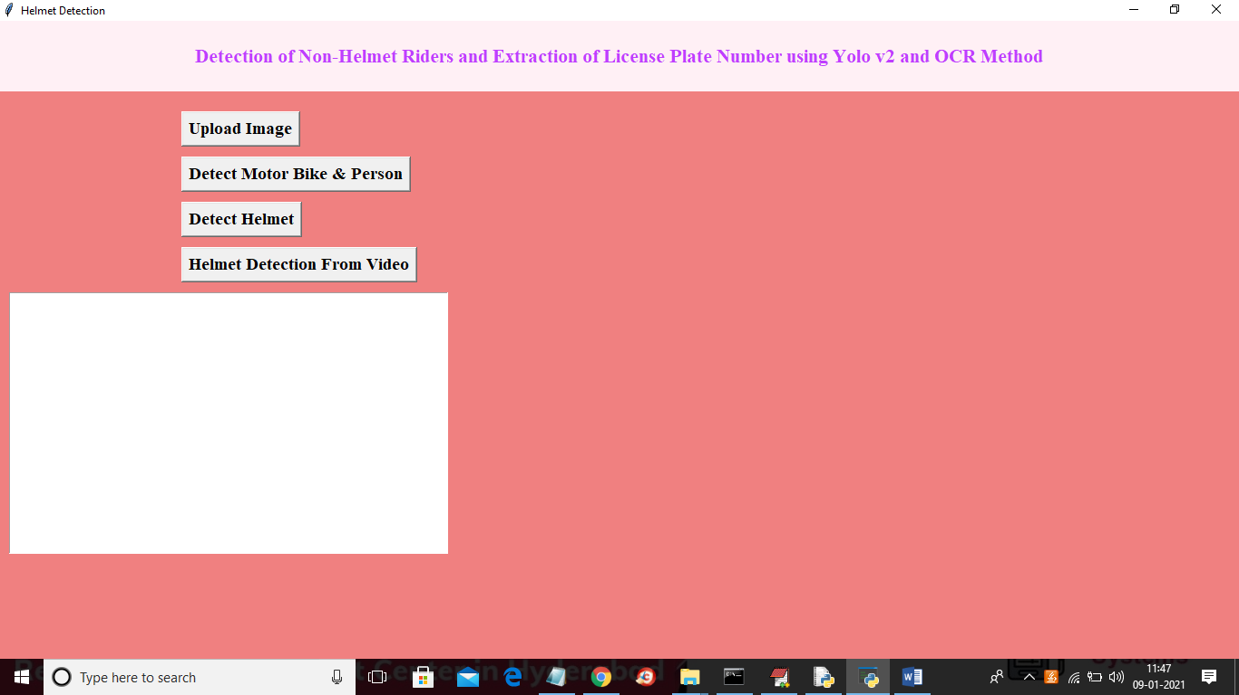

In above screen click on ‘Helmet Detection from Video’ button and upload video

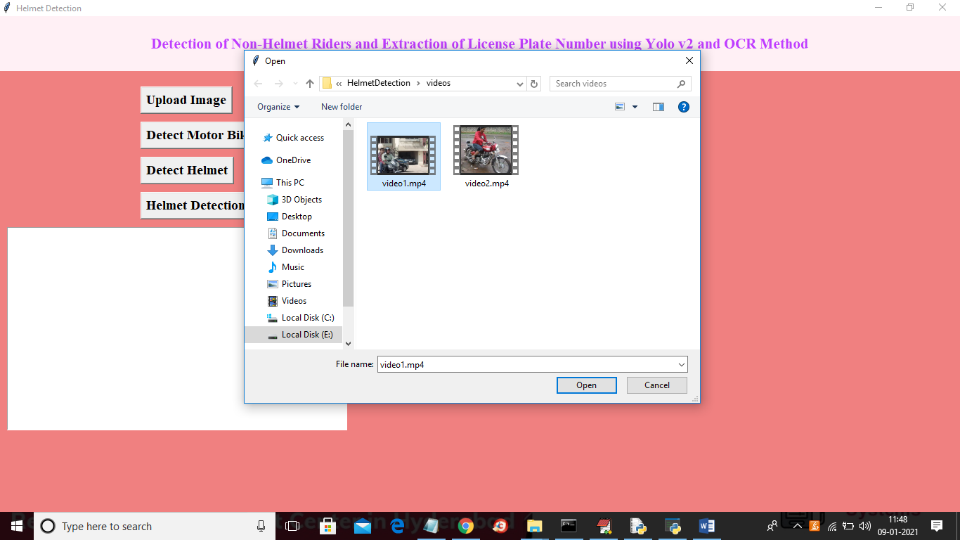

In above screen selecting and uploading video1.mp4 and after few seconds video processing will start to detect helmet



In above screen if helmet detected then it will display helmet label with matching percentage value

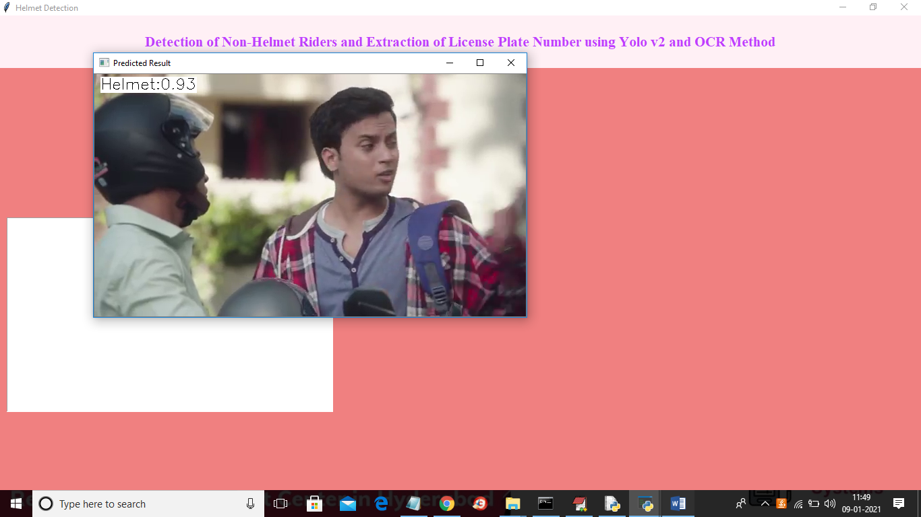

In above screen video keep on playing and the helmet will detect with bike person and now below screen will upload another video

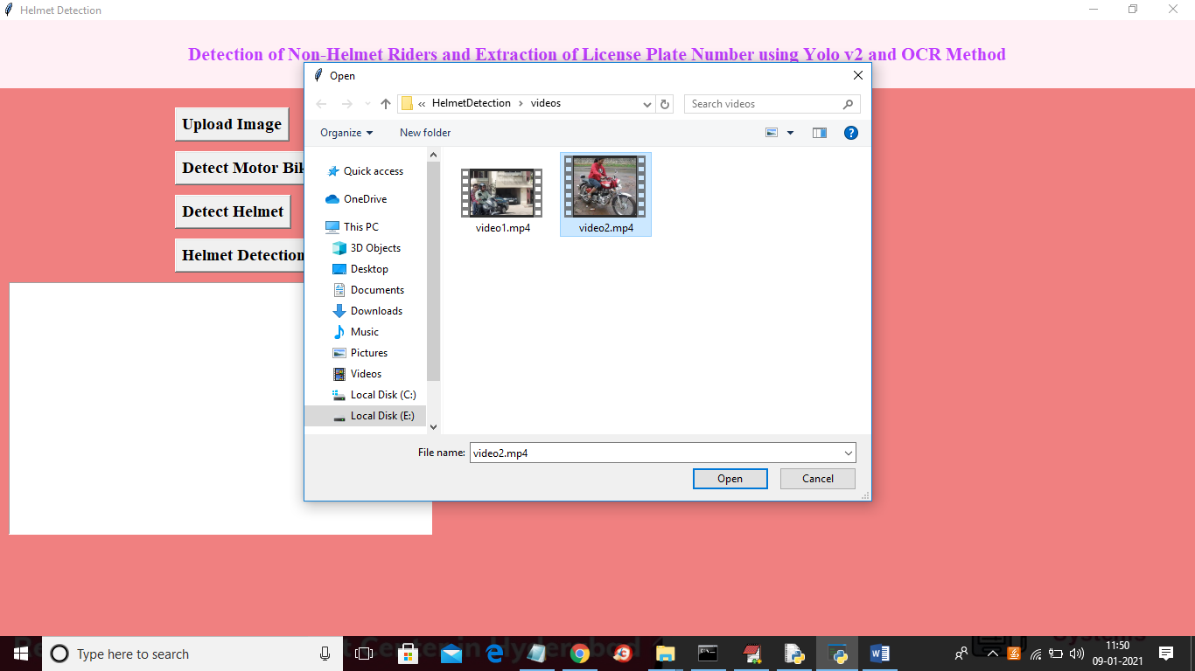

In above screen uploading second video and below is the detection result

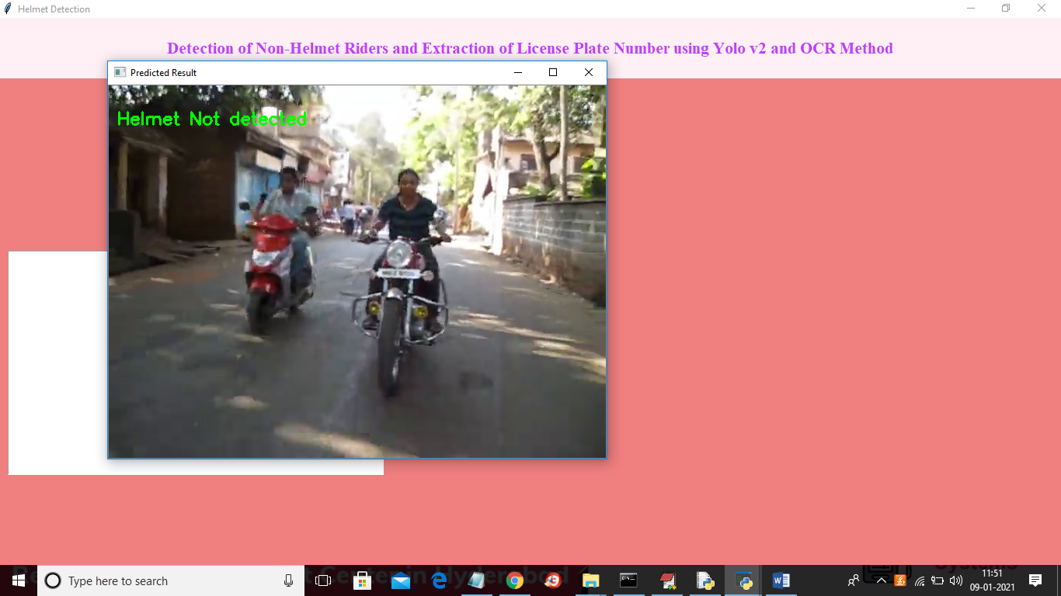

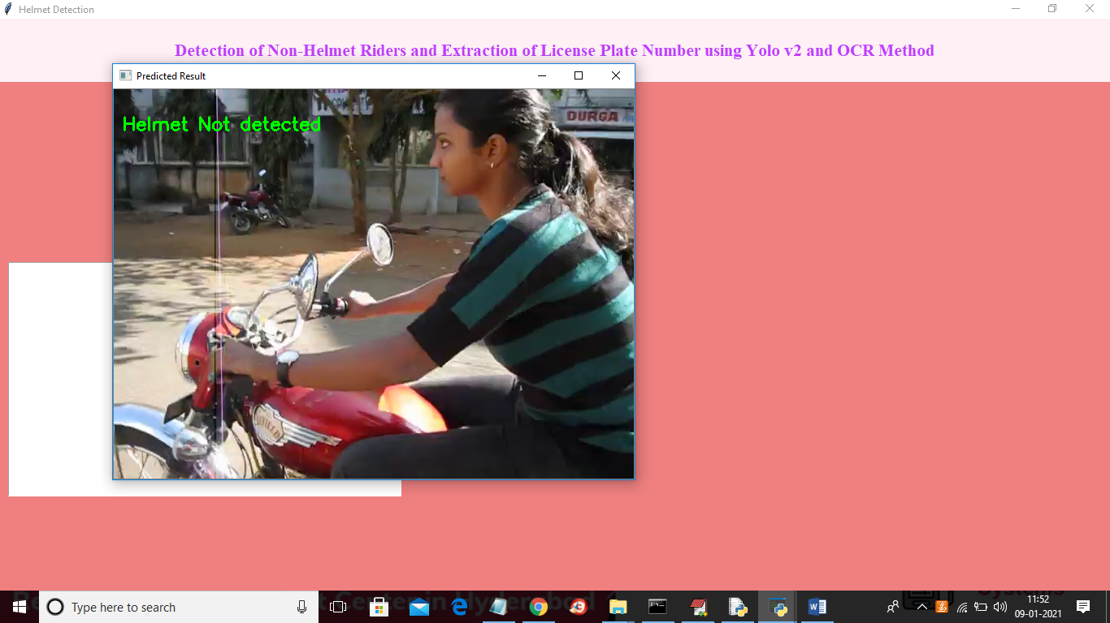

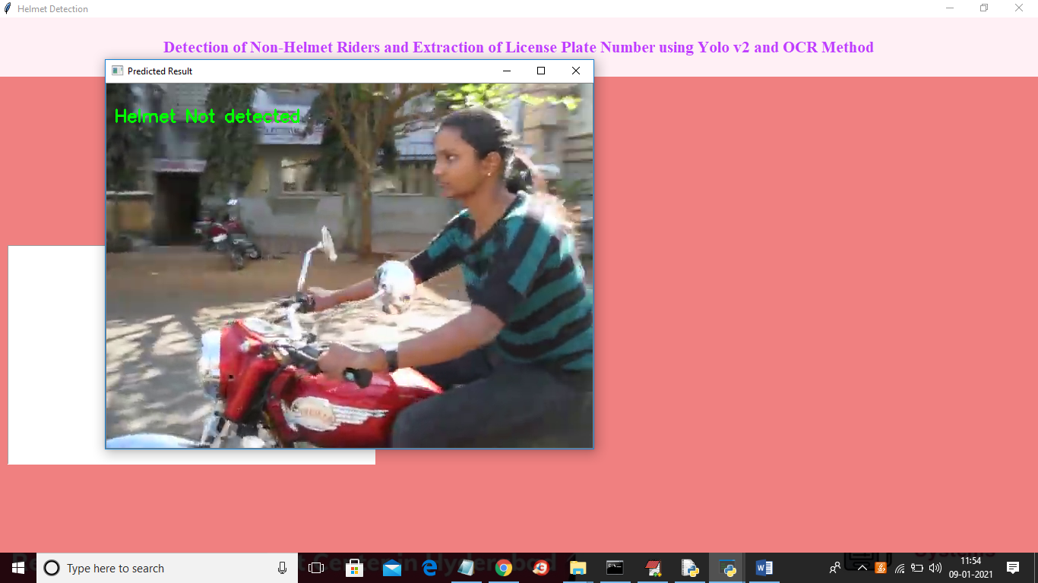

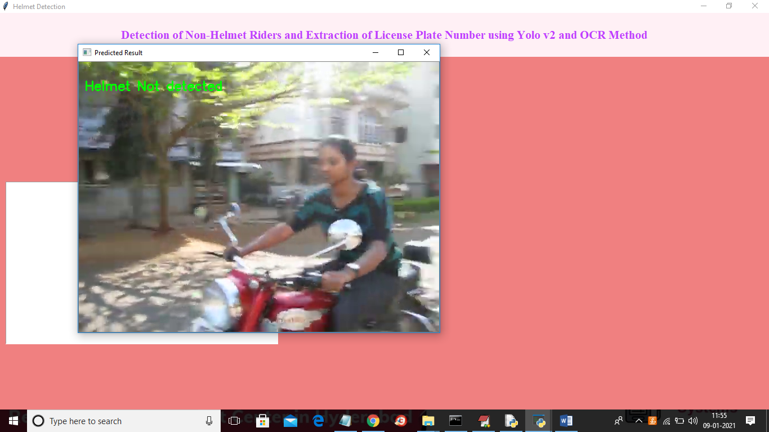

Due to processing video will be played slowly