Detection of Non-Helmet Riders and Extraction of License Plate Number using Yolo v2 and OCR Method

In this project we are detecting whether two wheeler rider wearing helmet or not, if he is not wearing helmet then we are extracting number plate of that two wheeler. To extract number plate we have YOLO CNN model with some train and test images and if you want to add some other images then send those images to us so we can include those images in YOLO model with annotation to extract number plate of those new images.

To implement above technique we are following or implemented below modules

1. First image will be upload to the application and the using YOLOV2 we will check whether image contains person with motor bike or not, if YOLO model detect both person and motor bike then we will proceed to step 2.
2. In this module we will use YOLOV3 model to detect whether object wear helmet or not, if he wear helmet then application will stop hear itself. If rider not wear helmet then application proceed to step 3.
3. In this module we will extract number plate data using python tesseract OCR API. OCR will take input image and then extract vehicle number from it.

To run this project install python 3.7 and please don’t use ANACONDA and using pip install require packages. Then install ‘tesseract-ocr-setup-3.02.02.exe’ which I am sending with this code.

After installing tesseract follow below steps to set path for tesseract. Right click on your laptop ‘my computer’ and choose ‘Properties’ and then click on ‘Advance system settings’ and then click on ‘environment variables’ and then under ‘System Variables’ click on ‘New’ button and then enter below values

Variable name : tesseract

Variable value = C:\Tesseract-OCR\tesseract.exe

Install packages using below command

Pip install numpy

pip install pytesseract

pip install opencv-python

After setting path double click on ‘run.bat’ file to run project and to get below screen

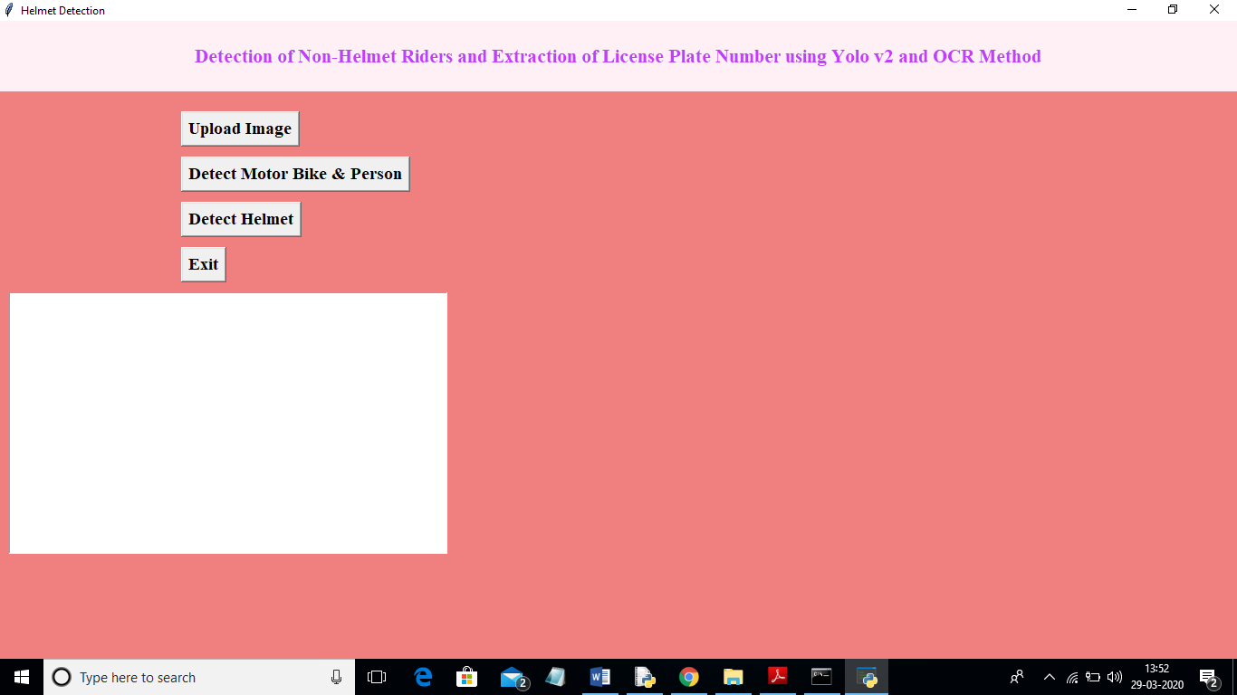

In above screen click on ‘Upload Image’ button and upload image

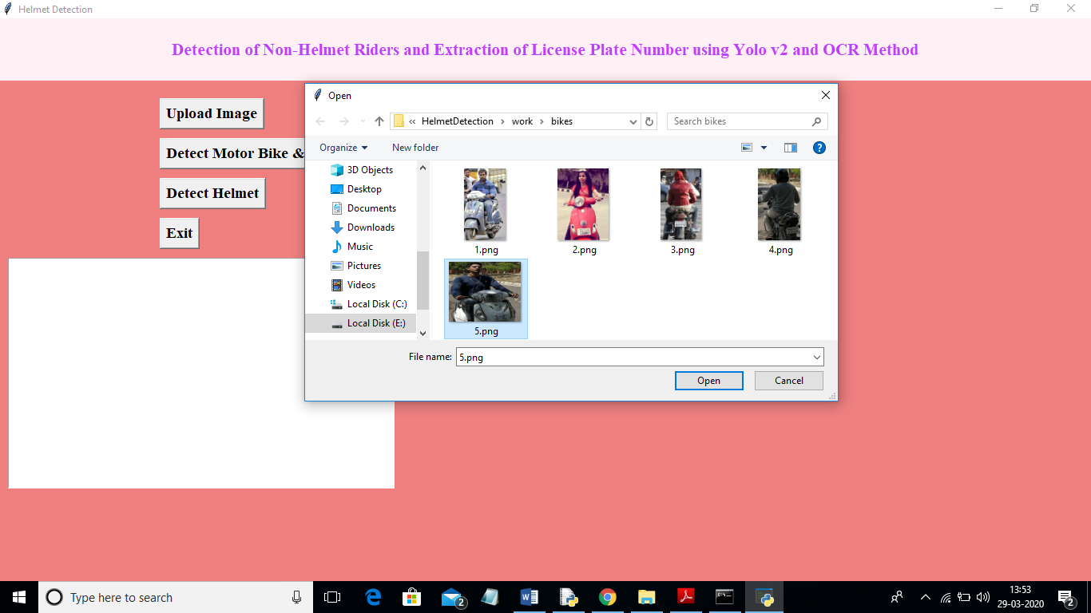

In above screen I selected one image as ‘5.png’ and click on ‘Open’ button to load image. Now click on ‘Detect Motor Bike & Person’ button to detect whether image contains person with motor bike or not

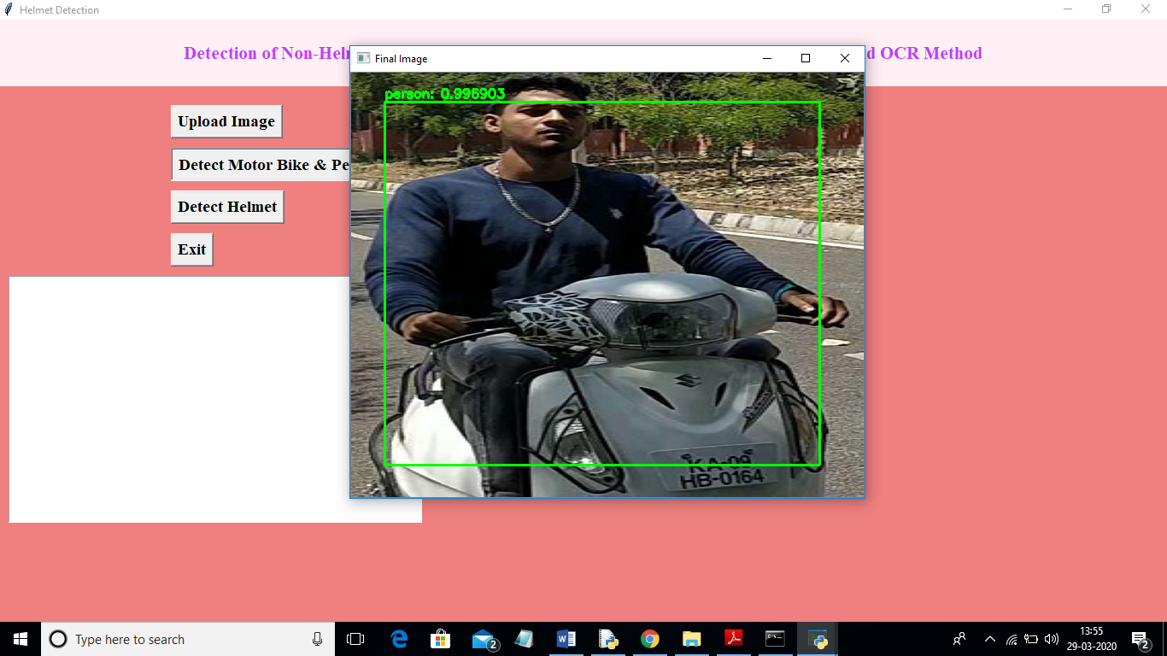

In above screen yolo detected image contains person and bike and now click on ‘Detect Helmet’ button to detect whether he is wearing helmet or not

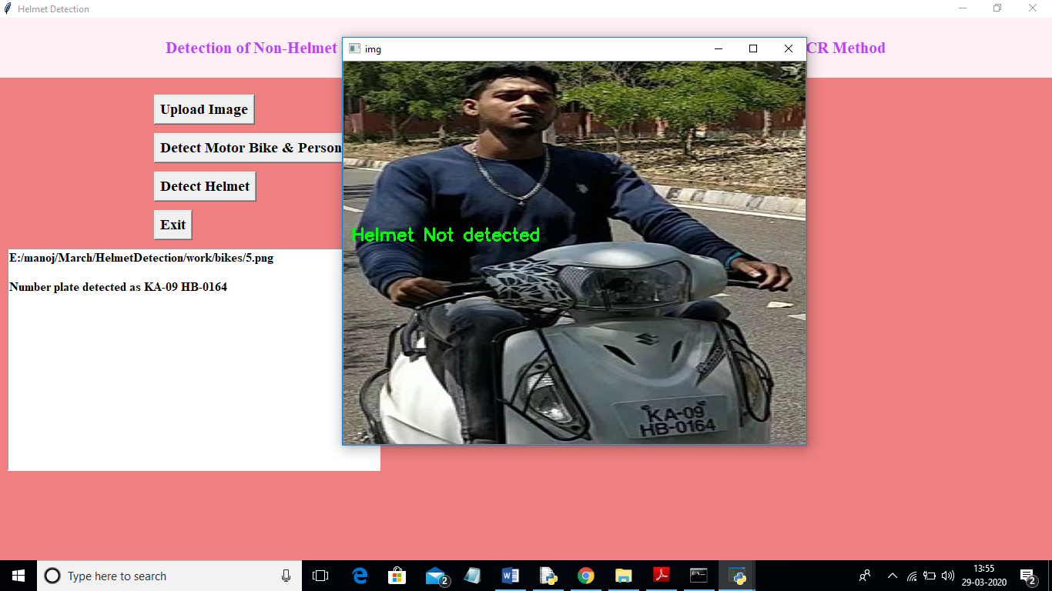

In above screen application detected that person is not wearing helmet and its extracted number from vehicle and display in beside text area. Now we will check with helmet image

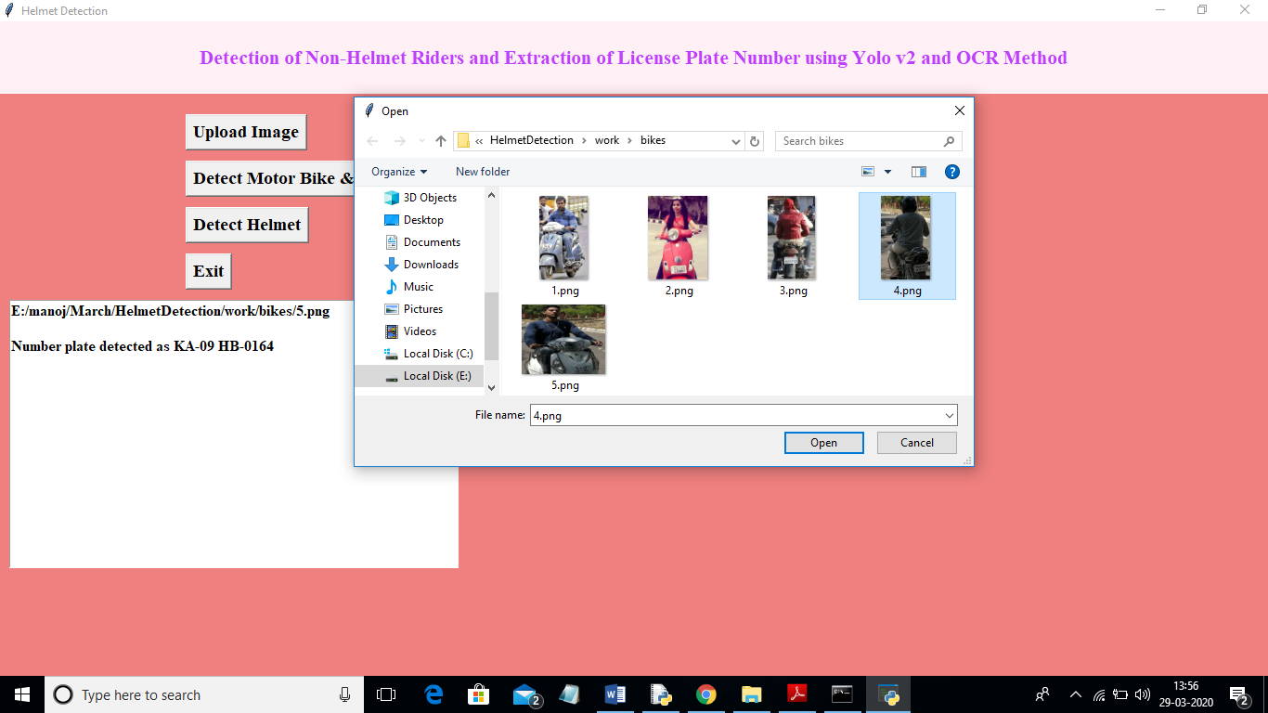

In above screen I am uploading 4.png which is wearing helmet and now click on ‘Detect Motor Bike & Person’ button to get below result

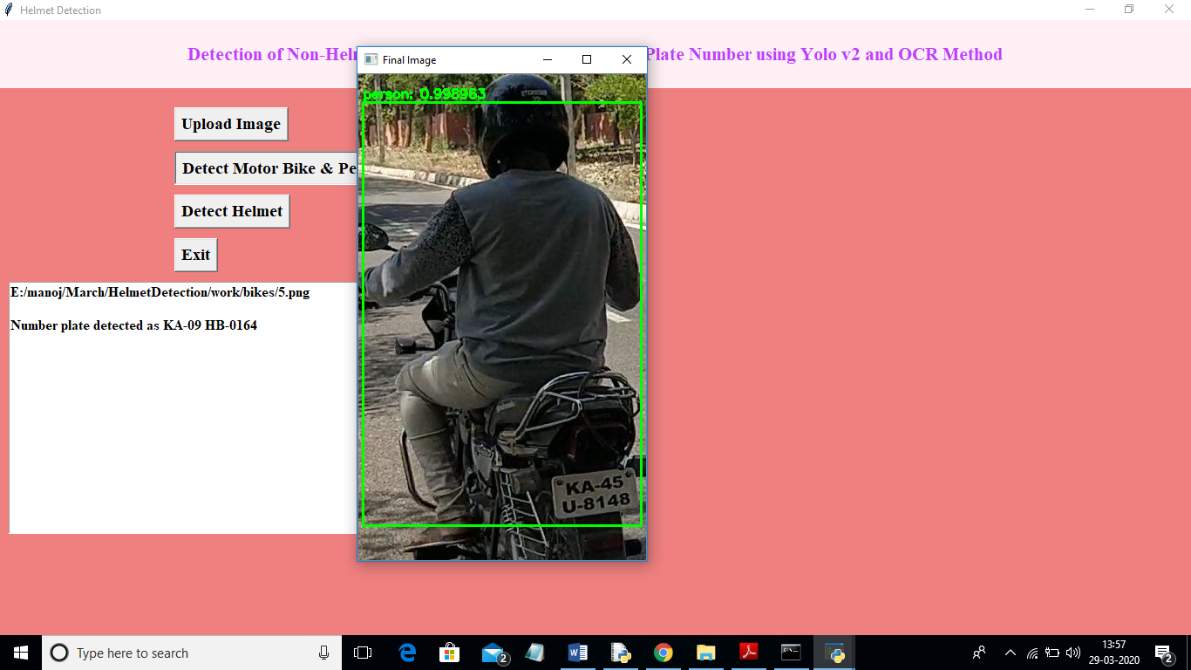

In above screen yolo detected person with motor bike and now click on ‘Detect Helmet’ button to get below result

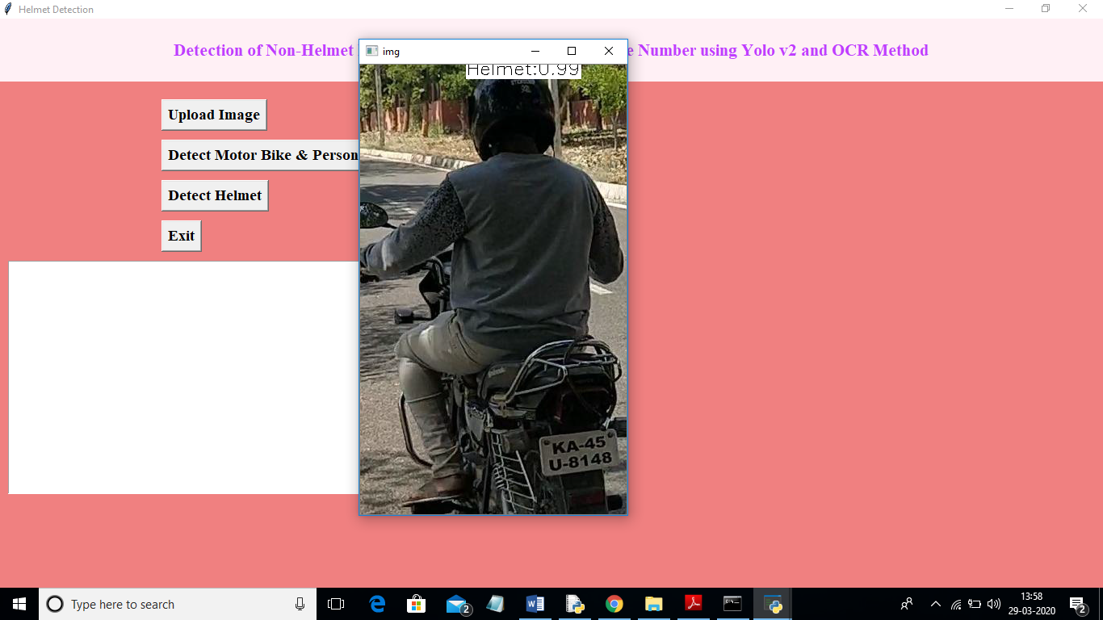

In above screen application detected person is wearing helmet and that label is displaying around his head and application stop there itself and not scanning number plate.

Note: To implement this project and to extract number plate we have trained few images and if u want to extract for new images then send those new images to us, so we include those images in yolo model to extract new images number plate also.