1. Alpha=0 Forward Euler  
   Quad Element (tsteps=10):-  
   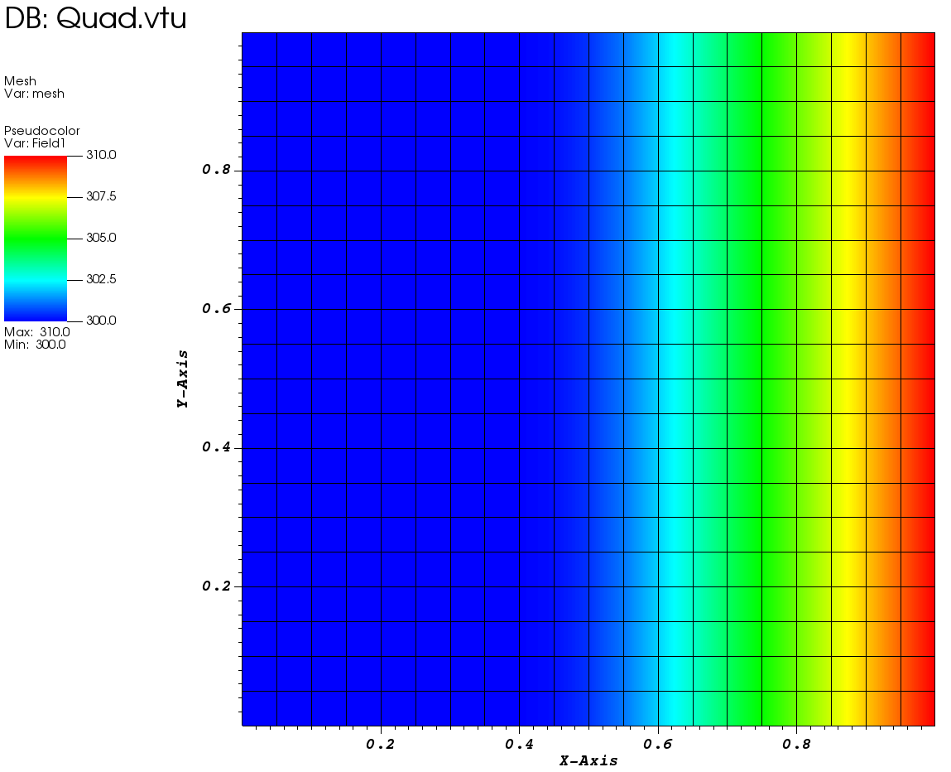  
   Alpha=0 Forward Euler  
   Quad Element (tsteps=25):-  
   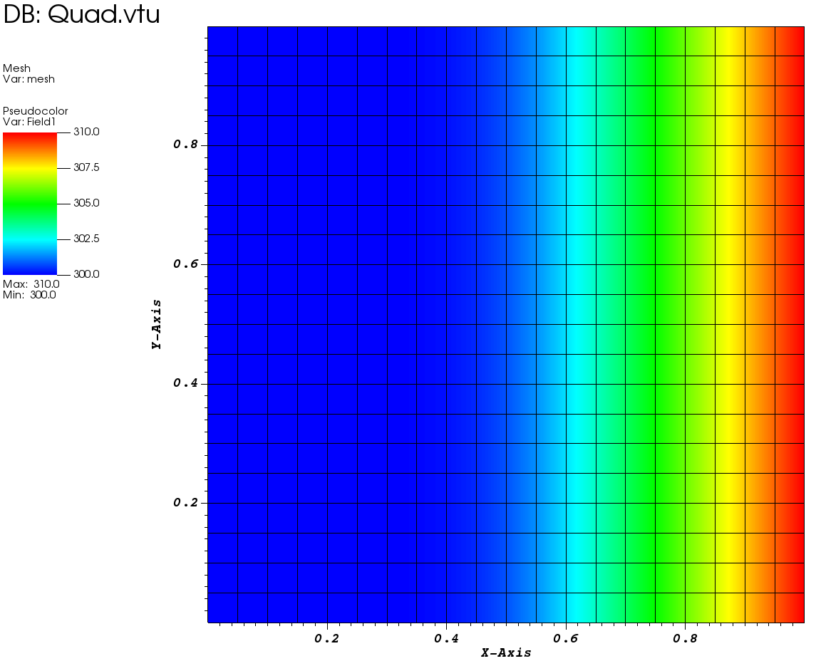  
   Alpha=0 Forward Euler  
   Quad Element (tsteps=100):-  
   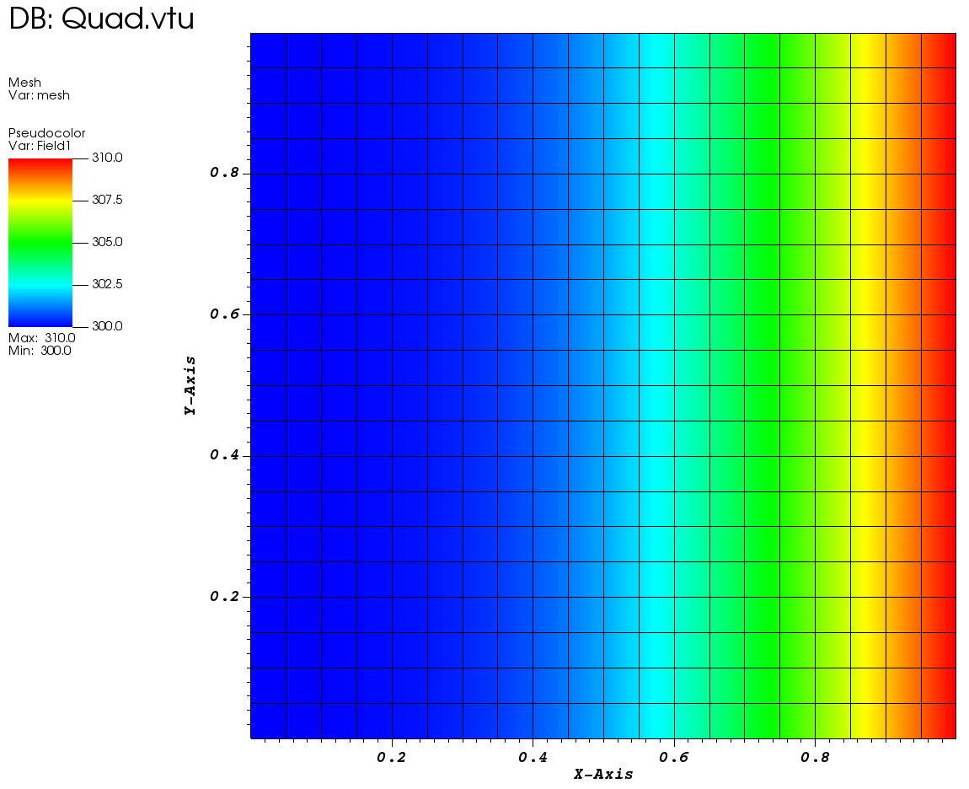  
   Alpha=0 Forward Euler  
   Quad Element (tsteps=1000):-  
   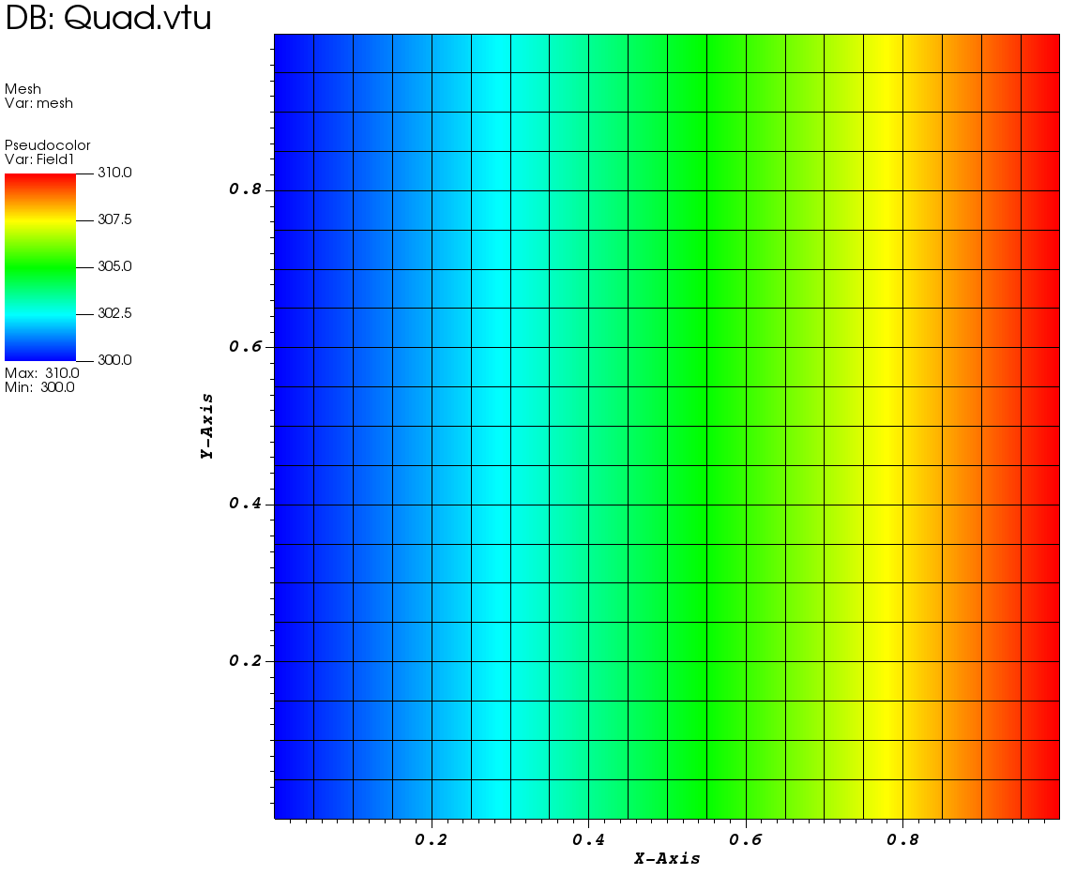  
     
     
     
     
     
     
     
   2)Alpha=0.5 Centre  
   Quad Element (tsteps=10):-  
   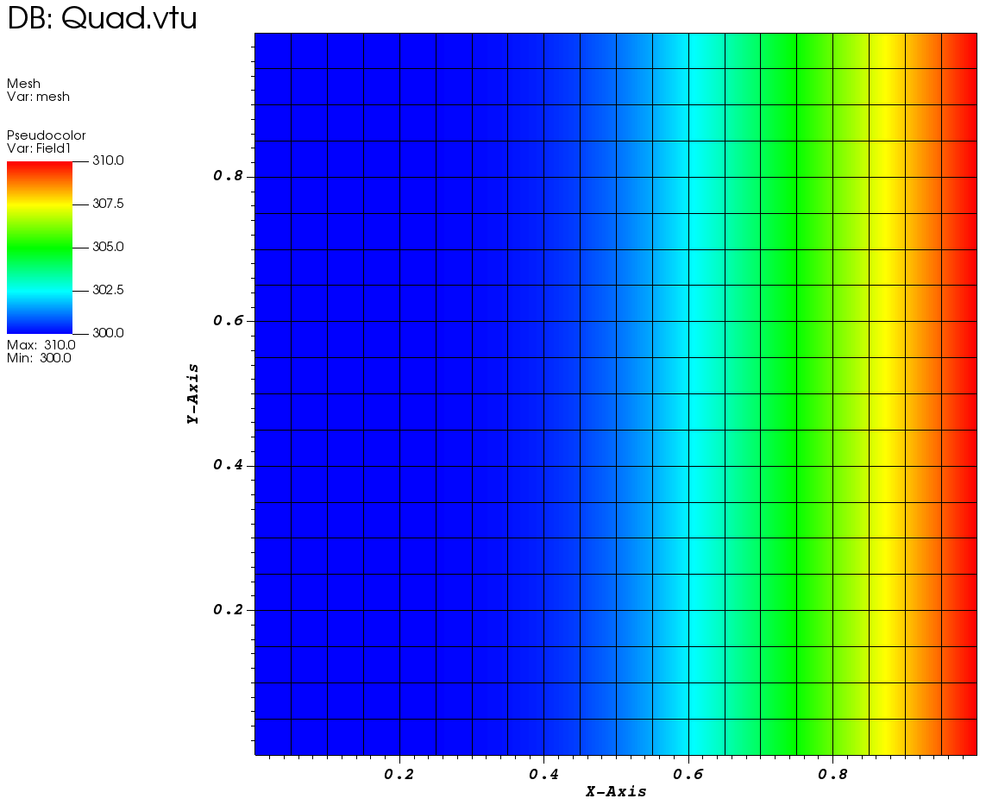  
   Alpha=0.5 Centre  
   Quad Element (tsteps=25):-  
   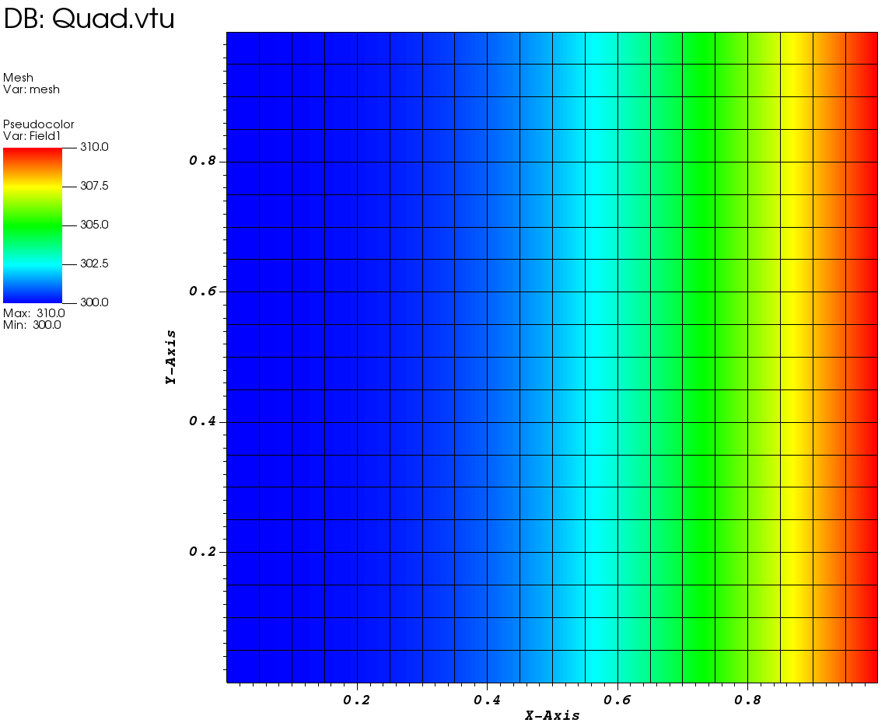  
   Alpha=0.5 Centre  
   Quad Element (tsteps=100):-  
   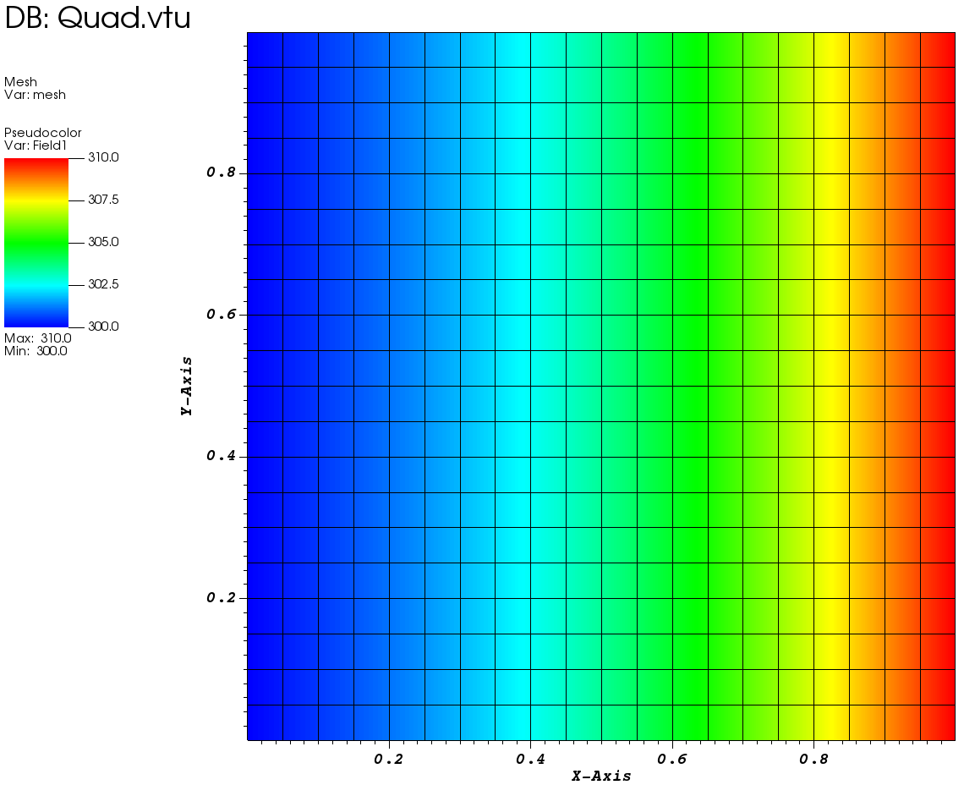  
   Alpha=0.5 Centre  
   Quad Element (tsteps=1000):-  
   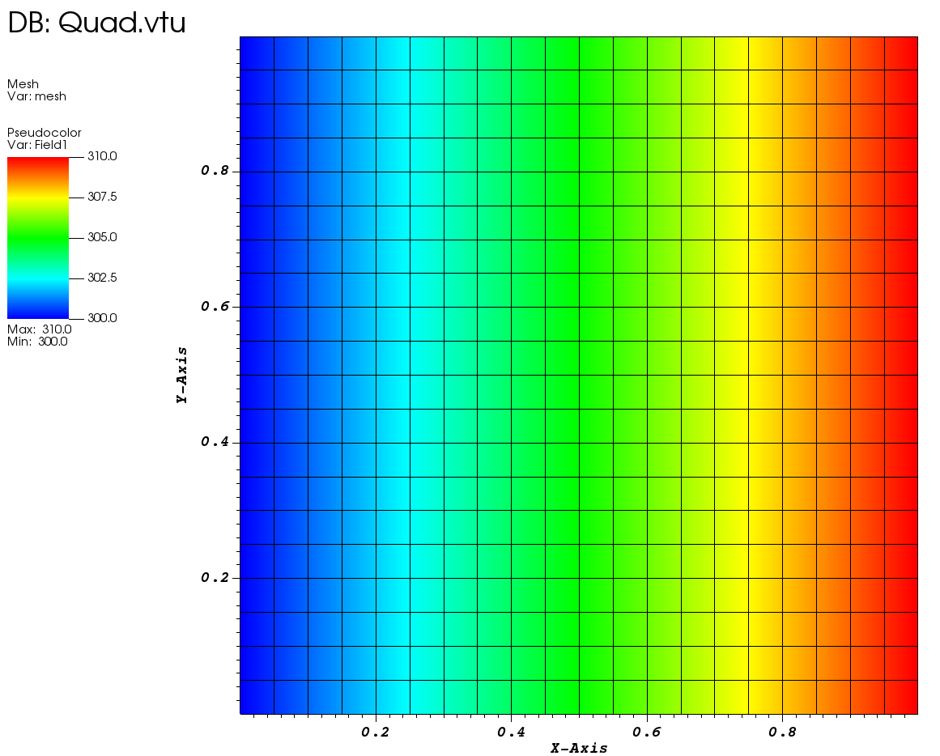  
     
     
     
     
     
     
   3) Alpha=1 Backward  
   Quad Element (tsteps=10):-  
   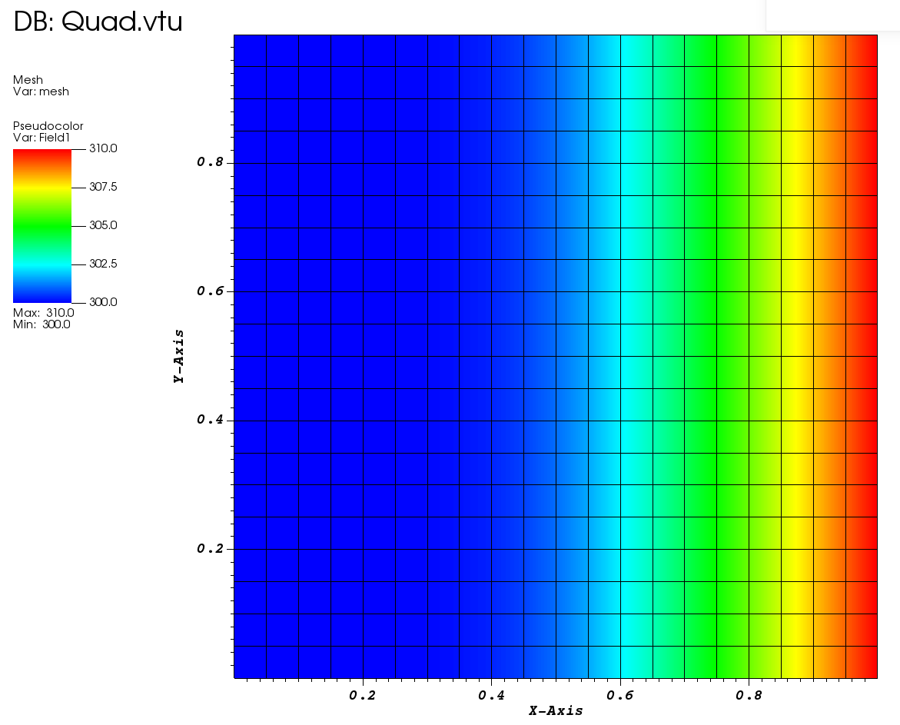  
   Alpha=1 Backward  
   Quad Element (tsteps=25):-  
   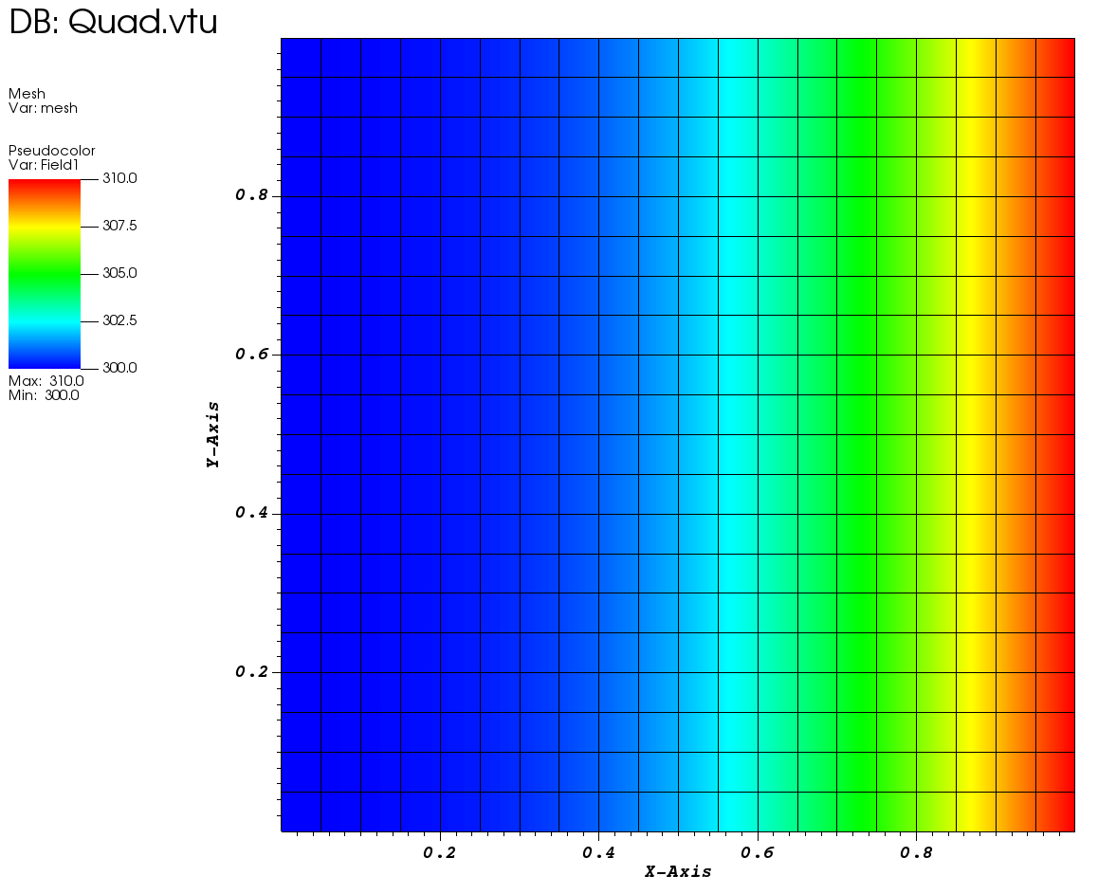  
   Alpha=1 Backward  
   Quad Element (tsteps=100):-  
   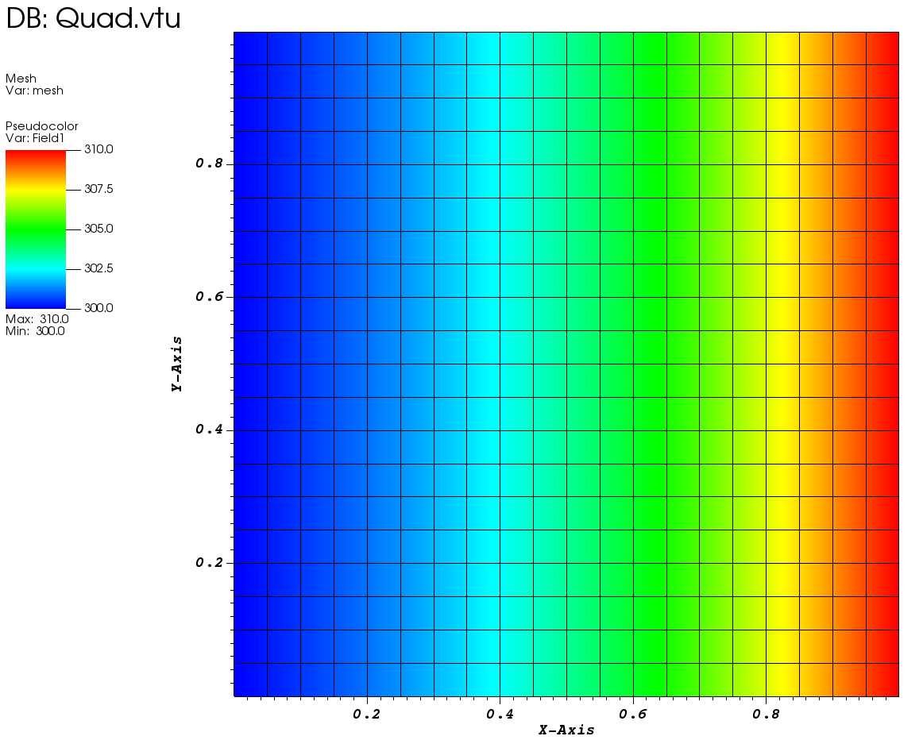  
   Alpha=1 Backward  
   Quad Element (tsteps=1000):-  
   