**Study of Quality Evaluation Standards**

Quality evaluation standards in software engineering refer to a set of guidelines or criteria .In software engineering, quality evaluation standards are used to assess the quality of software products, processes, and systems. These standards provide a set of guidelines and best practices to ensure that software products are reliable, maintainable, and meet user requirements.

**Principles of Quality Standards**

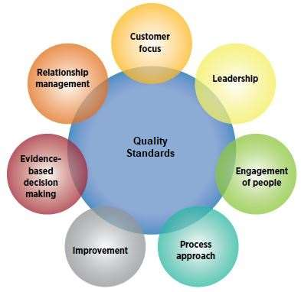

* **ASQ QUALITY STANDARDS**

|  |  |
| --- | --- |
| **Topic:** | **Standard:** |
| Quality Management | ISO 9000 ISO 9001 |
| Auditing | ISO 19011 |
| Environmental Management | ISO 14000 ISO 14001 |
| Risk Management | ISO 31011 |
| Social Responsibility | ISO 26000 |
| Sampling by Attributes | Z1.4 |
| Sampling by Variables | Z1.9 |
| Food Safety | ISO 22000 |

Here are some of the commonly used quality evaluation standards in software engineering:

**ISO/IEC 25010:** This standard is used to evaluate the quality of software products based on eight quality characteristics: functional suitability, performance efficiency, compatibility, usability, reliability, security, maintainability, and portability.

**ISO/IEC 12207:** This standard specifies the process for software development and maintenance. It defines the activities and tasks that should be performed during the software development life cycle.

**ISO/IEC 15504:** This standard is used to assess the maturity of an organization's software development processes. It provides a framework for evaluating and improving software processes.

**CMMI:** Capability Maturity Model Integration is a process improvement framework that provides a set of best practices for software development processes. It is widely used to assess and improve the maturity of software development processes in organizations.

**IEEE 829:** This standard defines the format for software test documentation. It specifies the documents that should be prepared during the testing process, such as test plans, test cases, and test reports.

**IEEE 1061:** This standard provides guidelines for software quality metrics. It defines the characteristics that should be measured to evaluate the quality of software products and processes.

**IEEE 1471**: This standard provides a framework for software architecture. It defines the terminology, concepts, and models that should be used to describe software architecture.

**SPICE:** Software Process Improvement and Capability dEtermination is a framework for assessing and improving software development processes. It provides a set of best practices for software process improvement.

* WHO USES QUALITY STANDARDS?

Organizations turn to standards for guidelines, definitions, and procedures that help them achieve objectives such as:

* Satisfying their customers’ quality requirements
* Ensuring their products and services are safe
* Complying with regulations
* Meeting environmental objectives
* Protecting products against climatic or other adverse conditions
* Ensuring that internal processes are defined and controlled

## WHY ARE STANDARDS IMPORTANT?

* **For businesses:** Standards are important to the bottom line of every organization. Successful companies recognize standards as business tools that should be managed alongside quality, safety, intellectual property, and environmental policies. Standardization leads to lower costs by reducing redundancy, minimizing errors or recalls, and reducing time to market.
* **For the global economy:** Businesses and organizations complying to quality standards helps products, services, and personnel cross borders and also ensures that products manufactured in one country can be sold and used in another.
* **For consumers:** Many quality management standards provide safeguards for users of products and services, but standardization can also make consumers’ lives simpler. A product or service based on an international standard will be compatible with more products or services worldwide, which increases the number of choices available across the globe.

In summary, quality evaluation standards play a critical role in software engineering by providing a set of guidelines and best practices for assessing and improving the quality of software products and processes

By following these quality evaluation standards, software engineers can ensure that the software products they develop meet the desired quality requirements and are fit for their intended purpose.