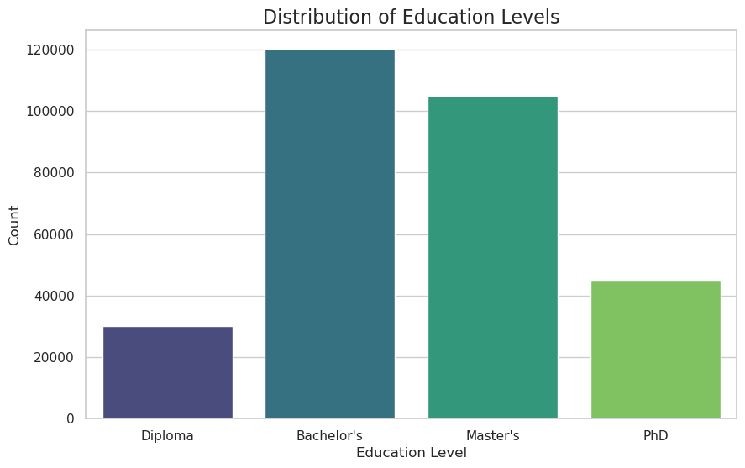、
Chart 1：Distribution of Education Levels
Graduates' qualifications is mainly Bachelor's (120,000) and Master's (105,000), while Diploma (30,000) and PhD (45,000) are relatively few
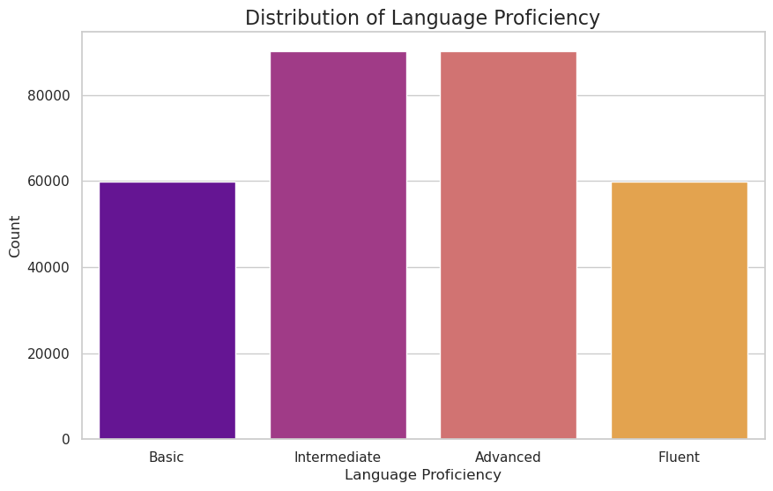
Chart 2：Distribution of Language Proficiency
The language proficiency is mainly Interactive and Advanced, and the number of Basic and Fluent is close, both around 60,000
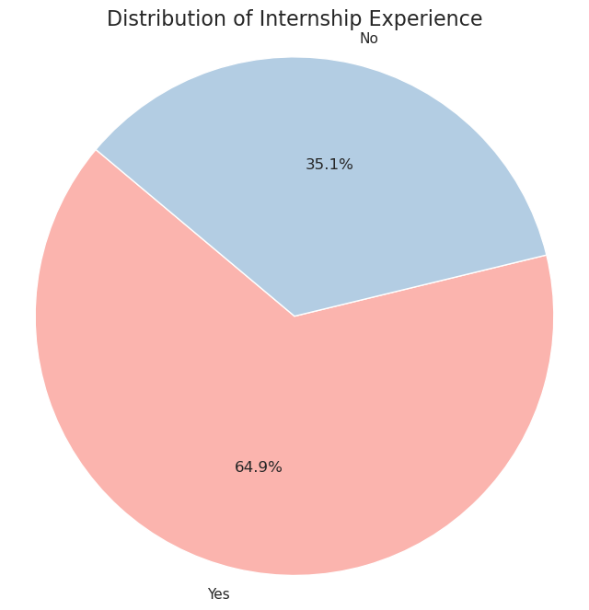
Chart 3：Distribution of Internship Experience
The proportion of graduates with internship experience reaches about 64.9%, while more than 30% of graduates lack internship background
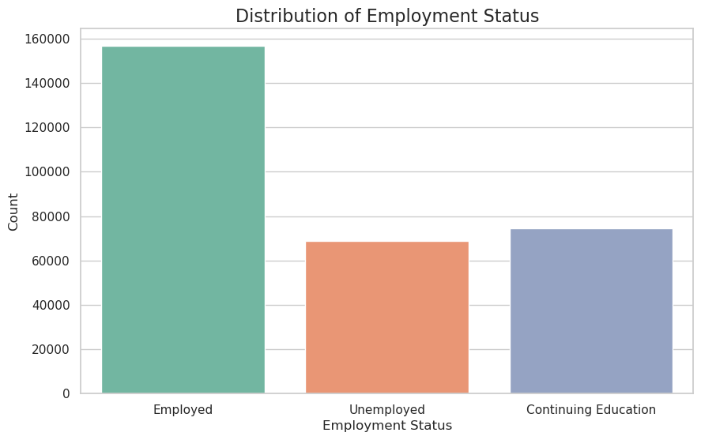
Chart 4:Distribution of Employment Status
The development path of graduates after graduation is mainly employment, followed by continuing education and unemployment, and the data is similar, around 70,000

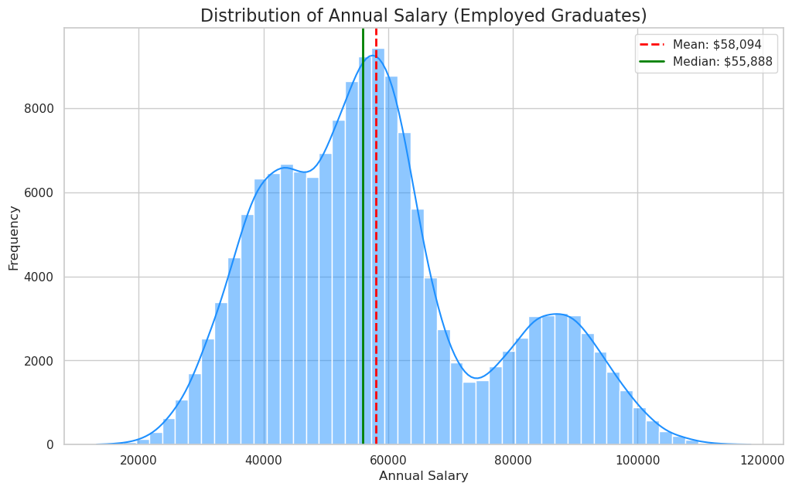
Chart 5:Distribution of Annual Salary
The annual salary of employees shows a bimodal distribution, with an average of about $58,094 and a median of about $55,888. Employees' salaries may be stratified by industry and position

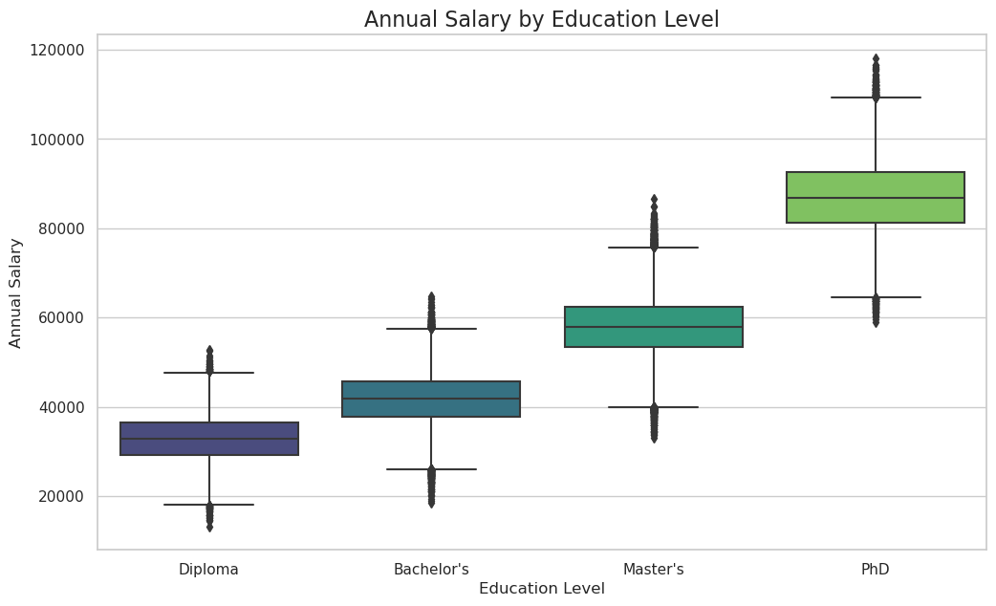
Chart 6:Annual Salary by Education Level
The higher the education, the greater the salary potential, which is most significant in the PhD
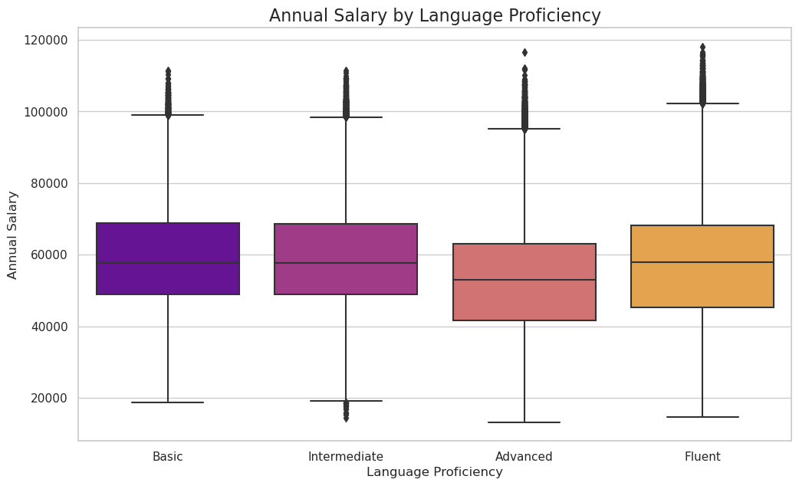
Chart 7:Annual Salary by Language Proficiency
The Fluent group had the highest median and upper salary and the second highest salary for Basic, but it is worth noting that the median salary and overall range of the Advanced group were lower than those of the Basic and Intermidiate groups.

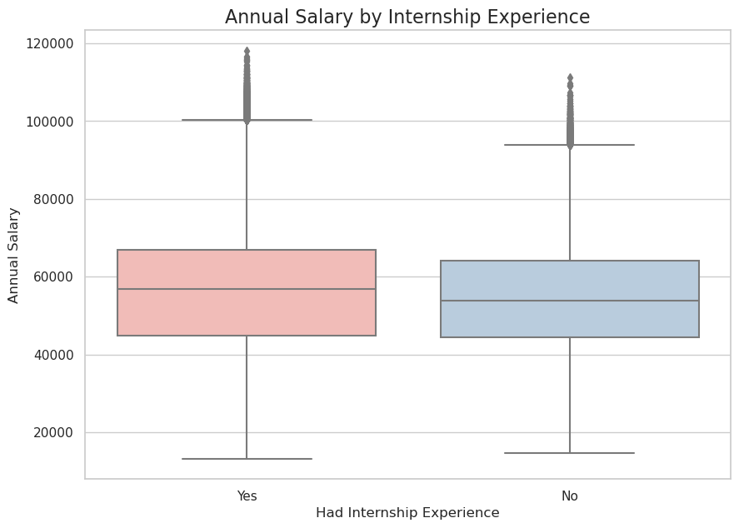
Chart 8:Annual Salary by Internship Experience
Internship experience is positively correlated with salary increase
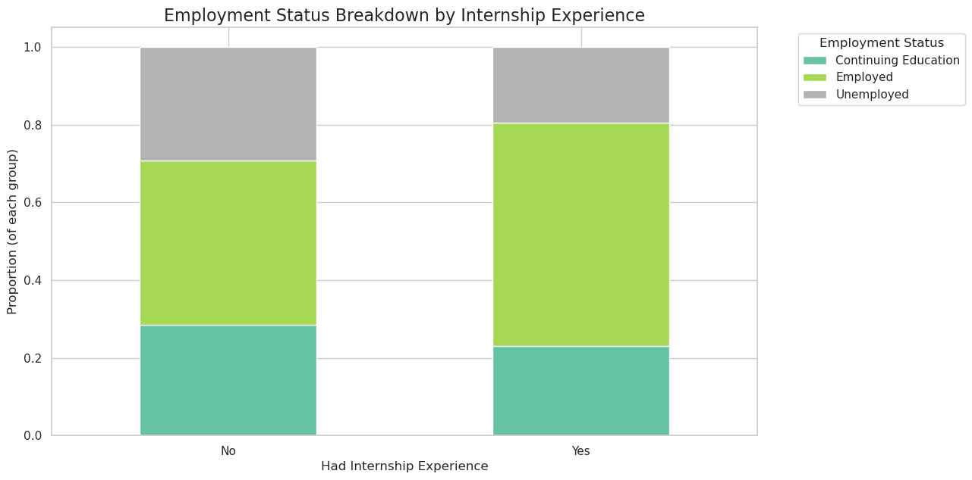
Chart 9:Employment Status Breakdown by Internship Experience
The employment rate of graduates with internship experience is higher than that of those without internship experience, and internship experience can effectively improve the employment conversion rate

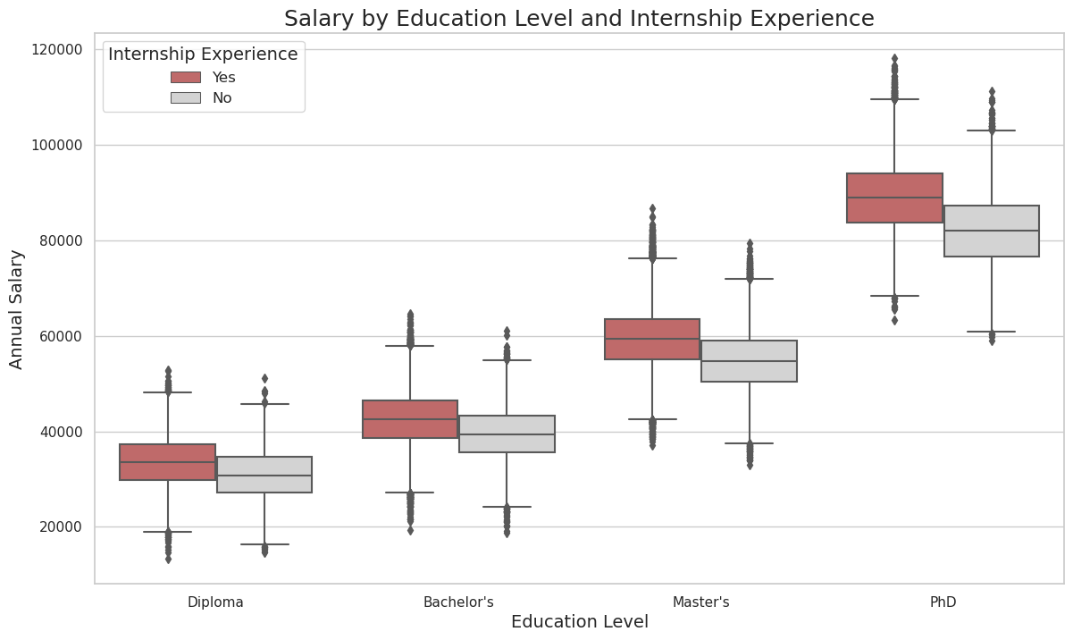
Chart 10:Salary by Education Level and Internship Experience
High education level and internship experience are two key factors that have a significant positive impact on increasing an individual's annual salary

